- MICROSOFT LABS | - October 17, 2018

Immigration Management system application
A Solution to perform Immigration process for organizations using Dynamics 365 CRM

Contents
Overview 3
Users 6
FN Management 6
Documents 8
Critical Immigration Dates 9
Case Management 11
Form Management 16
Questionnaire 17
Master Data Configurations: 20
Business Process Flows 21
Master Case Configuration 22
Master Forms 23
Master Documents: 24
Master Steps 26
Master Letters: 28
Stage Queue Mapping 30
Case Tabs 31
Binder 31
Master Attorney Configuration 32
Dynamics Questionnaire Configurations 33
Dashboards 36
FN Portal 37
Invite User to FN Portal (For Local login) 46
UCI Client 49
Creation of New Business Process Flows 52
Creation of New Questionnaire 57

Overview

Application Objective

The Immigration Management System (Referred as IMS) provides an end-to-end solution for organizations providing immigration services for their employees. IMS better manages employee immigrations needs and streamlines the HR process giving better results, meeting regular immigration requirements consistently and working with more collaboration.
This document provides how the IMS app uses Microsoft Dynamics Business Applications including the customer engagement app which is customized to suit immigration needs and further customized to extend the end users organizations process.

Components of the IMS APP

The principal components of IMS App are: Case template definition, Foreign National (FN) management, Case Management, Questionnaire Management, Forms Management, FN Portal and Azure Blob storage. Each of the components has different features and process flows within the system.

Foreign National (FN) Management

The Foreign National (FN) in the system is an OOB contacts entity. The FN is a visa dependent immigrant employee of the company and the accompanying dependents (Direct Family) are also contacts/FNs in the system.
- FN Summary & Sections - Provides information about Personal Information, Current Job Details, J1 Details, Export Control details, Address, Masters and HCAP details, Reporting Hierarchy, Critical Immigration Details, Documents, Dependent Details, Education history, FN Cases and their dependent cases etc.
- Deactivating FN & auto case Closures – FN’s are deactivated if they are of the immigration status PR and their respective cases are auto-closed.
- FN Case Management – Cases required to process for employee immigration purpose which are created in the systems are listed in the FN profile.
- FN Document Management – All the documents acquired from the FN and the documents uploaded in the case are managed in the Employee Documents section.
- FN Dependent Management – FN Dependents associated with FN are available in the Dependent Details and their cases are available in Dependent case history sections enabling management of Dependent information within FN profile.
- FN Portal– FN Portal is designed for Foreign National to view their cases, history, dependent, questionnaire’s, active tasks and other details.

Case Template Definition

IMS allows users to create dynamic case template definitions where the behavior of the case is defined by configuring the case-specific forms, documents required from the FN for the case, case stages and case steps required to work on by the Immigration team within a case, questionnaires to be sent to FN EE and all of letters, and email templates of the case. All these configurations can be dynamically created and managed by the Business Admin of the system. The cases created using the templates behave based on the template definition and pull the respective document, forms, and questionnaire and other related configuration settings. This definition can be modified at any point in time by the admin and all the changes made will reflect on newly created cases.
- Case Stage and Case Steps - Case stages and case steps required to work on by the Immigration team within a case
- Document - Case specific documents are configured to show in FNEE questionnaires for upload.
- Dynamic Questionnaire – Questionnaire configurations allow the Admin to configure specific web steps forms in the desired order which in turn consists of questions grouped logically. These questions are required to fill the USCIS forms of the case. All the information that needs to be filled by the FNEE are acquired using the questionnaire and directly auto-populates into the forms available in the case. The questionnaire also pulls the documents configured in the case and requests the FN to upload the documents to submit the questionnaire.
- Forms – 17 USCIS Forms that are commonly used to file work permit petitions are available in IMS as a dynamic editable PDF. These are added in the case template based on the petition type.
- Letters & Email Template – The admin can map the pre-defined email templates and letter to a case template based on the case type. This, in turn, will pull case specific letters and templates into the cases.
- Stage Queue Mapping – Mapping of the teams/queues to be working on the case on a specific stage and the respective SLAs for the stages are configured here.
- Case Tabs – The template allows the admin to configure the required tabs for the case. To illustrate further, the PERM Details tab is configured in PERM cases only and does not appear in any other cases.
- Binders – The order required for filing the case petition is configured and maintained in this feature. This automatically binds the documents in the required order in the cases which on printing will print documents in the chosen order.

Case Management

  - Template Association – The cases are based on the configuration settings of their respective case template. Each case loads a unique set of forms, documents, letters, emails, steps, and stages based on the master settings.
  - Case Stage Management – Stages help in managing business sub-processes within the case and track the ownership and SLAs associated with the stage.
  - Case Email Management - Email Activity management is a solution providing inline options in the case/ contact form enabling organization and management of emails on the same page in Dynamic 365 CRM.
  - Case Steps Processing – Each stage has a set of steps instructing the logical progression of the case which is to be executed to move on to the next case stage.
  - Questionnaire Process - The questionnaire can be sent to the FN on a button click and the information flows into the FN summary details and respective master forms available in the case. The questionnaire also acquires the documents from the FN needed for the processing of the specific case.
  - Case Document Management - Case specific documents are requested and acquired through questionnaires. The documents can also be configured to fall on the queue of specific teams
  - Forms Management
  - Binder – Binder allows the user to create a Filing Documents Sequence which on printing will create the case filing binder thus eliminating the usual manual binding process.
  - Case Status Management and Closures – Case statuses are maintained in tandem with the case steps and case stages closure and the different statuses help to manage the progress of the case.

Forms Management

Forms Management feature provides 17 master forms that can be added to the case and drafted, generated and saved in the case. The form can be directly sent to the FNEE through an email.
Licensing requirement – In order to use this feature through IMS, the system must be enabled with Itext. The respective license associated with the tool must be acquired for forms management to function in IMS.
Azure Blob Storage

Massively scalable storage for documents of different file type and varying sizes are possible with the Azure blob in IMS. IMS handles numerous employees, their dependents and all the immigration documents of each of their case. The blob serves as a document storage repository thus enabling management and maintenance of multiple documents.

Users

- Foreign Nationals who are Visa Dependent Employees of the company who access the application from online CRM portals.
- Attorneys and Paralegals who access the application from online Dynamics 365.
- Business Admin who manage the background configuration of the case templates.
- HR Associates involved in the recruitment of new hires and college hires.
- FN employees, Family Dependents, and Candidates for filling out the questionnaires as triggered by Attorneys.
- Other Immigration Team users –Admins, Program managers, Partner users, process outsourcing users.

FN Management

The FN in the system can be created using one of the following methods.

- FNEE – manual using CRM
- Dependents – manual using CRM
- Dependents – Automatically from dependent information section in the Questionnaire

The FN of employment status candidate if recruited, the employment status will get converted to FTE and the FN will get converted to an FNEE in the system.
Steps to create FN and associated features of FN Management
- Click on Service > Foreign Nationals in the navigation bar. My Active Foreign Nationals view opens, Click on the ‘New Foreign National’ button.

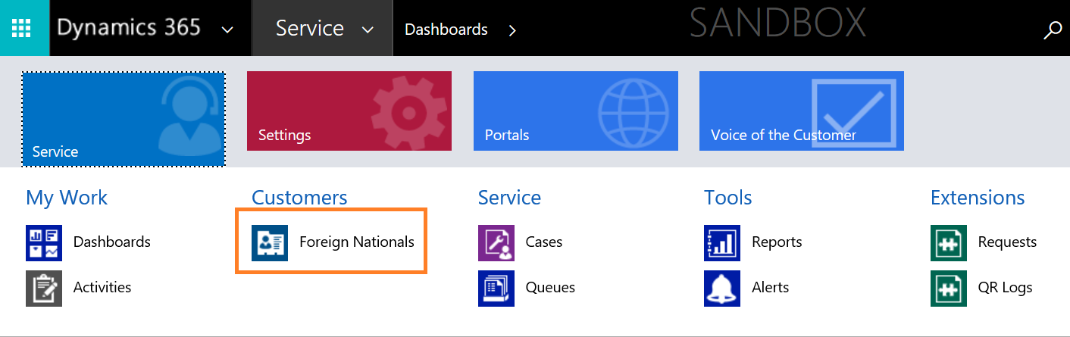

- Fill in the mandatory fields and click on Save. The Employee ID is used for Full-time employees and Candidate ID must be used for Candidates applying to join the company.
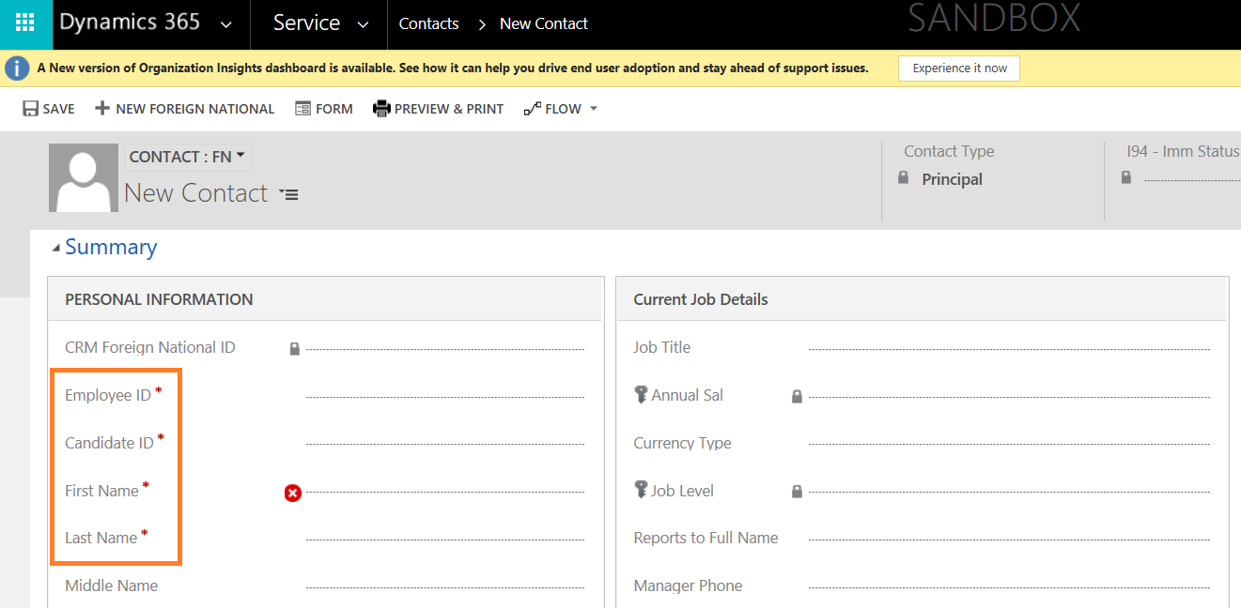
- Fill in the fields that are applicable to the FN and click on save.
- Some of the fields, in Summary, are mapped to be populated from the details provided in the Questionnaire sent to the FN. The fields are,

  - Country of Citizenship
  - Country of Birth
  - Date of birth
  - Home Address
  - Foreign Address
  - All the field in J-1 Details

- The FN is created and marked with Contact type Principal if they are FNEE and as Dependents for their dependents.

Documents

- To add Documents manually click the ‘+’ button on the grid. New document form opens.
- Provide the document type and fill in the required details and click save.

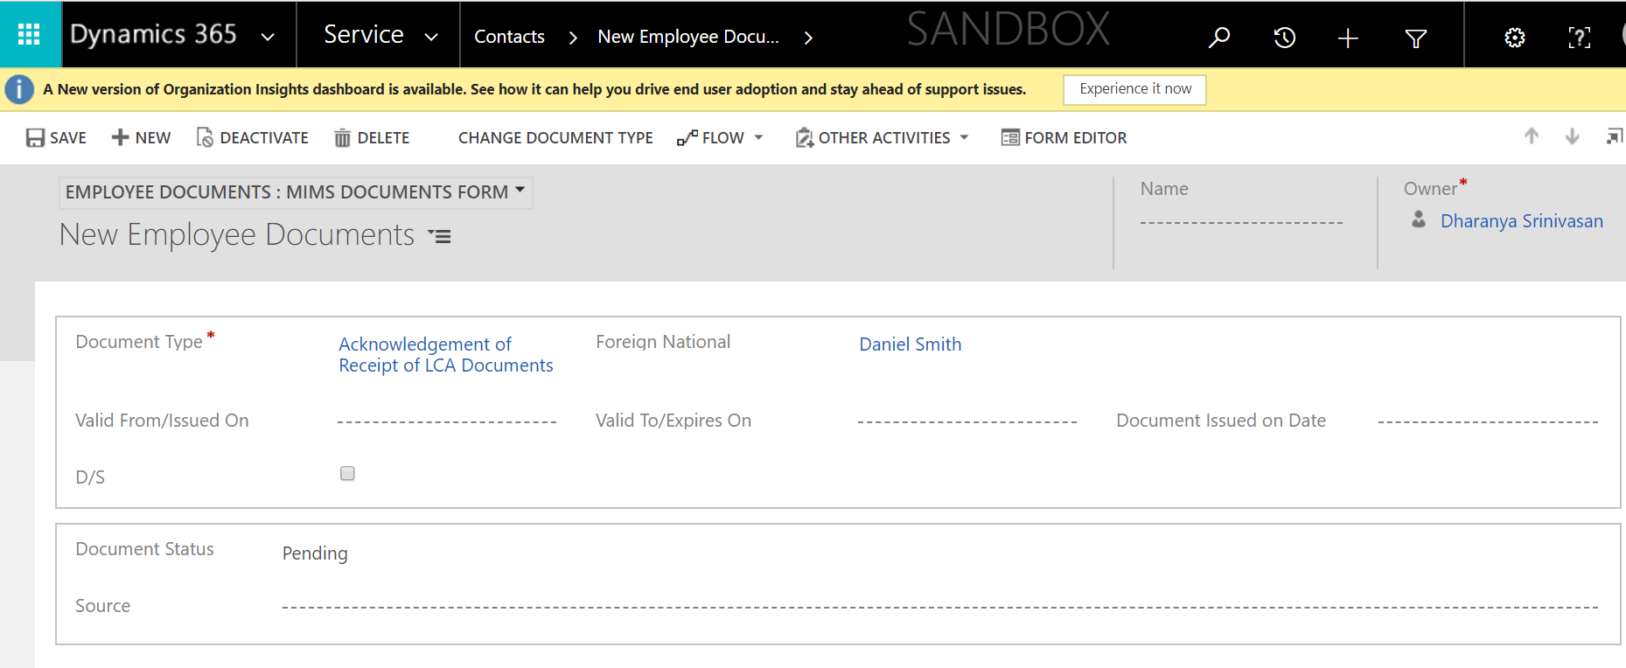

- Click on Notes to add an attachment and click save.
- The documents are also collected through the questionnaire. When they are uploaded into the questionnaire or portal, they land in case/FN and FN documents respectively.
- Preview and Print Functionality: Print and preview functionality provides a preview to all the selected document into a single component and then we will be able to print the document.
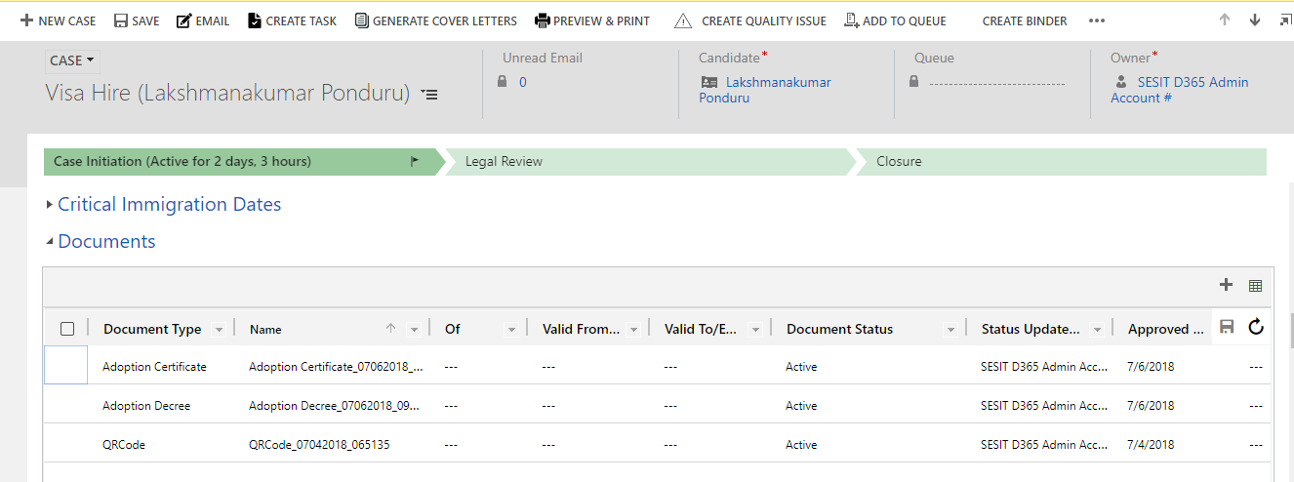

- Select the documents that need to be printed. The status of the document should be Active and those documents which are not Active will not be printed.
- Click the Preview & Print button on the ribbon, to merge all the selected documents then preview the document and it is ready to print.

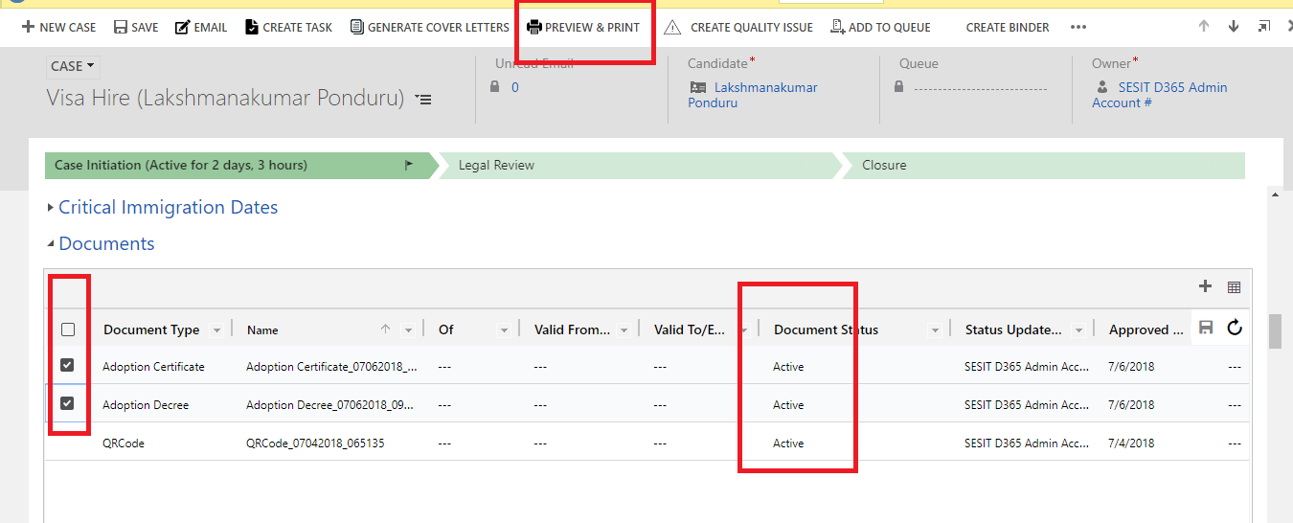

Critical Immigration Dates
- Critical immigration date records are created and available when an FN is created.
- To add details into the Date type, open the record and add the details.
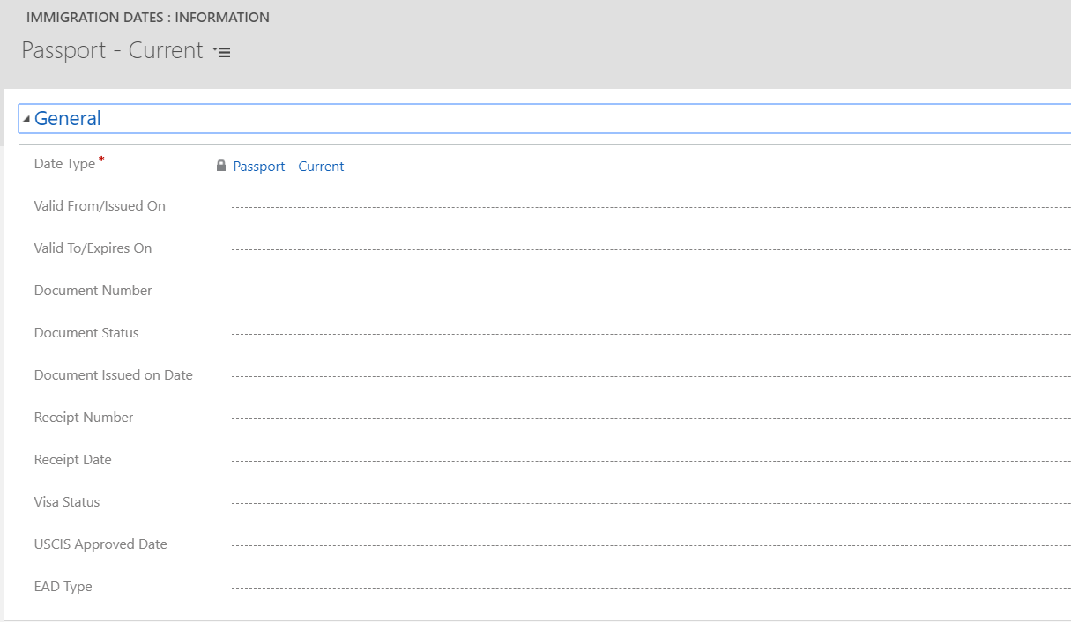
- The Critical immigration dates are automatically updated when the document associated with the date is uploaded manually or from questionnaire in the documents grid.
- Some documents that are marked for approval (Approval required after uploading is marked yes) will land in Employee Documents with status Pending. These documents will not be updated in the Critical Immigration Date section as the document status is Pending.
- Documents that are of status Active will be updated in the Critical immigration dates automatically.
Other Sections in FN Form
- Case history and Dependent Case History – Provides the list of cases opened for the FN and his dependents respectively. The user can click on the record to open the case.

- Company Job history and Other Job history – Provides the list of changes in the job title within the company and previous job positions respectively. The Other job history pulls information submitted through the questionnaire.

- Dependent Details and Parent Details – These sections are used to maintain the dependents and the related FNEE dependent associations within the system. Dependents can be added into the system from the Dependent details grid or through the dependent information section in the questionnaire.
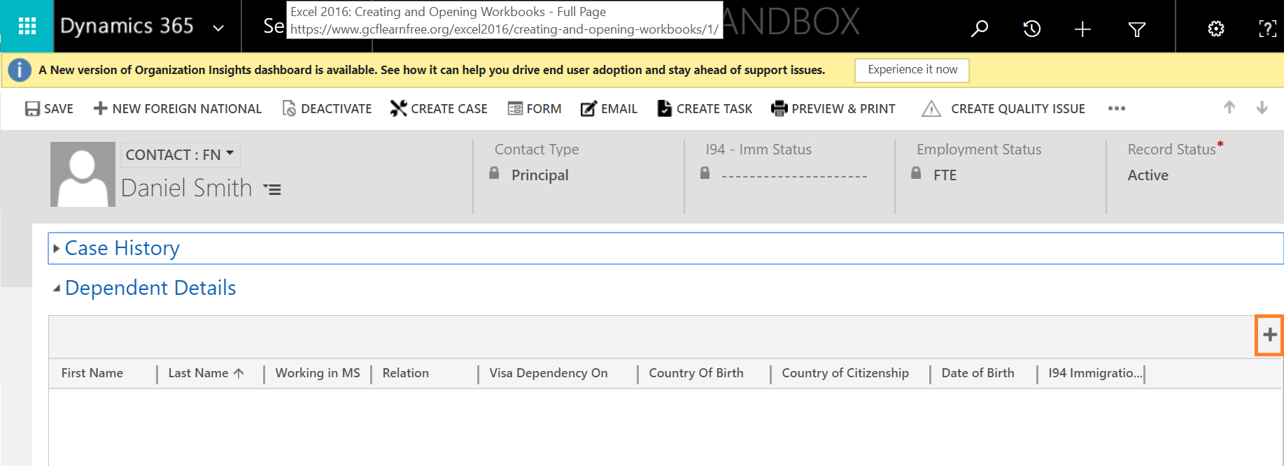
- Education History – This section pulls information from the questionnaire submitted by the FN.

- Hiring Details - The fields in this section are pulled from the HR Portal form which is used to create FNs in the IMS system. These are information provided by HR when the FN is of employment Status Candidate.

- Requests – This section provides the list of requests initiated by the FN through the FN Portal.

- Export Control Details – This section handles the fields associated with the Export control license analysis. This field is marked as Yes based on the values given by the FN in the questionnaire for the fields, Country of Citizenship and Country of Birth. These countries are created in Settings > Export Control Country List
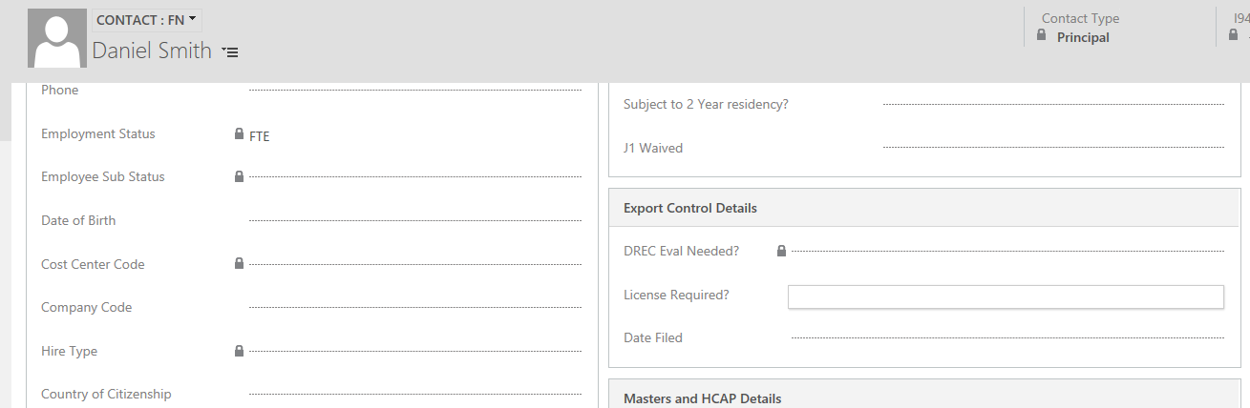

Case Management

Steps to create a case

The case can be created manually from the from CRM.

- A case can be created from the create case button in active cases view (Service> Case > My active cases > Create Case) or from the foreign national form.

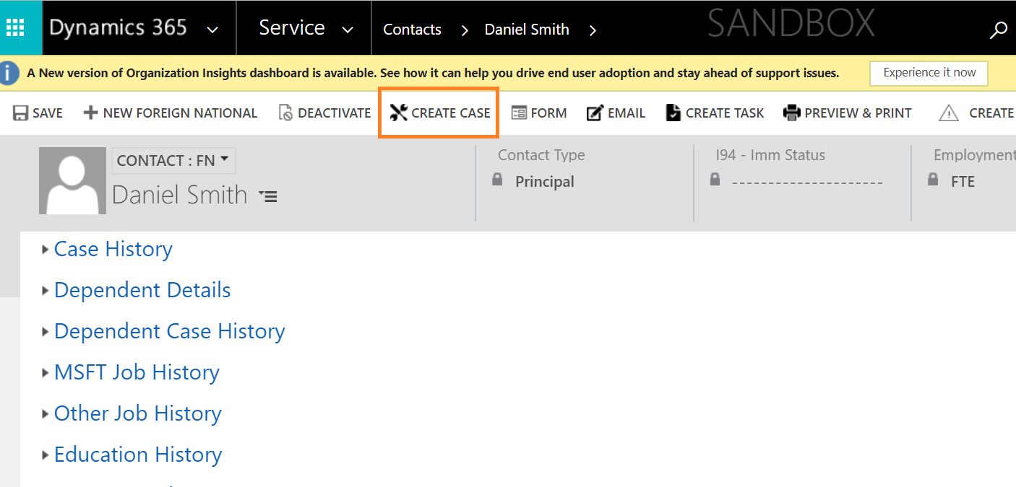

- Fill the mandatory fields and click on save.
- The field Legal group determines if the case is handled by the company or the outside counsel, the case will be assigned and maintained based on this field.
- The template name field is the case type (Visa petition) and user must choose the respective category. Category determines the case steps of the case. It is pulled from Master case configuration settings.
- Fill the necessary case details in the summary and click save.

Completing Case Steps

- Navigate to the case steps grid and flip the view to current stage steps.
- Complete the applicable steps by selecting the step, changing the Status to Completed and click on save within the grid.
- Send emails associated with the case step using the ‘Email’ button. It will pull the predefined email template to the email as highlighted below.

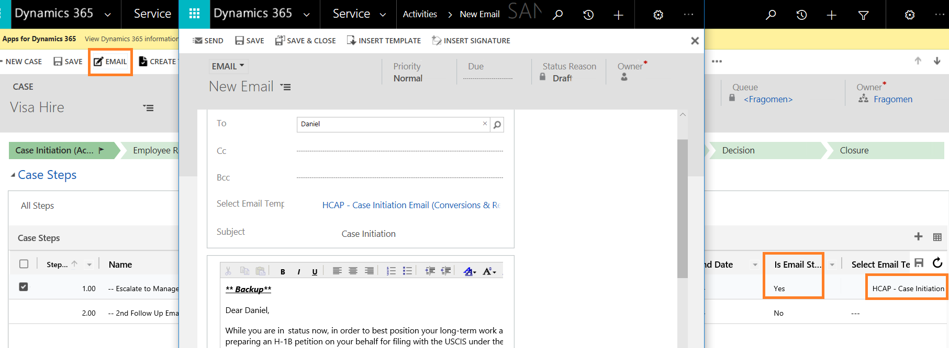

Moving between Case Stages

- Case steps are tagged to case stages based on their sequencing in the Master Case Configurations.
- After completing the case steps in a stage, the user must move the stages to work on the next stage-based case steps.

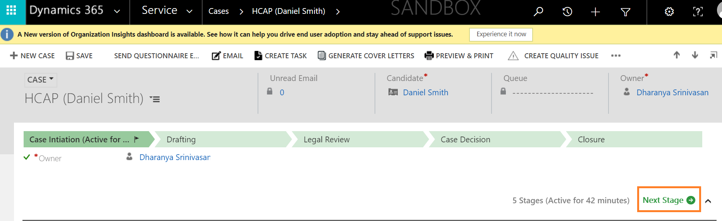
- The stages information is indicated in the summary under Queue Details. Also, the stages are assigned to the respective queue mapped in the Stage to Queue Mapping settings in the Master case Configuration.

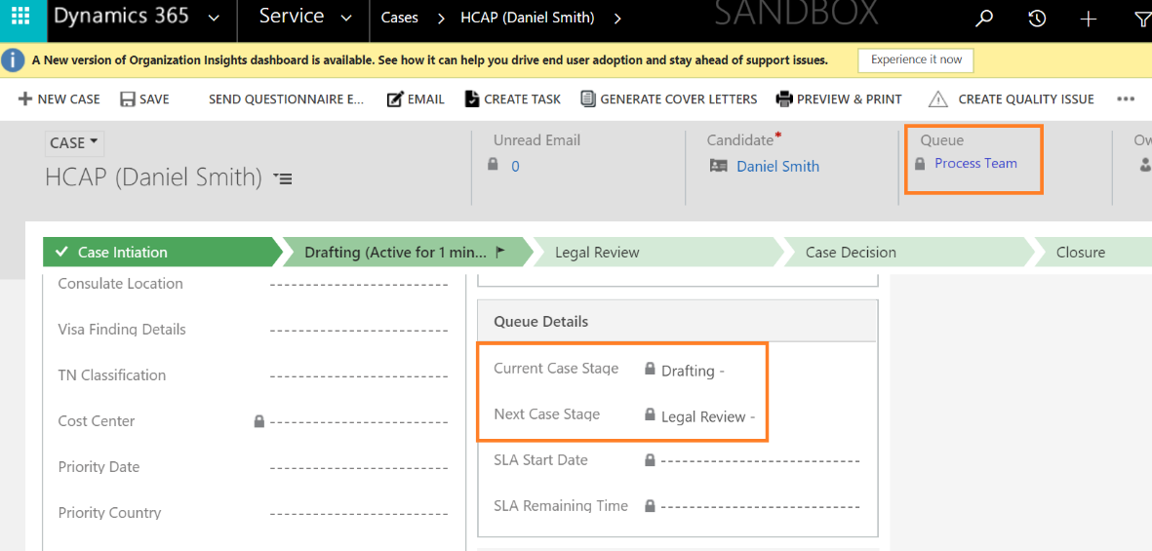

- The case can be manually reassigned using the Assign button.
- After all the case steps are completed, the case will be in the final stage and must be closed. There are four Case statuses which handle the status of the case.
  - Open
  - Approved
  - Completed
  - Closed
  - Denied
- If the case is closed/denied/approved, the case will be resolved, and the form will be locked for editing. To reactivate the case, use the Reactivate case button. This reenables the edit functions within the case form.

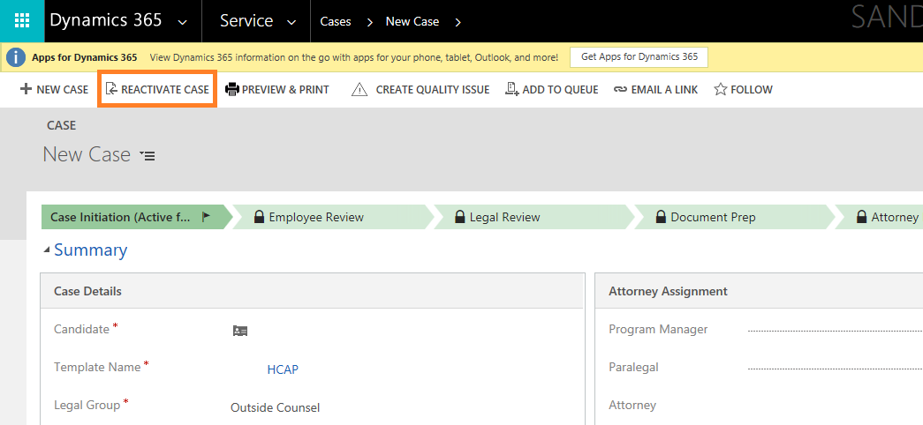
Binder

The Binder is the feature that enables automatic sequencing of the case documents as required for submission to USCIS during the time of filing. This feature is managed in the Master Case Configuration Settings for each case type.

- The binder sequencing is created in a case by clicking on the ‘Create Binder’ button.
- The document for the different contact type (Principal & Dependent) can be managed in the same case. This feature will be required for Dependent Cases.
- The document availability in the system is indicated by the Availability field in the Binder.
- Cover letters must be generated before creating the binder.
- When all the documents of the binder are available, click on Binder Ready button. This will combine the documents into a single file and make it available in the Case Documents as a single document.
- The binder documents can be refreshed using the Refresh Binder Documents button.
- The user can print the documents at any point to add to the filing packet.

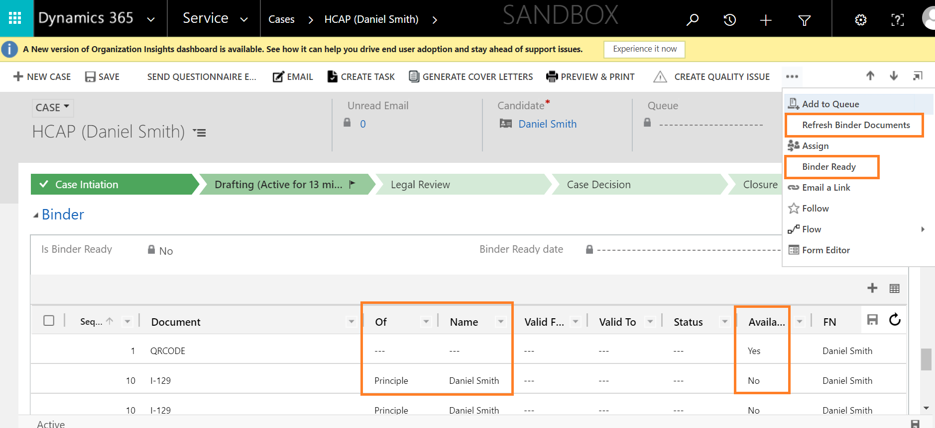

Other Components of the case

- Forms – Forms in the system are of two types, Master forms, and Other forms. Master forms are available as editable PDF and can be mapped to a case in the Master Case configurations. There are 16 Master Forms. All the Other forms must be drafted outside of the system and attached to the case.

- Questionnaire – The questionnaire is sent to a FN from a case using the Send Questionnaire button. The questionnaire link is sent via an email and must be reviewed and submitted by the FN. The information from the questionnaire populates into the case, FN page and forms in the case.

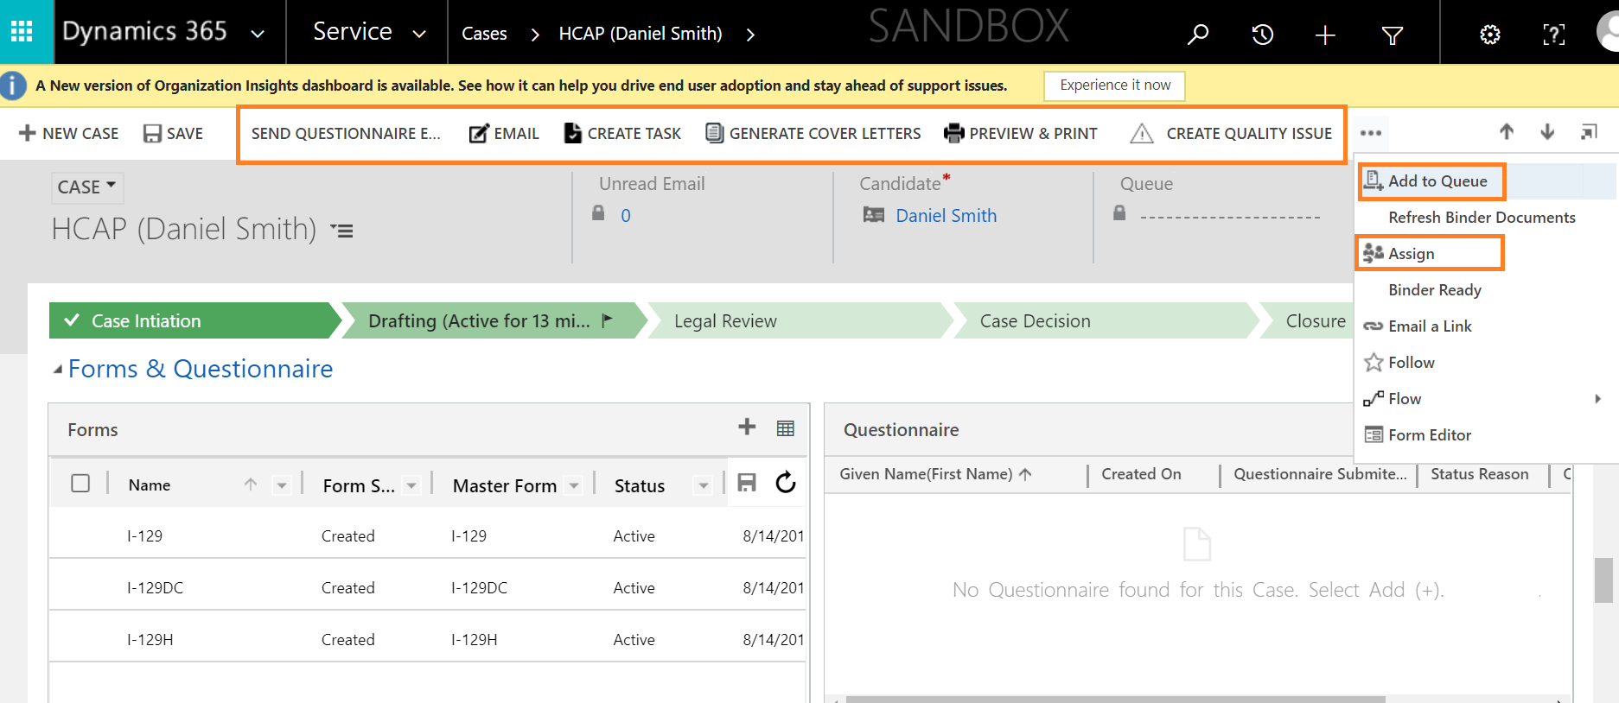

- Email – the email button is tied up to case step and can pull predefined email templates.
- Create Task – Tasks can be created for the Immigration team using this button. Task Categories can be added and managed by the business admin in Settings > Task Categories

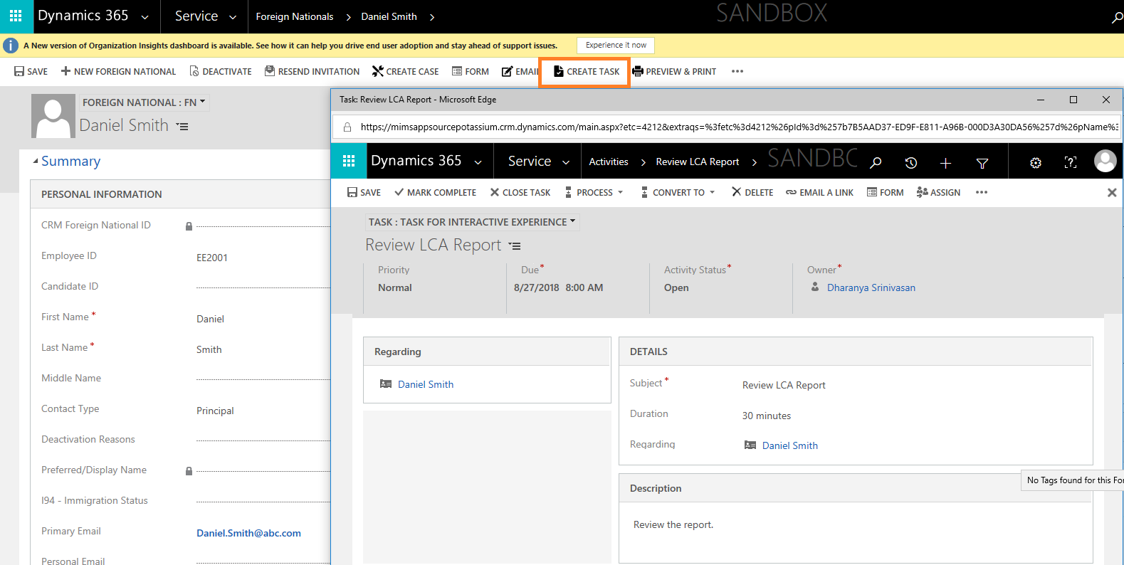

- Generate Cover Letters – This button must be pushed for the cover letters to pull the latest information from FN and case in the cover letters.
- Preview & Print – This button provides an option to print multiple documents at a time. Check multiple documents from the case document grid and push the button, the documents will be stitched together and displayed.
- Add to Queue & Assign - Case ownership is assigned in the master settings. Through the progress of the case, the case can be reassigned to a team or owner using Add to Queue and Assign buttons.

Form Management
Forms in the system are of two types, Master forms, and Other forms. Master forms are available as editable PDF and can be mapped to a case in the Master Case configurations. There are 16 Master Forms. These forms are the most commonly used forms in the immigration processing of FNEEs. All the Other forms must be drafted outside of the system and attached to the case.

Steps to create and draft forms
- The forms are added to the case in the Master case configurations based on the case type. These forms are automatically created when a case is created.
- To manually add a form, click on the + button above the forms grid in the case.
- The form can be drafted by clicking on the front of the form record in the forms grid.
- The form opens with data populated from three places,
  - FN Summary
  - Configuration Entity (Settings > Configuration > Static Field Values for USCIS Forms)
  - Questionnaire
- Draft and Save the form to continue drafting later.
- Click on Generate form and then View form button to view the form as a PDF.

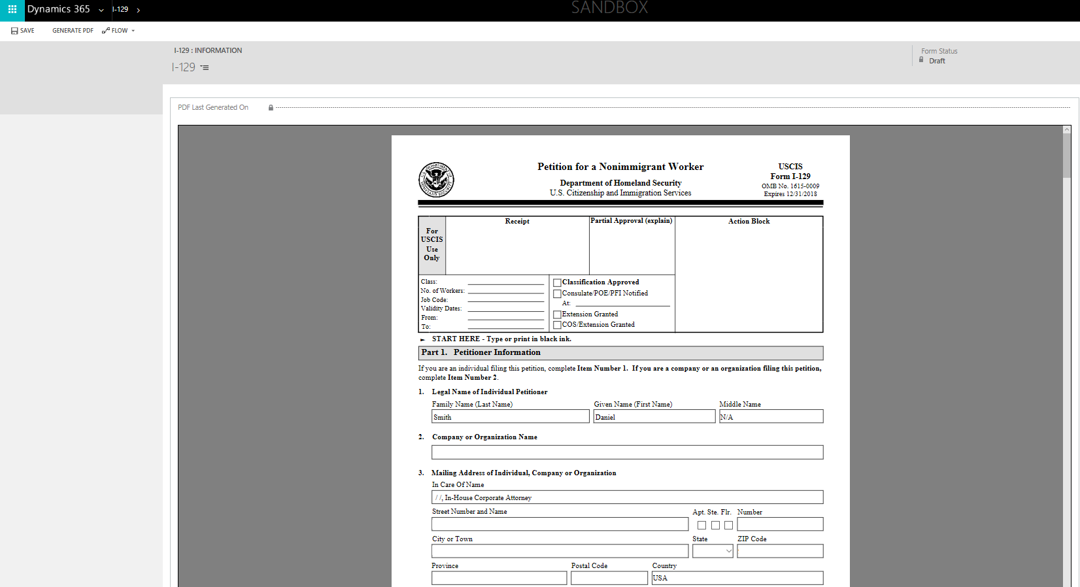

Questionnaire

The questionnaire in the case is created in the Settings > Questionnaire Configuration and mapped to individual case type in Settings > Master Case Configuration. There are 31 questionnaires built in total. These questionnaires request for immigration information related to the forms associated with the case. (E.g., H-1B – I-129 form).

To enable start step for Questionnaire
- Navigate to Questionnaire configuration entity in the settings.
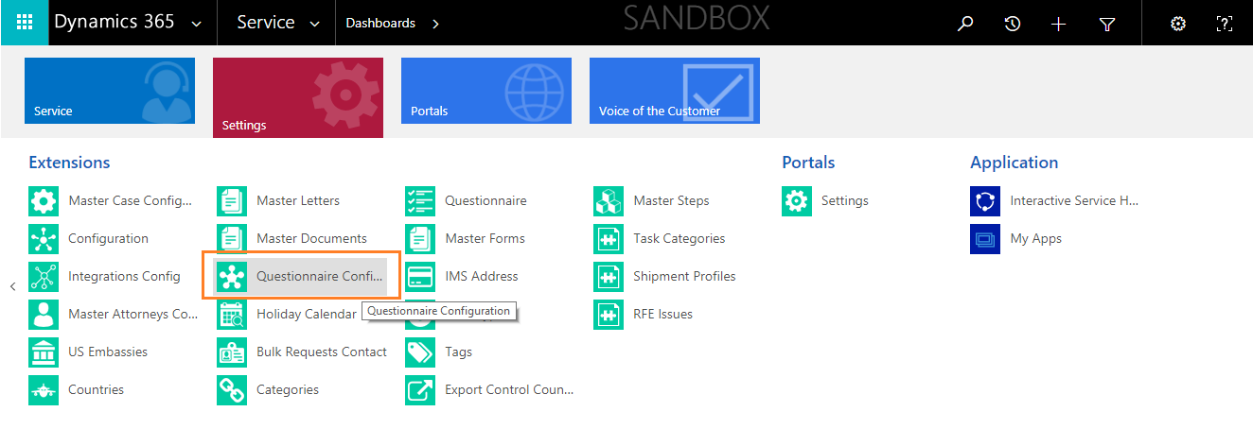

- Open the Questionnaire configuration record for which you want to enable the start step.
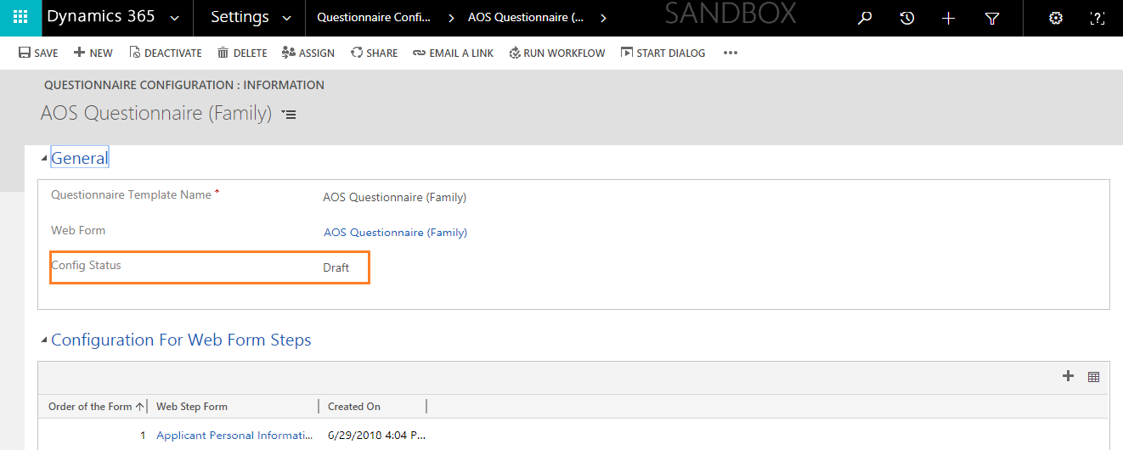

- Change the Config status to ‘Active’ and save the record. Then wait for a few minutes. 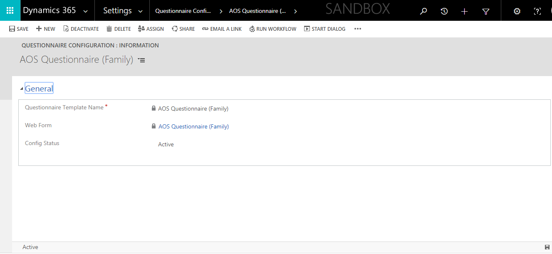
- Then start step will be created.

Questionnaire Process within a case

- Questionnaires can be sent to FN, by pushing the Send Questionnaire Button.
- The questionnaire is sent in the form link in an automatic email.

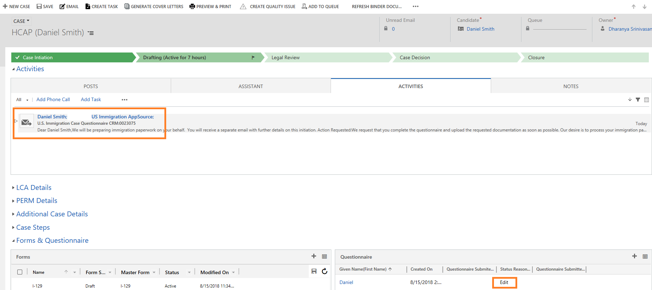

- Login in Questionnaire is of two ways based on the type of FN. If FN is of the employment status FTE, they can log in using the SSO option. FN of employment status Candidates can sign in by giving the username and password.

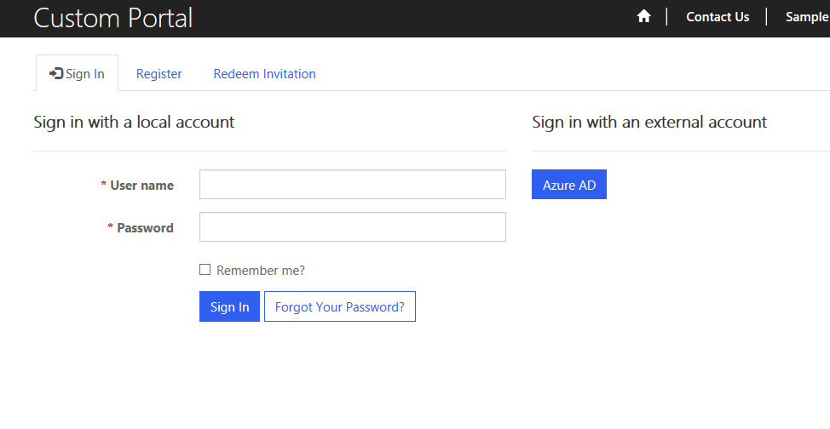
- The Candidates receive a registration link through email when a questionnaire is sent out for the first time. Upon registering they can set up a username and password to login into the questionnaire.
- For FTE’s SSO is enabled based on the company email address added in the Primary email address field in the FN Summary.
- FN must log in into the Questionnaire and complete all the sections, upload the requested documents and click on submit.

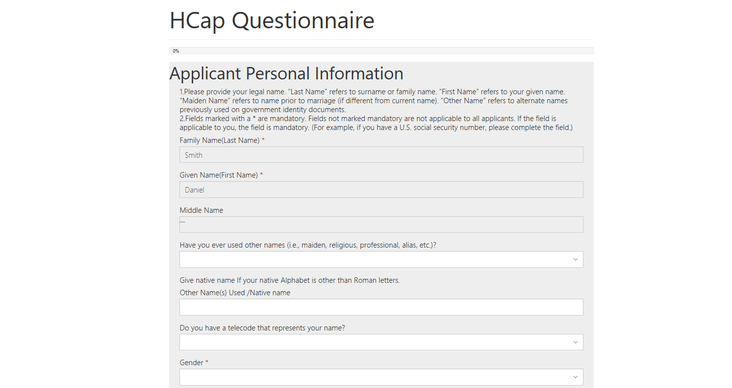
- After submitting the questionnaire, if the user tries to open the same questionnaire with the same URL which he/she got in the email, it would open in the read-only format. He/she will not be allowed to make any changes in the submitted questionnaire.
- On submission, all the information mapped to the USCIS forms in the case will be auto populated.
- Submitted Questionnaire can be accessed from the Questionnaire grid in case.
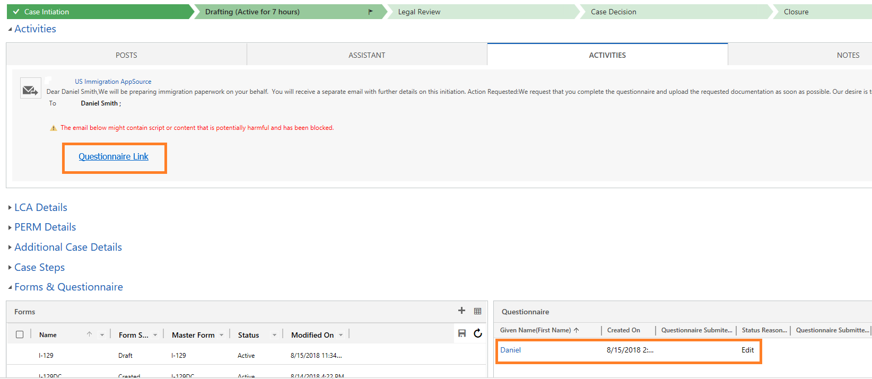

- The uploaded documents will be available in case documents grid.
- The questionnaire can be resent using the Resend Questionnaire button, but updated information does not copy into the USCIS forms.
- Questionnaire data is stored in the master questionnaire which prepopulates into every new questionnaire sent to the FN in different cases.

Master Data Configurations:
Master Data held by an organization describes the entities that are both independent and fundamental for that organization, and that the organization needs to reference to streamline, maintain and process its cases. Cases comprise of primarily the various immigration petitions and the respective processes associated with the processing and filing of them. It also includes other business processes including visa prerequisites involved in the hiring of new employee and respective evaluation from an immigration standpoint.
Below is the list of Master case, process and data configurations in this application:
- Business Process Flow
- Master Forms
- Master Documents
- Master Steps
- Master Letters
- Master Case Configuration
- Tags
- Questionnaire Configuration
- Task Categories
- Requests Configuration
- Case Categories

Business Process Flows

A Business Process Flow in this application is meant to help users to manage sub-processes within a case through a specific case stage in the system. The stages are associated with business-specific case steps that need to be completed within the stage. The stage can be assigned to a specific team or owner who will work on the respective case stage. Business process flows are representations of your different case stages and are displayed visually in our application as a chevron across the top of an entity form.

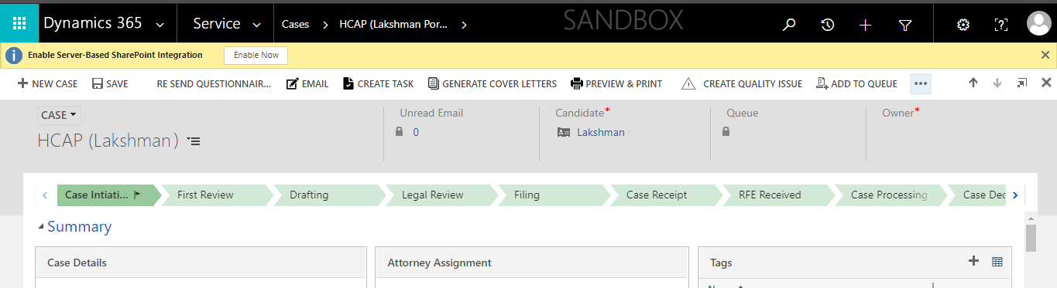

Steps to create a Business Process Flow

If you want to create any Business Process Flow, navigate to Service > Settings > Processes.

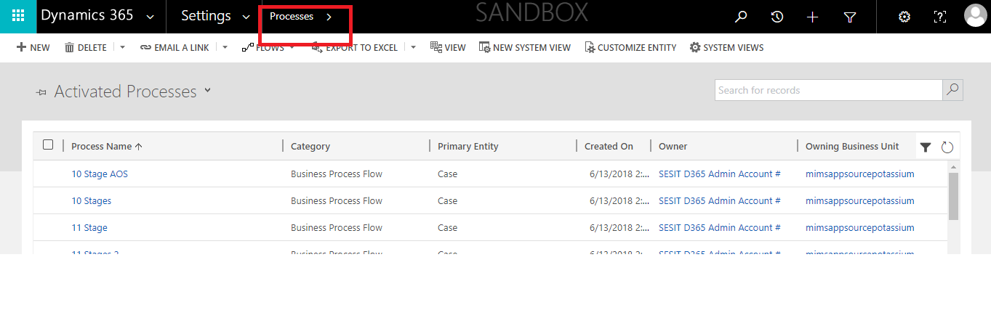
Then click on the new button, to create a new BPF and give the process name, Category as Business process flow and Entity on which you want this BPF should be activated to be selected in Entity drop-down.
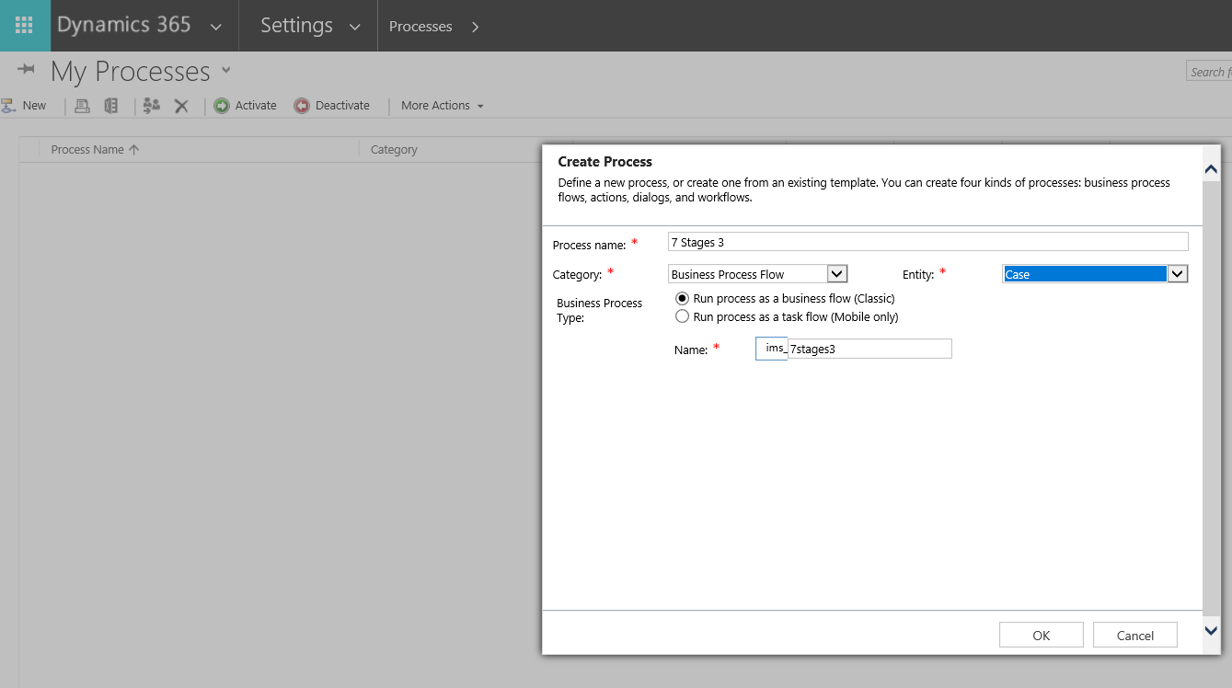

Stages:

Stages are configured using the BPF and they make the workflow logic easier to read and explain. If a process has stages, all the steps within the process must be contained within a stage. Steps to add steps to a stage and to add a stage owner are given in Master Steps and Stage queue Mapping from below.

Master Case Configuration

Master Case Configuration is the place to create and manage the case template. This template allows users to configure respective cases with specific documents, forms, steps, tabs, letters, and binder. The Template can be created by selecting the respective BPF, Questionnaire Template, Case Visa Type. Steps to create Questionnaire templates is detailed in the Questionnaire (Link) discussion.
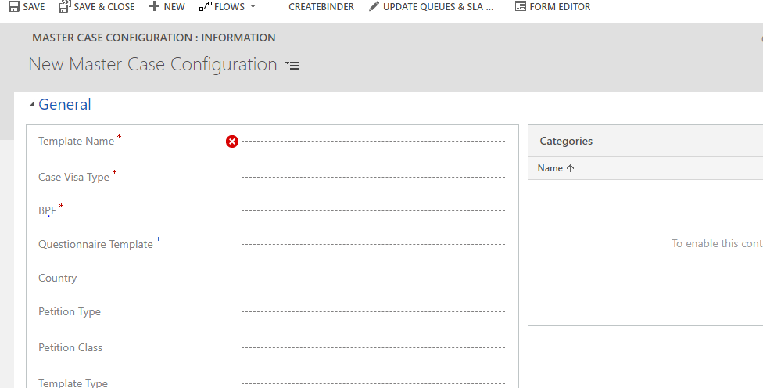
Since we cannot take the OOB business process flows as a lookup, we must provide the custom business process flow.

Master Forms
The United States Citizenship and Immigration Services (USCIS) issues several forms relating to immigrant and non-immigrant visa statuses for people to fill and submit along with their immigration petitions. The IMS App provides 17 commonly used forms in the form of editable PDFs which enables within the case for the user to edit and draft the form for the FN to view and sign. These forms can be added to the master template based on the petition type.
These include application forms related to entry to the United States, leaving for the United States, and work authorization in the United States. Ex: I-130, I-129F, DS 230.
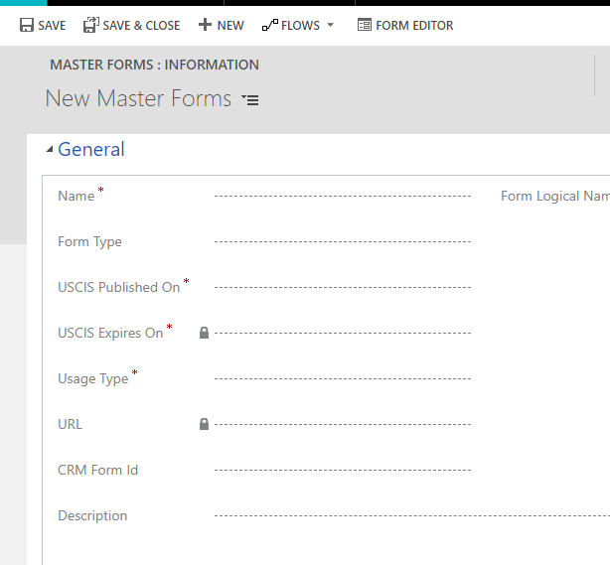
Click on (+) symbol and click on new as shown below and enter the required fields and Save the form. Now the form will be added to the Master case configuration.

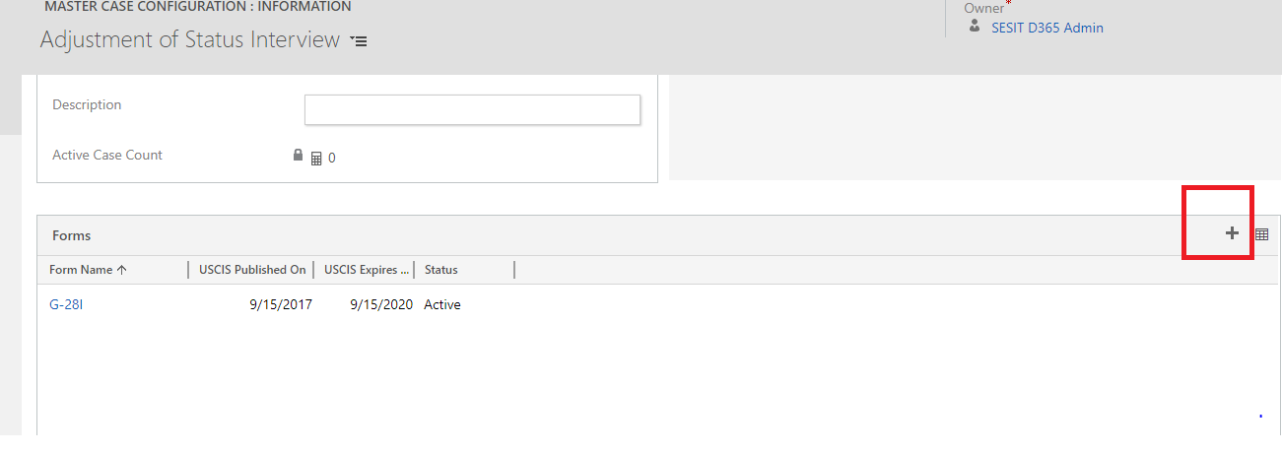

Master Documents:
Supporting documents which are related for the completion of the immigration case are created and managed as Master documents to control all the associated features associated with each document. In other words, we call these documents as Case documents or Employee documents when they are created in the case or employee level. These documents can be managed in the Master documents where specific document related configurations such as Validity date requirement, displaying of the document to the employee, employee viewable document descriptions and other document related settings can be managed for individual documents.
Create Master Documents

- Navigate to Settings > Master Documents > New
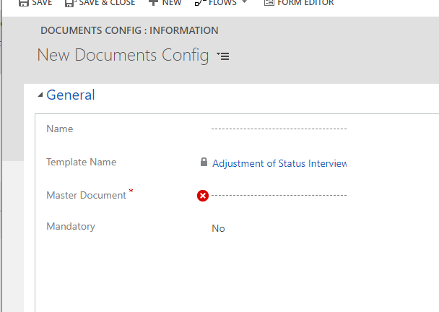
- Add the values for the below fields to configure the document settings for each document type.
Document Settings | Feature in Documents
Approval Required after uploading? | The field routes the documents uploaded by FN to a queue for review.
Document Expiring in 6 months Task Required | It creates an alert in the FN Portal when a document is nearing expiry.
Is Critical Immigration Date | The document is tagged as a date so that it appears on the critical immigration date grid.
Display to Employee? | Show or hide the document to the employee.
Mandatory | Does not allow FN to submit questionnaires without uploading the document.
Description | Brief description of the nature of the document.
Valid From/To Required? | Makes the validity date fields mandatory during document uploads.
Is Document Type? | Allows users to upload documents when creating the document.
Issued on Date Required? | Show or hide Issued on the date in the portal.

Adding Master documents to Master case Config

- Navigate to Settings > Master Case Configuration > Documents
- Click on (+) symbol and click on new as shown below and enter the required fields and save the form. Now the document will be added to the Master case configuration.
- These documents will be a part of the case questionnaire requested from the FN where the FN can upload the respective documents from.
- The documents can be marked as a mandatory document in this stage using the Is Mandatory? field. This will, in turn, require the FN to submit the document before submitting his case questionnaire.
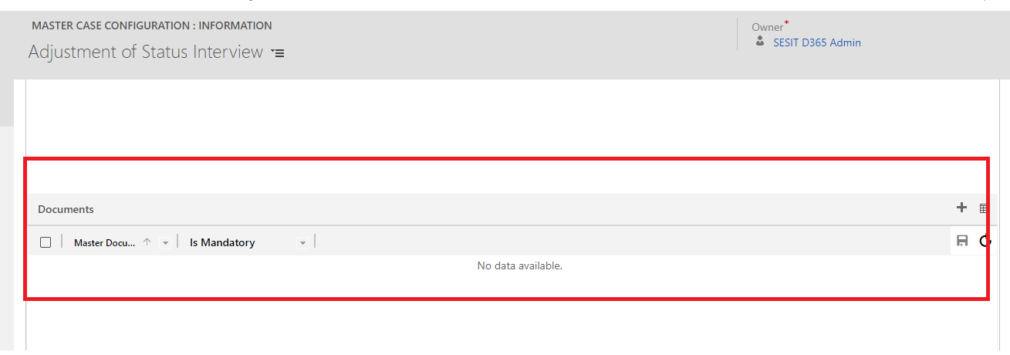

Master Steps

Steps are a unit of business logic within a workflow. Steps can include conditions, actions, other steps, or a combination of these elements.
Here we maintain the general information of the step including the step name, Step order and Step process stage as shown below.
Create Master Steps

  - Navigate to Settings > Master Steps > New
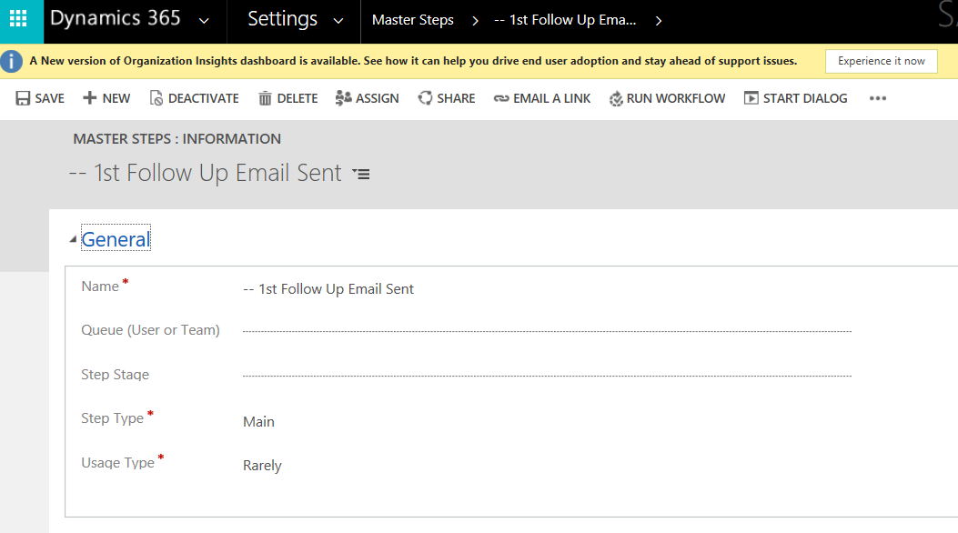
  - Enter the Name of the step and click Save.

Linking steps to Master Case Config

- Navigate to Settings > Master Case Configuration > Steps

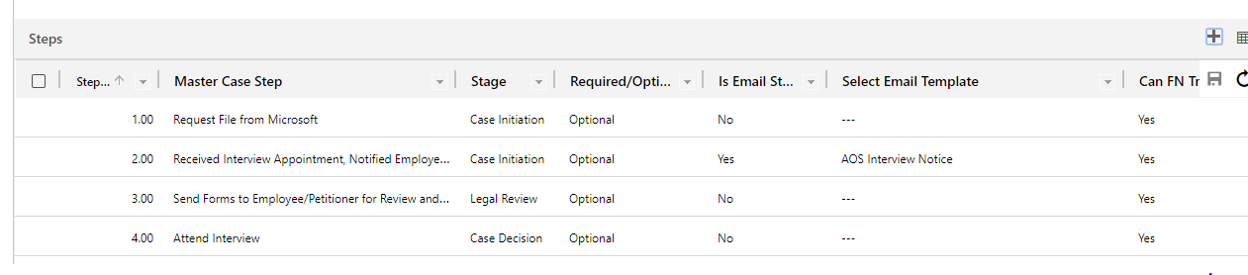
- Click on (+) symbol and click on new as shown below and enter the required fields and save the form. Now the step will be added to the Master case configuration.

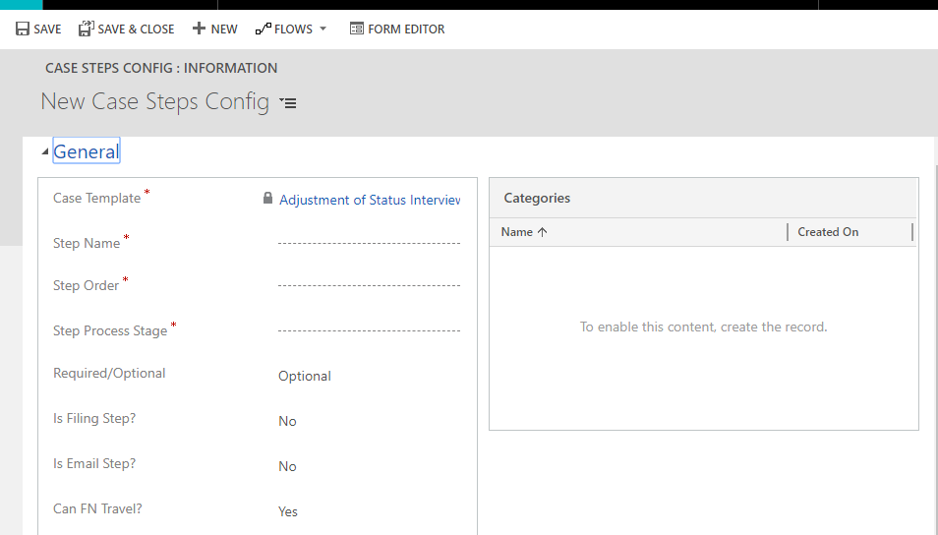

- Add the required configuration settings for the given steps. The features associated with each step attributes are given below.

Case Step Settings | Feature in Case/Case Step
Step Name | Name of the Step as it appears in the case.
Step Order | Order of appearance in the case.
Step Process Stage | Case stage in which the step must appear.
Required/Optional | The required step will not allow the case to be moved between stages unless it is marked as ‘Completed’
Is Filing Step? | This field will populate the filed date within a case when the case step is completed.
Is Email Step? | The field allows case steps to allow an email template association. When the user clicks on the case step, the email mapped to the step will populate in the email body.
Select Email Template | Maps the respective email template to the case step.
Can FN Travel? | Allows CRM users to show and hide travel warning on the Portal based on the case step/stage of the FN.

Master Letters:

Master Letters are Document Templates of OOB CRM.

Master Letters Creation

- Create and upload one document under the document template and
- With the same name create a letter in Settings > Master Letters

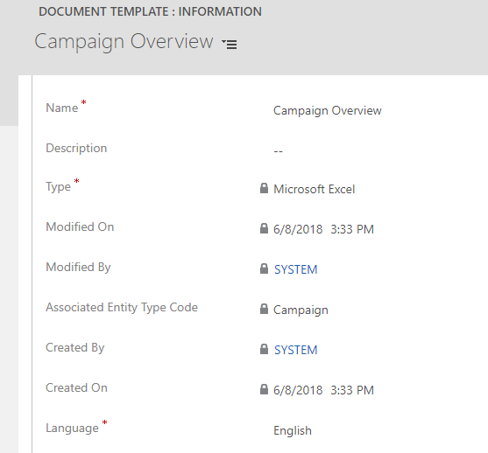
Adding a letter to Master case Config

- Navigate to Settings > Master Case Configuration > Letters
- Use the ‘+’ to add the pre-created letters from the above steps.
Letter in case
After clicking on Generate Cover letters button on the case, the letters associated in the master case config of that case template would be generated under Letters sub-grid.
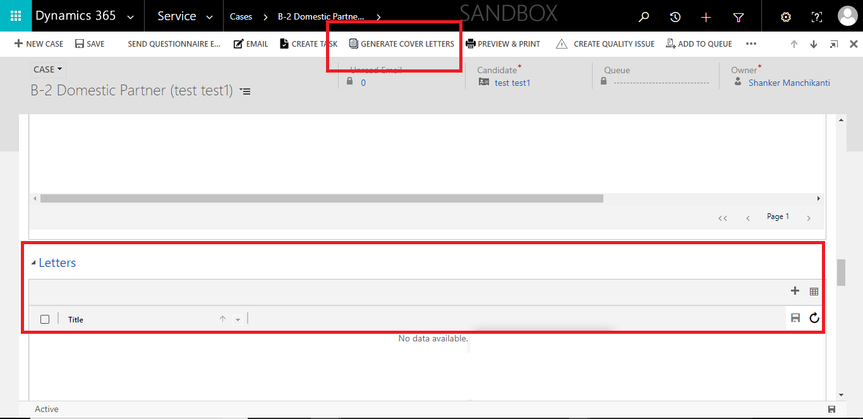

Stage Queue Mapping

As the name states mapping between stages of BPF and Queues are added in this entity. For every stage, a Queue and respective SLA is configured in stage Queue mapping configuration entity. While navigating from one stage to other, based on the current stage the Owner of the case would also change. Based on the queue SLA is calculated.

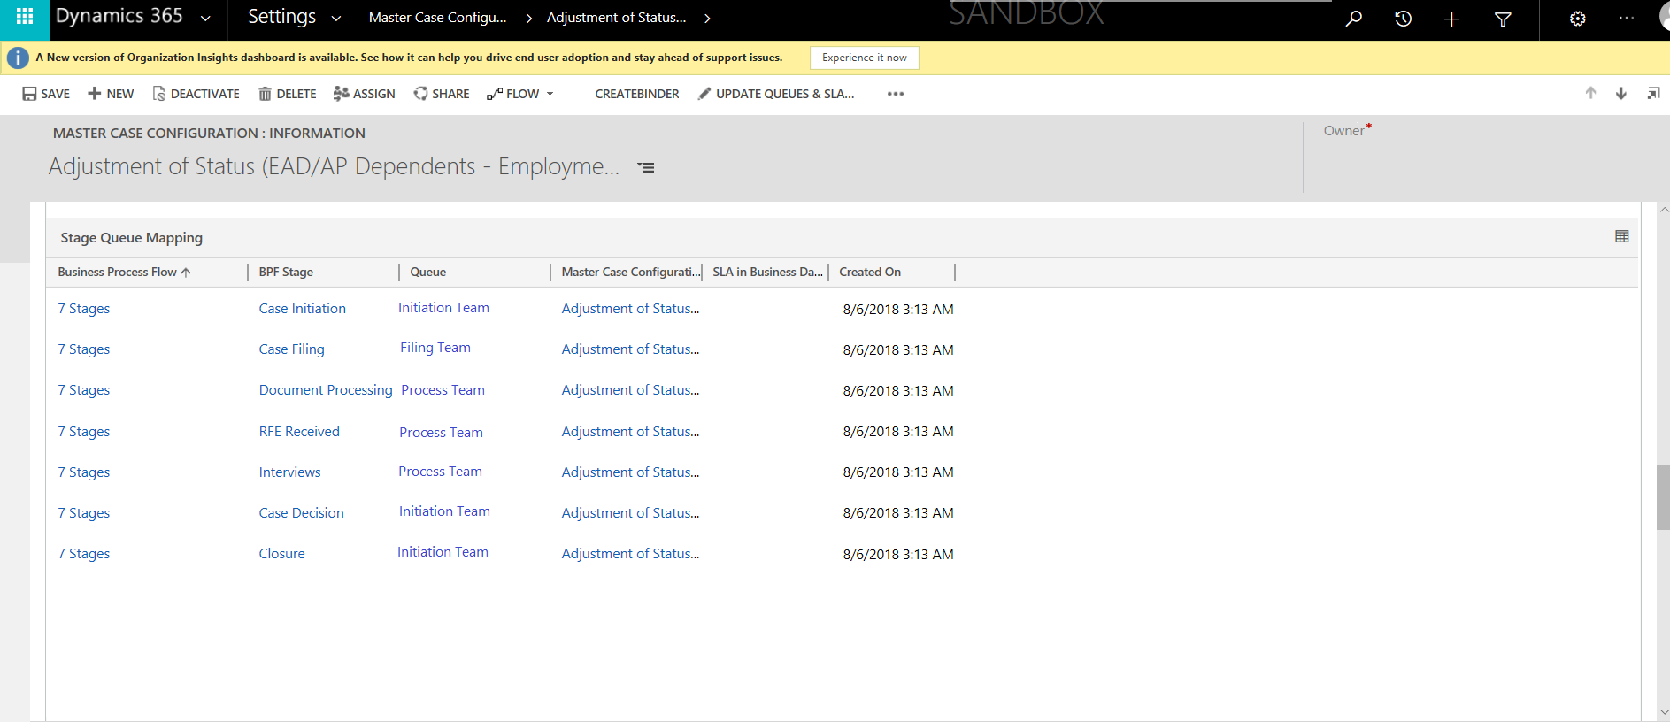

To modify the stage queue mapping, click on the record and add the necessary details and click save.
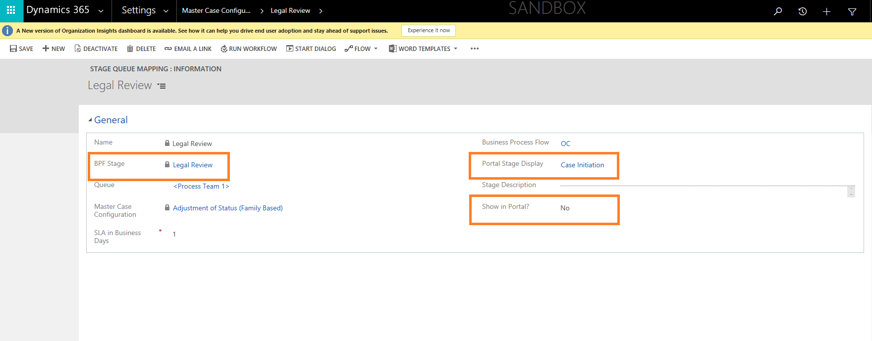
The fields Portal stage Display and Show in portal controls the visibility of the case stages displayed in the portal in the case page. The BA can configure the Portal stage display to show any stage based on the requirement of the case. The stages ordering must be in tandem with the BPF of the case. If there are ten stages in the case, this feature allows the user to show only four stages in the portal.
In the above record, although the current stage of the case will be Legal review for the FN it will show as Case Initiation stage based on the Portal Stage display value.
If the same stage as appearing CRM case view must be displayed in the portal, mark the field Show in Portal as yes.

Case Tabs

This feature in the master case configuration allows the user to customize the required tabs based on the requirements of the case type. The following tabs are available in the system.
- Activities
- Additional Case Details
- Case Steps
- Critical Immigration Dates
- Documents
- Education History
- Export Control
- Forms & Questionnaire
- LCA Details
- Letters
- MSFT Job History
- Other Job History
- Owner & Case Stage Logs
- PERM Details
- Stem Training Plan & Evaluation Details
- Summary
The tabs can be added using the + option above the tabs grid. The tabs can be easily removed from the grid.

Binder

- After creating a Master Case Configuration record with all Steps, letters, documents, forms, etc. and save it then we will be able to see Create Binder button on the ribbon.

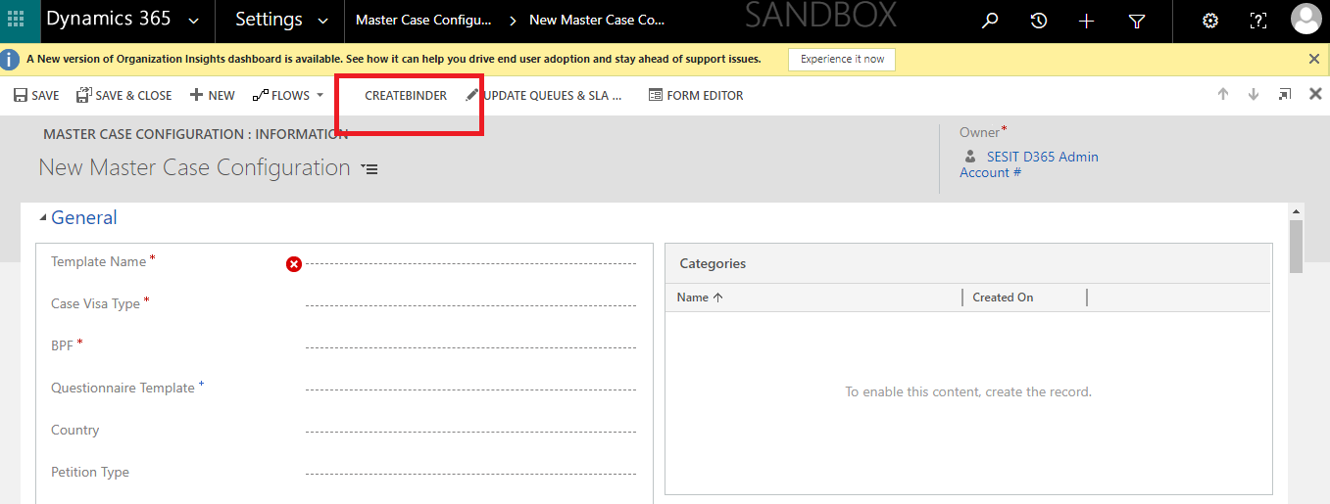

- On click of that button, it will pull all the Forms records, Documents and letters of that record and show the same in the Binder Admin Config sub-grid of the same record.

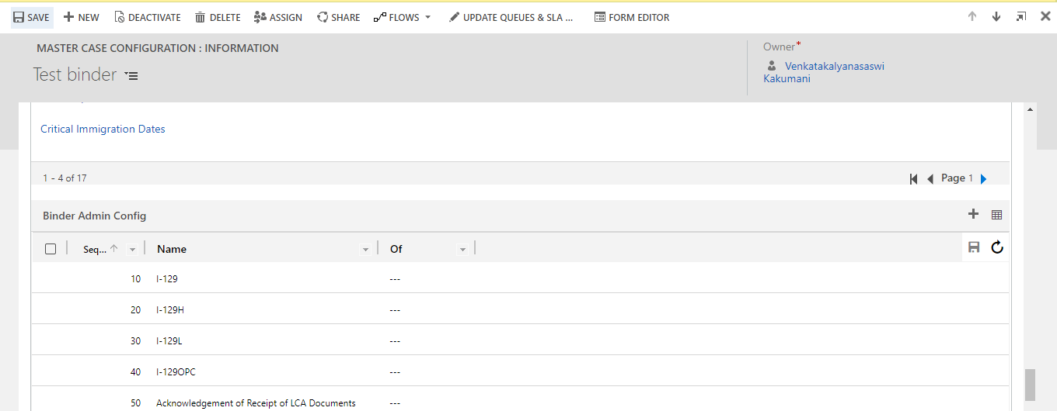

Master Attorney Configuration

The configuration for the Attorney is made in the Master Attorney Configuration Entity. IMS allows users to configure the Attorneys for the Foreign nationals based on the first alphabet of the Last Name for the foreign national.
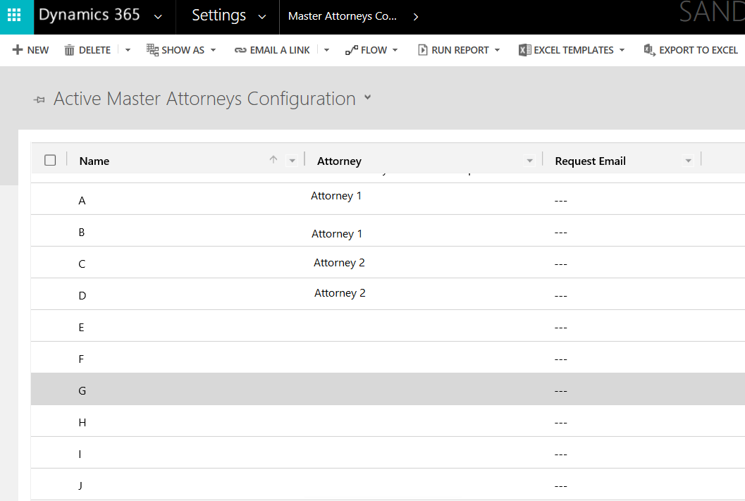
This configuration has the below two implications on the system
- FN – In the FN profile page opened for the foreign national, the US Immigration Attorney field is auto-populated based on the above configuration.
- Case – In the Cases, the Attorney field auto-populates based on the above configuration.
- The My active cases also pull cases based on the above rules.

Dynamics Questionnaire Configurations

Creation of Web Forms:

To create a Dynamic Questionnaire Configuration, create a Web Form by navigating to Service> Portals > Webform > New. Give the below values in the form and click save.
- Website - Custom Portal
- Entity Name - Questionnaire

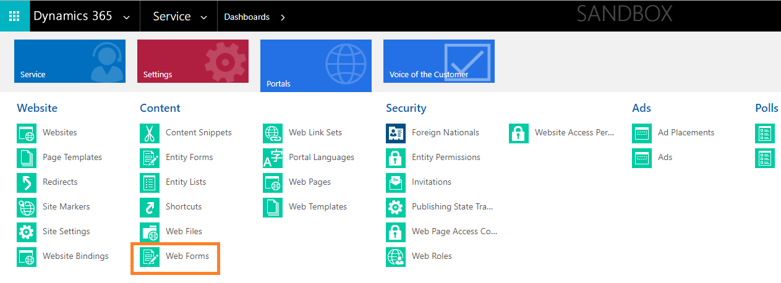

A web Form and another web form will be created with the same name but will be appended with ‘_Read-only’.
Creation of Web Pages:

Create a Web Page by navigating to Service> Portals > Web Pages > New. Give the below values in the form and click save.
Select the same details as provided below in Web Site, Parent Page, Page Template, and Publishing Site. Also, select the web form which was recently created in the above step.
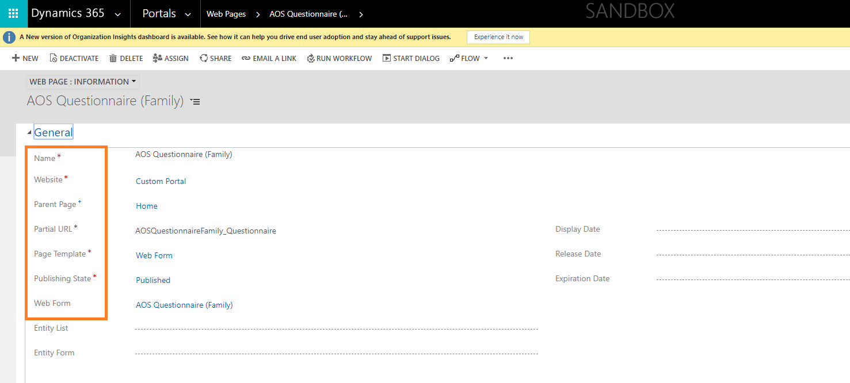

Create two web Pages one for Edit and one for Read-only mode. The names of the Web Pages must be “webpage” and the other Name must be “webpage_readonly”.
Create Web Pages with names as “X” and other Names as “x_readonly”.

Creation of Questionnaire Configuration:

Navigate to Settings> Questionnaire Configuration > New
Select the Web Form that was created above and click save.
Add Webform Steps into the sub-grid using the + and provide the sequence of the questionnaire as required to be displayed to the FN using the Order of the form. The web form steps represent the sections within the questionnaire that will be displayed to the FN based on the case.
Change the Config Status to Active and Save the Form.
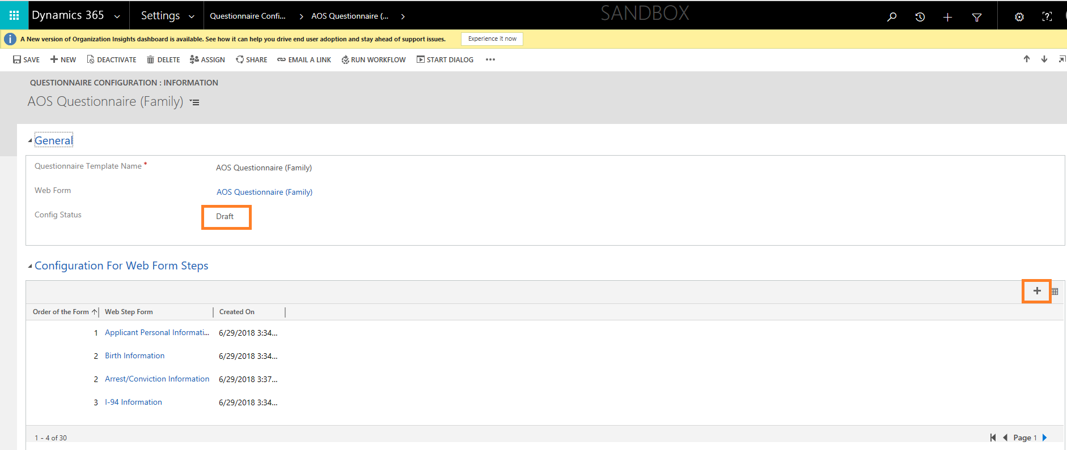
Associate this Template to Master Questionnaire Configurations

Select the recently created Questionnaire Template and add it to the Master Questionnaire Configurations.
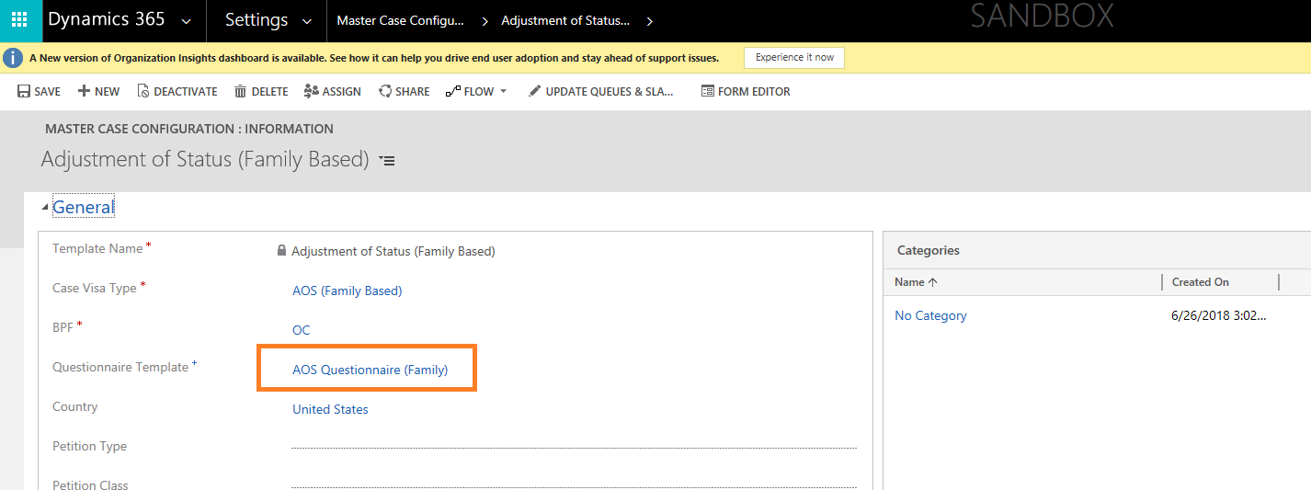

Dashboards

Dashboards are the powerful tool for executives to summarize information and present an easily digestible view of business performance to facilitate decision-making.
Based on security roles, the Dashboards will vary. When the user logs into the application, the dashboard of that user will be loaded as the landing page.

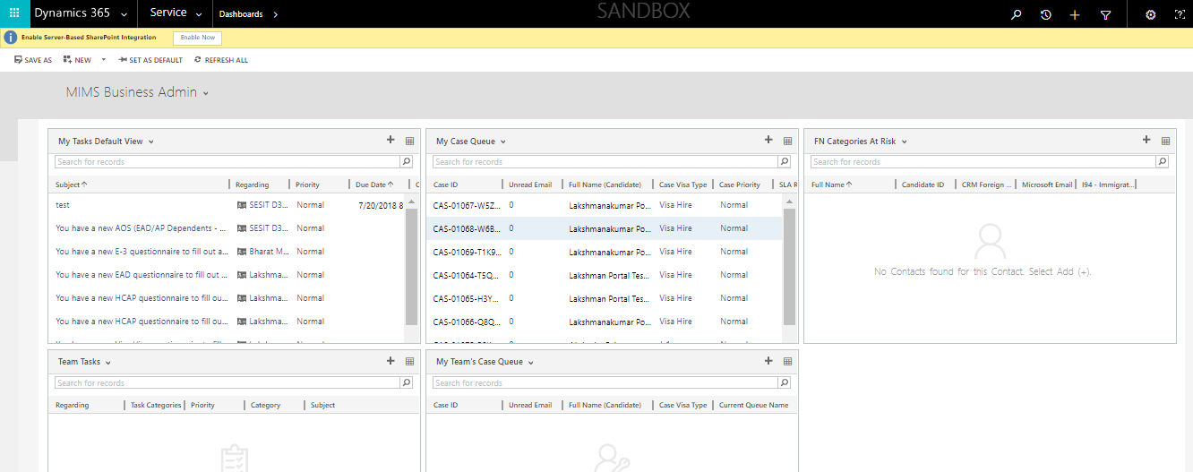

In the above screenshot, four different views, My Tasks View Dashboard, My Case Queues Dashboard, Team Tasks Dashboard, Team cases Dashboard are displayed.
For instance: The My Case Queues Dashboard, shows all the cases which are under the user’s queue. The views can be changed or updated in the Dashboard. Initially, the dashboards are loaded with default views which are configured while creating them.

FN Portal

Portal overview

A portal is an opportunity to extend the functionality of CRM and leverage its integration potential. Portals are frequently an important and necessary implementation for organizations or businesses that want direct input and interaction with their clients. Here in this application, we are using the custom portal. To navigate to the custom portal: Navigate to Portals -> Websites.

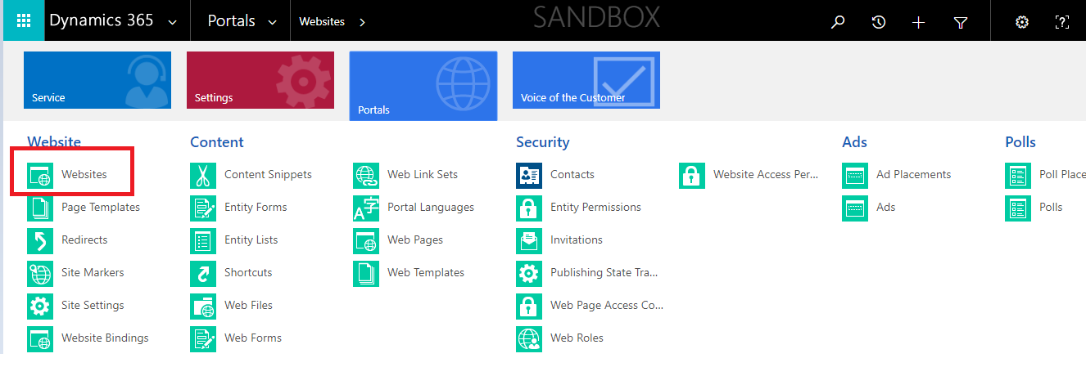
Under Active Websites, there is one Custom Portal record. Open that record, to view the portal URL, through which the user can access the portal.

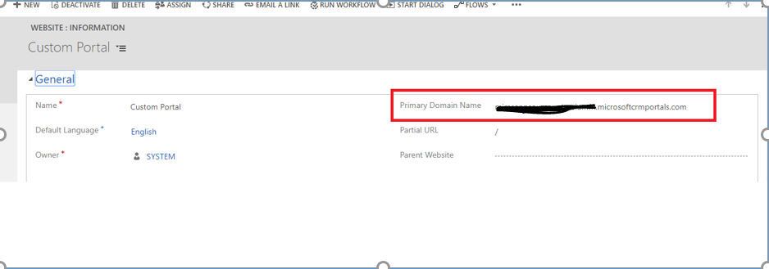

FN Portal

The FN portal contains all the information the immigration team shares with the Foreign National regarding their immigration cases.
Portal Login and profile navigation

- Click on the login button to navigate into the home page of the login user.
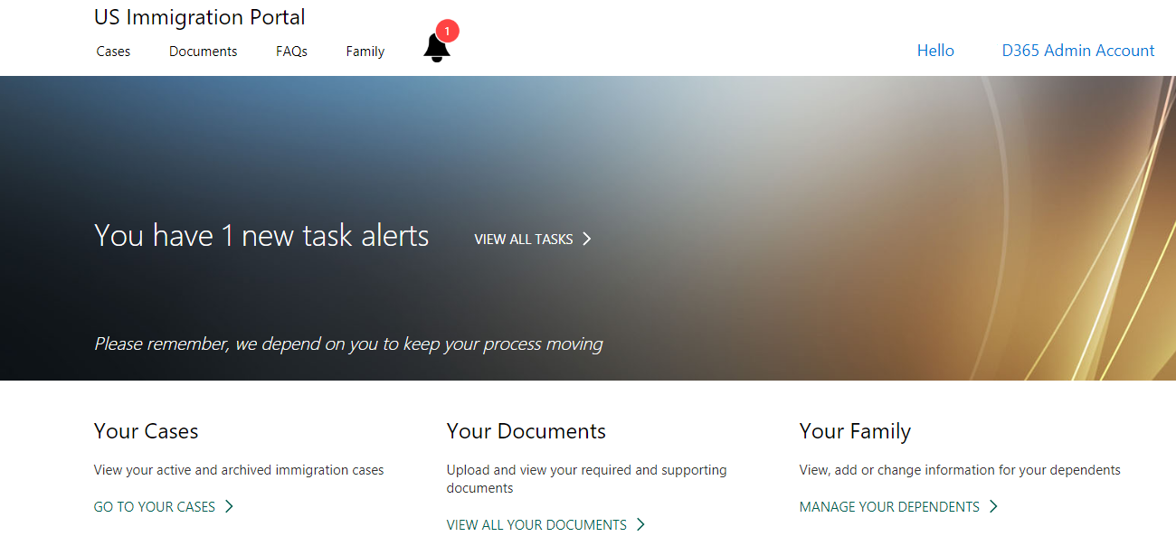
- Click on the FN name on the top right corner of the home page, to see View Profile, switch profile and sign out options.
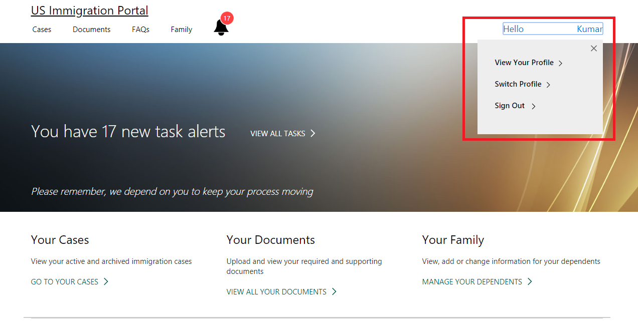
- Click on View profile. This is the screen where the FN can manage their profile. The FN can view and edit their name and other basic information using the edit button.
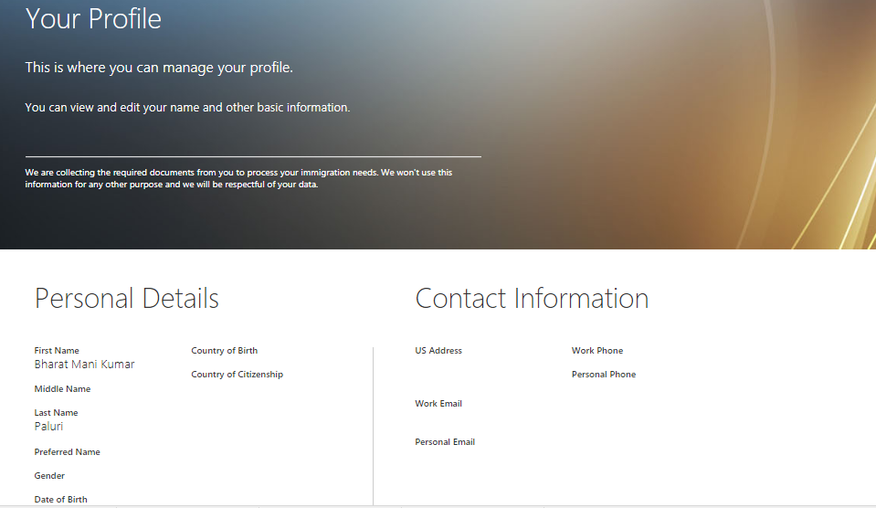

- The Switch profile tab shows the dependents list associated with the FN in IMS.
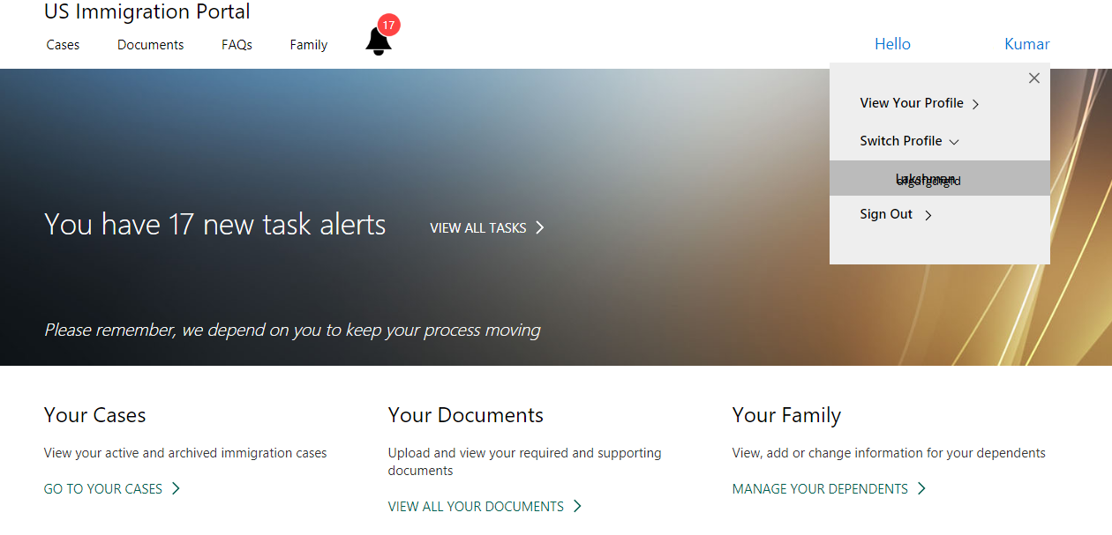
On clicking a dependent, the page navigates to the home page of that dependent where their cases, documents, and tasks can be managed.
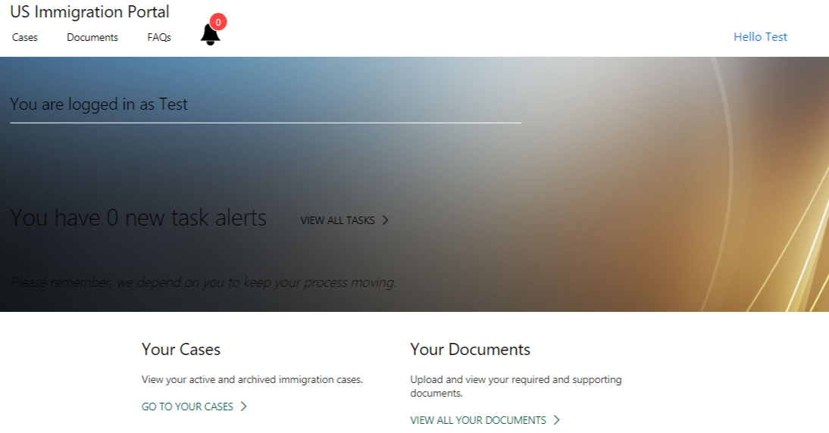
FN Pages
The Homepage consists of different Tabs on the top like Cases, Documents, FAQs, Family, and Tasks. We will discuss each in detail below.
Cases

Click on the Cases tab on the home page of the portal to view the cases associated to the logged in user (FN).

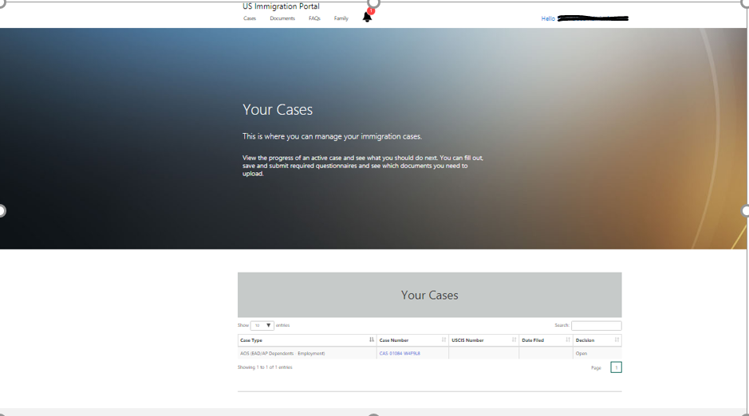
Documents

Click on the Documents tab on the home page of the portal, to view all the documents associated with the FN. These are the same documents which are shown in the document sub-grid of the FN form.
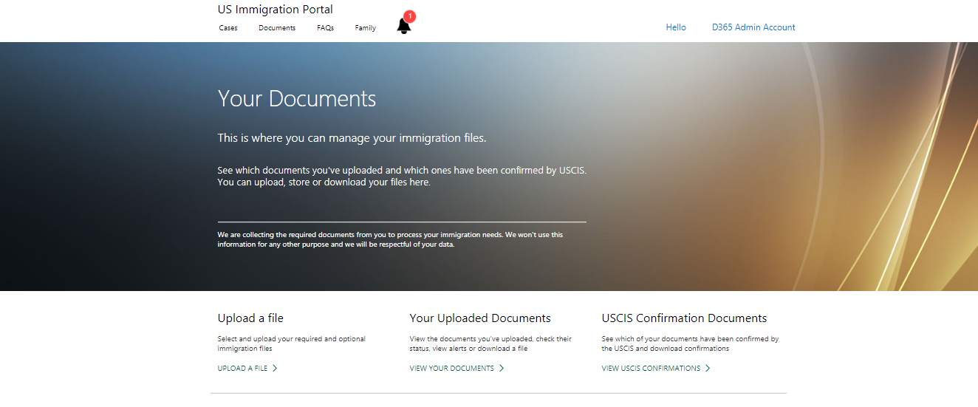
- Click on the upload a File hyperlink on the page, then the page navigates to the upload view. Choose the document type and add the associated validity dates.
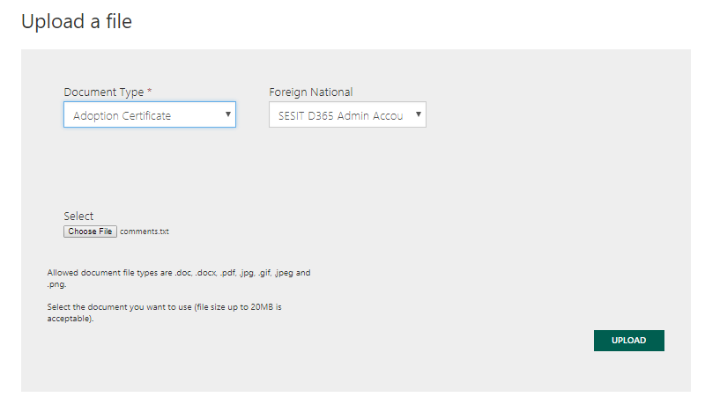

- All the documents which are uploaded through FN are shown here.
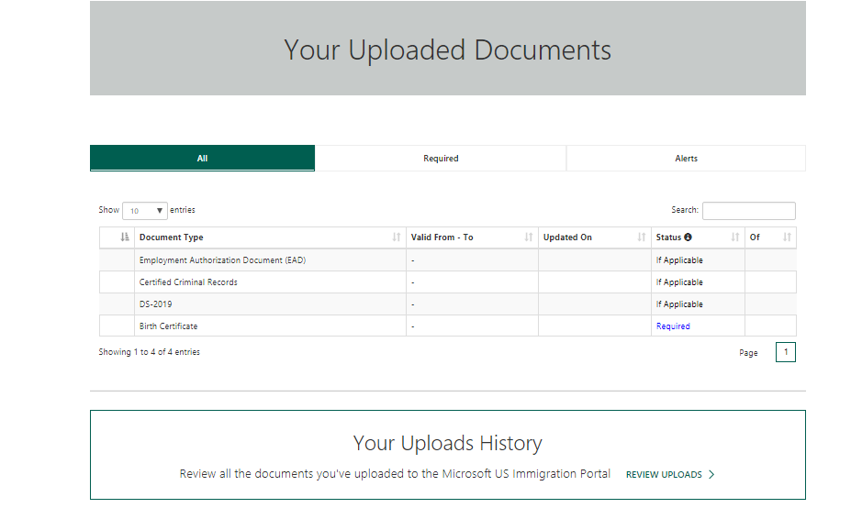

- All the case documents uploaded by the immigration team are shown in the USCIS Documents view.
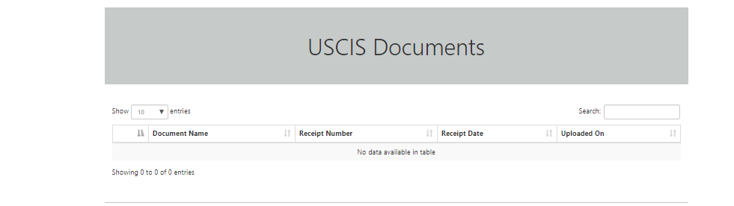

Family

The Family tab on the Home page is the place where the FN can manage their dependents. The FN can view each of the family member’s profiles, add or remove dependents and request profile updates.

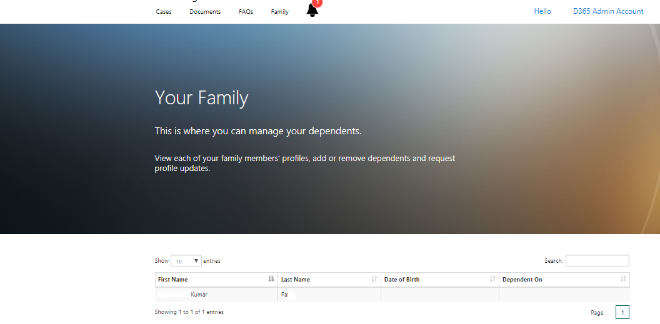

Tasks

Tasks help the FN to keep track of action items or other “To Do” items. All Immigration Tasks are managed from here.
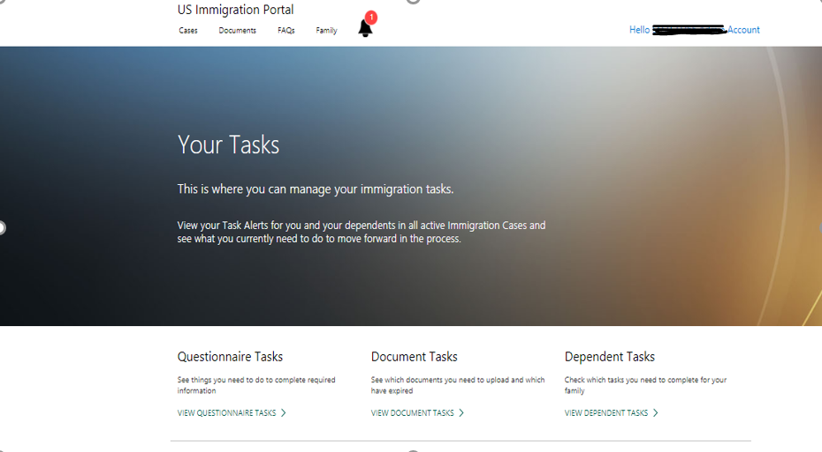

Questionnaire Tasks

This questionnaire tasks will show the details of the Questionnaire to be filled out and yet to be submitted by the FN.

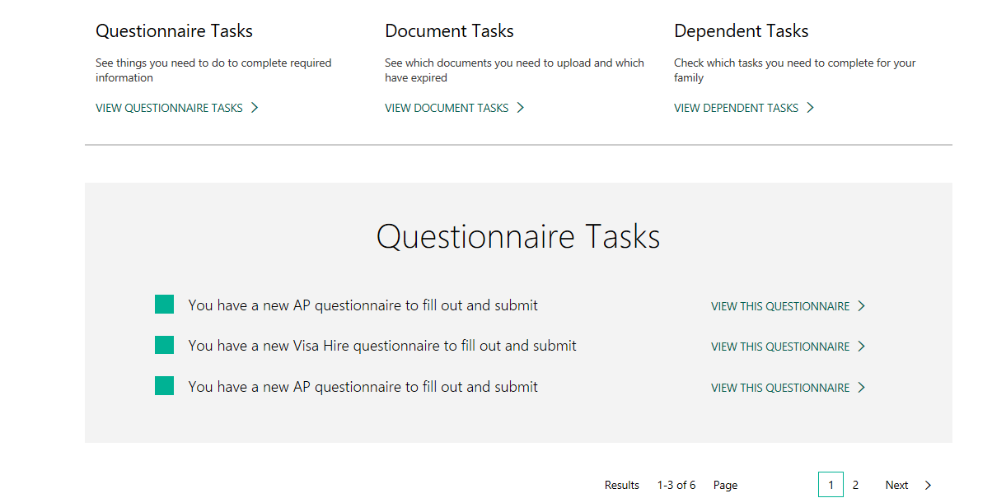
Documents Tasks
This task will provide the below details:
- The required documents to be uploaded.
- The Documents whose validity is expired.
- The Documents which are about to expire.
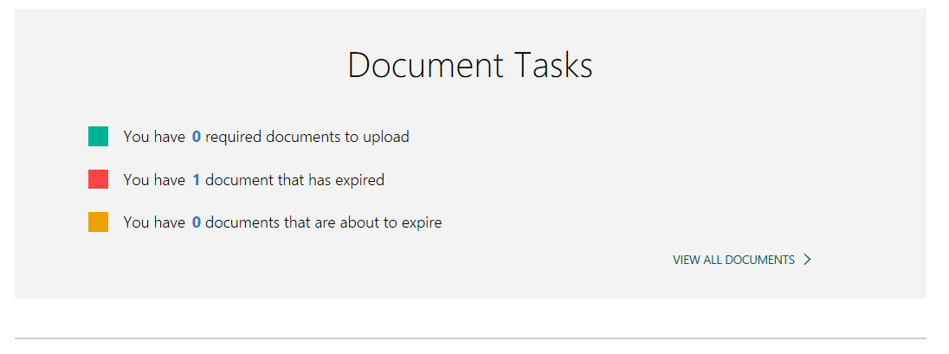

Dependent Tasks

This task shows the dependents tasks (Dependents of FN) which are yet to be completed.
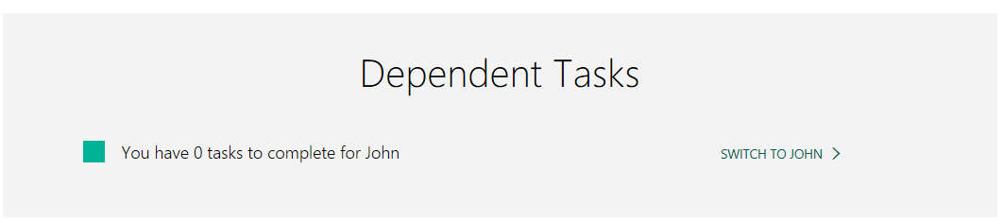
From here the FN can navigate to Dependent home page by clicking on the “switch to” hyperlink.

Invite User to FN Portal (For Local login)

Send Invitation Process

- Open Foreign National Record for which invitation need to be sent. Click on “Send Invitation” button.
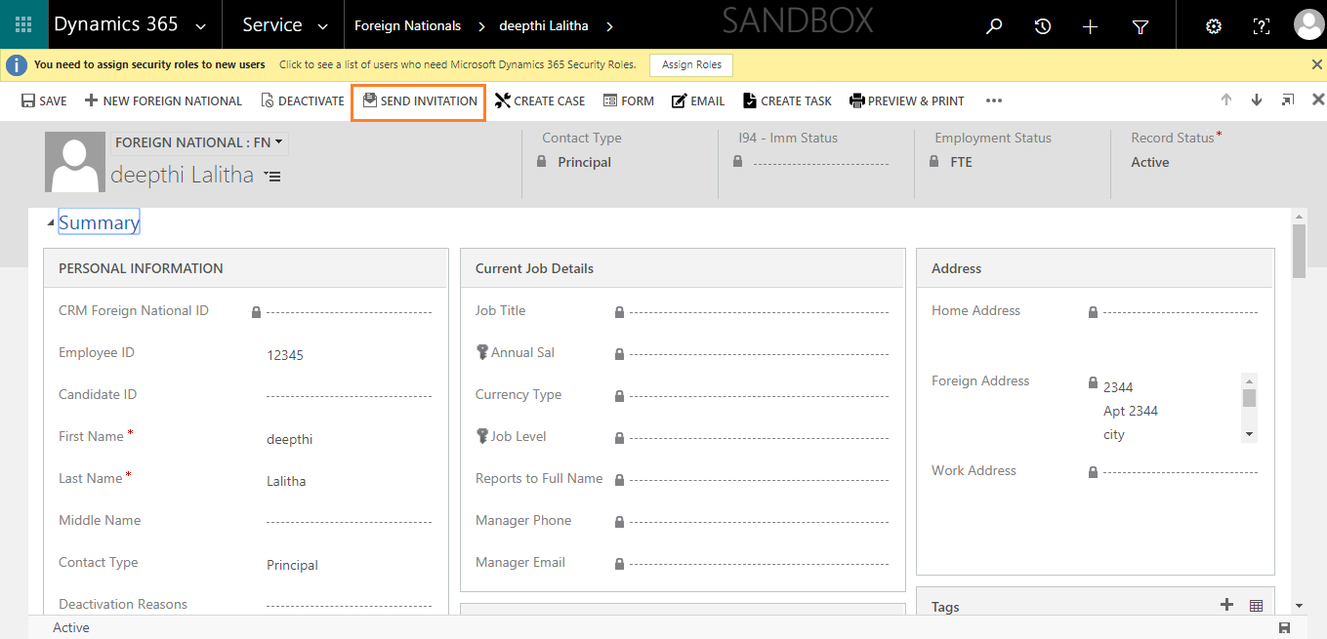

- An invitation form will be opened when the send invitation button is clicked. Save and close the invitation form.
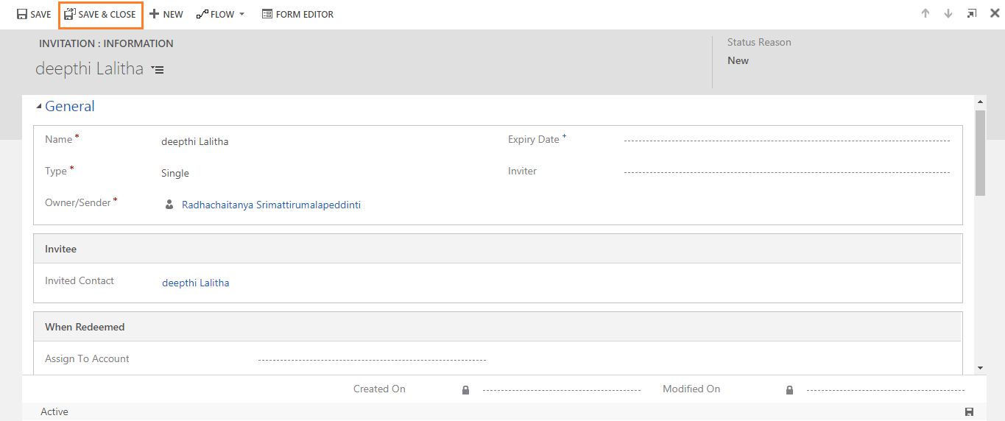

- An invitation email will be created in the activities of the FN.
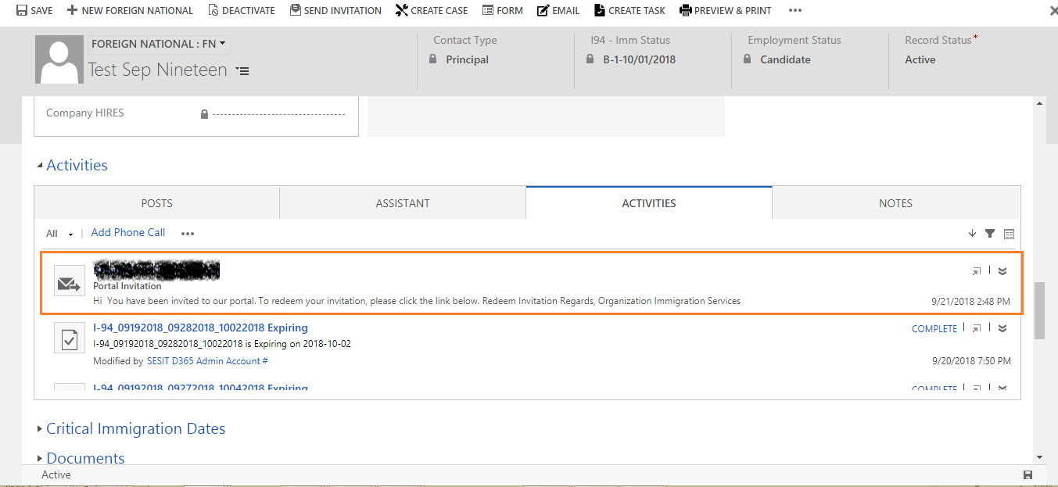

- Open that email and click on Redeem Invitation link in the email.
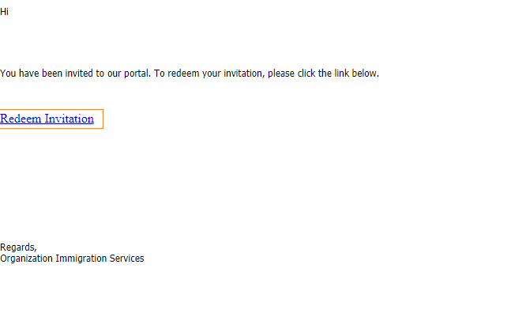
- An Invitation code will be opened. Sign up with that invitation code by clicking on register button.
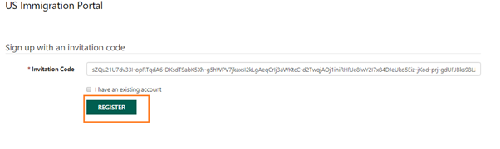

- Enter the email id associated to that FN in the CRM. Enter any user defined username and password. Click on “Register” button.
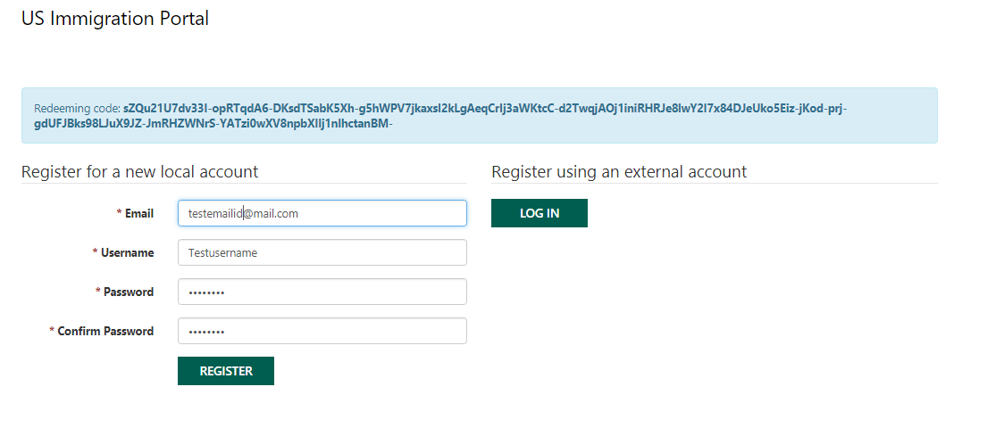
- When Register button is clicked, Page will be redirected to FN Portal logged in with the FN details.
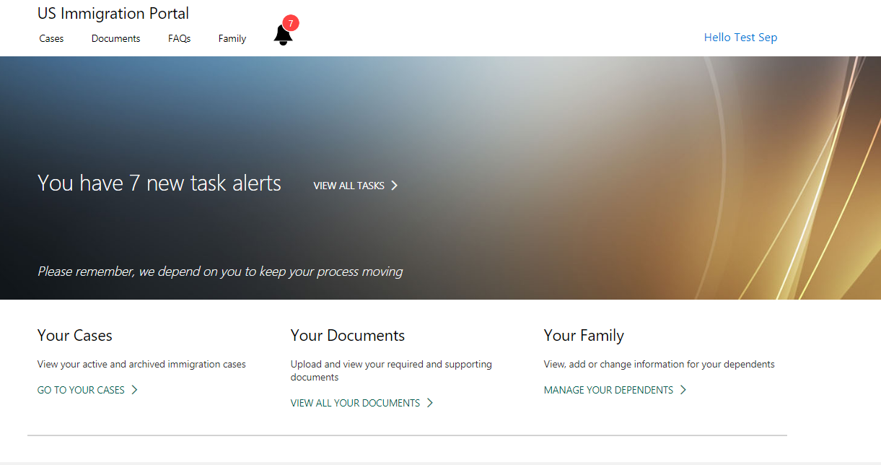

UCI Client

Unified Interface is the new metadata driven client interface that is designed to provide a consistent experience across devices and form factors. It provides users a consistent, accessible, uniform user interface, and follows responsive design principles for optimal viewing on any screen size or device.
The new Unified Interface brings all the rich experiences to any client that a user is using. Whether users are on a browser, tablet or phone, they will be able to consume similar experiences. Some examples:
- Similar form experiences to update and view your records.
- Interactive dashboards across all devices to view your information and drill into it.
- Reference Panel is now available to be used with all entities supported in Unified Interface.
Most of the core functionalities of sales and customer service have moved to the Unified Interface client.
You can access all the system and user dashboards from within your Unified Interface apps. The interactive dashboards are now available for all record types with richer interactive dashboard capabilities across the board.
Here is the small screen shot of UCI of our application for Site Markers entity.
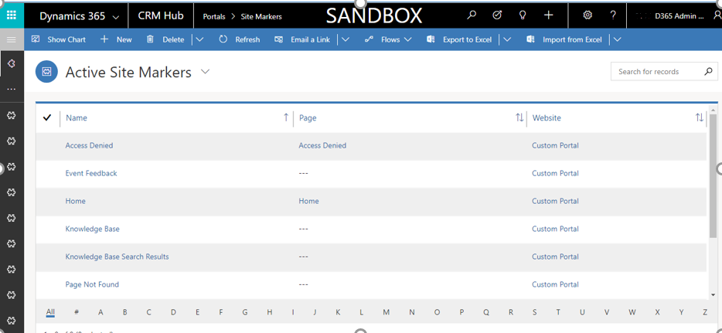
To make any configuration changes on the UCI screen we must navigate through setting - > My Apps.
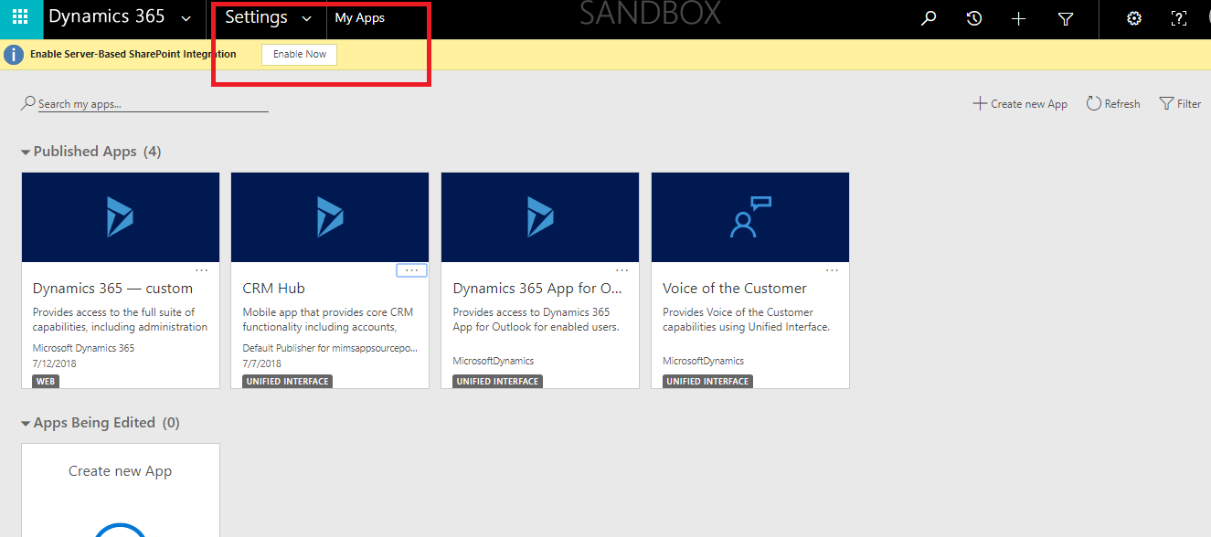
In My Apps screen CRM Hub - >APP designer.
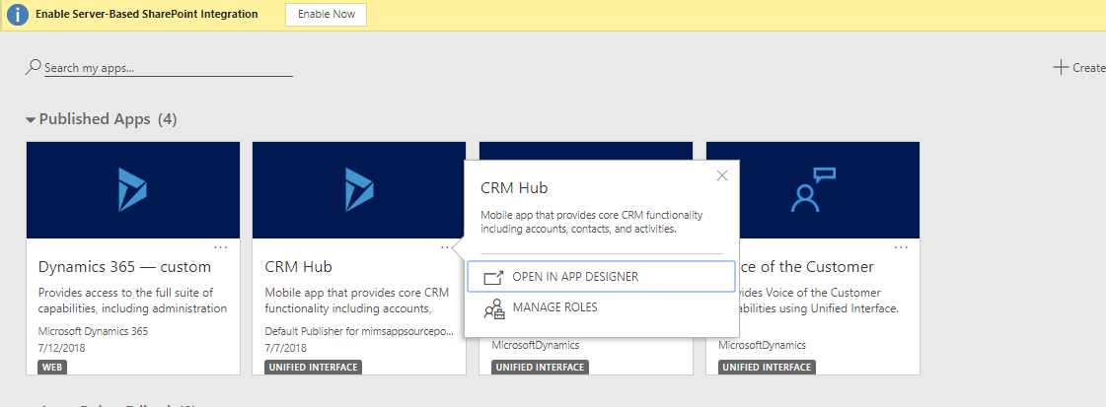
Here is the designer view from where we can add or remove components:
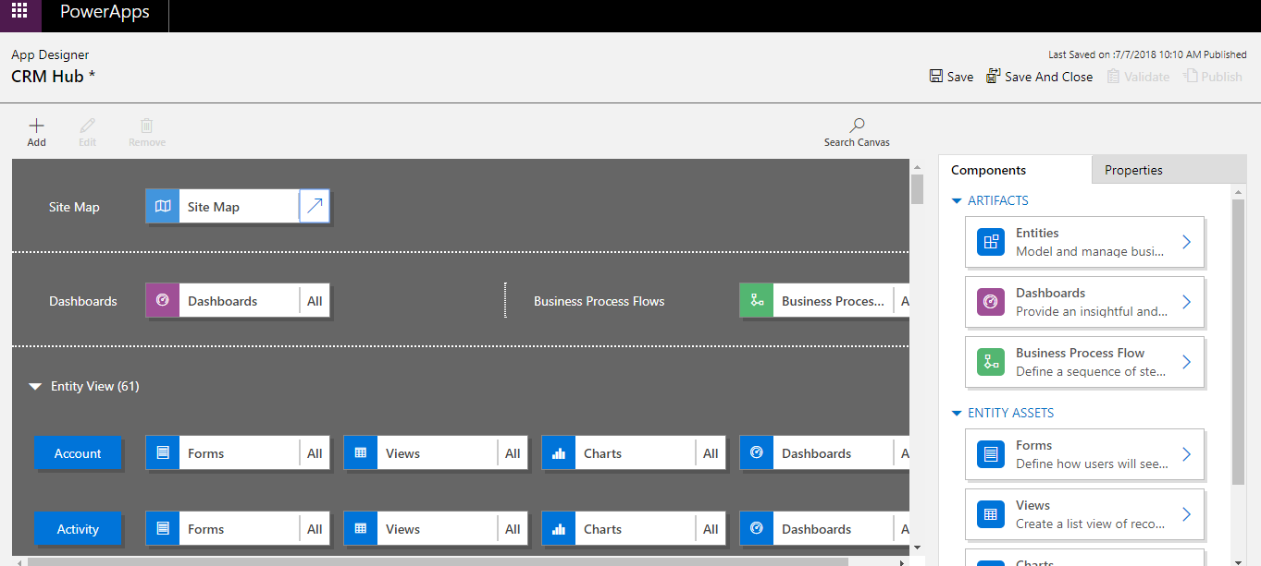
Click on Add (+) button to add any component like Area, Group and Sub area. Based on the selection, it will display Components and Properties Tab on the right side of the screen. In Properties tab we define what needs to be displayed.
For Instance: If we select Sub Area, under Properties:
- Type: Entity, URL, Web resource and Dashboard.
Based on the Type selection other properties would be displayed.
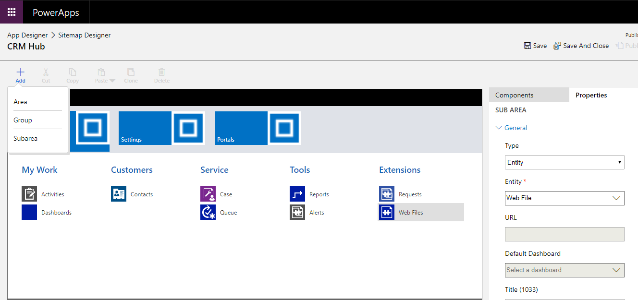

Creation of New Business Process Flows

- Create a new Business process flow.
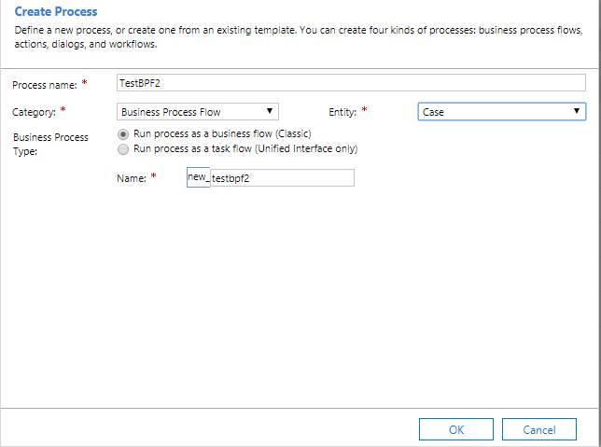
- Configure the required stages and activate the business process flows.

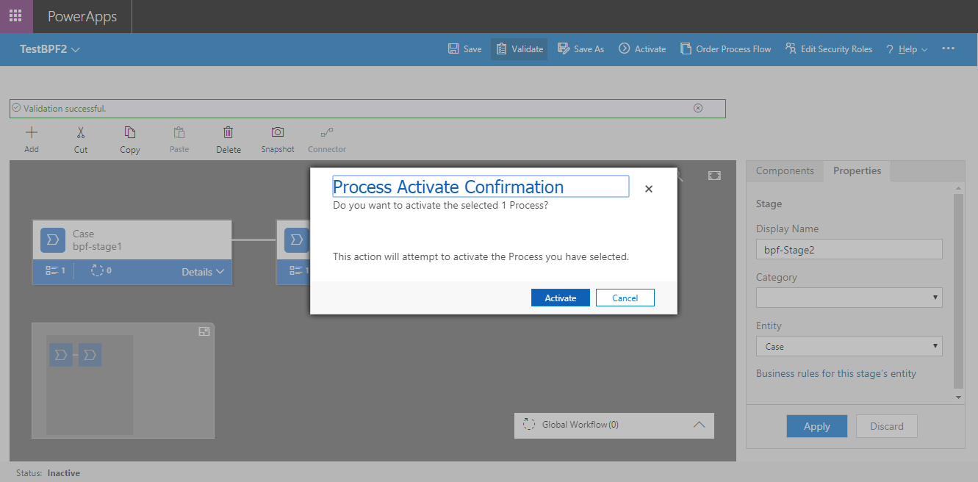

- Open Plugin Registration tool.

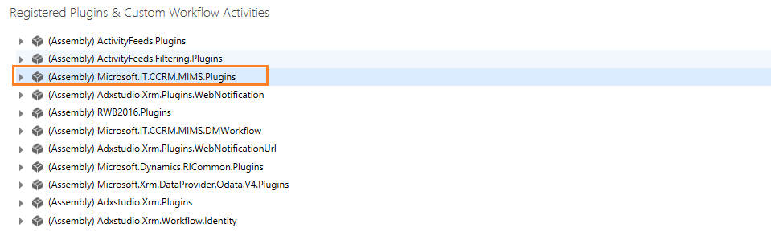
- Go to the PostBPFEntityUpdate plugin among all the plugins.
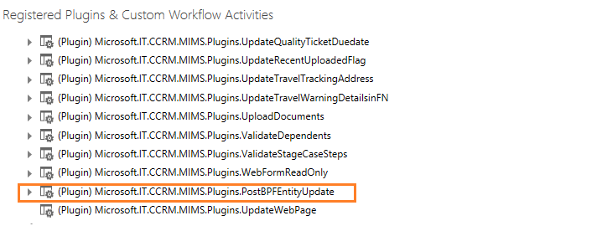
- Register new steps on that plugin as shown below.
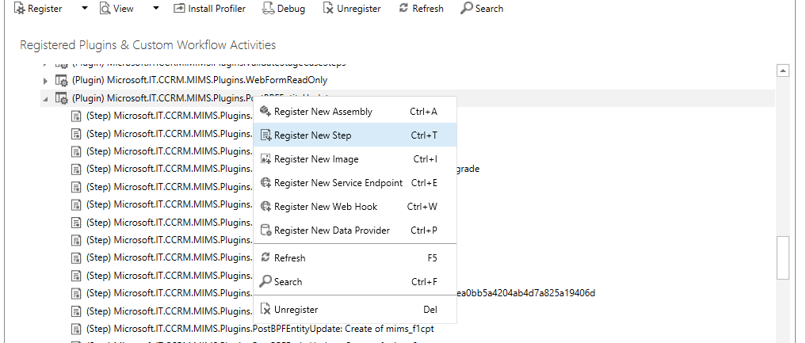
- Need to Register the Plugin on create of the BPF entity.
Message: Create
Primary entity: BPF entity
Event Pipeline: Post-operation
Execution Mode: Synchronous
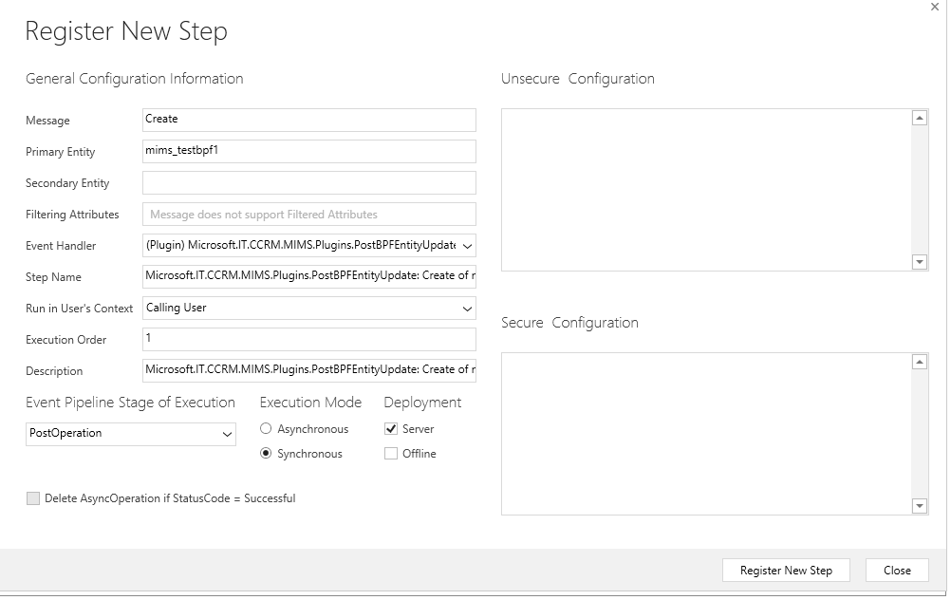

- Need to Register the Plugin on update of the BPF entity.
Message: Update
Primary entity: BPF entity
Event Pipeline: Post-operation
Execution Mode: Synchronous
Filtering Attribute: Active Stage (activestageid)

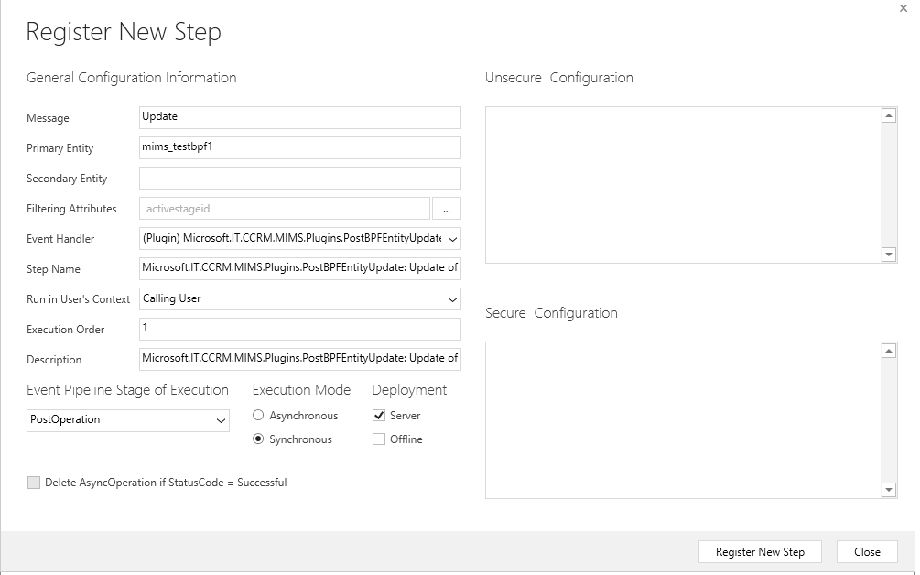

- Create a new Master Case Configuration Record by clicking on New button.
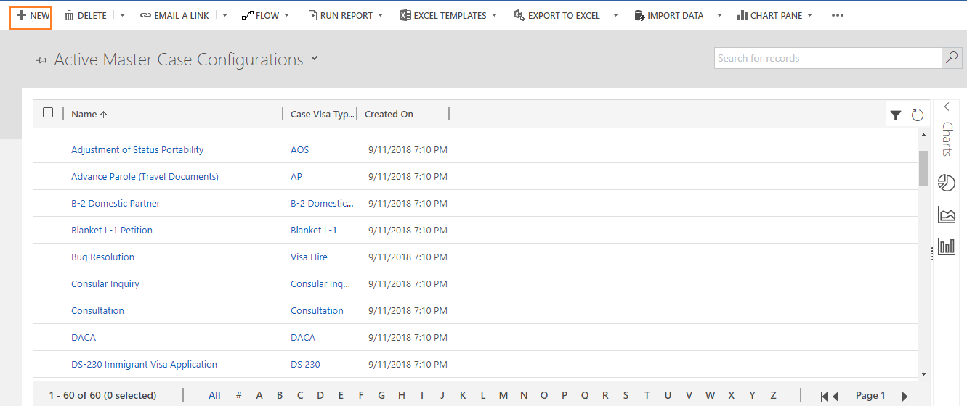

- Select your BPF in the BPF field and fill all the mandatory details and save the record.

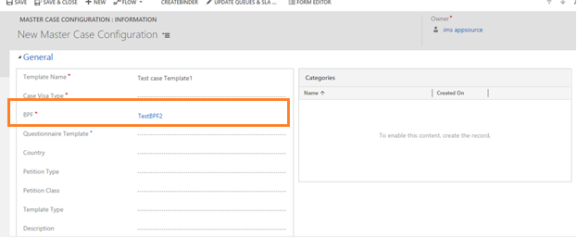

- Check the stage queue mappings in the record. All the stages in the BPF must be Visible under the Stage queue mappings section.
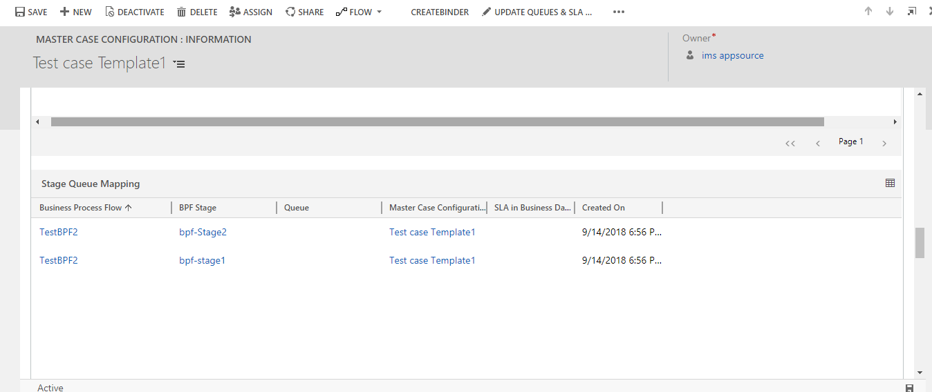

Creation of New Questionnaire

- Open “Web Forms” tile under Portals.
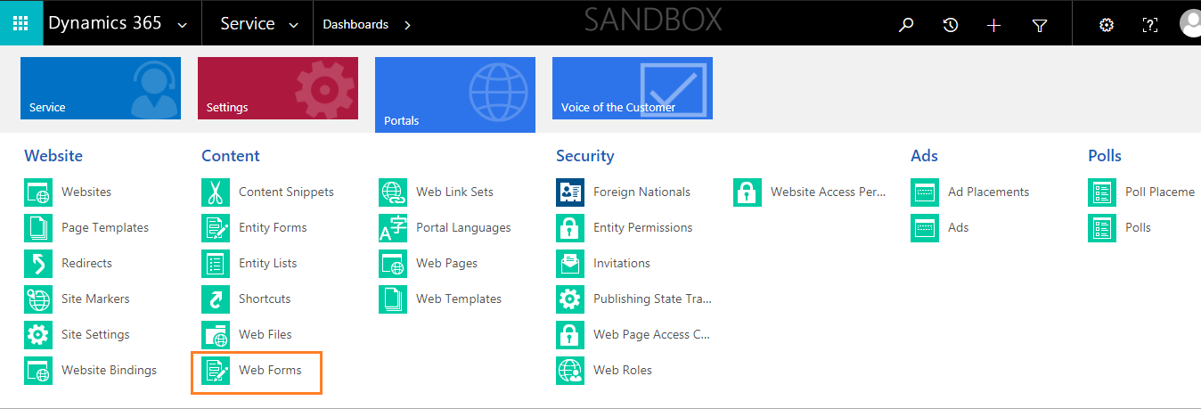

- Create a new web form by clicking on “+New” button.
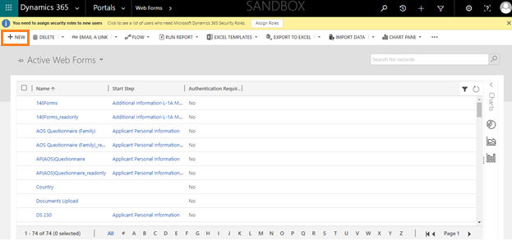

- Enter the web form name, website as custom portal and save the record.
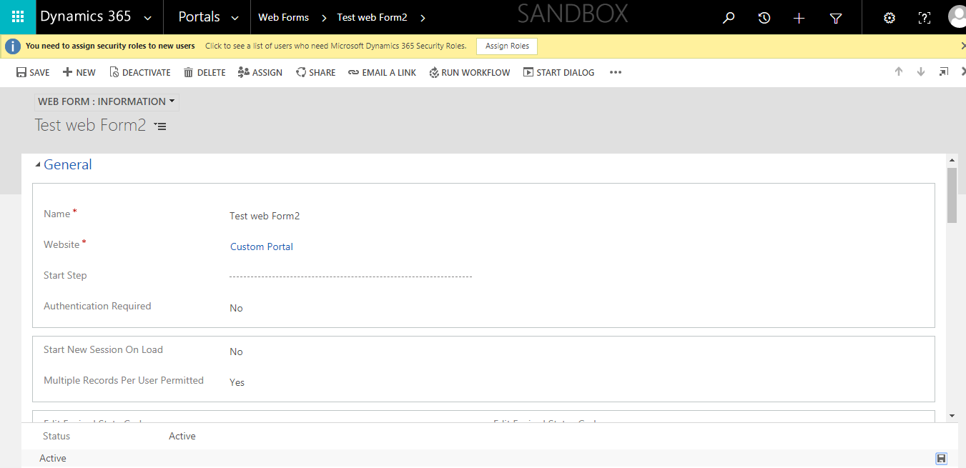
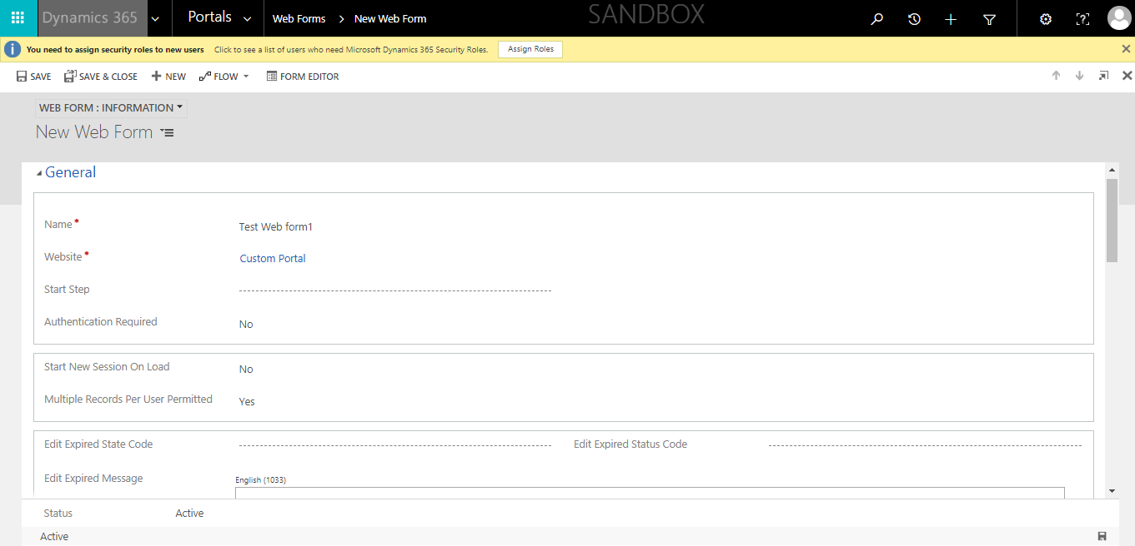

- Navigate to Web Pages of the web form as shown below:
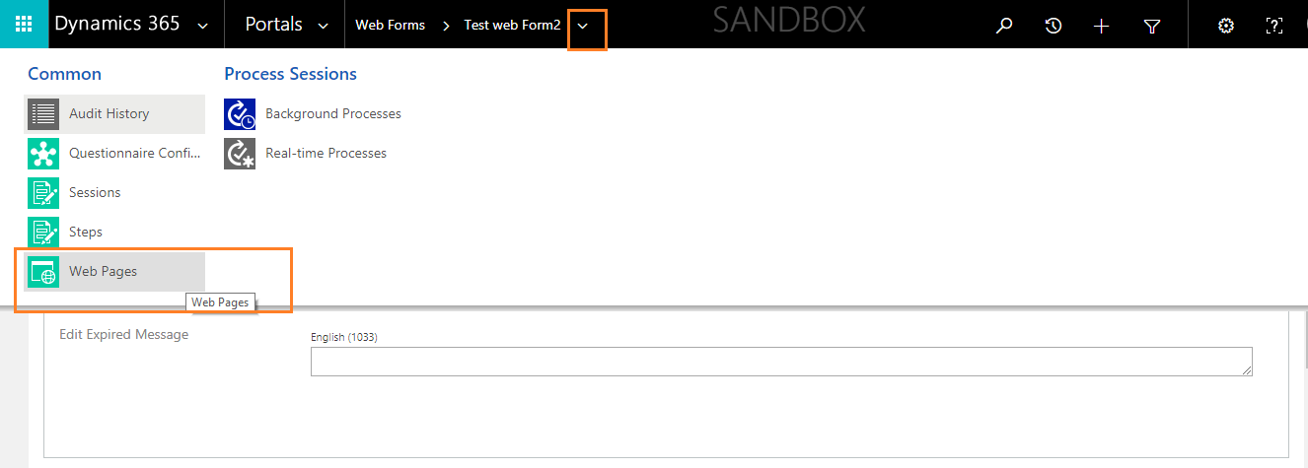

- Create a new web page by clicking on “Add new web page” button.
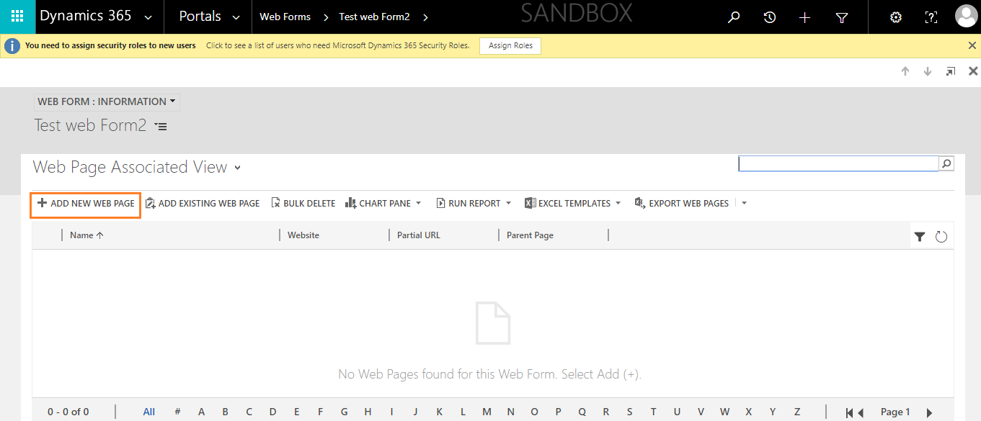

- Give the details for the web page as follows:
Name: Any user defined name
Website: Custom portal
Parent Page: Home
Partial URL: name_Questionnaire
Page Template: web form
Published state: Published
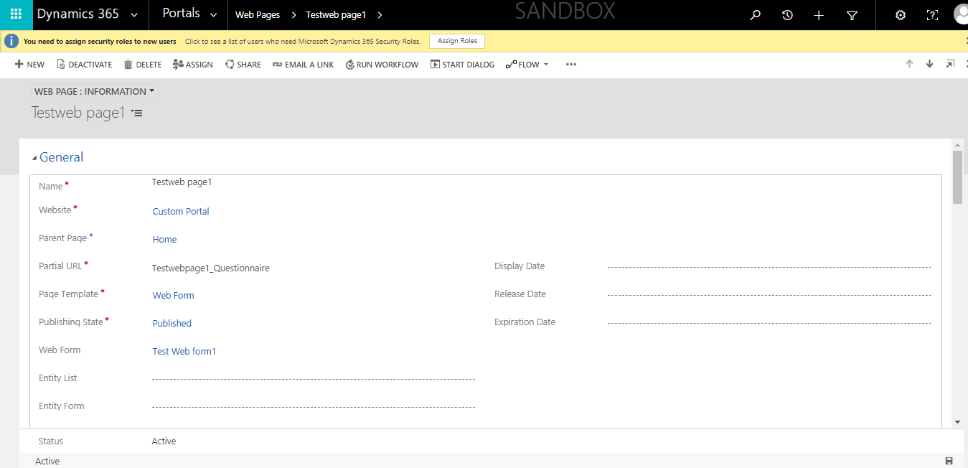

- Navigate to Questionnaire configurations in settings.

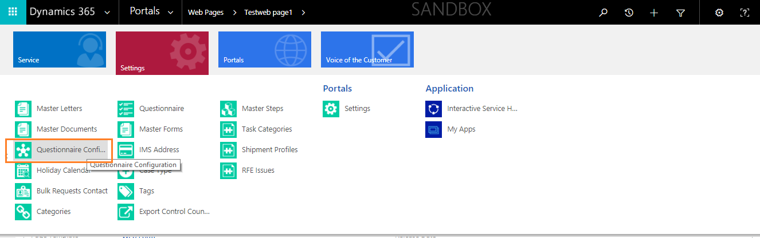

- Create a new Questionnaire configuration record by clicking on “+New” button.
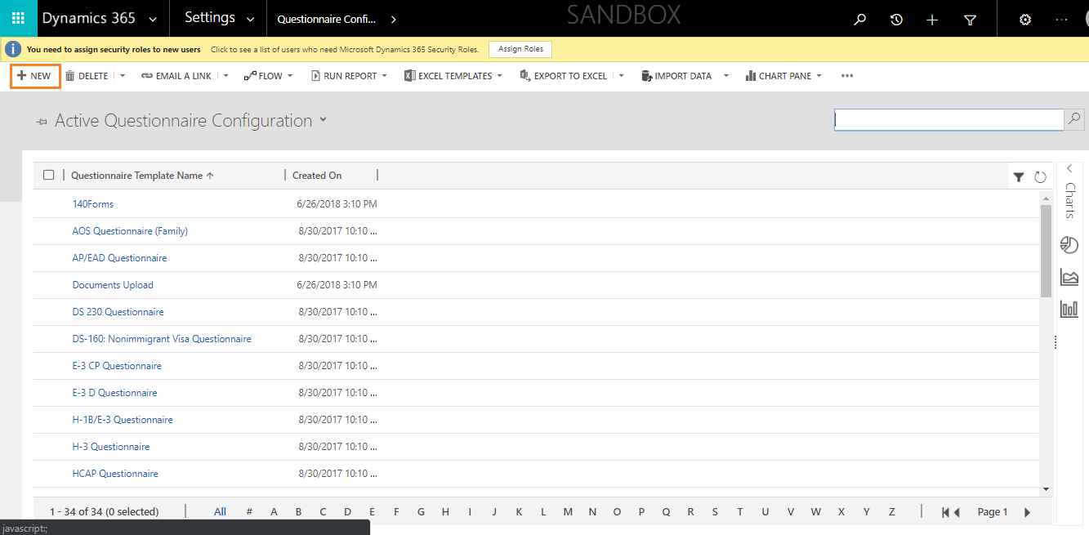

- Enter the questionnaire template name and fill the web form field as above created web form.
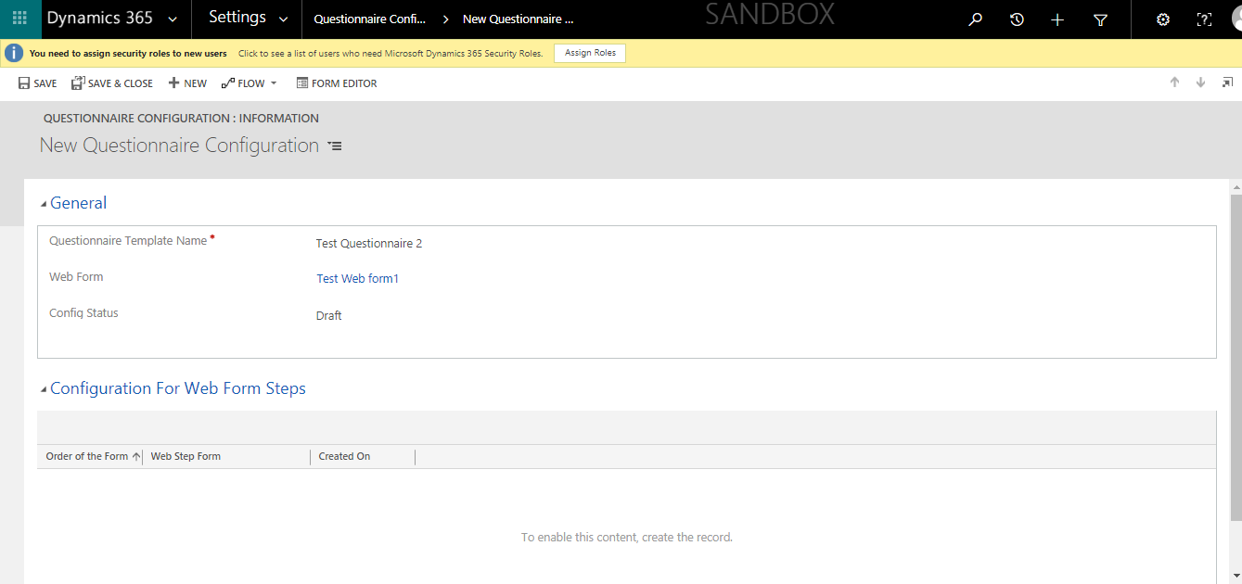

- Add the required web form steps by clicking on “+” button in the configuration for web form steps tab.
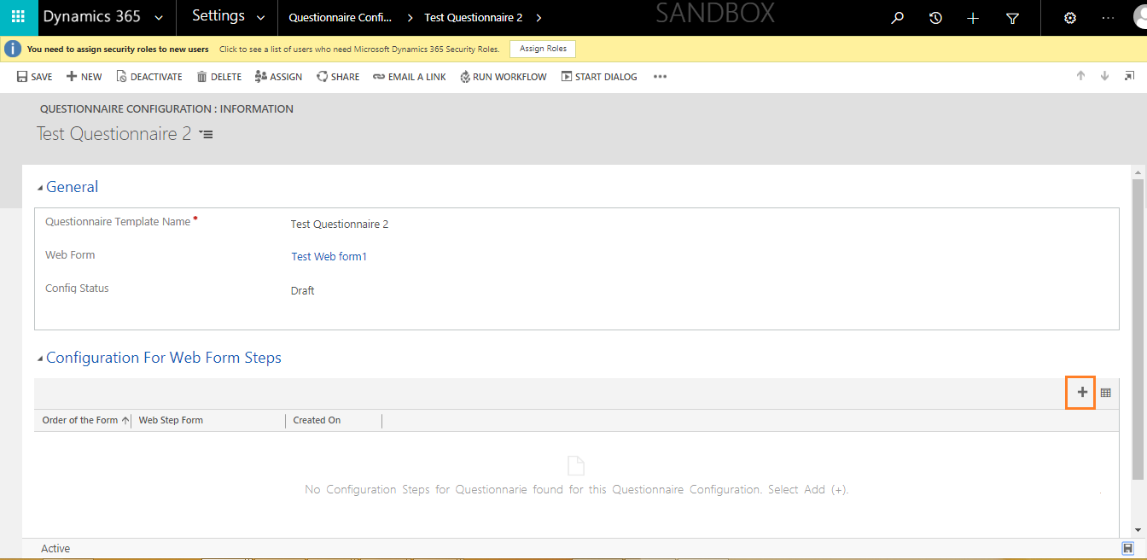

- Add the steps and specify the order of the step to be displayed on the questionnaire form. Save the Record. Now the step will be added in the configuration for web form steps tab.
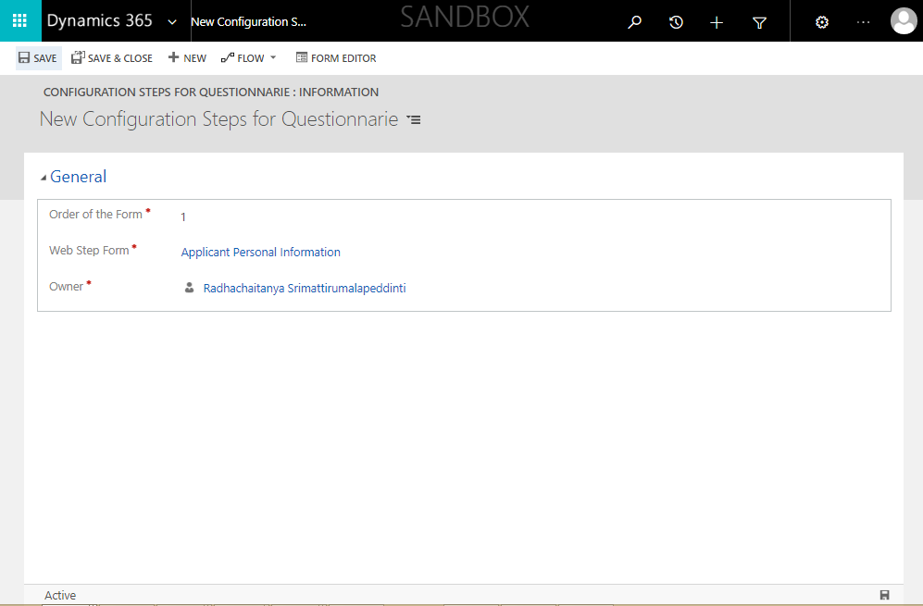

- Change the Config status field to “Active” in the questionnaire configuration record.
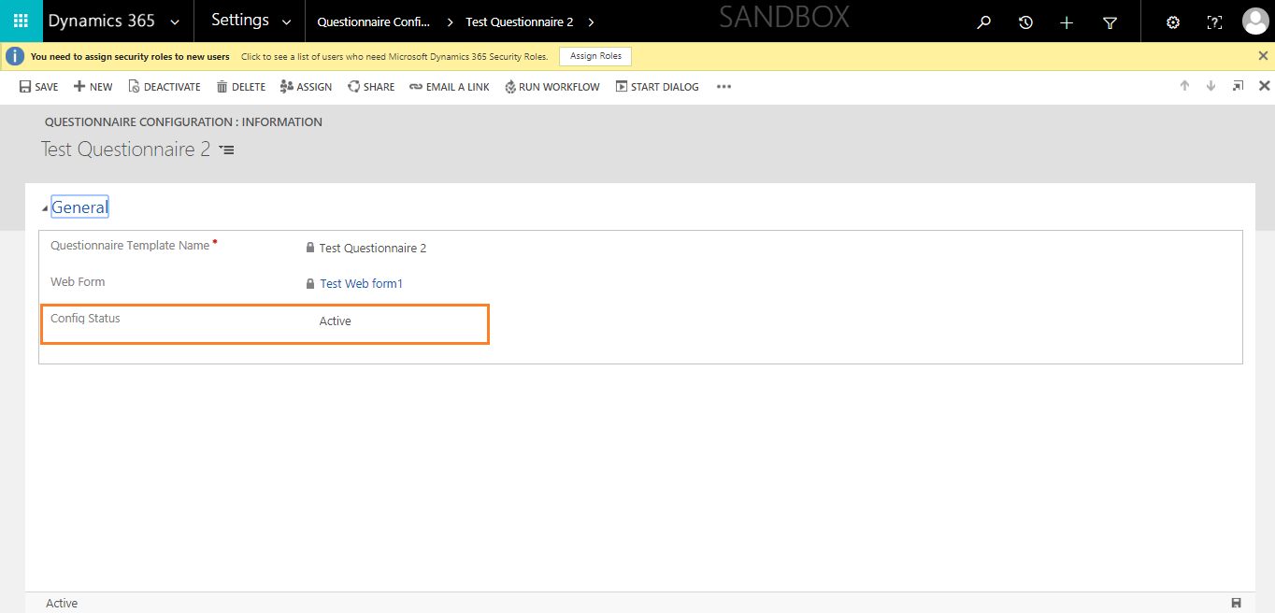
- Go to advanced find and search for web form steps.
Specify the web form as your web form name.
Click on Results.
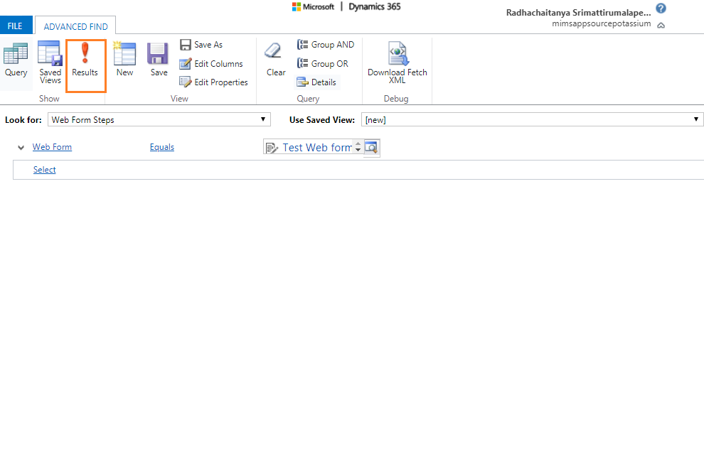
- Check if all the steps configured are present in the results. If all the steps are present there, Questionnaire configuration record is ready and can be used in any master case configuration as questionnaire template.

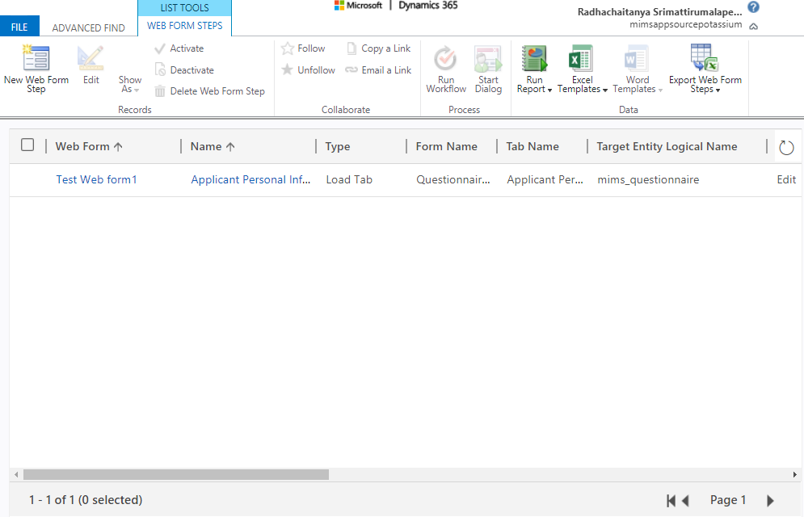
End of document

