24/7 TimeTracker is actually quite easy to install and use. Please follow the steps shown below:
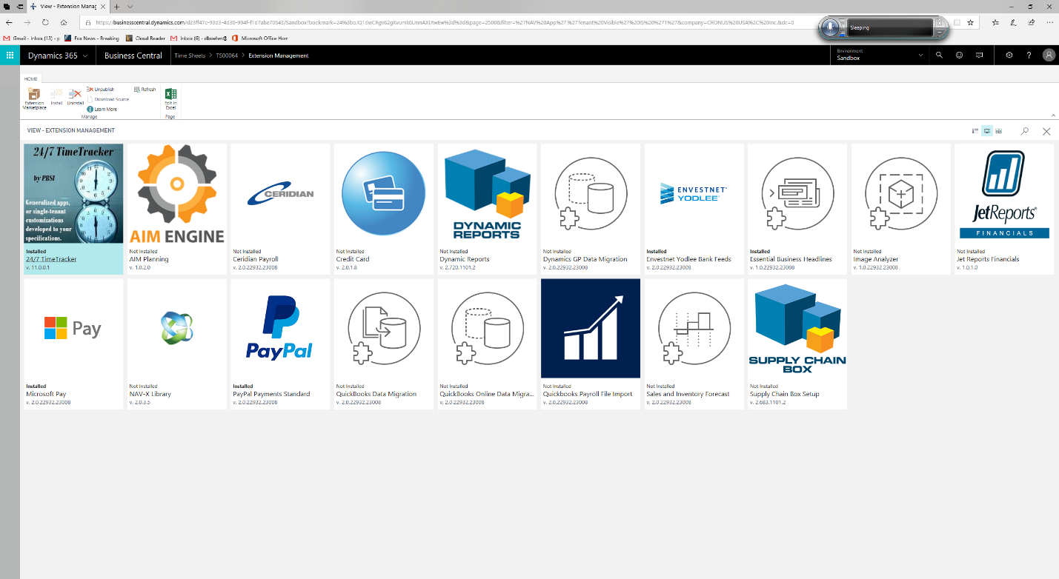

Installation and Setup
- You can use the Page Finder (I.e. the "Magnifying Glass") in the black banner at the top right of your Microsoft Dynamics 365 Business Central screen to navigate to the "Extension Management" page. Then click on the “Extension Marketplace” action.
- Look for the 24/7 TimeTracker app. When you find it, click on it to install it.
- You'll see the following screen:
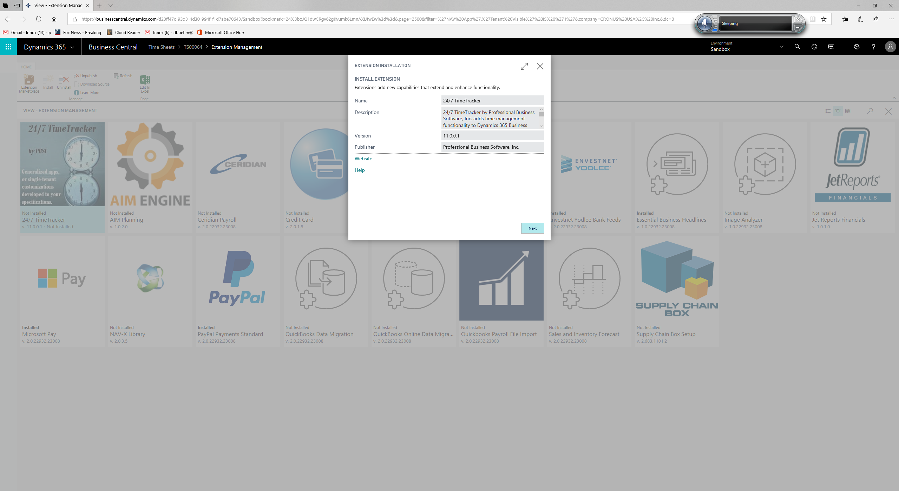
- The installation page shows you a description of 24/7 TimeTracker, along with links to our “Terms and Conditions”, “Privacy Statement”, “Website” and "Help". The "Website" link takes you to the Homepage of our website. The "Help" hyperlink takes you to the landing page for 24/7 TimeTracker within our website. This webpage also lists our contact information, so you can email us or call us. This contact information will be useful when you choose to activate the extension.
- Click on "Next" to begin the installation process.
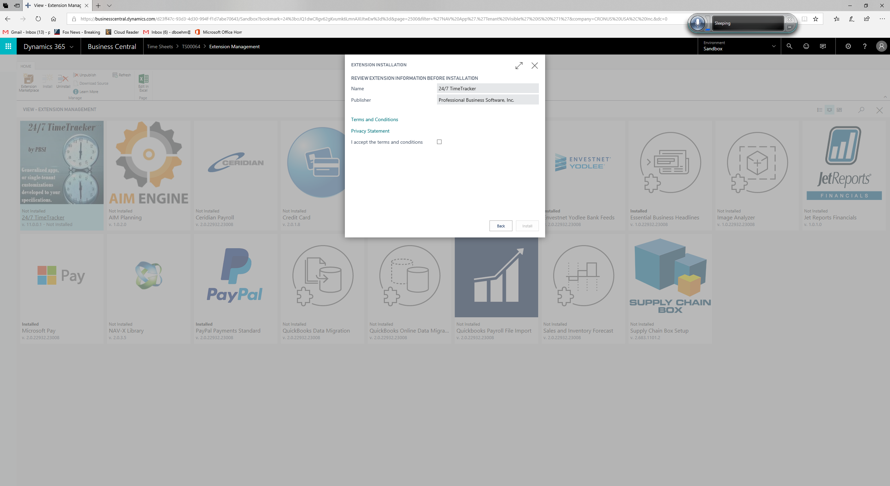
- From this page, you can also click on the "Terms and Conditions" or "Privacy Statement" links. Once again, these links will bring you to a page within our website.
- When you are ready to continue with the installation process, click in the "I accept the terms and conditions" box.
- Then click on the "Install" button in the lower right-hand corner of the screen.
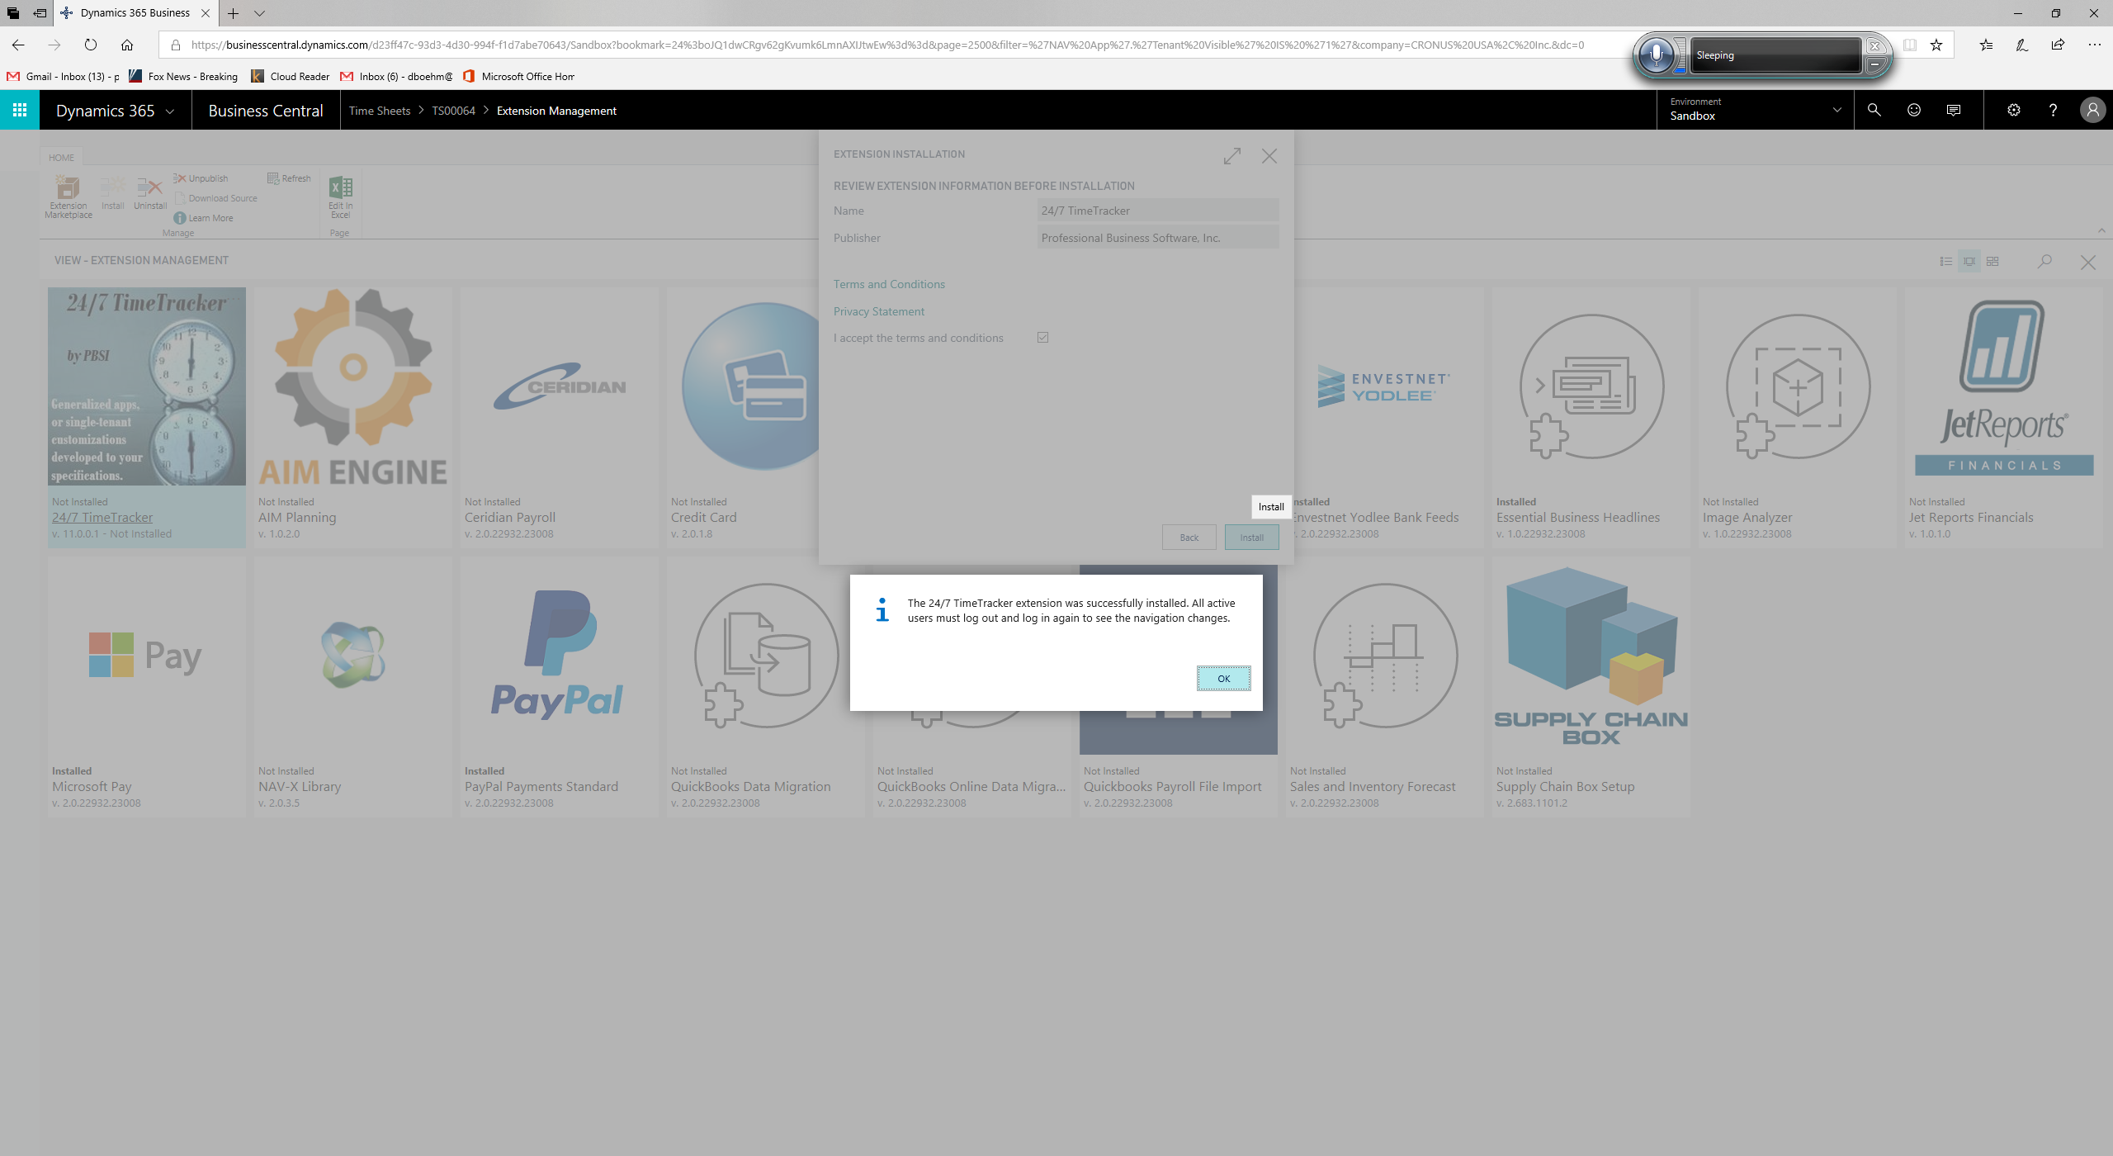
- At this point, you should see the message shown above, informing you that "The 24/7 TimeTracker extension was successfully installed.", etc.
- If you don't see this message, please contact us at 817.502.3969.
- In order to use 24/7 TimeTracker, you'll still need an activation code. Please call us at 817.502.3969 or contact us via email (from the link on our website's "Contact" page) to get an activation code. Remember, the first month is free...
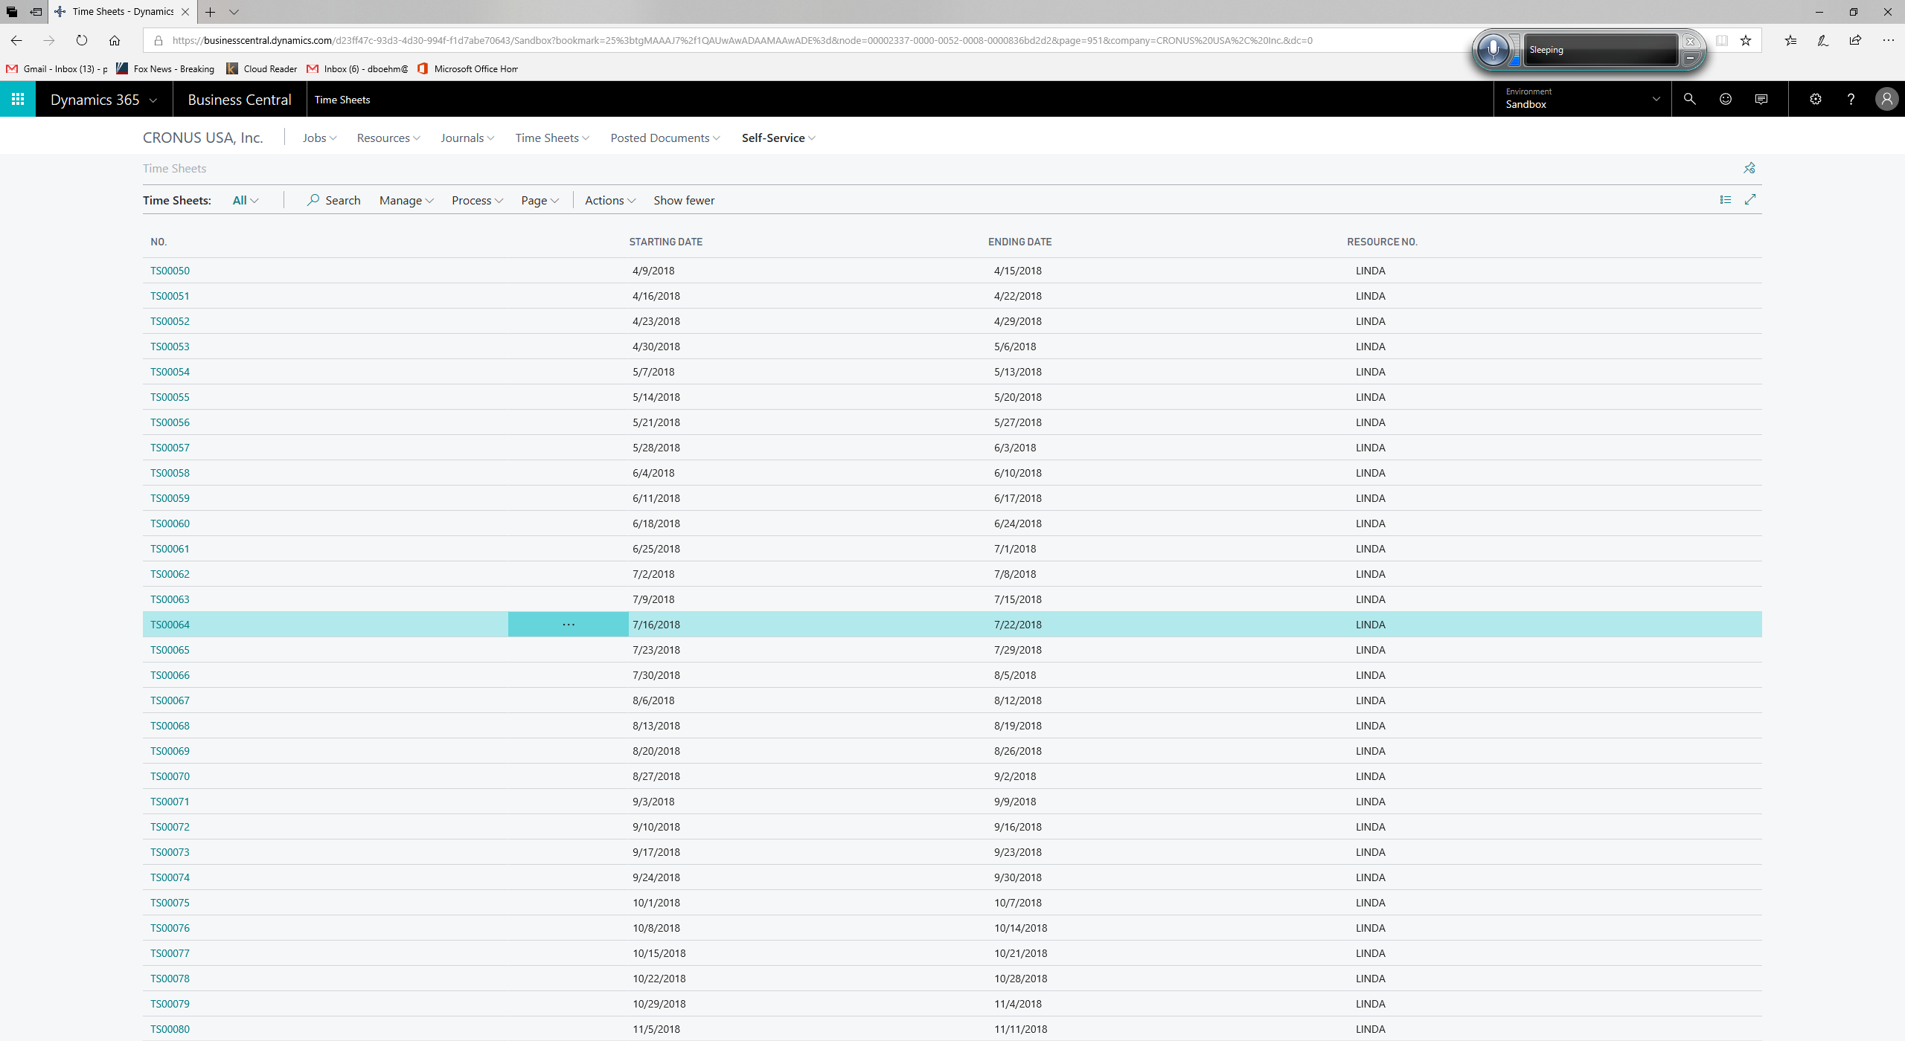
- From within Dynamics 365 Business Central, navigate to the "Time Sheets" list page. At this point, we'll assume you are comfortable doing this either through the menus or the "Page Finder".
- Click on the Current weeks' time sheet. When you do this, you'll open the “Time Sheet” page as shown below:
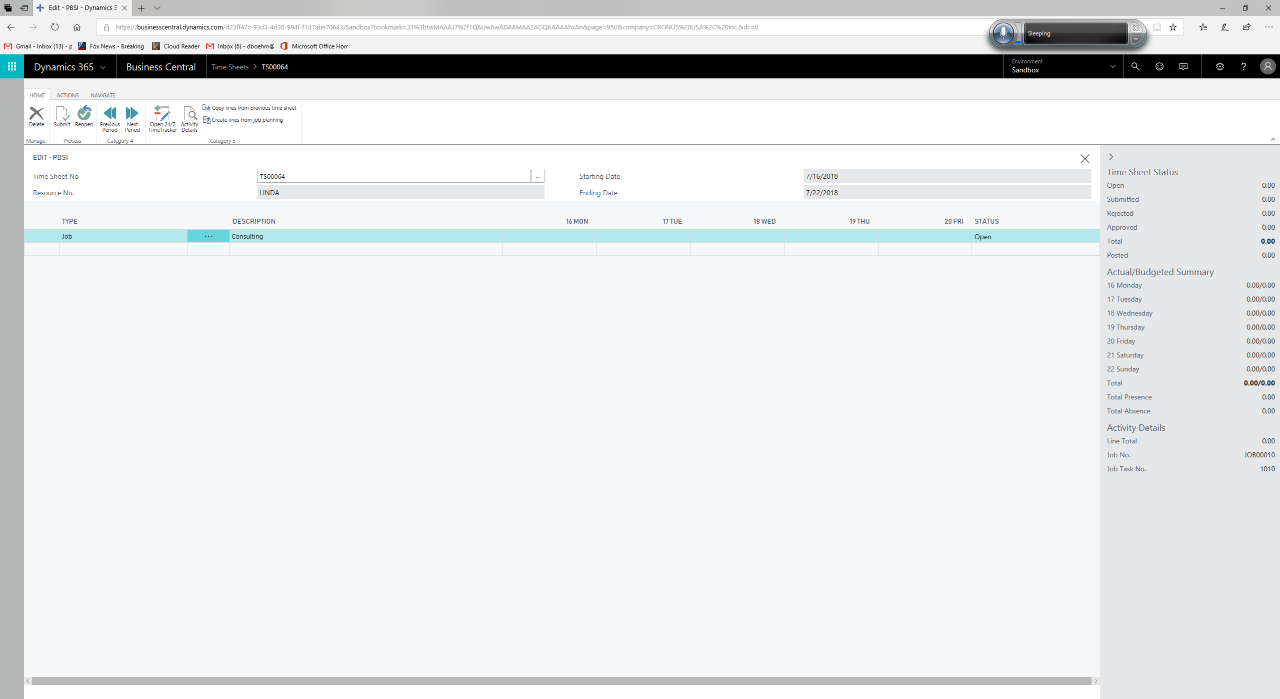
- Depending on how your Project Management module is configured, your screen may look a bit different, but you'll basically start a time sheet line by filling in the "Type" field, “Description” field, and sub-fields associated with the description.
- Once you've done this, you are ready to use 24/7 TimeTracker to start tracking your time.
- To start tracking your time, click on the ”24/7 TimeTracker” action (shown in the Action Ribbon).
- The first time you ever do this, you will be prompted to enter an "activation code". This will be the code we send you after you've contacted us (as explained above). Once you've done this, you will be presented with the following screen:
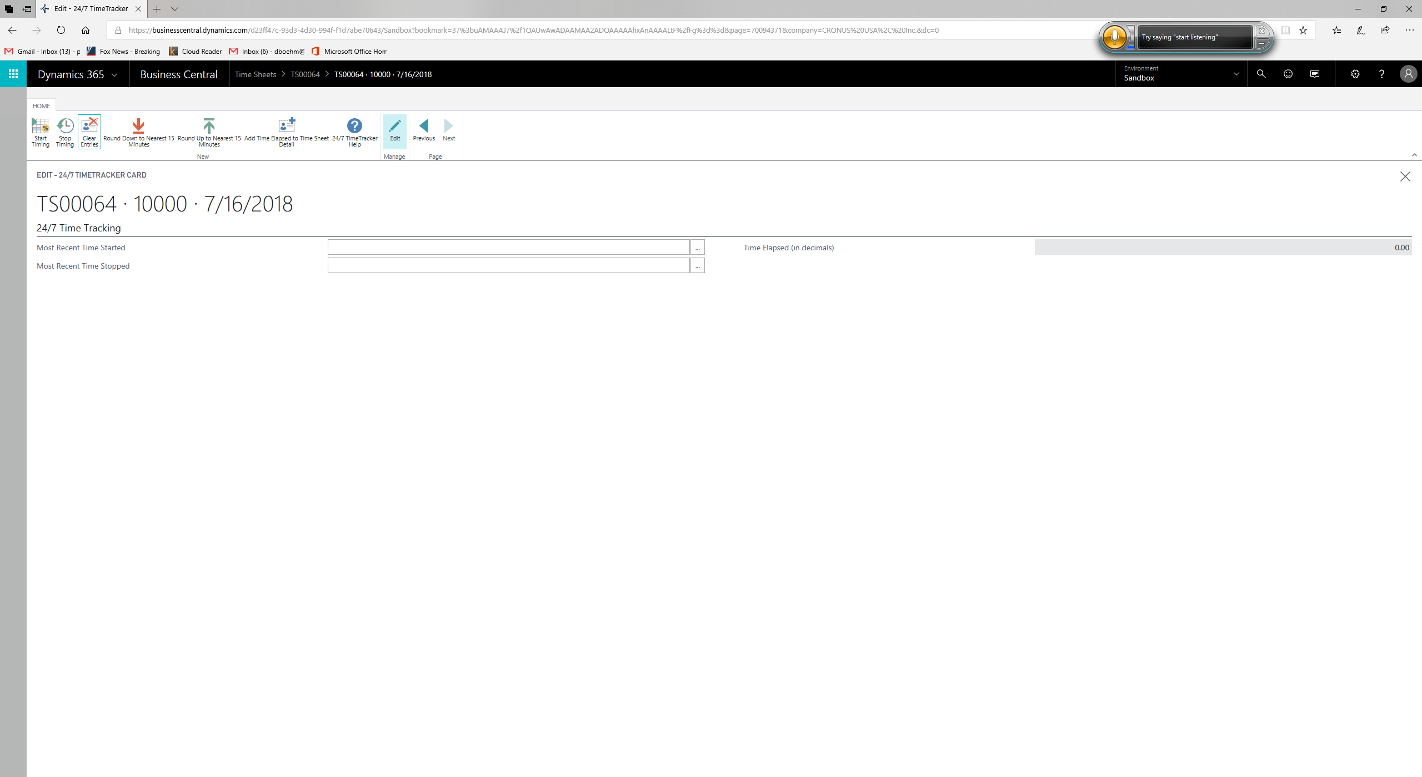
- At any time, you can enter time and date information into the "Most Recent Time Started" and "Most Recent Time Stopped" fields, however the easiest way to track your time is by using the Actions in the Action Ribbon.
- When you are ready to start timing, click on the "Start Timing" action. You can then close this page and continue on with your job duties.
- When you are finished, re-open this page and click on "Stop Timing".
- If for some reason you decide not to add this elapsed time to your time sheet, you can simply click on the "Clear Entries" action.
- If your company has a policy of charging in 15-minute increments, you can use the "Round Down to Nearest 15 Minutes" or "Round Up to Nearest 15 Minutes" actions.
- Finally, when you are done you can click on "Add Time Elapsed to Time Sheet Detail" to add the elapsed time to your time sheet.
- If you have questions or need to contact us, you can click on the "24/7 TimeTracker Help" action to see the "Help" page (as shown below). You'll see our contact information on this page, as well.
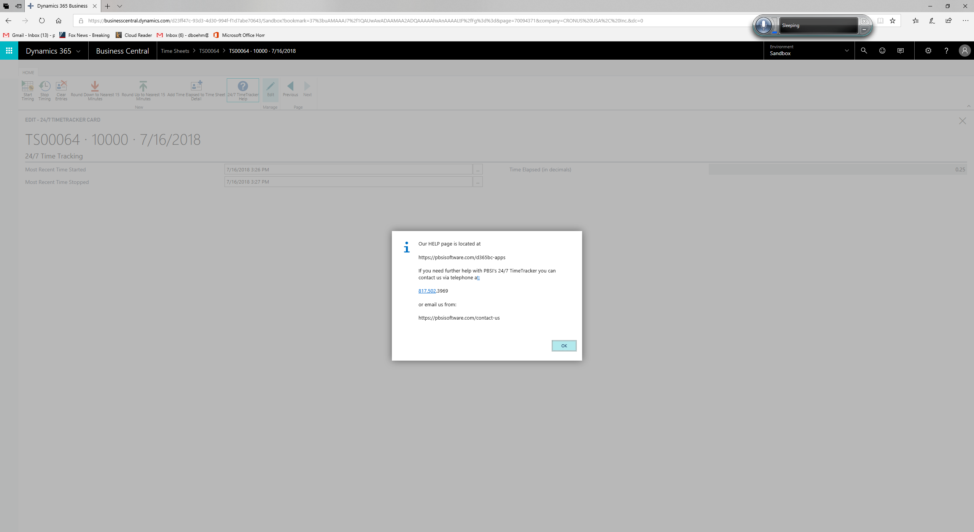
- This concludes our help tutorial. Once again, if you have any questions about 24/7 TimeTracker, or would like to discuss your own customization needs, please don't hesitate to contact us at 817.502.3969. We can also be reached from our contact page at https://pbsisoftware.com/contact-us

