USER SCENARIO DOCUMENT IN Self Setup ES
In order to generate a complete cycle of the solution IN Self Setup ES, it is needed to follow the next steps:

New company creation (Dynamics 365 Business Central ES version)
First of all, a company should be created. Once this step is done, the setup process can begin.
As shown in Fig. 1, this is the data of the company.
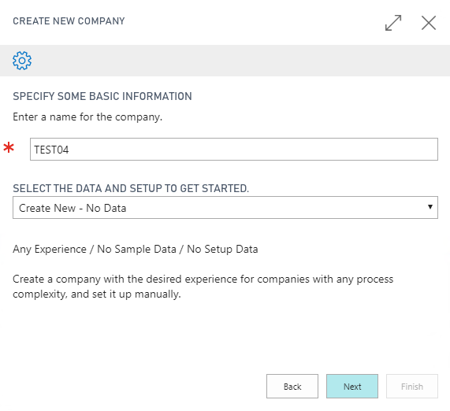
Fig. 1: New Company Data.

Assisted Setup
The first step is to choose the Self Setup Extension. In order to do so, click on the light bulb, as shown in Fig. 2, and then search for Assisted Setup.
Fig. 2: Search Button

Next, choose “Set up IN Self Setup ES”, as shown in Fig. 3.
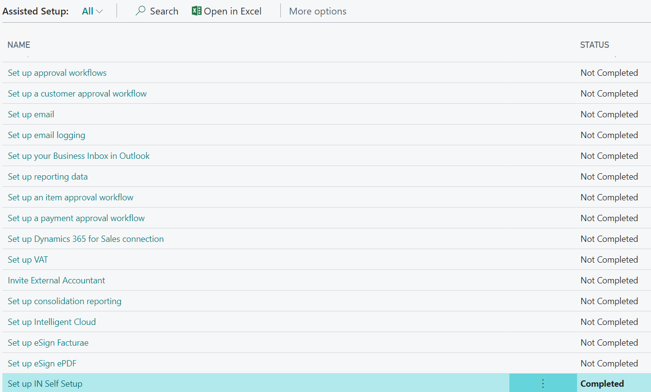
Fig. 3: Assisted Setup List

Customer Welcome Page and Data Load
Once the last steps are completed, it is needed to setup the solution through the Wizard.
This consists in the following steps:
- Log in to the Innova Portal and copy the Identifier from the Customer Information section.
- On the first page of the Wizard, paste the Identifier in the rectangle and click Load Initial Data, as in Fig. 4.
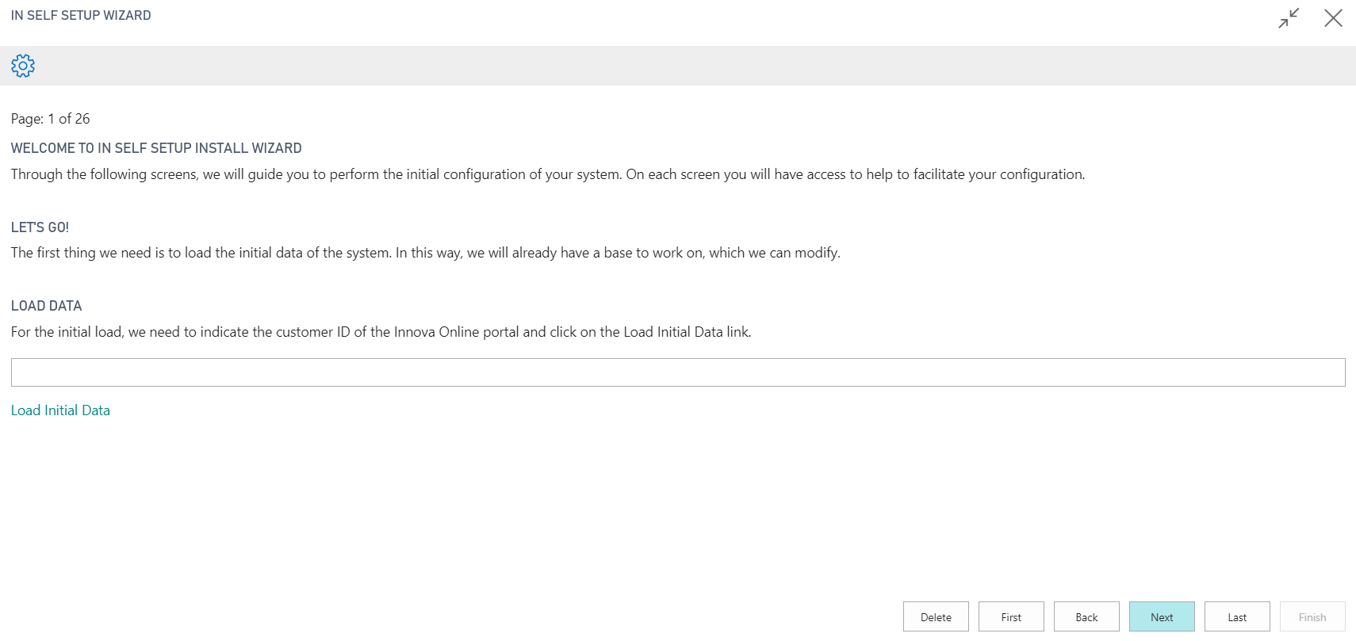
Fig. 4: Welcome Wizard Page
At this point data should be loaded, which might take some minutes.

Accounts Setup
Data has been loaded into the Wizard. It can be checked on Page 3 of the Wizard, and also in Fig. 5.
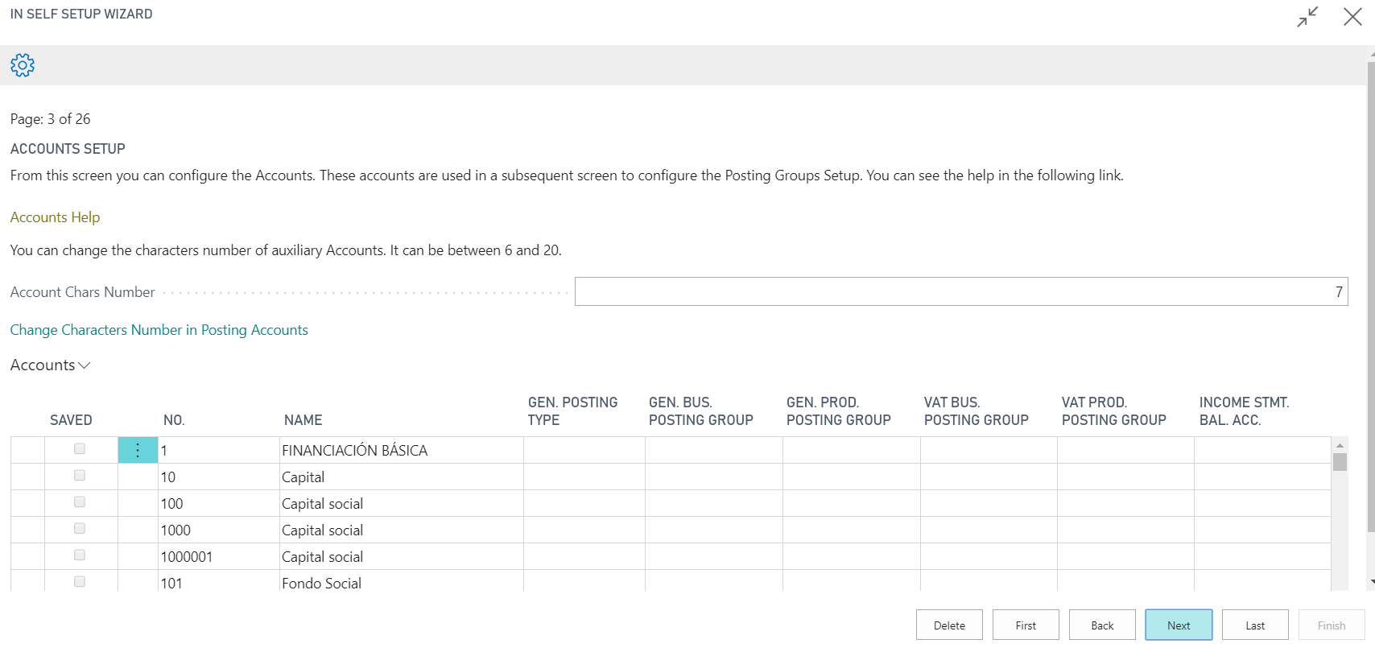
Fig. 5: Accounts Setup with Loaded Data
It should be checked that the loaded information is correct, and also that the user can make his own modification of the fields.

Customers, Vendors and Items Pages
To demonstrate that data is working properly, it has been introduced some in the “Customers”, “Vendors”, and “Items” Wizard pages, as it can be seen below.
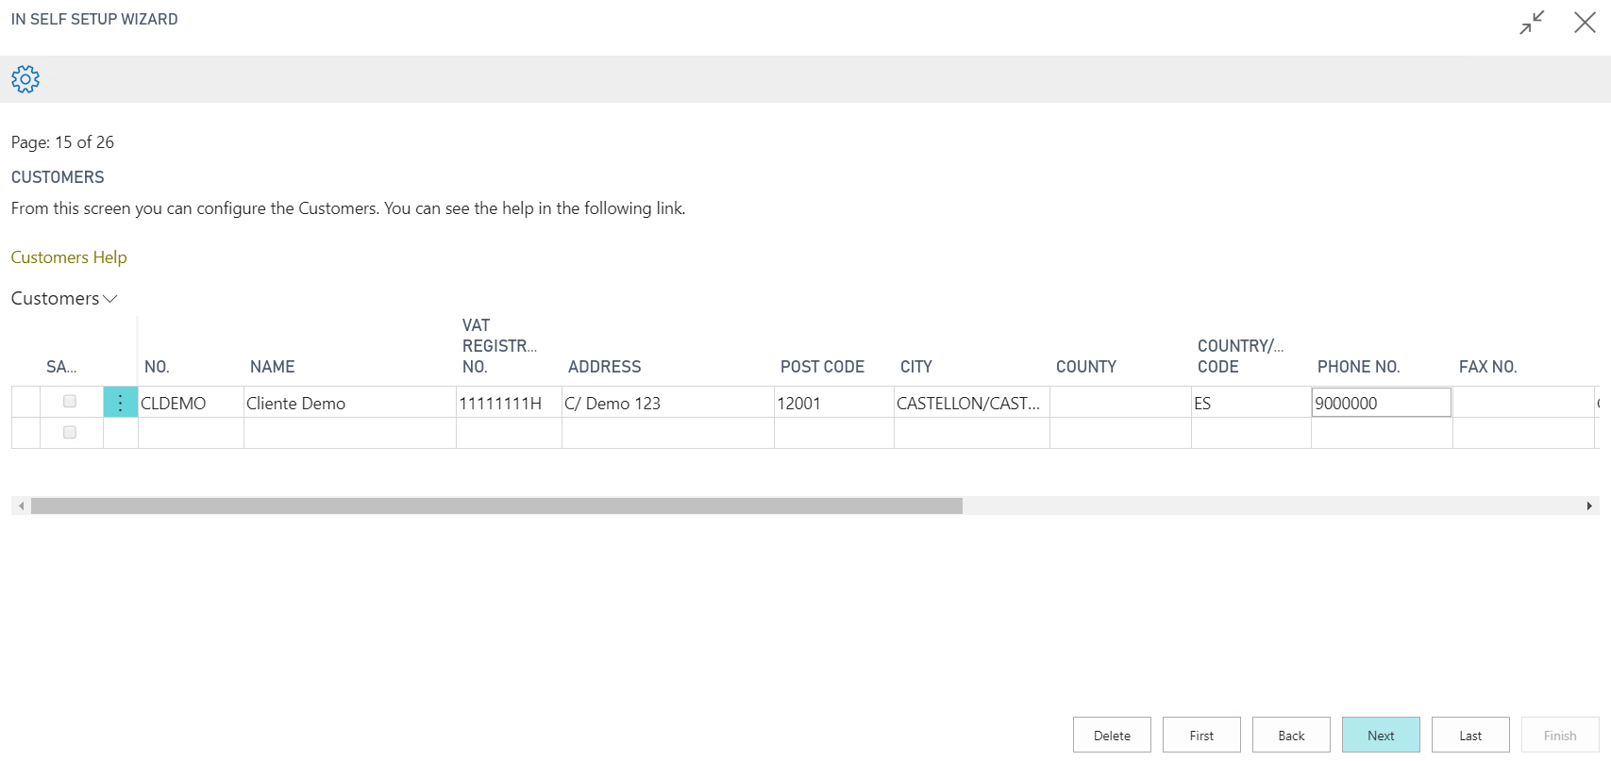
Fig. 6: Customers Data
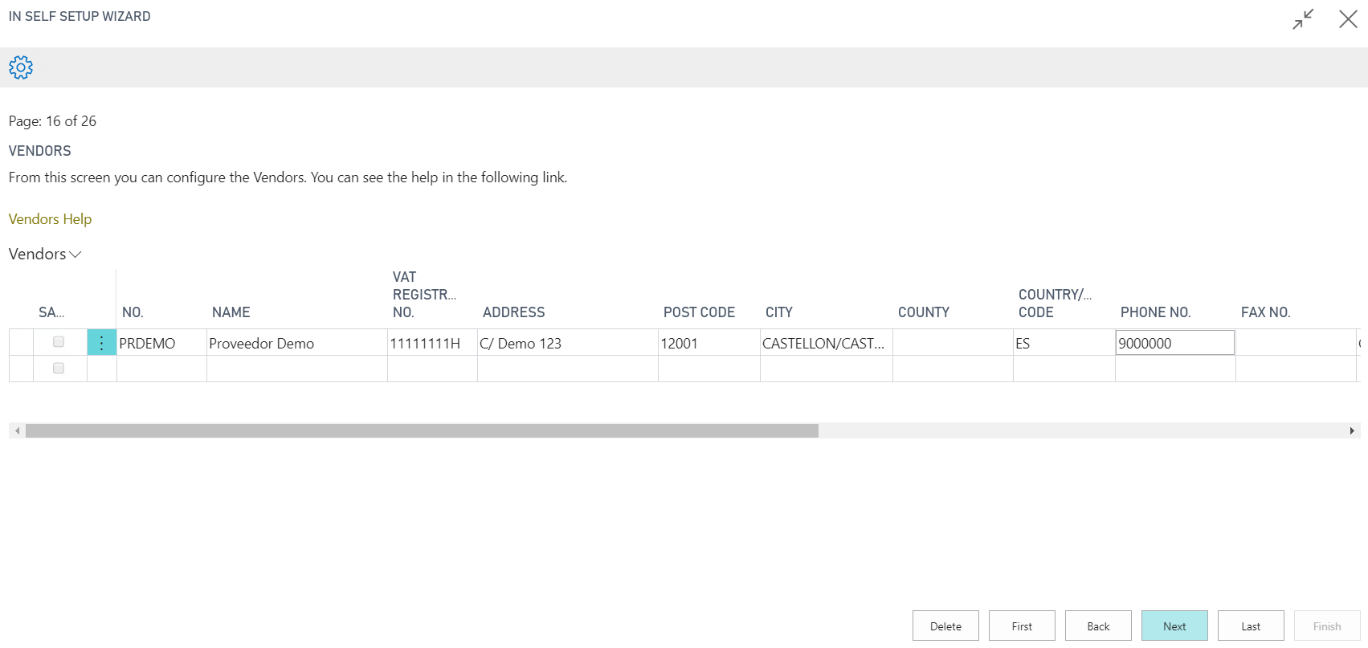
Fig. 7: Vendors Data
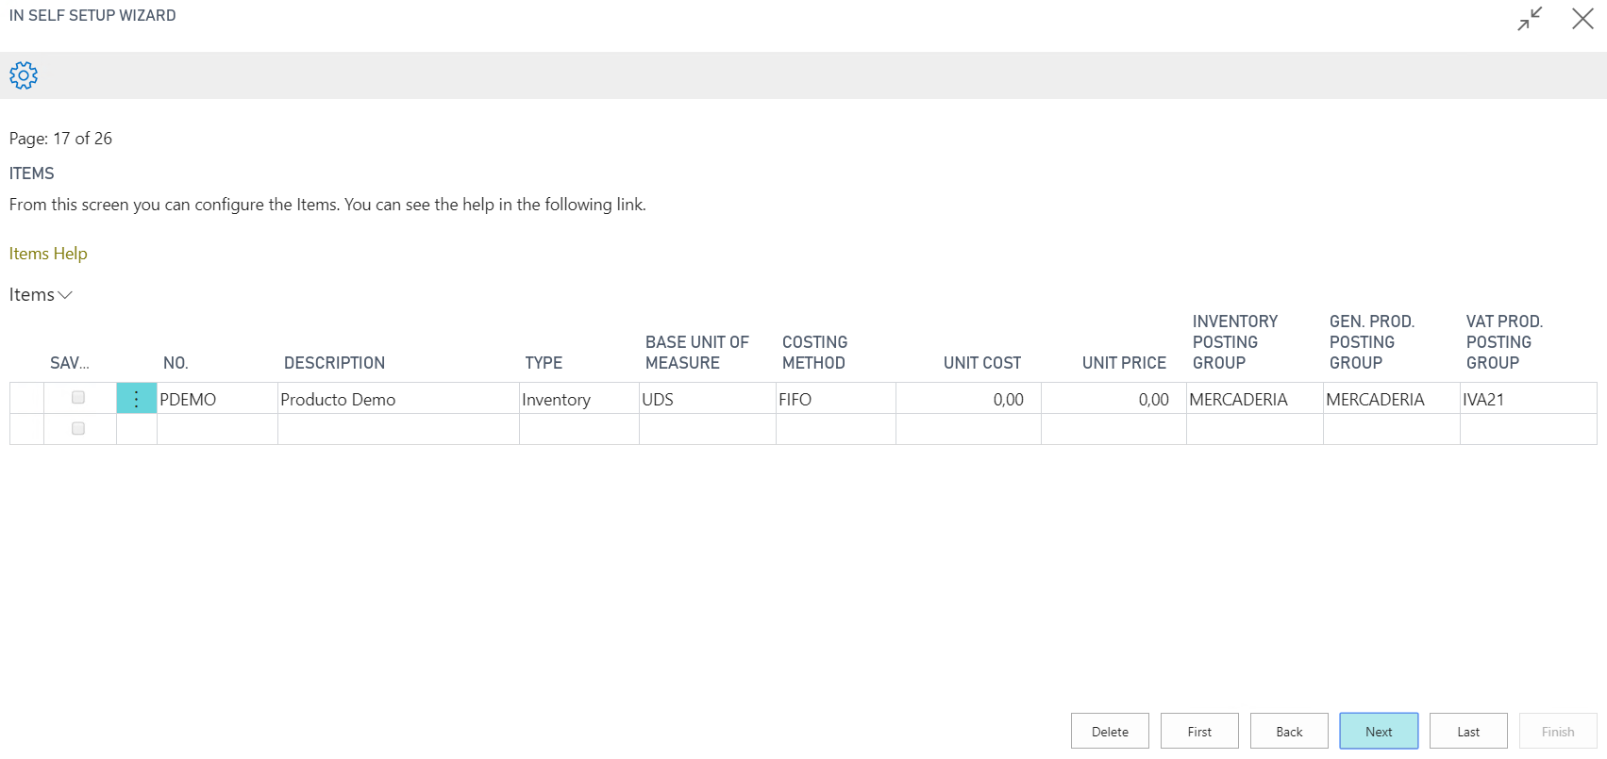
Fig. 8: Items Data

Also, this type of page can be filled manually. From the “Edition Page” data can be processed to Excel.

Setup Pages
Data has been also introduced in the setup pages that can be found next:
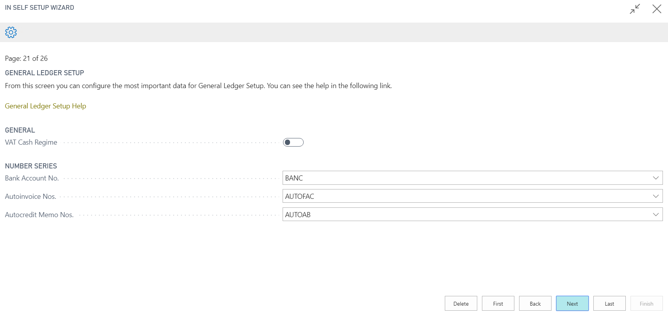
Fig. 9: General Ledger Setup data
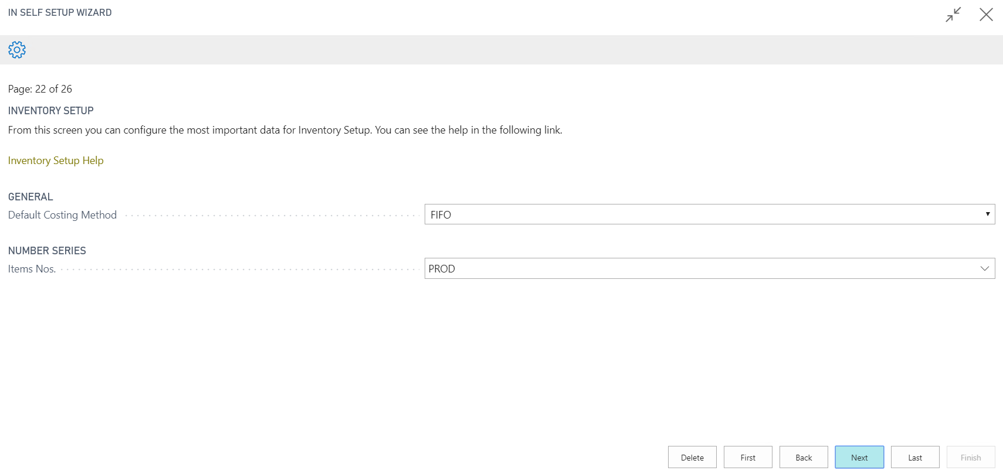
Fig. 10: Inventory Setup data
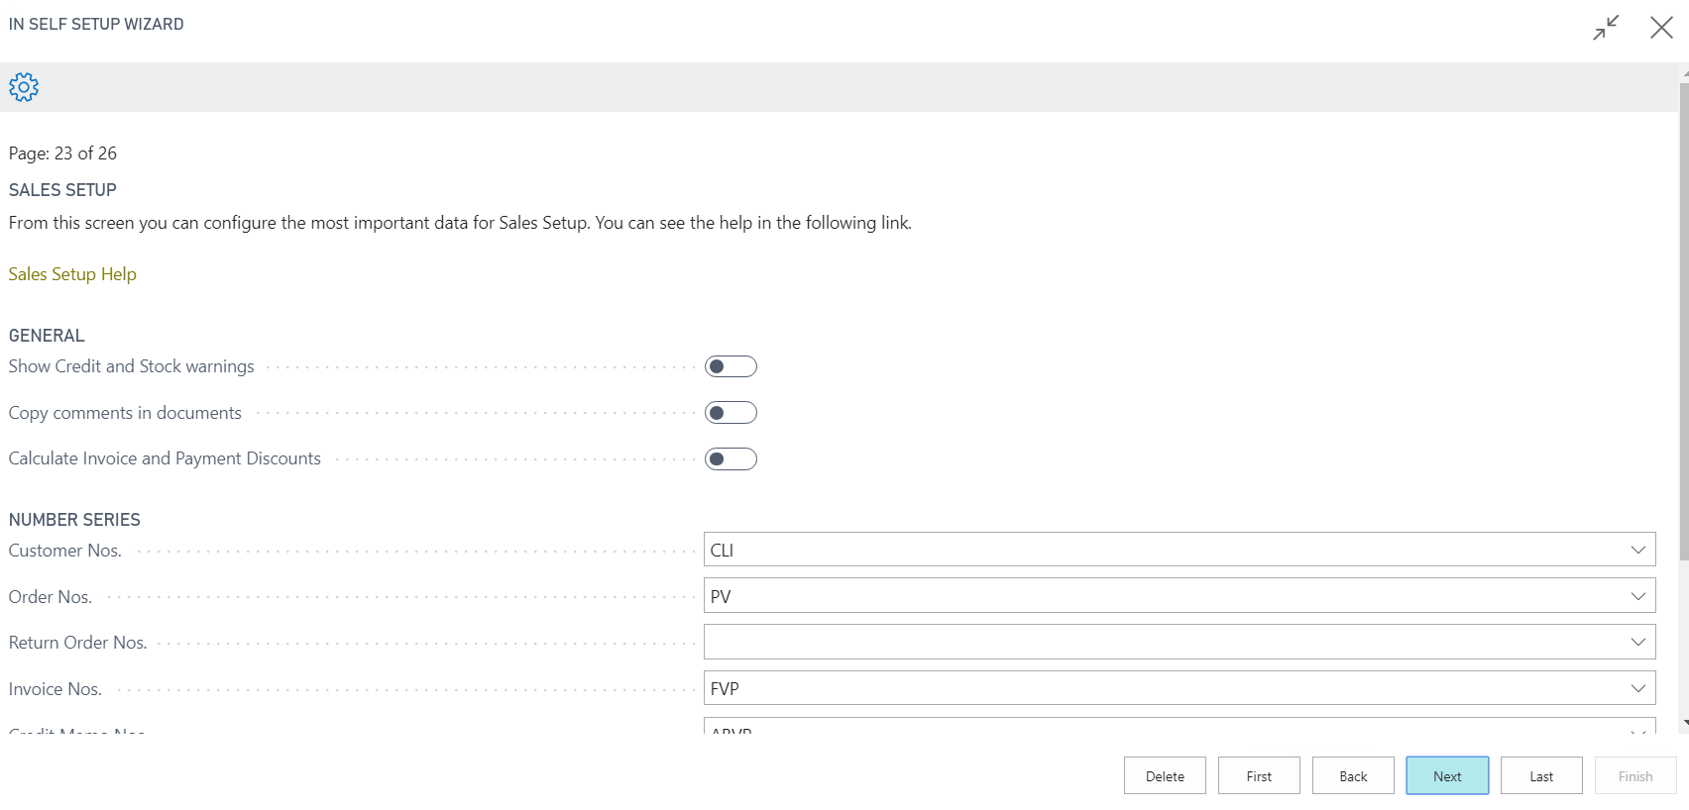
Fig. 11: Sales Setup data
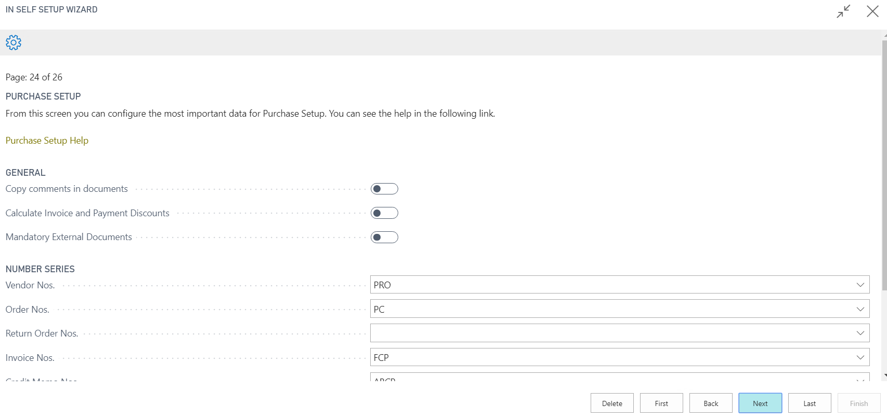
Fig. 12: Purchase Setup data
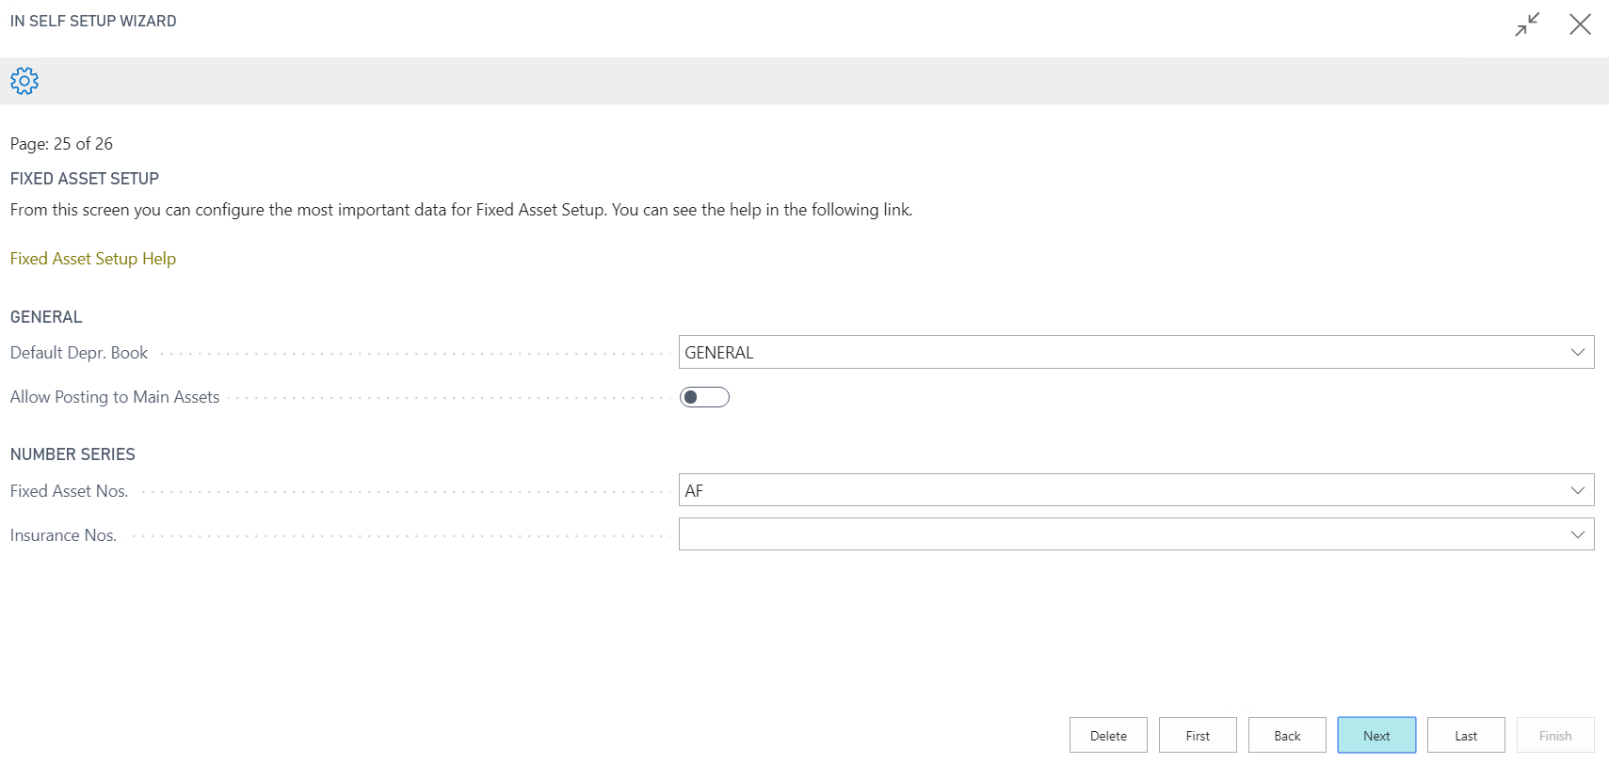
Fig. 13: Fixed Asset Setup data

Summary
Finally, after all the configuration is done, the last page will show the summary. An example can be seen in Fig. 14.
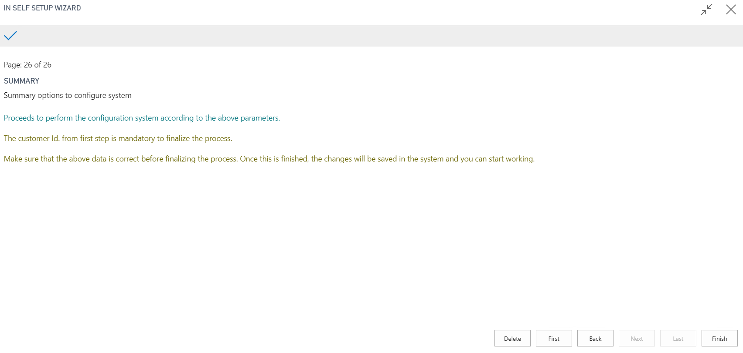
Fig. 14: Summary Data

Testing of a real Purchase and Sell order
The following steps will implement a Purchase Invoice.
It has been created a purchase invoice for a specific customer, as shown in Fig. 15.
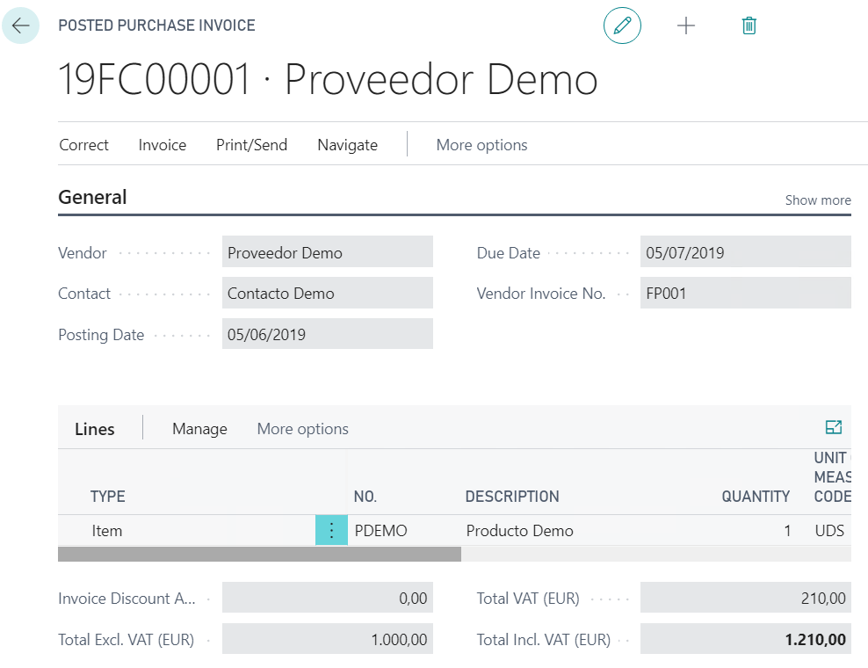
Fig. 15: Purchase Invoice Data
Finally, it can be seen that the total price has been loaded into the Chart of Accounts.
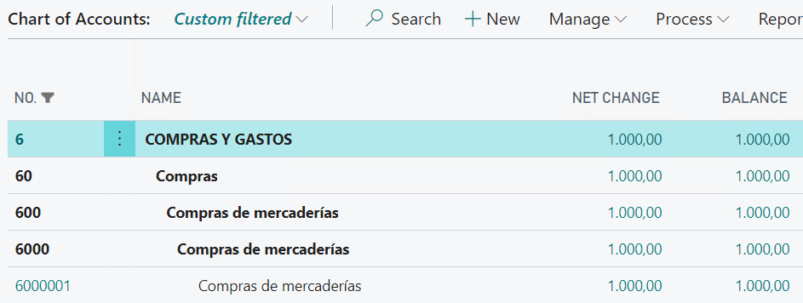
Fig. 16: Chart of Accounts Data

The following steps will implement a Sales Invoice.
It has been made a sales invoice for a specific customer, as shown in Fig. 17.
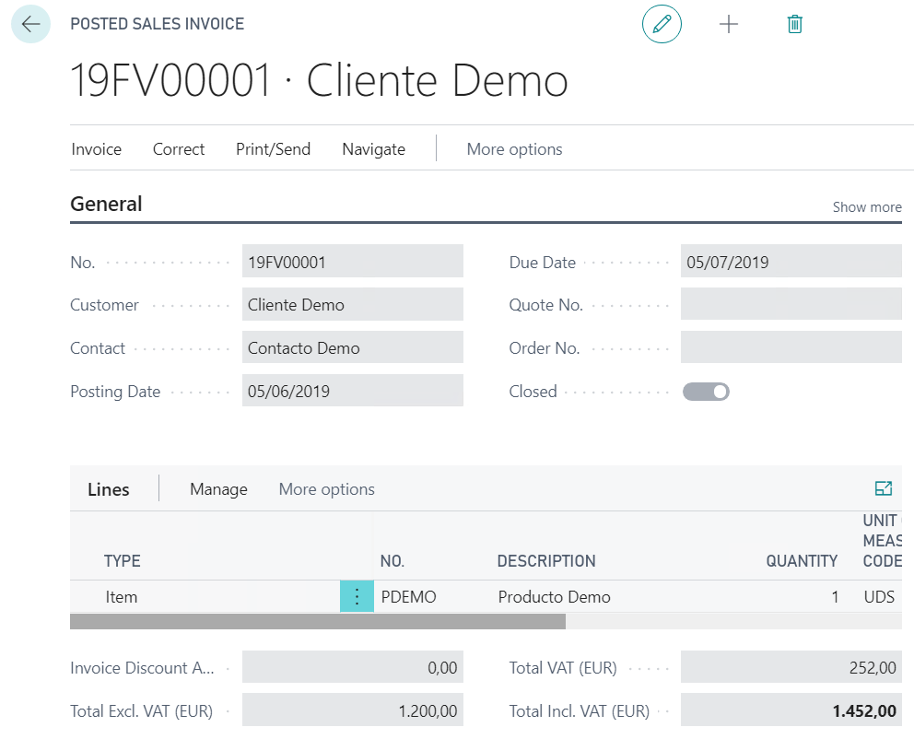
Fig. 17: Sales Invoice Data

Finally, it can be seen that the price has been loaded into the Chart of Accounts.
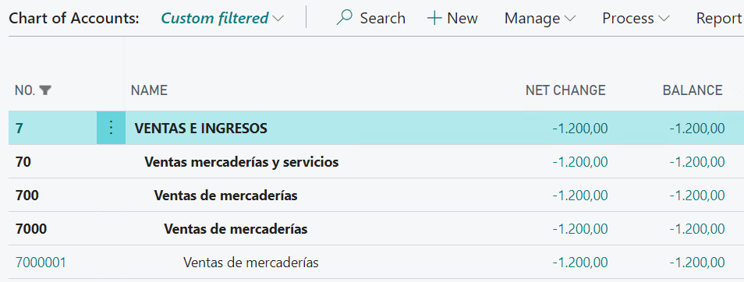
Fig. 20: Chart of Accounts Data

