User Guide
Editable Grid
CRM Online

Create Date: | 3/31/17
Revision: | 2.0
Revision Date: | 2/26/19

Getting Started
Welcome to the eLogic Editable Quote Grid user guide. This document outlines the functionality of your new software.
Let’s get started.

Navigate to a quote record of your choosing:
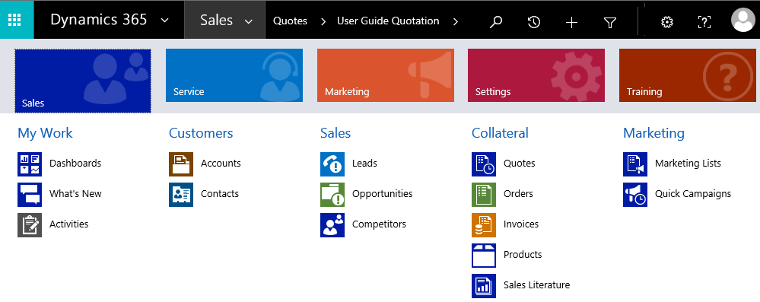

Next, locate the Grid on the form. The location of the grid may change depending on where your system administrator chose to place it. It looks like this:
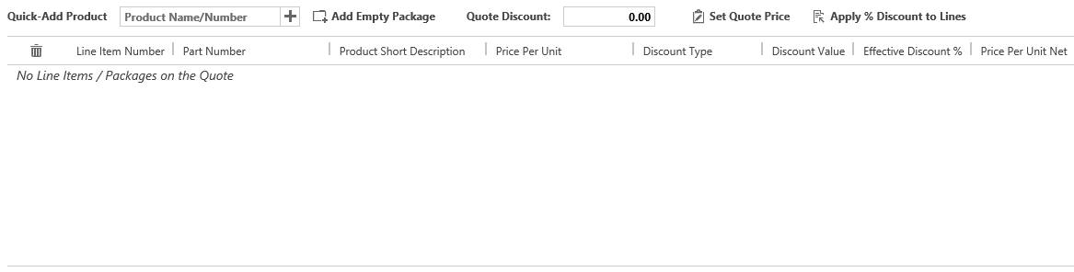

Note that as of D365 version 9, the Grid also supports Opportunities in addition to Quotes. The functionality is the same in both places, although different columns may be displayed at the choosing of your system administrator.

Administrator Information

Basics
The Grid is controlled by two entities: Column Configurations and Editable Grid Settings. These are most easily accessible through the Advanced Find function in D365.

Column Configurations
This entity controls which fields appear on the grid, which order those fields appear in, and which fields can be edited. Any fields, even your own custom fields, may be added as column configuration records. If no such records exist, the Grid will default to a set like the ones you see below.
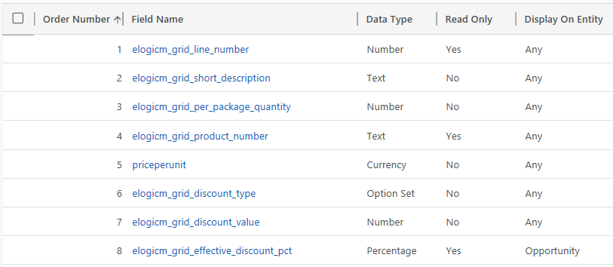
At a quick glance, you can see the order of the fields, which field is to be displayed, the type, whether it is editable, and which entity (Quote or Opportunity) it should appear for. Note that matching the D365 field type to the display field type is very important. Selecting a different field type may cause errors.
Column ordering will not update automatically across records. Ensure the order is correct and use each number only once for best results.

Opening a record reveals a few additional fields. We can control the alignment of the field, as well as the pixel width of the field. The Grid will size based on data and data type if these fields are not set.
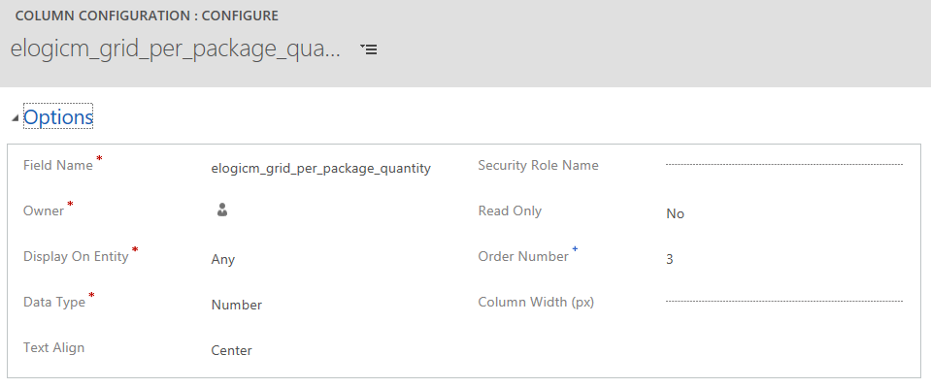
Special note here to the security role name field. If you would like some columns to only display to users of certain security roles, put in the name of the role (exact text) and the column will show or hide accordingly for users. Only one role can be populated here, but the same field can be added more than once for multiple roles.
New to the D365 version 9 release is support for lookup fields as well as date fields. These field types are especially helpful for service quotes, as you may need to list a related asset, as well as contract start and end dates. Pair this with the security role feature and gain a tailored experience for your service team without disrupting your core sales organization.

Editable Grid Settings
Currently two functions are supported for Editable Grid Settings.
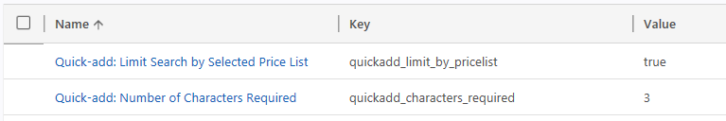
The first is the ability to filter the Quick Add product search by the selected price list on the Opportunity or Quote. If the value is set to true, the search will be limited. Some use cases require the users to be able to see products that they cannot add to their quote, so they know that they need to switch their price list. For that reason, this setting can also be set to false.
The second setting is the number of characters required before Quick Add begins searching. For larger numbers of products, a higher search threshold may be desired. The default is 3 but this can be set higher or lower.

Using the Grid

Basics
The Grid is made up of two basic parts: the button bar at the top, and the line display below. The line display has a number of columns, which are chosen by your system administrator.
Most screens should show all of the buttons on a single screen, but additional columns may not be visible. Make sure to check for scroll bars on the bottom and right side of the Grid if something is missing from your view.
By default the Grid will show around 10 lines worth the height, even if empty. It will grow as you add more lines, so that you can see all your records in one place. Note that with a large number of lines, loading may take a few moments.
The Grid supports packages. A package is a combination of line items. These lines may be related, or they may not be. The usage is up to you. However, the Grid does require all lines be added to a package, even if you have just one.

Adding Lines and Packages
Now that the basics are out of the way, let’s get hands on. You’ll see two buttons right at the top of the Grid. They look like this:

The first allows you to search for and add products. The second allows for the addition of packages. Adding a product with no packages will automatically add one. Go ahead and click the Add Empty Package button. A dark gray line should appear in the grid, like this:
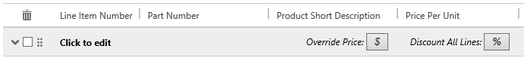

We will get into the other features of packages later, but for now, we can Click to edit to give it a name. I’ll call mine Example Pack One. Now, let’s add some items for this package. Your products will be based on what data is in your CRM. For me, I have some widgets in the system. I’ll click into the Product Name/Number field to search.
Once I type 3 characters and pause, searching happens automatically. It searches both product short description and part number, and automatically adds wildcards. The number of characters prior to searching can be customized by your system administrator.
In my case, you can see I typed “widget” into the search, and the system has found some records for me. Note that this search takes longer if you have a lot of products. Being specific when you can be helps.
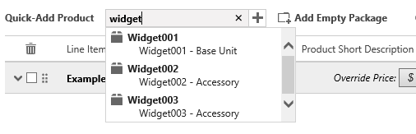
I’m going to go ahead and add all three items to my quote. You’ll note that they add in a new package called “Non-Packaged Items” which is just a placeholder. We’ll move them into our package next.
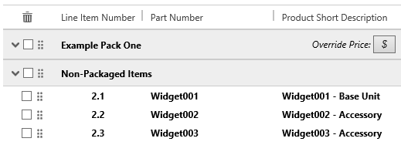
Also new in D365 version 9 is the ability to add lines directly to an existing package, skipping the “Non-Packaged Items” section entirely. To do this, just check the box next to the package you would like to add the lines to before adding the lines.

Reordering and Repackaging Lines
Added lines go into the Non-Packaged Items package as a staging area. This helps keep your quote organized, so you don’t lose track of lines you’re adding. Lines can be added or removed at any time. Let’s go ahead and move those lines into our package.
On the screenshot below, notice the six-dot icon on each line and each package. Also note that the cursor changes to a crosshair when placed on the icon.
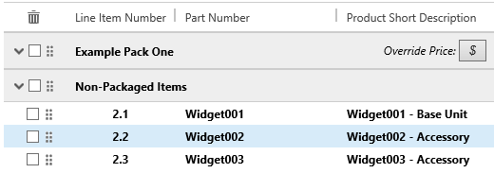
Now we can simply click and hold to drag and drop the line from our Non-Packaged Items package to the Example Pack One we created. Note that the lines automatically renumber once you let go of the line.
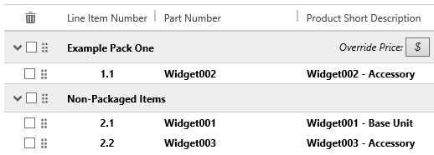

Once we’ve moved all the lines up into the proper package, we can get rid of the Non-Packaged Items package. Note that it will come back if we add more lines. To remove something, check the box next to it, and click the trash can icon at the top corner.
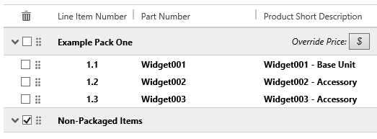

Note that packages can be reordered the same way. Any time you see the six-dot icon, you can drag and drop that element in the Grid.

Line Discounting
There are three kinds of discount for lines, and these form the foundation of package and quote discounting. These discount types are:
- Dollar Amount
- Percentage
- Override Price
A dollar amount discount allows us to subtract a specific amount off the price of an item. See the first line in the example below. The original price was $10,000 and a $1,000 discount was applied, so the price is now $9,000.
A percentage discount allows us to subtract a percentage off the price of an item. See the second line in the example below. The original price was $2,500 and a 10% discount was applied, so the price is now $2,250.
An override discount allows us to set the price of the item directly. See the third line in the example below. The original price was $250 and the price was overridden to $200, a discount of 20%.
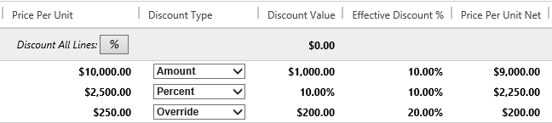
Note that for dollar amount and percentage discount types, a negative value can be used to mark up the price, rather than mark down the price. Additionally, an override price can be set higher than the original price to mark it up.

Package Discounting
Each of these discounts available to the line are also available to the package. Find the buttons and field that look like this:
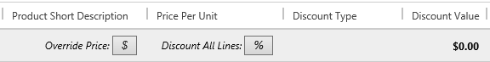
First, the override price button. This button will set the price of the entire package to a specific value. The amount discounted or marked up will be distributed across all lines in the package, weighted by the price of each item. Note that this may take some time for a package with many lines, as each line needs to be updated.
Next, the discount all lines button. This will apply a percentage discount to all lines in the package. However, this will not apply to any line with an override discount already set. That way you can override a line or two and apply a flat discount to the rest of your lines.
Finally, the discount value field. This will take a dollar amount off the package as an additional discount. It does not modify any of the lines, but rather is subtotaled separately.

Quote Discounting
The same functions available at the quote package are also available at the quote header.
The quote discount field, like the package one, is subtotaled separately and factored in to the total.
The set quote price field will allow you to override all the lines of the quote, to meet a specific target price. Again, this will be weighted and distributed across all the lines based on the price of each line.
The apply discount to lines will apply the same percentage to each line, again skipping over any lines with a line level override price applied.

