So Interim
by Apsolue
USER MANUAL

Contents
Introduction 3
General presentation of the SO INTERIM 3
Presentation of Dynamics 365 3
Login to the application 3
Navigate the application 4
Search in the application 7
Presentation of SO INTERIM 7
Accounts entity (standard) 7
Objective 7
Account form 8
Contacts/Candidates entity 9
Objective 9
Contact form 9
Candidate entity 10
Objective 10
Candidates' views 10
Candidate form 11
Opportunity entity 11
Objective 11
Needs expressions views 11
Needs expressions form 12
Use of SO INTERIM 13
Contact creation 13
Needs expression creation 13
The process of the needs expression 14
Creating an application 16
Advanced search screen 16
Application management 20
Closing an expression of needs 25
Manage your activity 27
Creating a personal dashboard 34
FAQ 37

Introduction

General presentation of the SO INTERIM

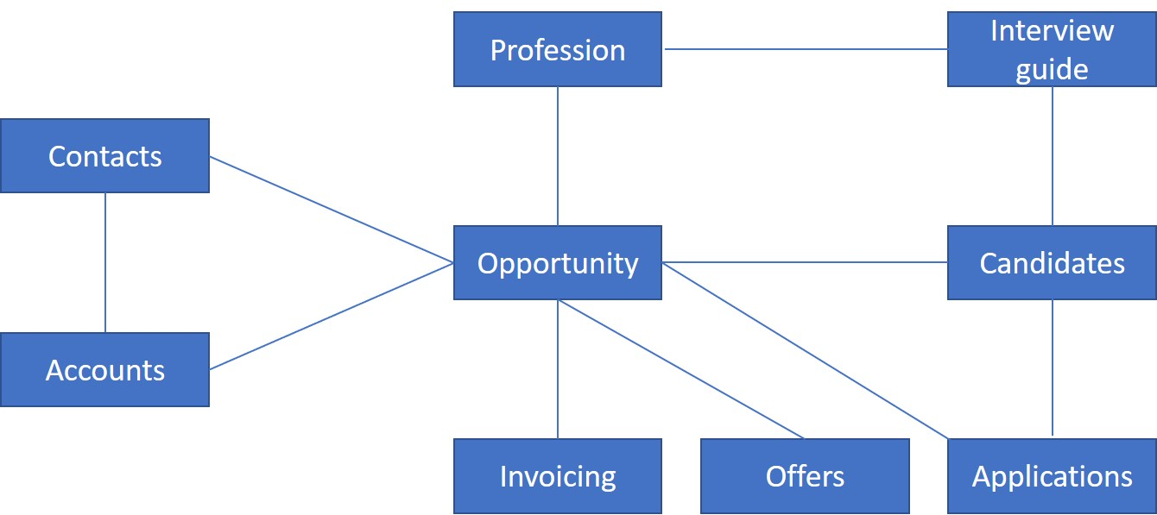
In the following document, we will successively present the various modules and functionalities of the SO INTERIM.

Presentation of Dynamics 365

The SO INTERIM is based on the Dynamics 365 solution and inherits native features of this tool. In this part, you will find an overview of the main features.

Login to the application

The SO INTERIM is in the 365 portal. To connect, go to your portail 365 and select the Microsoft Dynamics 365 application .
From there, either the connection is done automatically, or you are redirected to the home page of all your business applications where you must choose the So Interim HUB application.

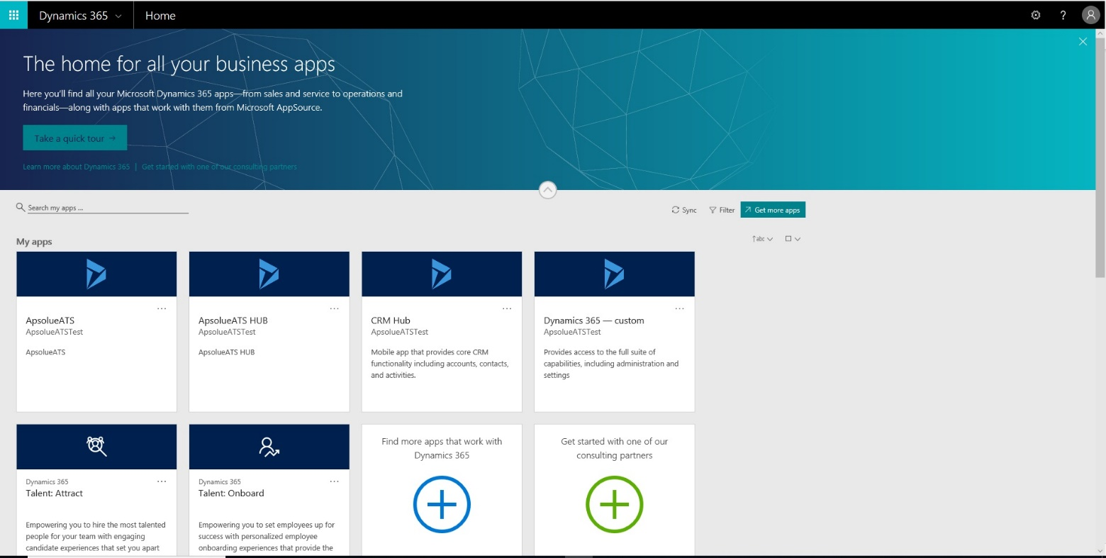

Navigate the application

Presentation of the SO INTERIM menu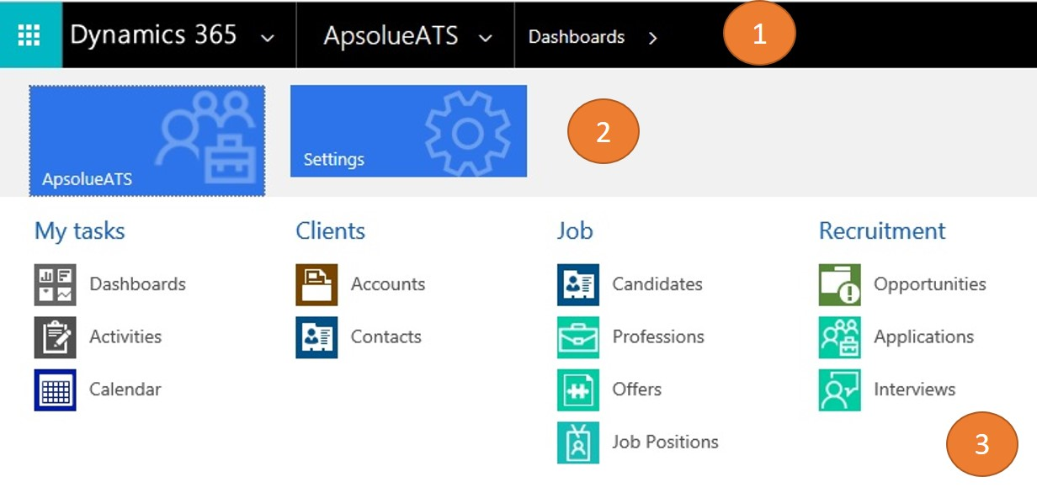

The Dynamics menu allows you to navigate between the different entities of the system.
It consists of three parts:
- The navigation bar: A click allows you to scroll down the menu. It also displays the path of the entity.
- Modules: By selecting one of the displayed modules the attached entities will appear.
- Entities: By clicking on one of the icons, you will open the window linked to this entity.

This menu allows to access next entities:
- Dashboard
- Activities
- Accounts
- Contacts
- Candidates
- Professions
- Offers
- Job positions
- Opportunities
- Applications
- Interviews

Views presentation

When you select an entity, you go to a new window that is called “view”. A view is a table that displays many records according to the request criteria.
The view name is displayed on top left and it's possible to change the view by click on the arrow near the view name.
By clicking on the record you'll open its form.

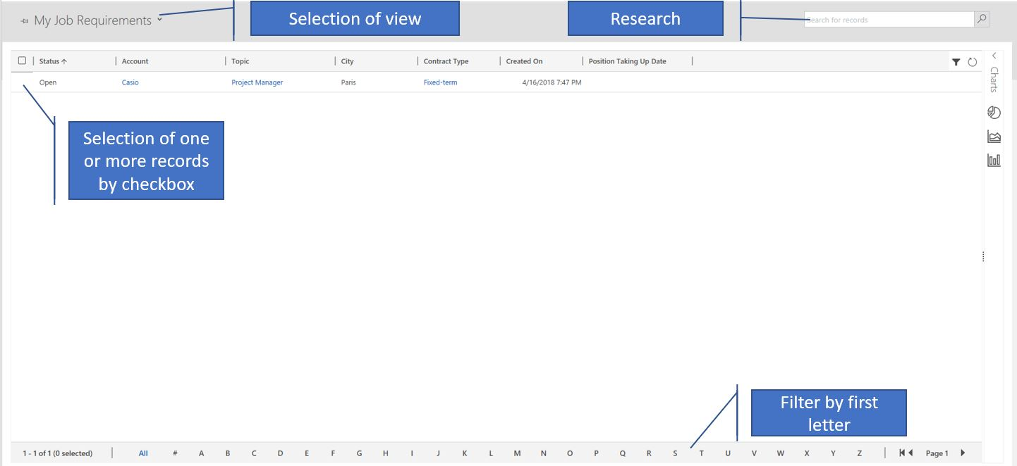

Task bar presentation

Actions bar that is located between the menu and the view allows to make different tasks.
Those tasks are different depending on have you chosen one or many records or none.
Task bar is also available from the form of the record.

Document management presentation

SO INTERIM allows to manage the document associated to the Candidate via SharePoint. To access the documents of the Candidate you should:
- When you are on the form of the Candidate, click on the arrow near the name of the Candidate on the band.
- Then click on the Document icon
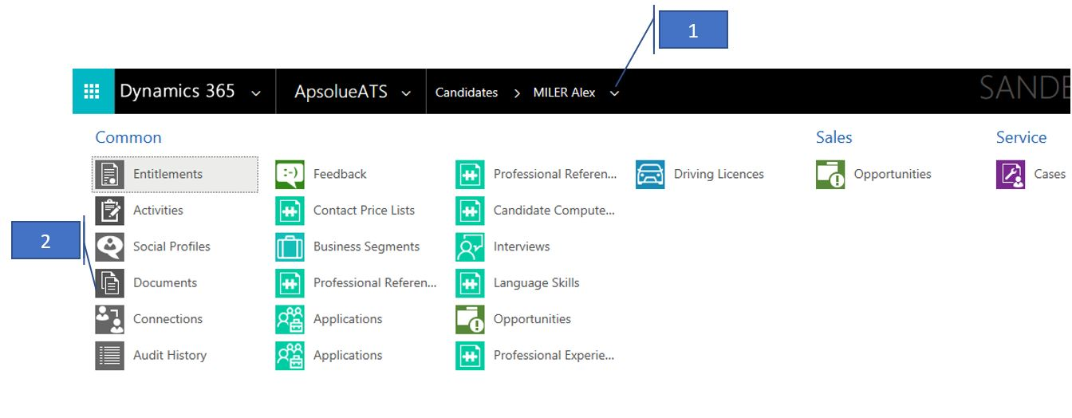
Then on the window of the documents you could realize different actions:

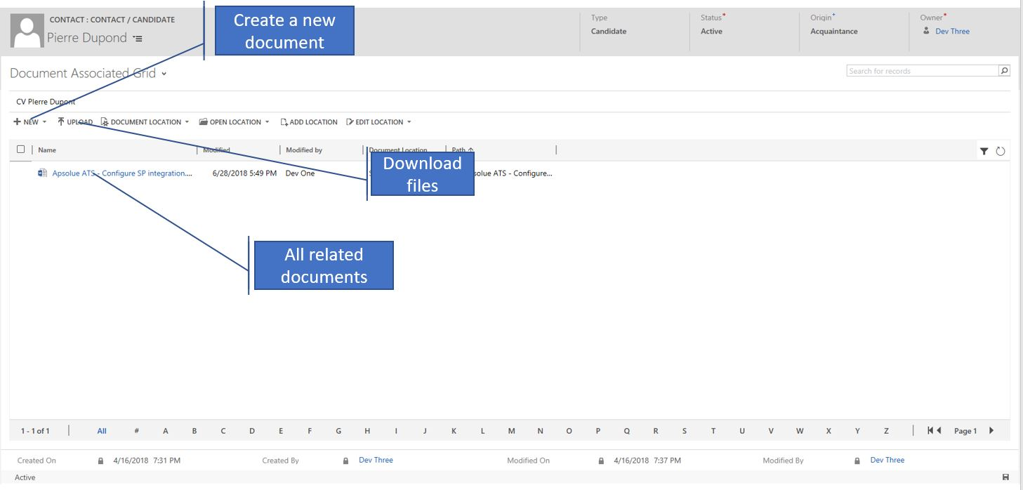
You could download the document through the next window:

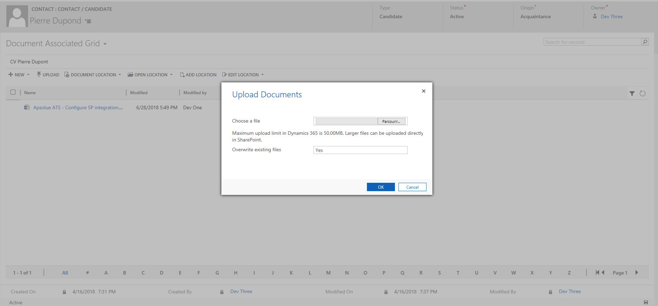

Search in the application

There are many types of search in the application: the easiest is to use the navigation buttons.
There are 5 very useful navigation buttons for the search or quick actions:
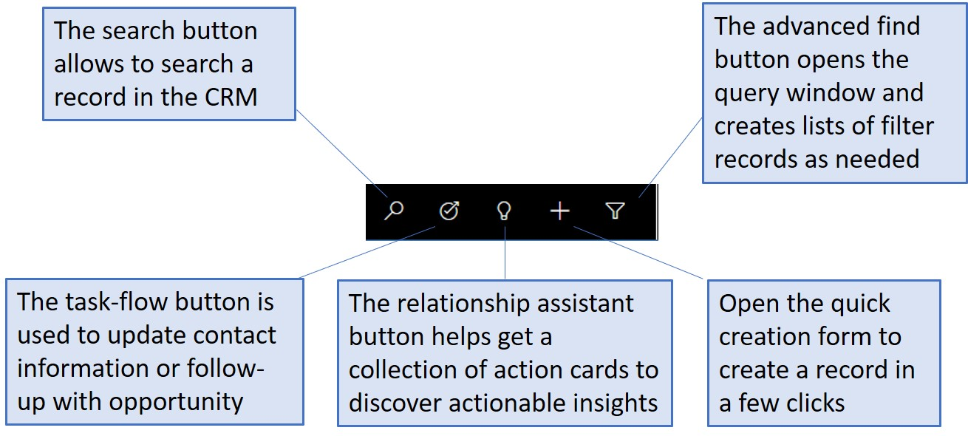

Presentation of SO INTERIM

In this part we present the main entities of SO INTERIM. Those entities are the heart of application and manage other connected entities.

Accounts entity (standard)

Objective

Account entity manages all the companies that are present in your CRM.
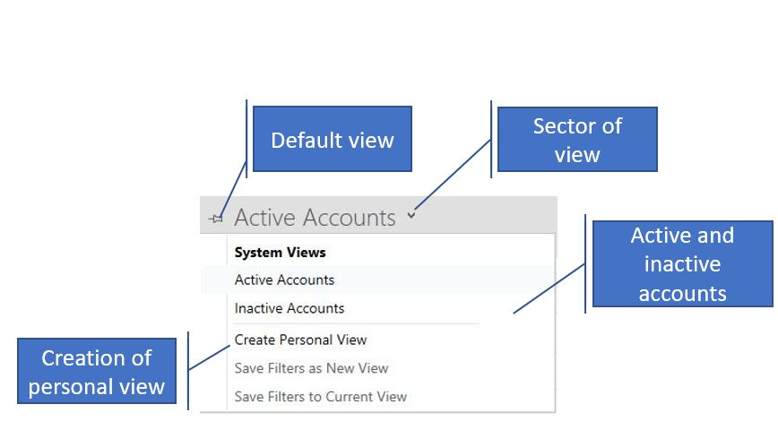

Account form

The form of Company is only available for consulting, it's not possible to create new one or to modify or to delete existing.

Like all entities of the application, it's composed of the sections that display information by category.

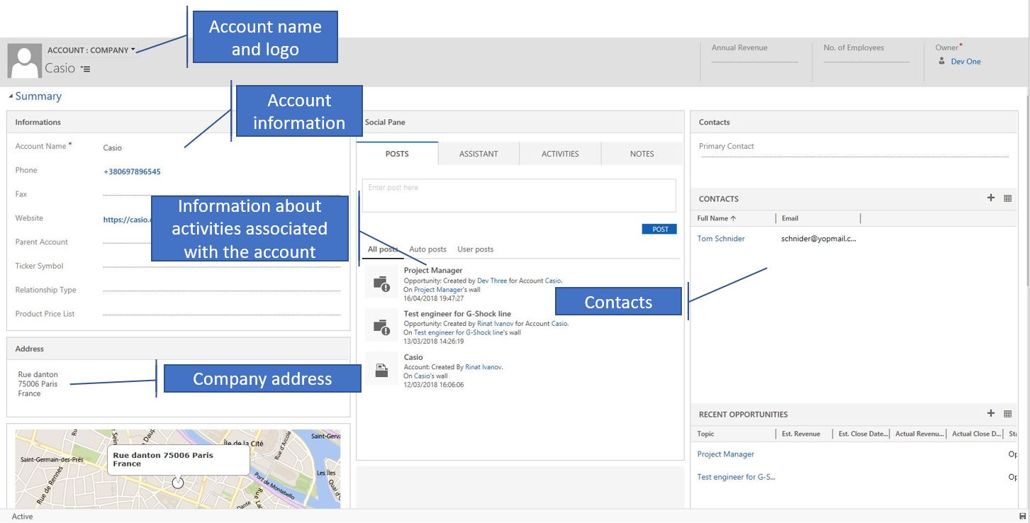

Contacts/Candidates entity

Objective

Contacts entity allows to manage the contacts of the companies.
In the SO INTERIM Solution, we also use this entity to identify candidates. A contact can be of two different types: a regular contact (in general related to an Account), or a candidate.
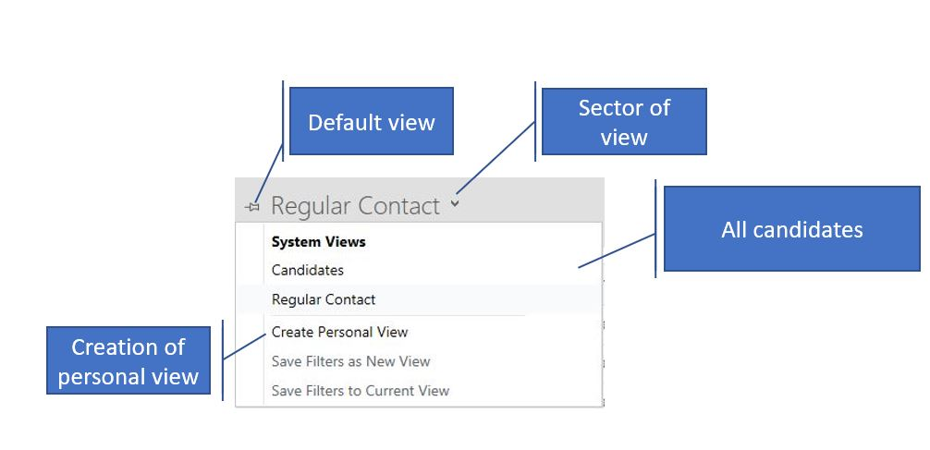

Contact form

Like all entities of the application, Contact form is composed of the sections that display information by category.

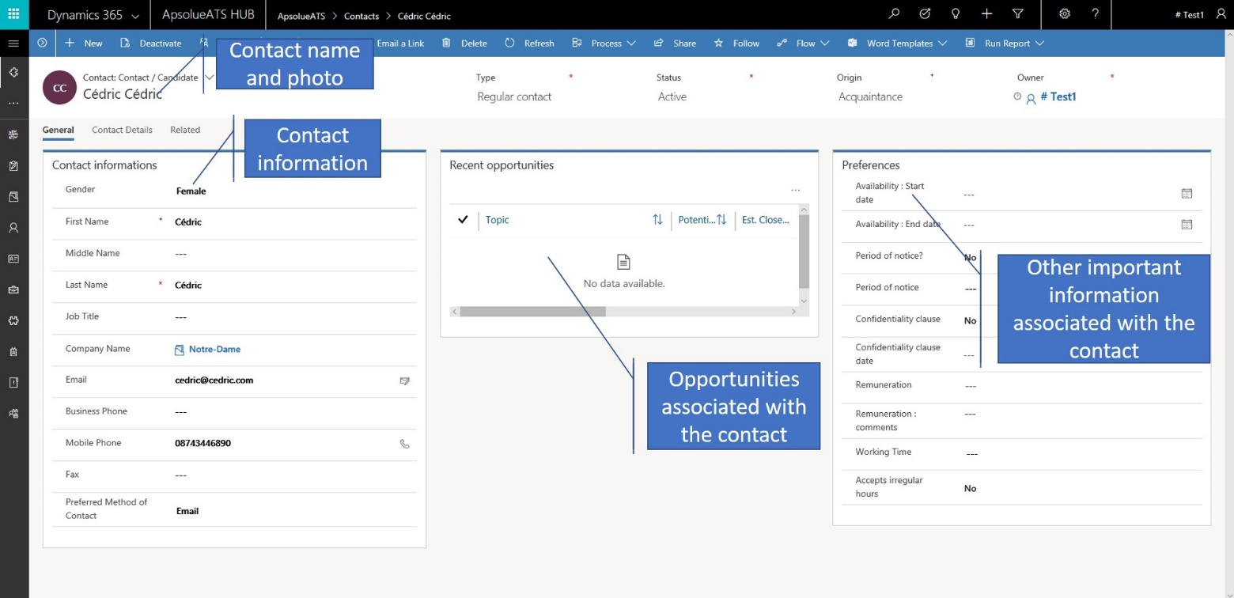

Candidate entity

Objective

Candidates are managed via the Standard Contact entity above.
Only views and forms have different design and functionalities, plus also several additional fields.

Candidates' views

In the SO INTERIM you could access the different lists of candidates, as on the screenshot below:
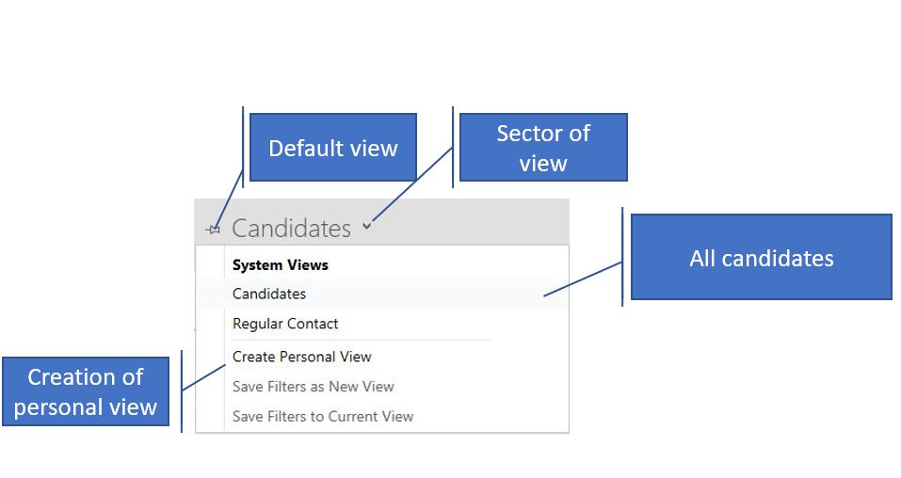

Candidate form

Like all entities, Candidate form displays the information by the sections. These sections manage either the information specific to the candidate (coordinates, birth information …), or linked to the search (job description/ interview guide).

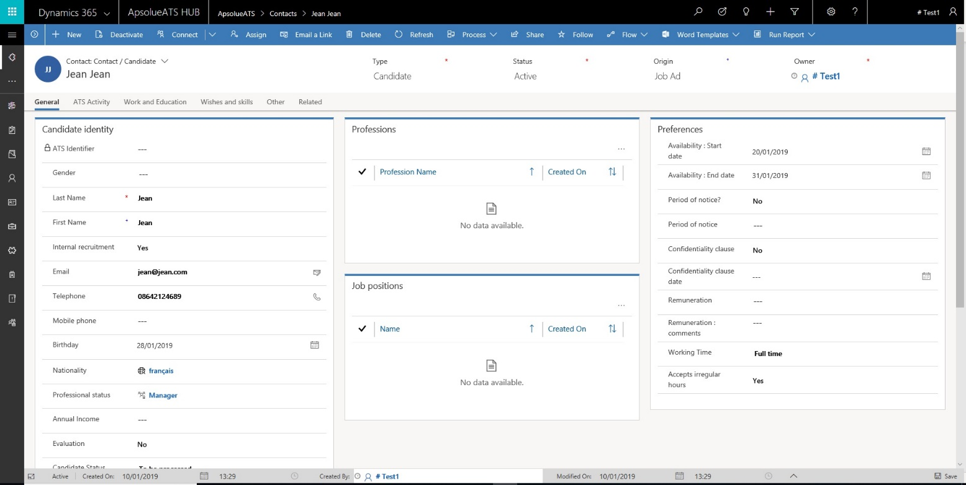

Opportunity entity

Objective

Opportunity is a standard entity from the Dynamics CRM.
In our Apsolue SO INTERIM solution it has been customized by adding several fields to reflect the details of customer needs for a specific job

Needs expressions views

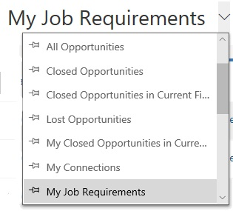

Needs expressions form
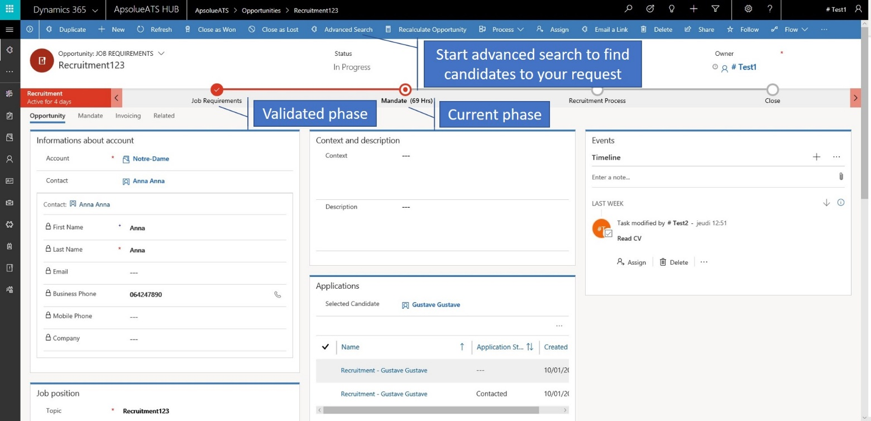

Use of SO INTERIM

In the SO INTERIM and depending on your rights you could create or modify any type of records (the only record that you cannot create/modify in SO INTERIM is Enterprise record).

When creating the record, you should, if it's possible, fill all the fields to dispose of the data quality and reliable database. However, only the fields with the red asterisk are mandatory to save the record.

Whatever the entity, you should click on the icon of the entity and then 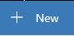 button to create a record.

Contact creation

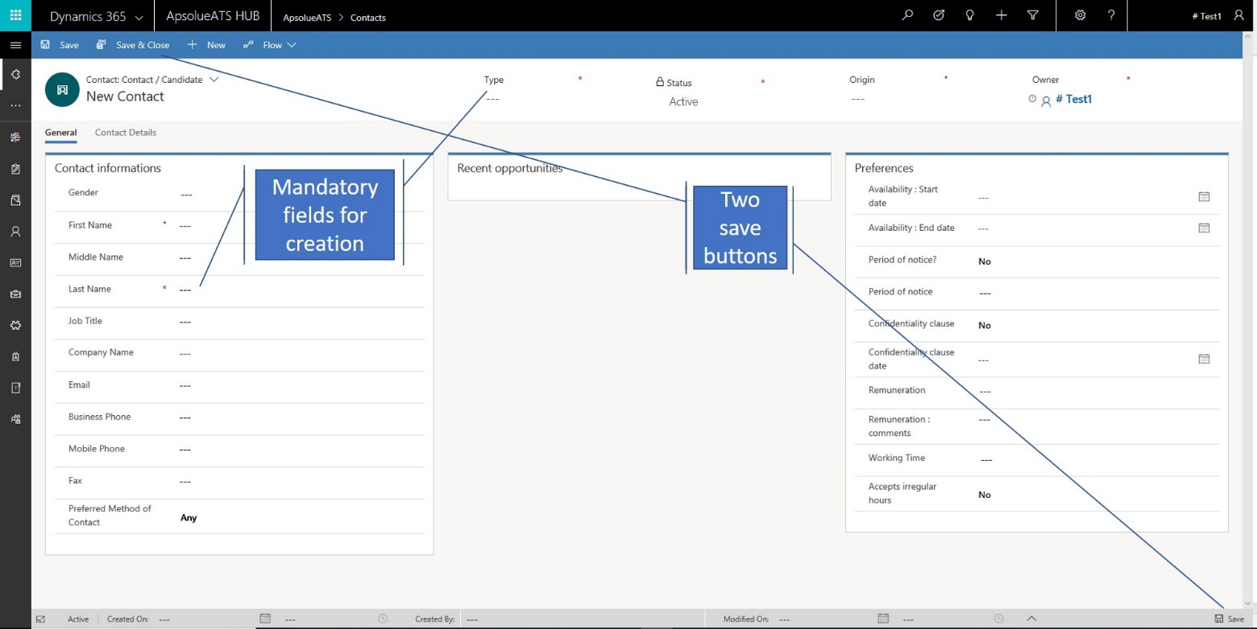
You could also use ctrl + S to save the record.

Needs expression creation

For the creation of the needs expression, there is the same principle that as for the candidate (or any other record). However, please note that this entity has the ribbon that helps user proceed with the treatment.

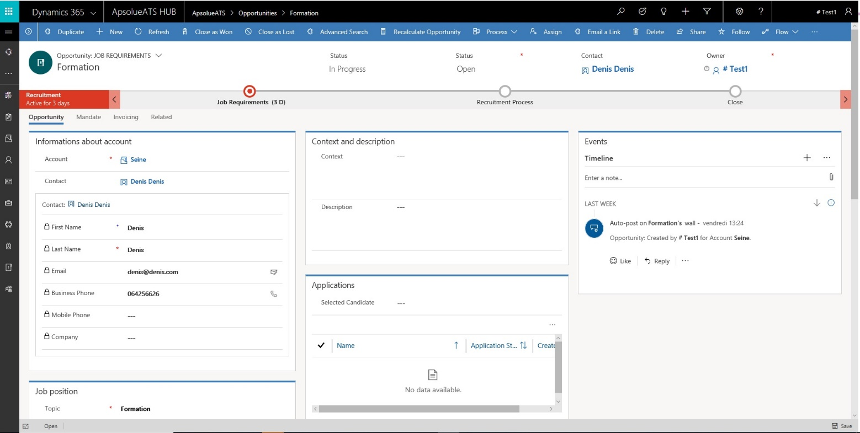

The process of the needs expression

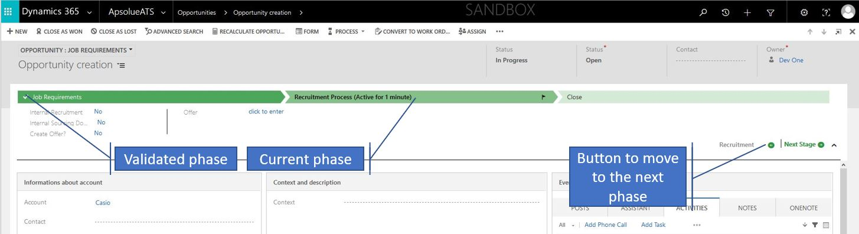

Step Needs Expression

The first step allows you to qualify the client's request and to prepare the mandate in the section of the same name.
When the information is completed you could edit the mandate by click on
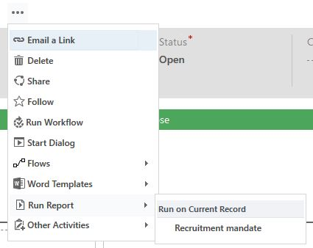

This operation opens the mandate preview, then you save it locally and finally communicate it to the client to be signed:
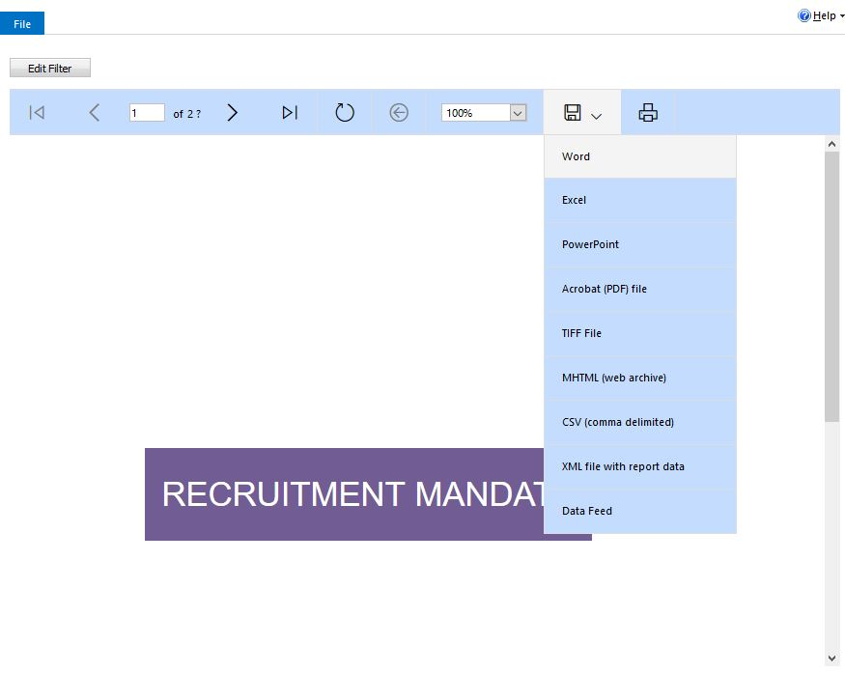

When this operation is completed, you could pass to the next step.

Step Mandate

This step allows to confirm the reception of the signed mandate and to affect this request to one of your colleagues. Think to add the signed mandate to the needs expression via Documents attachment.

Step Recruitment Process

When the mandate is signed (if mandatory), the person in charge of needs expression can start the search of the candidates that correspond to the client's request.
This search is realized into two levels:
- Internal sourcing via the advanced search,
- External sourcing via the publication of the offer (job vacancy) (in this case think to indicate that you have already perform the internal sourcing).

Step Finalization of the order

This step allows to rate the need expression either because you have found a candidate (close as won) or because the client has found by himself (close as lost).

Creating an application

From the expression of needs, you can create the candidates, offers and billing requests.
To create a candidate
For the creation of an application on the expression of needs you can go through the advanced search button 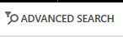 (to search for potential candidates) or directly by the "+" of the application grid in the requirements expression sheet (to add a candidate you already know).

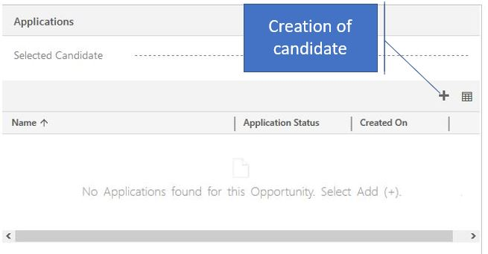

Advanced search screen

On click on the button Advanced Search there is a window of the search displayed:
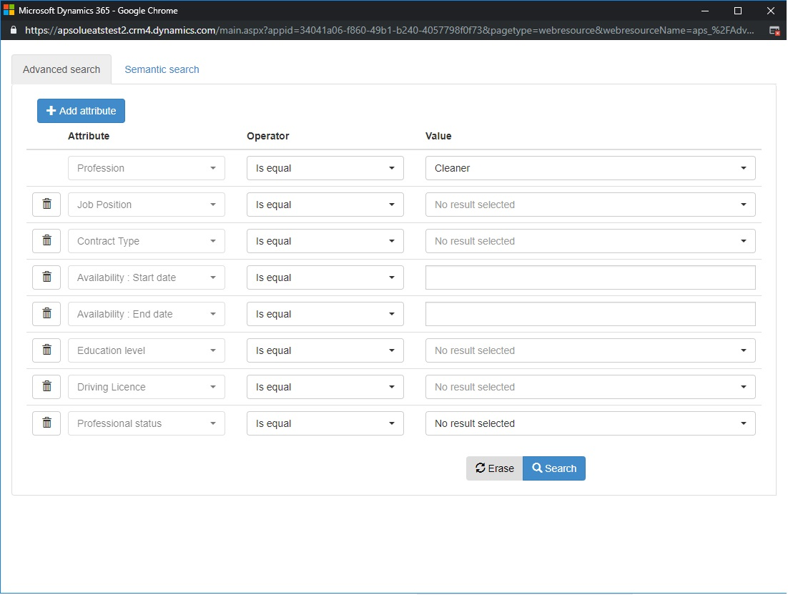
The search screen is initialized with the information of the needs expression (Job description and Vacancy searched).

Add Attributes
All the attributes are the fields associated to the candidate record. By default, some fields are already displayed in the advanced search:
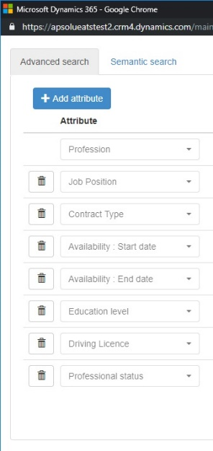

But it's possible to add other attributes with the button 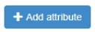

Search parameters

To set the parameters of the search you should chose the attribute and chose the operator from the list. The list of operators is different depending on the type of the attribute: attribute of the date type, lookup on another table (contract, driving license, job position…) or simple text field.
For the performance reasons the operator « Is equal » should be preferred.

Date type field
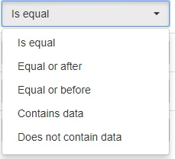
Operator:
- Is equal - matches exactly
- Equal or after - matches to the chosen date or next dates
- Equal or before - takes into account all the dates before the chosen date
- Contains data - it means that there is some data filled (not null)
- Does not contain data - if there is no data (null)

Search type field

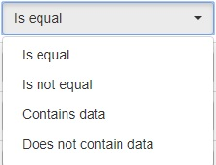
Operator:
- Is equal - corresponds exactly to the selected referential
- Is not equal - different from the referential
- Contains data - the field is filled for the candidate
- Does not contain data - the field is not filled

For the operator "contains data / does not contain data” you should not input the value into the field.

Text type field
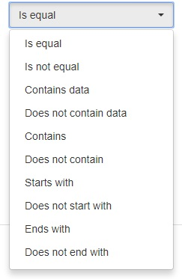
For the operators that have already been listed above, there are no changes, but there are some additional operators:
- Is equal - equals to the entered word,
- Is not equal - is different from the entered word
- Contains data - contains the entered word
- Does not contain data – does not contain the entered word
- Contains –
- Does not contain –
- Starts with – the attribute begins with the word that you have entered
- Does not start with – opposite to the word that you have entered
- Ends with - the attribute ends with
- Does not end with - the attribute doesn't end with.

Delete the search
You can delete the search if it doesn't correspond you with the button

Semantic search

This window allows you to search in the content of the cv.
The operators are AND and OR (always in UPPERCASE): Example (Director OR Manager) AND (Paris OR Marseille)

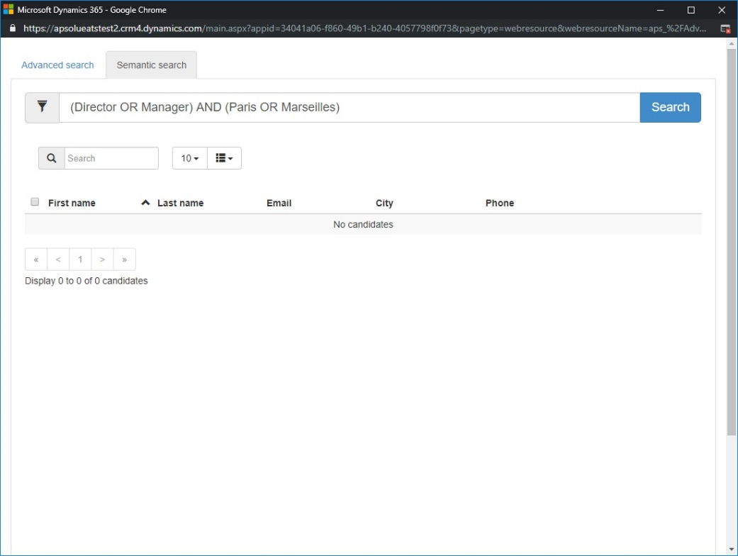
When the search is finished, at the moment of the validation, for all the selected candidates an application (candidature) is created.

Application management

When the applications are created (either manually or from the window of the search or from the web site) you could manage them via the dedicated band.
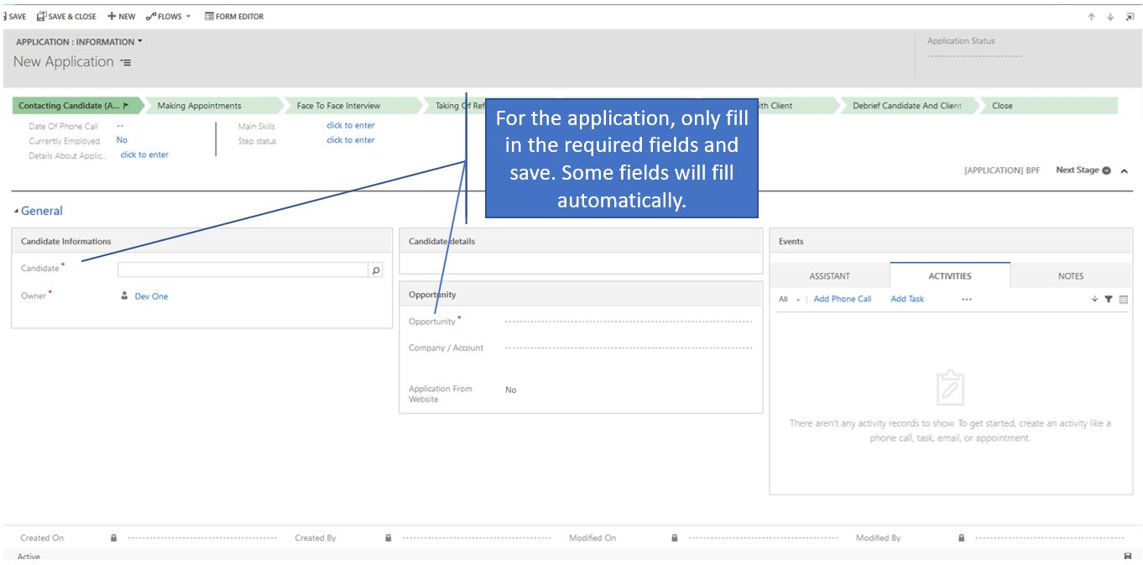

Note, please, that after saving the application, the fields associated to the candidate or to the needs expression will be automatically filled with the data from the candidate and needs expression.

All the modifications of the data of the candidate on the application form will modify the data on the form of Candidate.

The band of the application contains all the possible steps for the application but depending on the pack sold some steps should be ignored. For each step think to set the associated state status (to do, done, not required), this will lead to the automatic modification of the candidate and application status.

We present below different steps:
- First contact: this step allows you to make the first qualification of the candidate and to see quickly if this candidate response to your expectation.
- Making appointment: this step allows you to fill in the appointment between you and candidate.
  - At this step you should fill in the information related to the appointment and especially indicate if the candidate should pass the tests E-testing or PerformanSe. Once the information is filled and saved, you can create a confirmation email from the Events rubric:
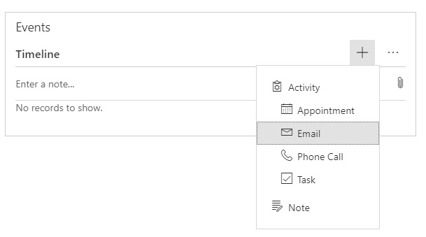
  - This action will allow you to open an email for creation where you will be able to choose a preferable email model (use the icon ). This icon allows you to fill an email based on the model. Here you should use “ATS [Candidate] Interview confirmation (by Skype)”:

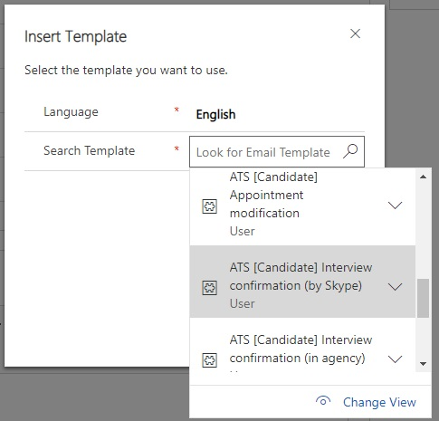

  - When the model is selected, you should save and the modify the email (add the attachment through the rubric of the same name). Then you could send the email via the button of the same name.

- One to one interview: this step corresponds to the interview between you and candidate. This interview is based on the Interview guide.
  - As a reminder, SO INTERIM manages an interview guide by job description. The interview guide is accessible by clicking on the field of the same name and opens the associated form.
  - This form is automatically filled by the candidate information (last name, first name, gender, email …) and information independent of the job description (for example, language skills). Be sure to fill in all the sections in order to have a quality base, this will allow you to easily find the candidates adapted to this or that mission:
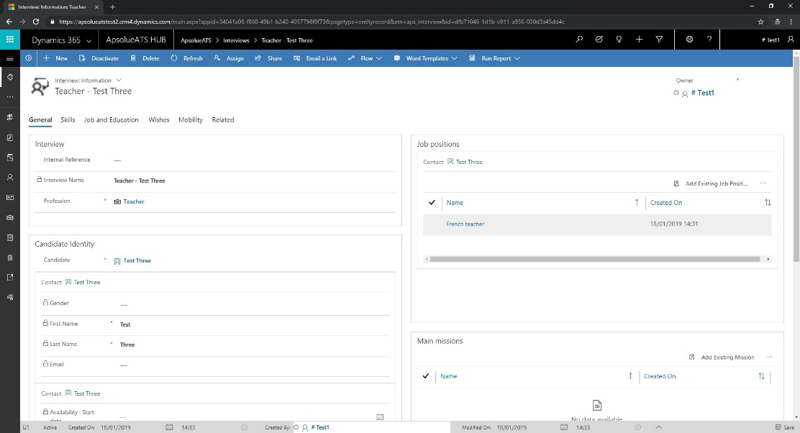

- References input: this step indicates whether you have checked the references provided by the candidate.
  - The candidate's references are managed from his form. You can add these via the icon +
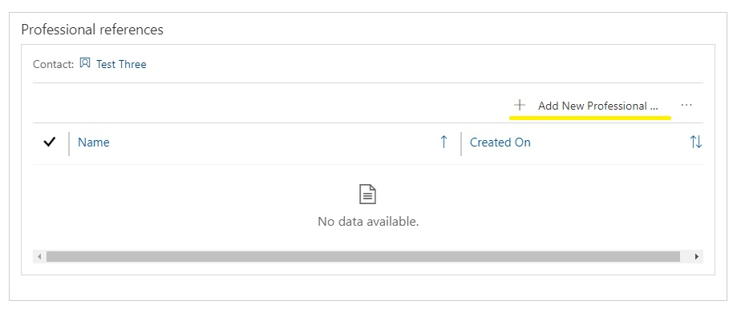

  - To enter a reference, you must fill in the associated form including the company and the contact concerned (this is an opportunity to fill in contacts that will not already be in the SO INTERIM and thus enrich the application):

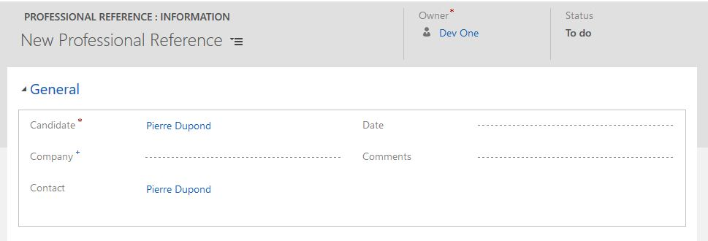

  - Referencing manages a status. This allows you to fill the references of your candidate for later processing (Status=To do).
- Presentation Application: this step allows to prepare and manage the presentation of the application to your client. Depending on the pack sold, the customer expects to receive more or less information (summary evaluation, recruitment summary, CVs, ...). It's up to you to inform and generate the expected documents:
  - Throughout the assessment process of your candidate, the SO INTERIM allows you to collect and prepare the information necessary for the synthesis establishment. Depending on the services offered, you must select the appropriate form among the three available to you.

  - Depending on the form selected, the lower part of the application will be modified to allow you to fill in the associated information (below example with Contacting candidate).

  - Once all the information has been entered, you can then prepare the sending of the email using the associated template and by downloading beforehand the desired documents (to add them as an attachment to the email) via the entry.

- Interview with a client: this step allows you to prepare and manage appointments between the candidate and your client. This step is designed so that you can create multiple appointments (with different people):

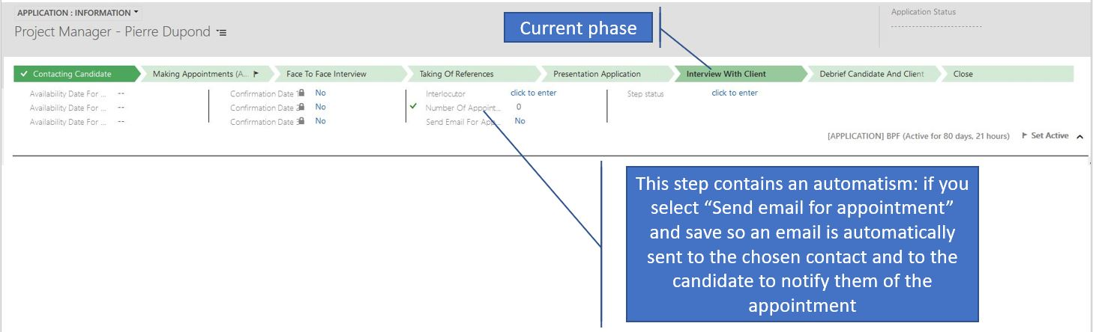
- Debrief Candidate and Client: this step indicates that you have done the debrief with the candidate and the client.
- Finalization Application: this step makes it possible to finalize an application that the outcome is positive or negative. In the case of the acceptance of the candidate, the expression of needs is automatically updated.

Creation of an offer.

To create an offer, you must start from the job requirements. The creation of the offer is possible at the "Recruitment Process" phase of the banner:

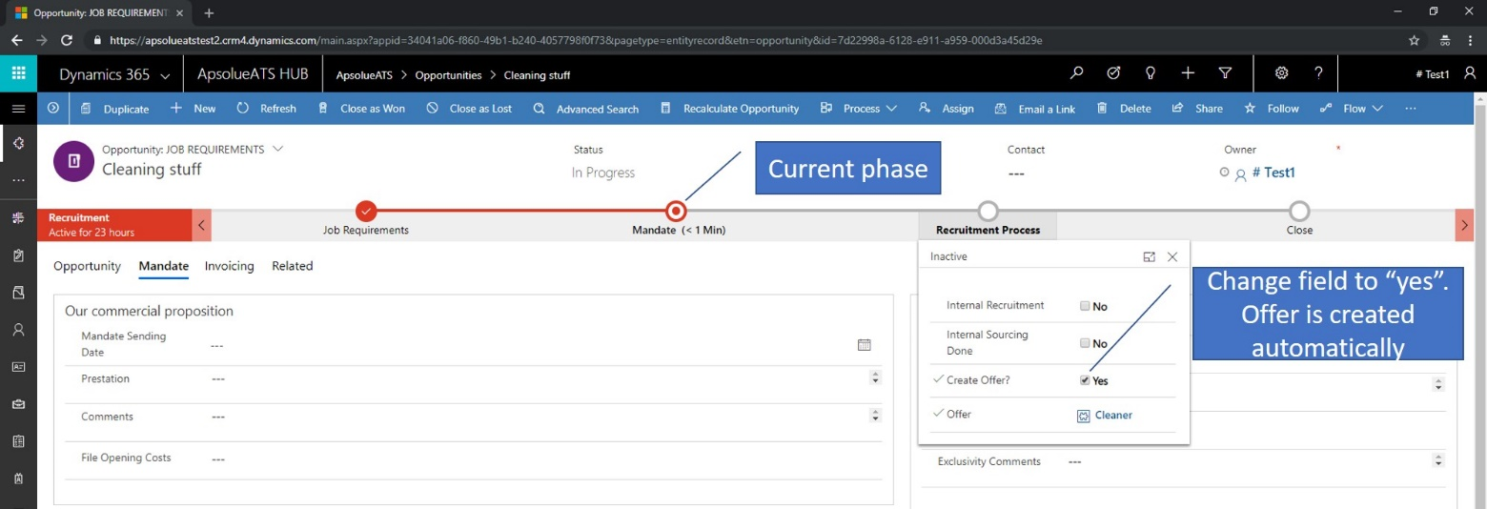
As for the application, the fields of the offer are filled automatically from the expression of needs:

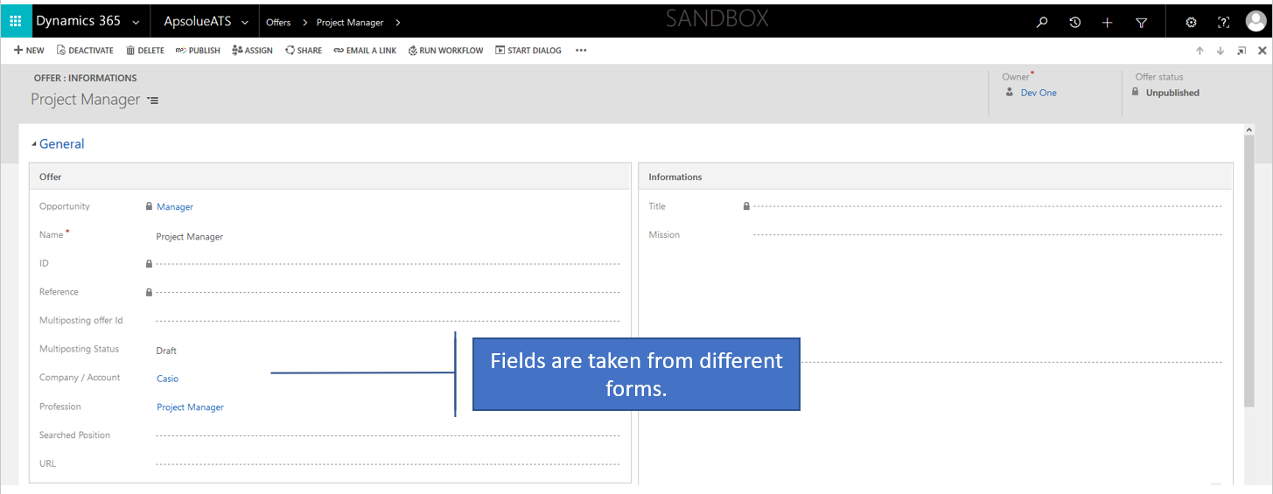

Once the offer has been completed / verified, you can distribute it via Multiposting, a third-party solution interfaced with the SO INTERIM.

Create a Billing Request.

As with the application and the offer, the billing request is based on the expression of needs (Invoices section).
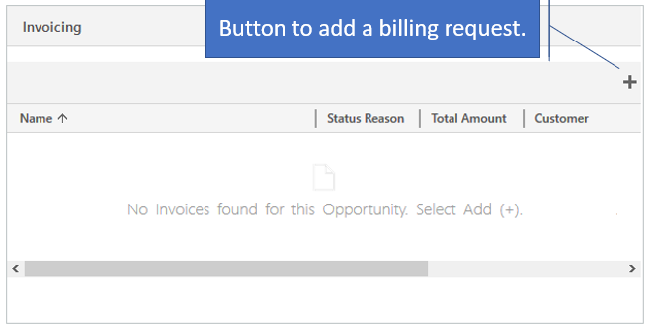
As for the application many fields will fill automatically after creation.

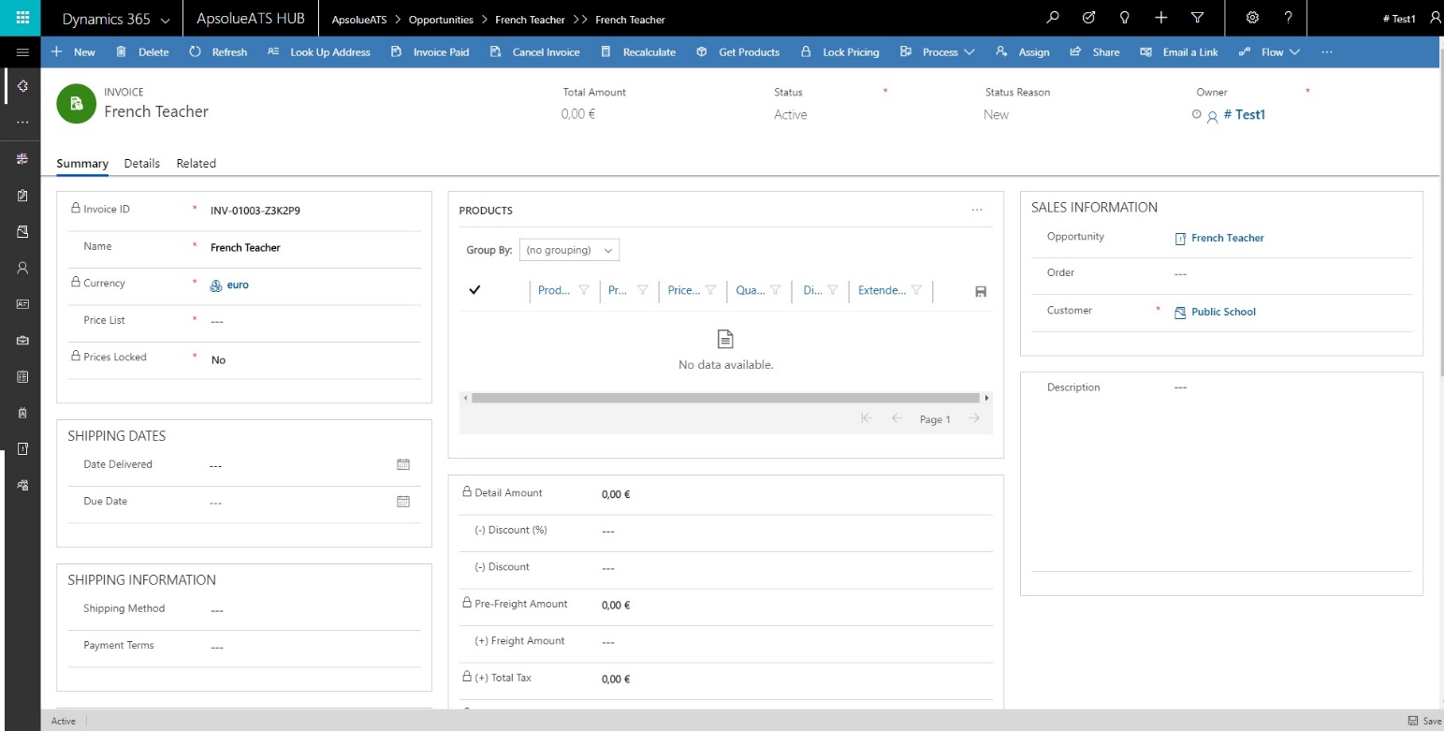

Closing an expression of needs

When an expression of needs comes to an end you must close it. To do this you have two buttons:
-When an expression of needs is lost 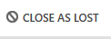
-When an expression of needs is won
Once you have selected the button you can enter different information.

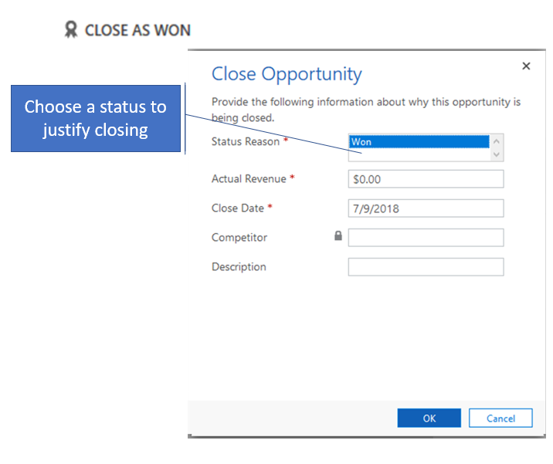
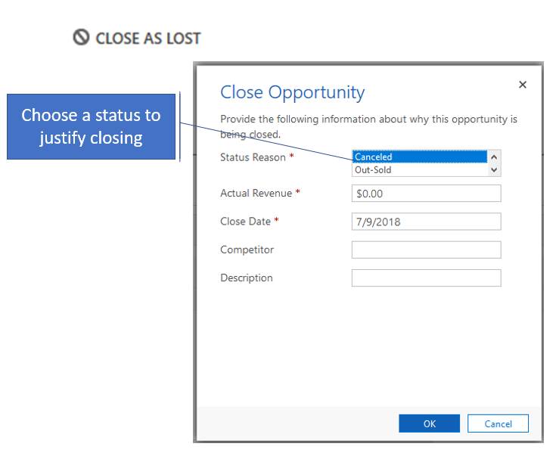

After this step the form is closed and the different information is displayed on the form.
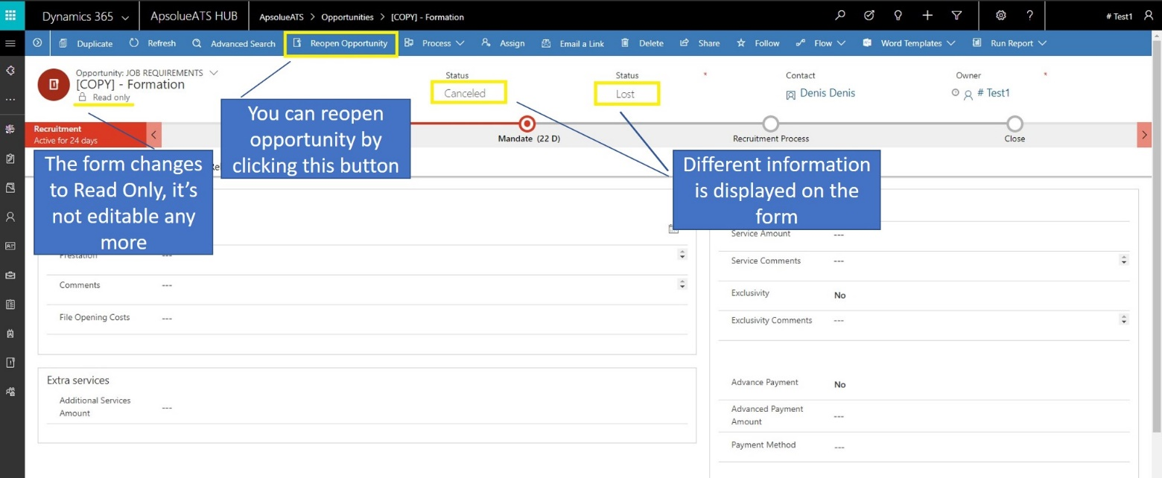

Manage your activity

In order to control your activity easily, the SO INTERIM puts at your disposal a set of dashboards accessible from the connection to the application or via a click on the menu:

By default, a General dashboard is displayed:

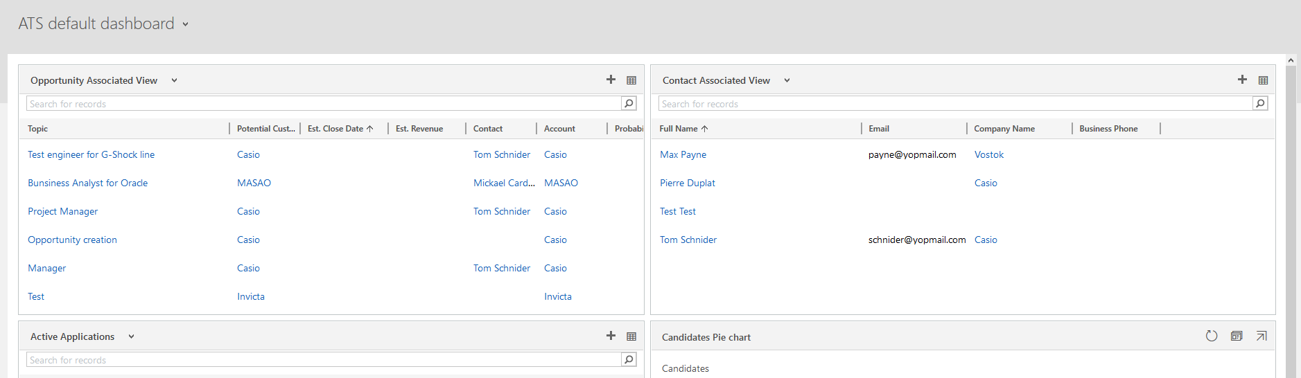

From this dashboard, you can access the relevant records via a click on the associated hyperlink.

Creating dashboards and custom views

In order to be able to find your data and manage your activity even more easily, the SO INTERIM offers you the possibility to create personalized views and dashboards. These customizations are shareable with other users.

Creation of a personal view.

Button to create a custom view:
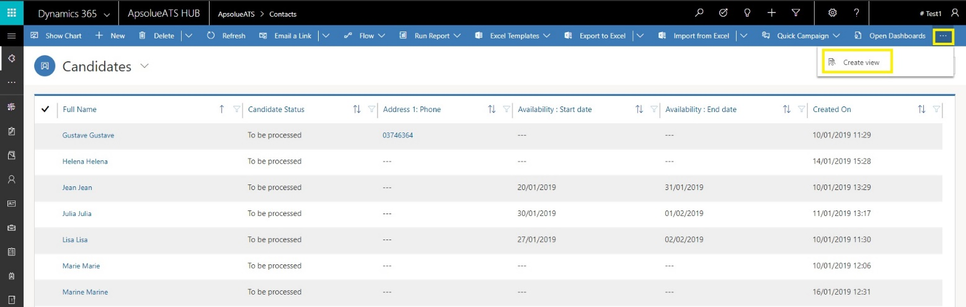

Window to create a custom view:
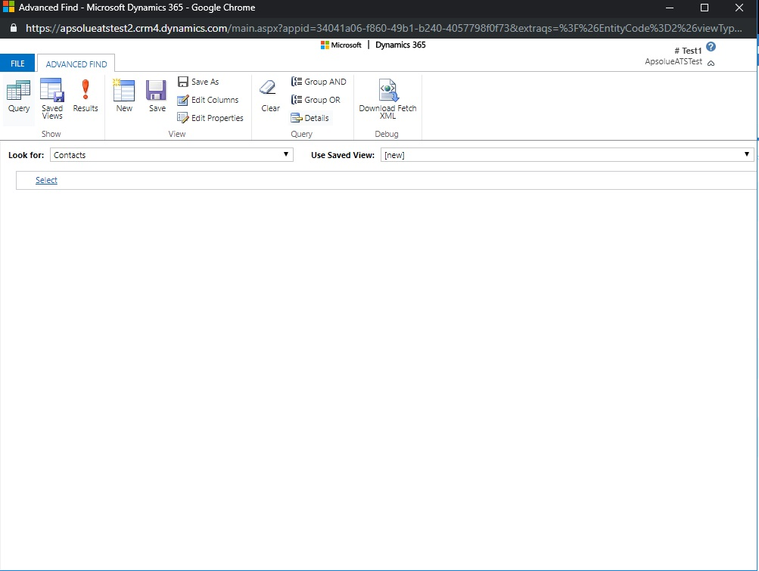
From the creation window, you can create your own query to have the information you want. Here is an overview of the view creation tool:

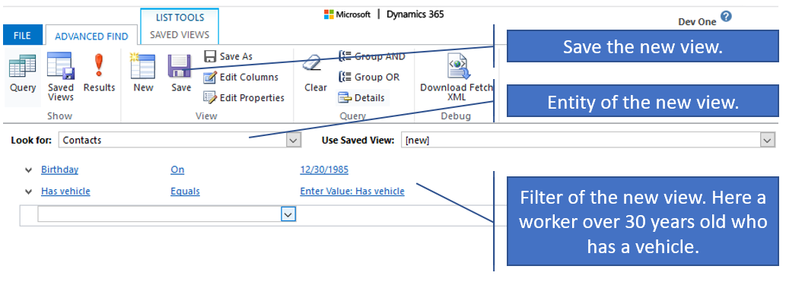

During the construction of the filter you can use the operators available to you.These are different depending on the type of field chosen for the filter. The list of operators is available in the advanced search section of the user manual.
You can choose to make the filter: a form field, a grid or an associated grid field.

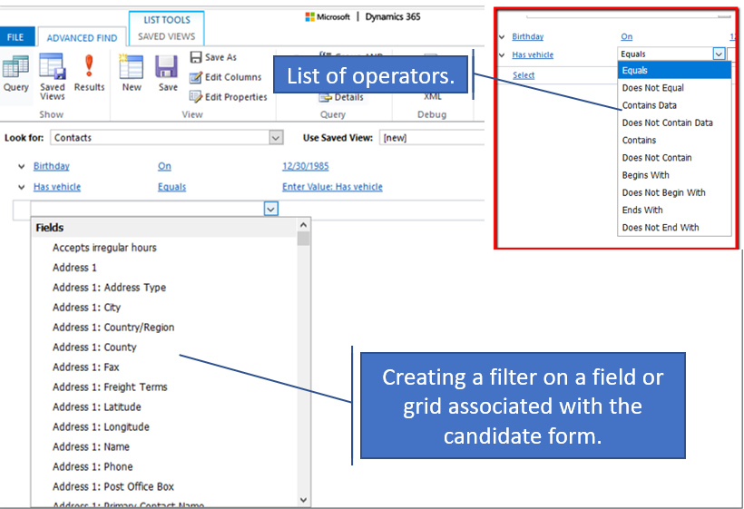

You can find your created view in the view selector.

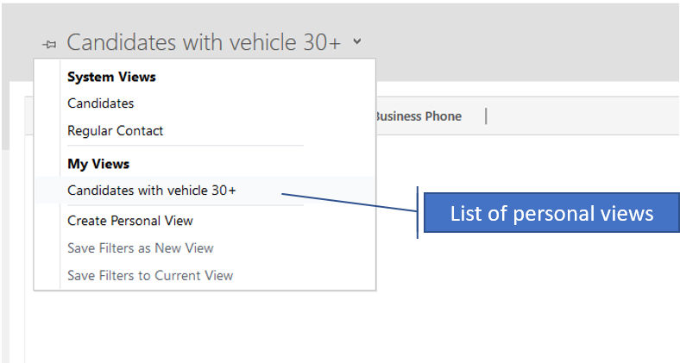

Share a personal view

Dynamics allows each user to create their own personal views. Creating a view extends search capabilities and personalizes your own user experience.
Personal views are editable, sharable, and deletable as many times as users want.
By default, created views only belong to the user who creates them. From the list of saved views in the advanced search, it is possible to grant more privileges to other CRM users:
- Assign: Just like a CRM record, a view can change owner.
- Modification : Gives the right to modify a view (Columns, Filters, etc ...)
- Deleting : Gives the right to delete the personal view
- Sharing : Gives the right to extend sharing to other users. The goal is to benefit all stakeholders who could use this view effectively
- Reading : Gives access to the view to this user

Note : From experience, it is inadvisable to give the right of deletion to another user. It would be a shame to lose carefully crafted views ...
To perform the actions listed above, you must go to the advanced search.
In the new window or tab that opens, select the entity in which the view to be shared is located (in the example, Contact):
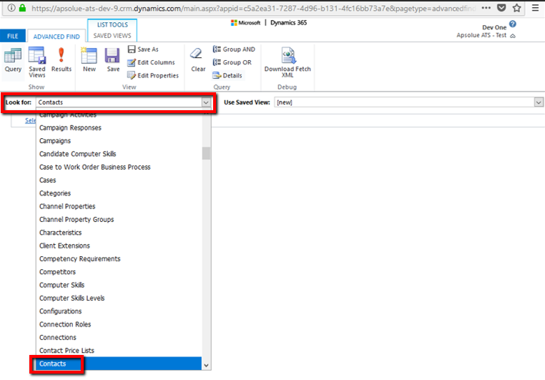
Then, if your view is already existing, click on Saved Views:
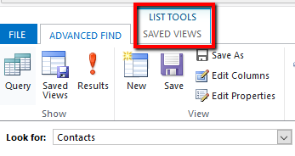
A list of all your personal views appears.
To reassign a view (so change its owner), select the target view and click on the button Assign a Saved Views item:
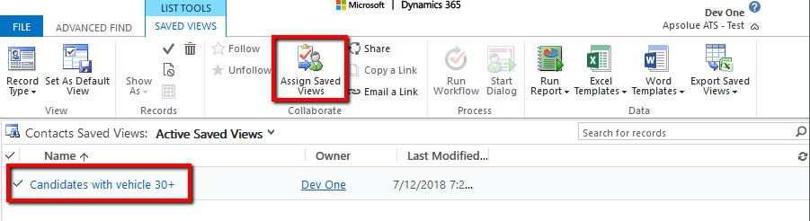
Then choose another CRM user and click on Assign
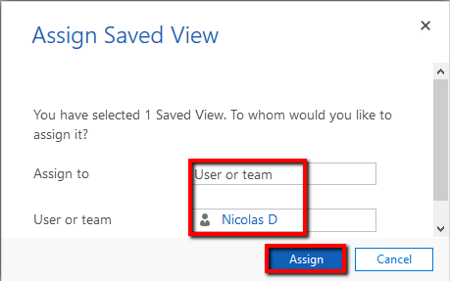
The view will now belong to the targeted user.
To grant more privileges to a view, select the target view and click Share. A new window opens:
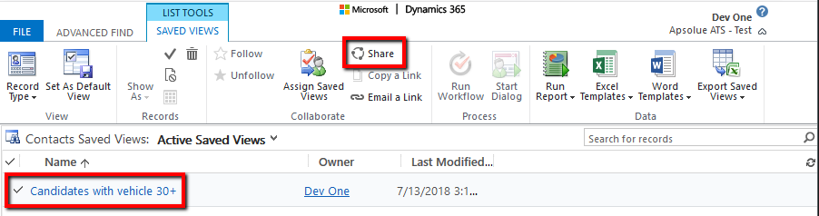
Add a new user to grant privileges to this view:
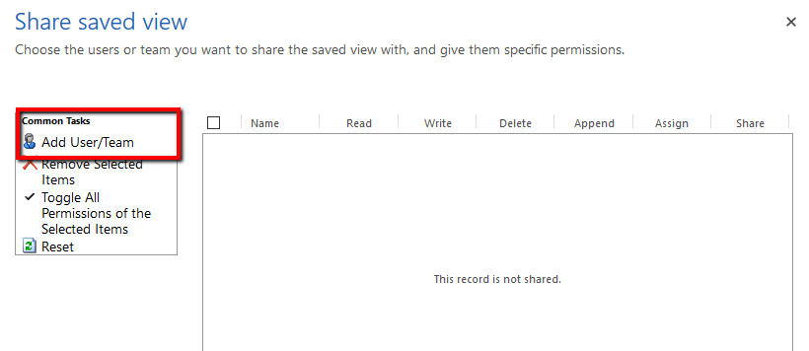
Search one or more users and click Add:
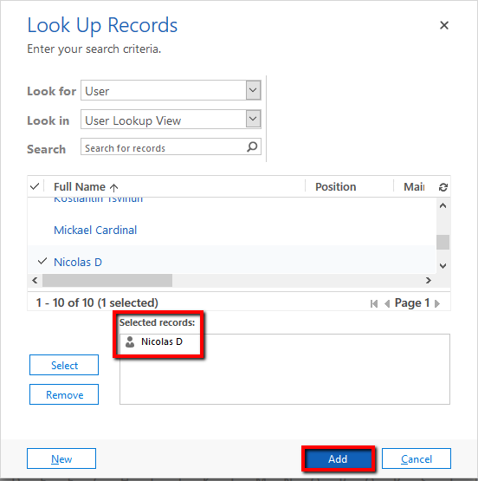

Then, select the privileges to give to this user:

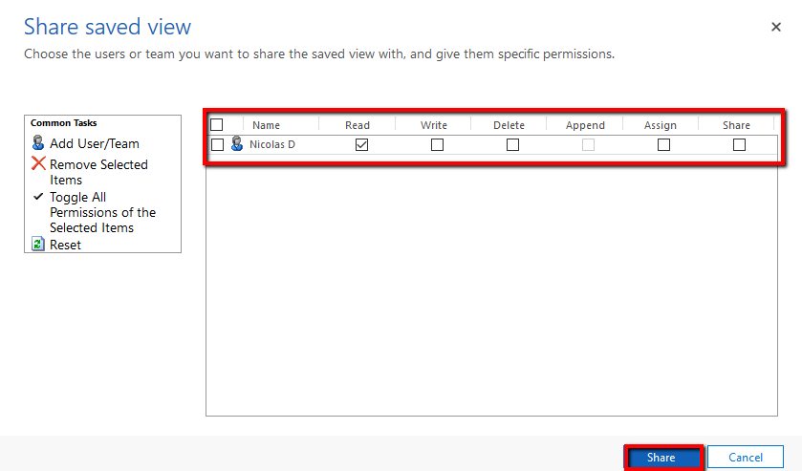
Now the user Nicolas D has access to this view in the list of these personal views. He can see it, modify it, assign it to another user and share it in turn but not delete it.

Creating a personal dashboard

The dashboard is the first thing visible on the SO INTERIM, it allows to see the important information to be done during the day or a summary of your activity.
Basically, you have access to the dashboards defined by your administrator, but you can create your own dashboard simply:

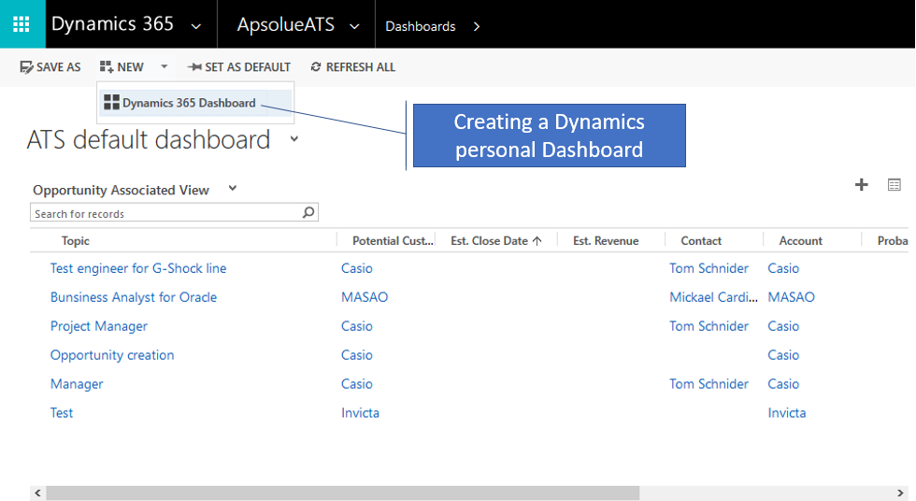
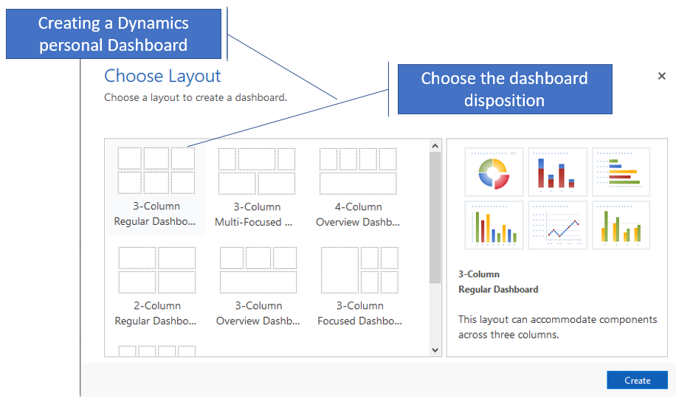

Once the layout of the selected dashboard you have the possibility to create different types of information in the dashboards:
- Graphics
- Lists
- IFRAME
- Webservices

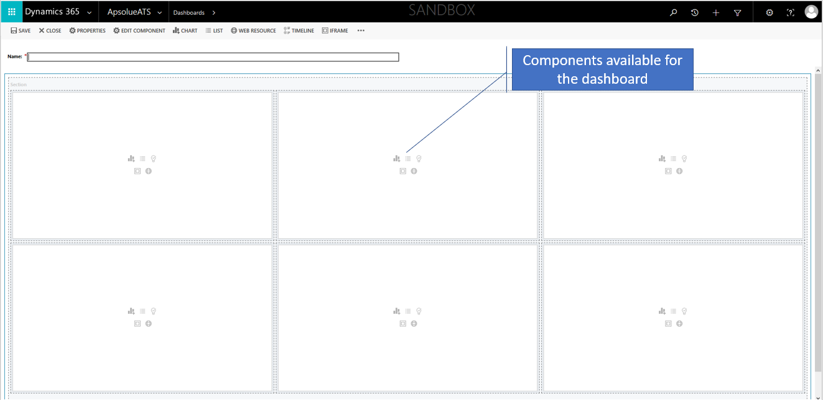

To add a chart. :
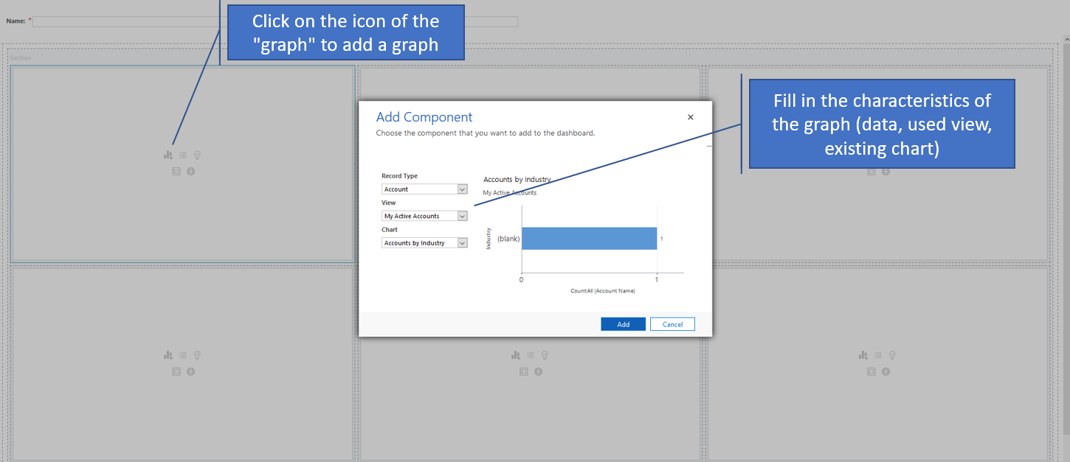
To add a list:

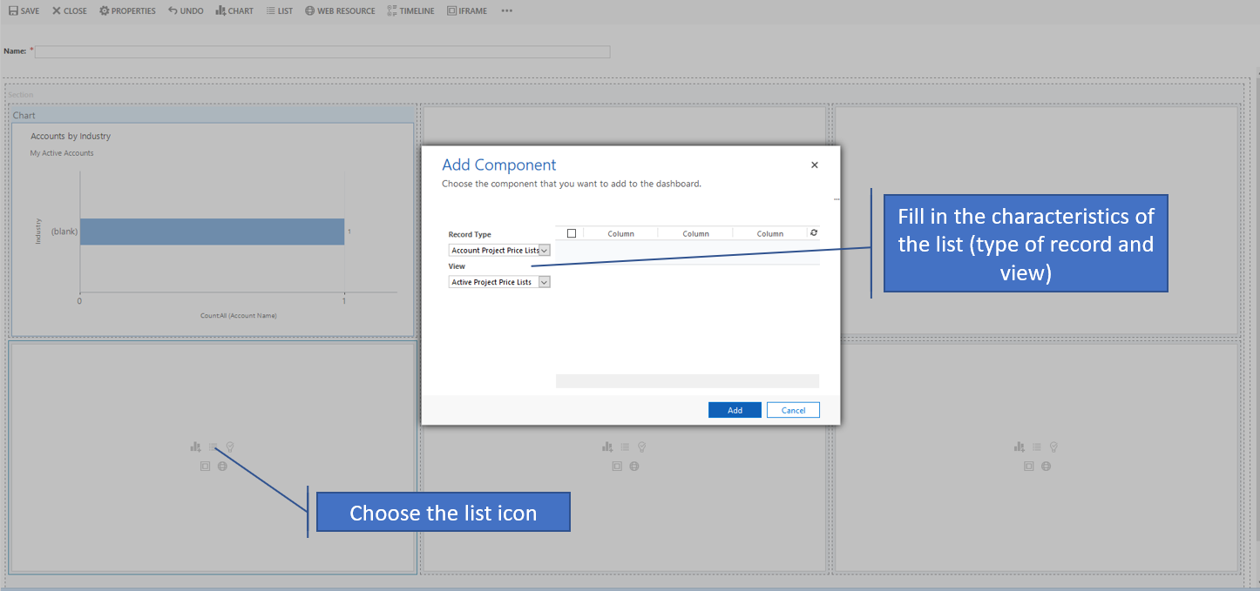

To add an IFRAME:
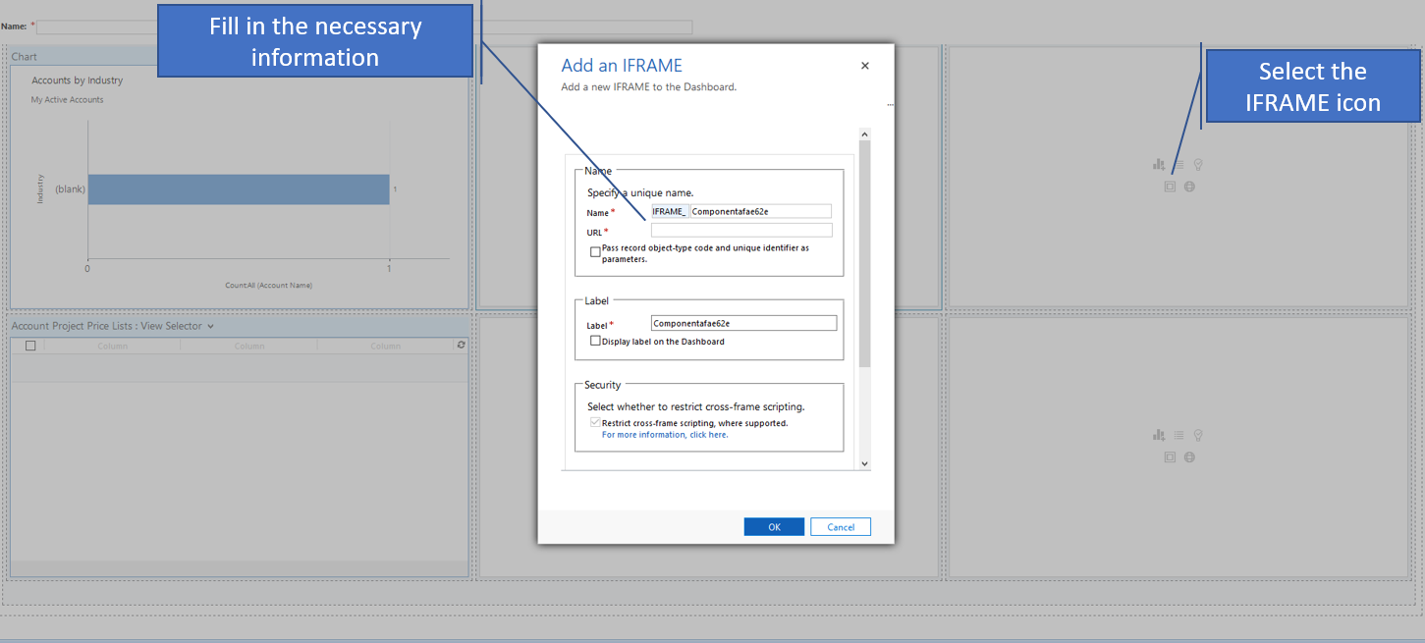

FAQ

To be completed gradually by support.

