The purpose of this Test Case is to provide evidence of the programme ability to match the User Story or Feature requirement.

Test Case ID: | TC002-1
Test Case Name: | Making An Online Application
Created By: | Hlayisani Garrine | Original Test Case ID: | TC002-1
Date Created: | 24/10/2018 | Last Test Date: | 31/10/2018

Description: | The purpose of the test case is to describe the steps of making an application online.
Test Objective: | To create an online application.
Test Steps: | - The user goes to the apply page on the portal.  - The user fills in the application form with the required information.  - The Birthday and Gender fields are autopopulated when the ID Number is filled in.  - The user clicks Next.  - The user clicks the Campus field to select a campus.  - The user selects a campus.  - The user clicks Select.  - The user clicks the Faculty field to select a faculty.  - The user selects a preferred program from the list.  - The user clicks Select.  - The user clicks the Primary Program to select the first choice of the academic program.  - The user selects the program.  - The user clicks Select.  - The user clicks the Study Year to select the intended year of study.  - The user selects the preferred year.  - The user clicks Submit.
Test Outcome: | Pass
Evidence: | 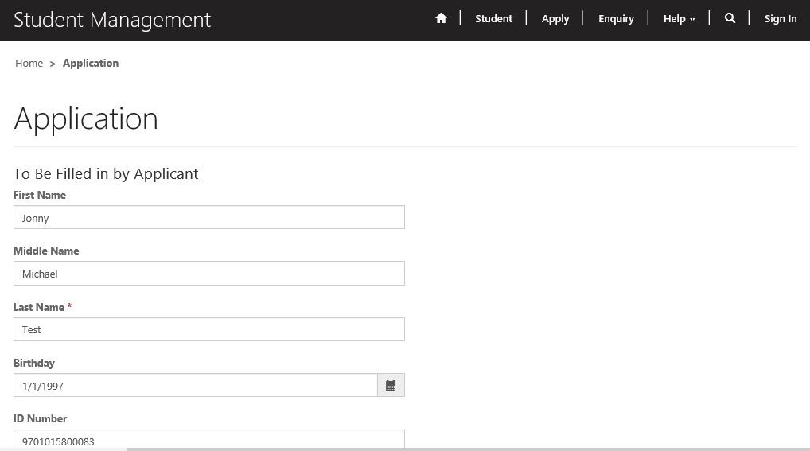  Figure 1.0: Application form on the portal  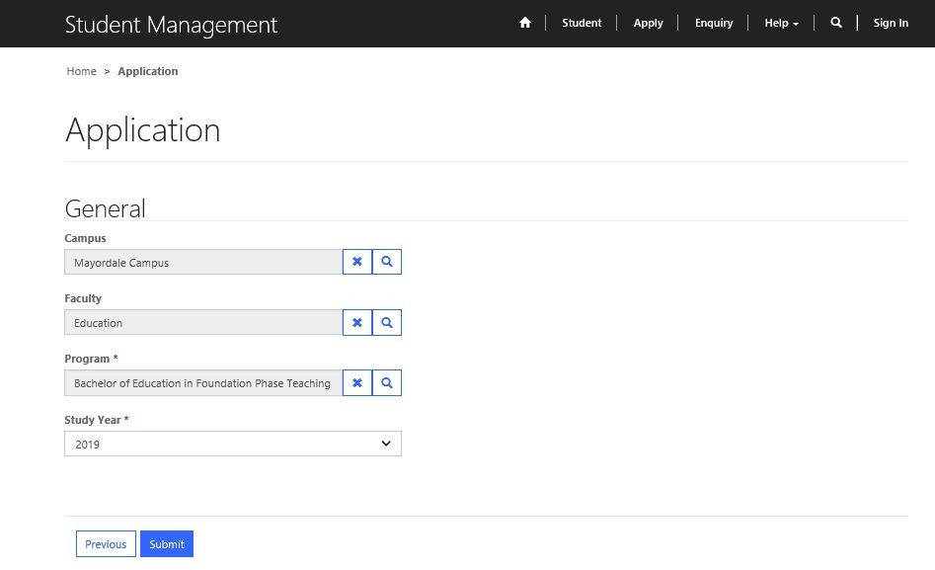  Figure 1.1: Qualification section for selecting academic program, campus, faculty and intended year of study  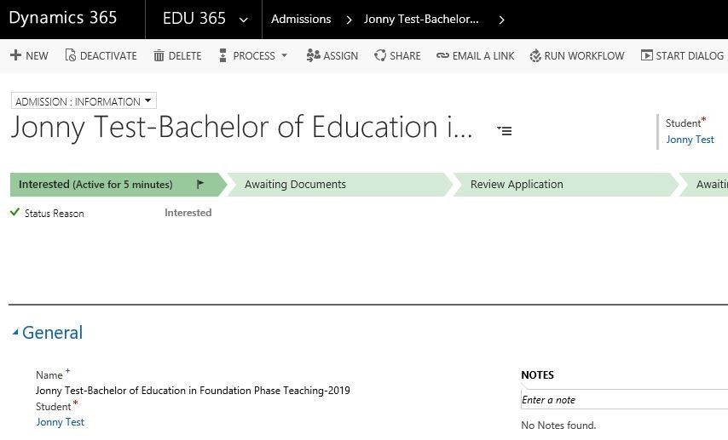  Figure 1.2: New admission with a status of Interested
Developer:
Tester: | Andrea Horsfall
Important Notes: | Suggested mandatory fields:  - First name  - Last Name  - I.D  - Email  - Mobile phone  - Postal Address  - Socio Economic Status

The purpose of this Test Case is to provide evidence of the programme ability to match the User Story or Feature requirement.

Test Case ID: | TC003-1
Test Case Name: | Making An Enquiry Online
Created By: | Hlayisani Garrine | Original Test Case ID: | TC003-1
Date Created: | 24/10/2018 | Last Test Date: | 31/10/2018

Description: | The purpose of the test case is to describe the steps making an enquiry.
Test Objective: | To make an enquiry online.
Test Steps: | - The user goes to the Enquiry page on the portal.  - The user fills in the Enquiry Request form with the recommended.  - The user clicks Submit.
Test Outcome: | Pass
Evidence: | 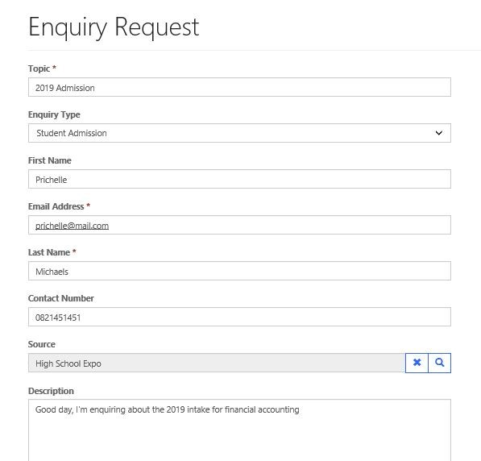  Figure 1.0: Enquiry Request form on the portal  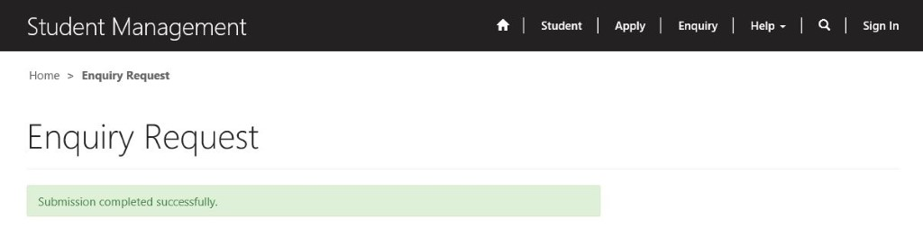  Figure 1.1: Successful submission of the form
Developer: | Nicholas Bradfield
Tester: | Andrea Horsfall
Important Notes:

The purpose of this Test Case is to provide evidence of the programme ability to match the User Story or Feature requirement.

Test Case ID: | TC004-1
Test Case Name: | Converting An Enquiry To An Admission
Created By: | Hlayisani Garrine | Original Test Case ID: | TC004-1
Date Created: | 24/10/2018 | Last Test Date: | 31/10/2018

Description: | The purpose of the test case is to describe the steps of converting an enquiry into an admission.
Test Objective: | To convert an enquiry to an admission.
Test Steps: | - The user navigates Enquiries entity in the system.  - Click on the ‘Carrot’, next to Sales option on Tool Bar.  - Click on the Heading EDU365 on Tool bar.  - Click on Enquiries entity under Processing heading  - Click on the correct enquiry to open.  - The user clicks on the enquiry they want to convert to an admission.  - On the navigation bar, the user clicks Convert to Admission button.  - In the popup message, the user clicks OK.  - In the new Admission record created, the user fills in the Program and Study Year.  - The Name field is auto-populated so there is no need to fill it in.  - Under the Billing section, the user fills in the Billing Period, Billing Period End and Billing Payment Plan.  - The user clicks Save.
Test Outcome: | Conditional Pass
Evidence: | 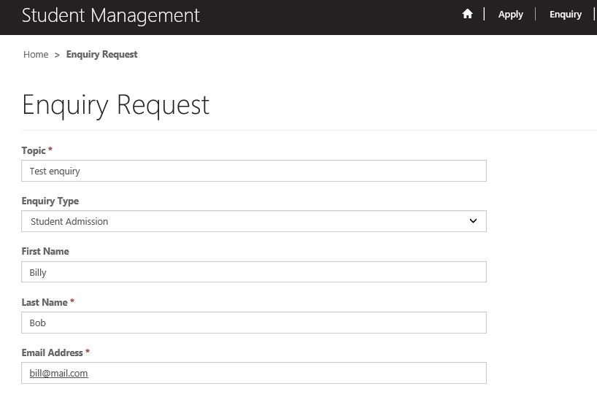  Figure 1.0: Enquiry form on the portal  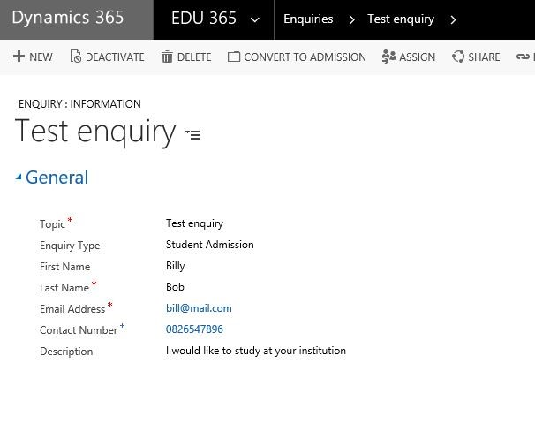  Figure 1.1: Enquiry record created in the system  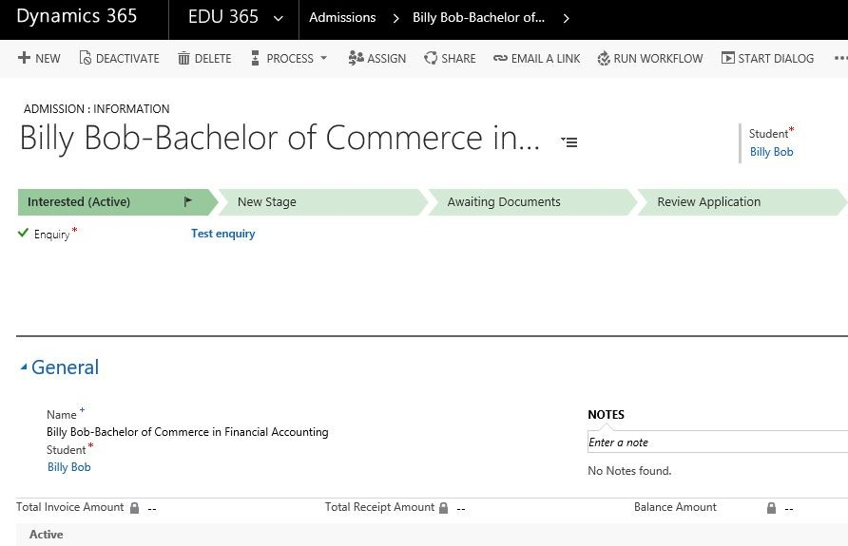  Figure 1.2: Admission created from the enquiry information
Developer: | Nicholas Bradfield
Tester: | Andrea Horsfall
Important Notes: | - When Enquires open, list should automatically default to the newest date first, but still have the option to search.  - Billing Period End – Description box should rather read ‘Date’, instead of ‘Value’.

The purpose of this Test Case is to provide evidence of the programme ability to match the User Story or Feature requirement.

Test Case ID: | TC005-1
Test Case Name: | Adding Document Requirements To An Admission
Created By: | Hlayisani Garrine | Original Test Case ID: | TC005-1
Date Created: | 02/10/2018 | Last Test Date: | 01/11/2018

Description: | The purpose of the test case is to describe the steps of adding document requirements to an admission
Test Objective: | To add document requirements to an admission
Test Steps: | - The user navigates to the EDU365 menu in the system.  - The user clicks on the Admissions entity under the Processing Header in the menu.  - The user selects the admission they want to add requirements for.  - Under the Requirements section, the user clicks the plus sign (+) on the Document Requirements subgrid.  - The user fills in the Name then clicks on Document Requirement Type field, click on magnifying glass and select document type.  - The user clicks Save.
Test Outcome: | Conditional Pass
Evidence: | 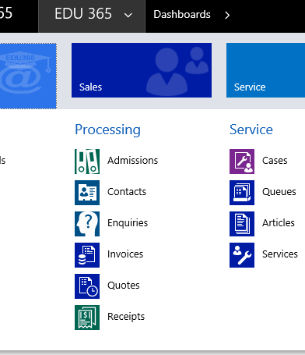  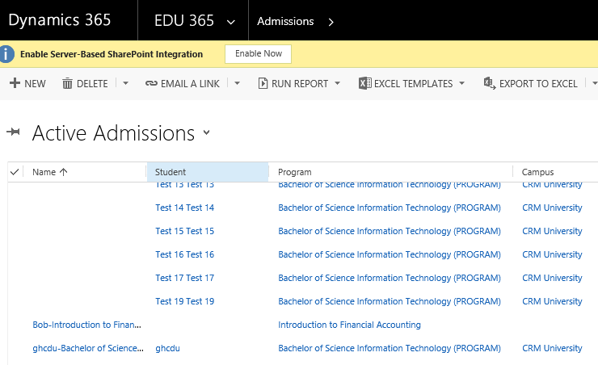  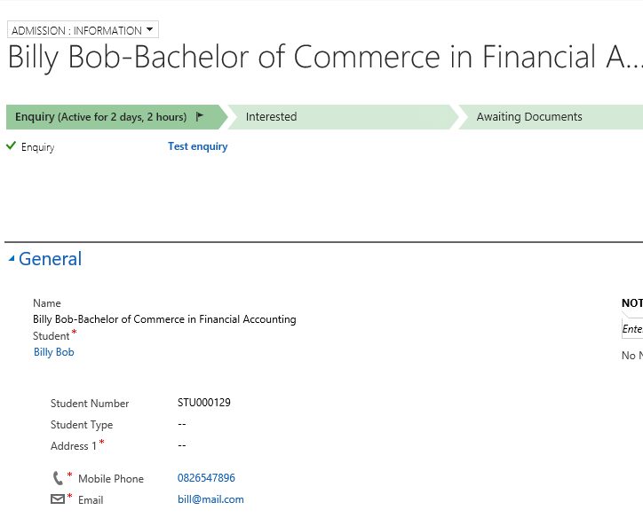  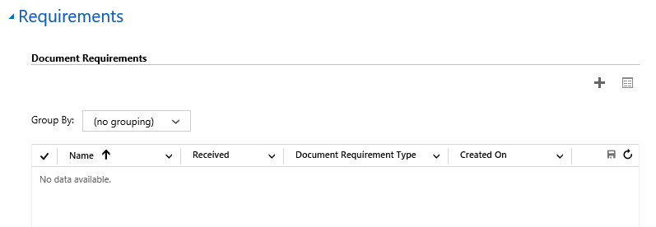  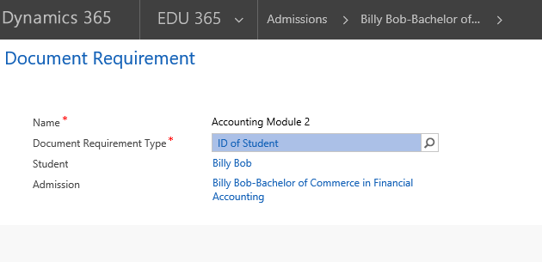
Developer:
Tester: | Hlayisani Garrine
Important Notes:

The purpose of this Test Case is to provide evidence of the programme ability to match the User Story or Feature requirement.

Test Case ID: | TC006-1
Test Case Name: | Adding Program Requirements to An Admission
Created By: | Hlayisani Garrine | Original Test Case ID: | TC006-1
Date Created: | 02/10/2018 | Last Test Date: | 01/11/2018

Description: | The purpose of the test case is to describe the steps of adding program requirements to an admission
Test Objective: | To add program requirements to an admission
Test Steps: | - The user navigates to the EDU365 menu in the system.  - The user clicks on the Admissions entity under the Processing header in the menu.  - The user selects the admission the want to add requirements for.  - Under the Requirements section, the user clicks the plus sign (+) on the Program/Module Requirements sub-grid.  - The user fills in the Name and clicks Module field, then clicks on the magnifier.  - From the list of modules, the user clicks the module of their choice.  - The user clicks on the Met and Approved for Registration fields to Yes.  - The user clicks Save..
Test Outcome: | Conditional Pass
Evidence: | 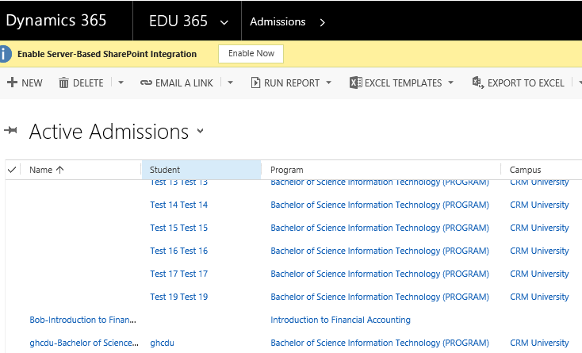  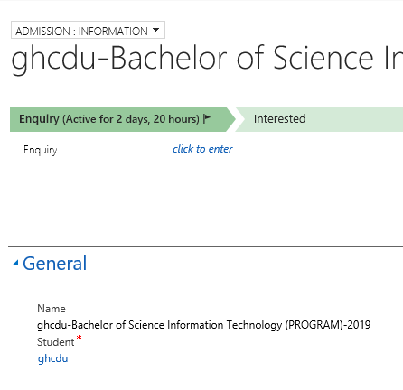  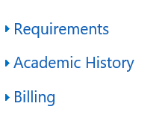  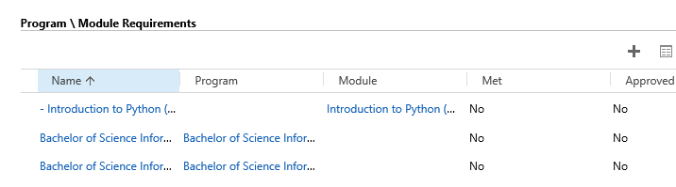
Developer:
Tester: | Hlayisani Garrine
Important Notes: | Tested up until step 6

The purpose of this Test Case is to provide evidence of the programme ability to match the User Story or Feature requirement.

Test Case ID: | TC007-1
Test Case Name: | Granting User Access To The Portal
Created By: | Hlayisani Garrine | Original Test Case ID: | TC007-1
Date Created: | 02/10/2018 | Last Test Date: | 01/11/2018

Description: | The purpose of the test case is to describe the steps of granting access to a user on the portal
Test Objective: | To grant access to a user on the student portal
Test Steps: | - The user clicks on EDU365  - The user clicks on Portal Header on tool bar..  - The user clicks on the Invitations entity under the Security Header.  - The user clicks New to create an invitation.  - The user fills in the Name and selects the Type (Single).  - The user clicks Save.  - In the Invitee section, the user clicks on the + sign then click on the magnifier on the Invited Contact field to lookup a contact  - The user clicks on a contact they want to select.  - In the Assign To Web Roles, the user clicks plus sign (+) to assign user roles on the portal.  - The user clicks the magnifier  - The user clicks on a web role they want to assign to the contact  - Under the Advanced section, the user selects and copies the code on the Invitation Code field.  - The user navigates to the portal (URL: https://crmportal.crmtechnologies.co.za).  - The user clicks on Sign In  - The user clicks the Redeem Invitation tab.  - In the Sign Up with An Invitation Code section, the user pastes the code into the Invitation Code field.  - The user clicks Register.  - In the Registration form, the user fills in the Username, Password and Confirm Password.  - The user clicks Register.
Test Outcome: | Conditional Pass
Evidence: | 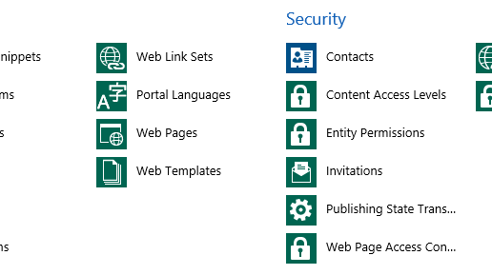  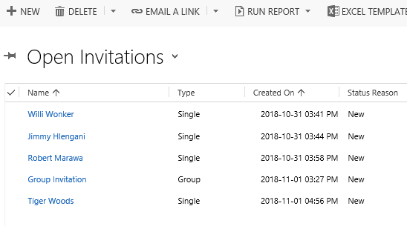  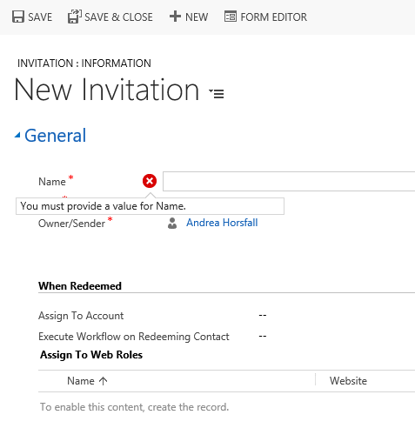  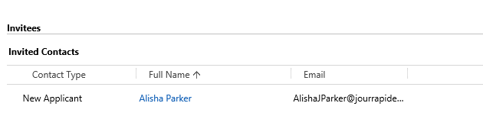  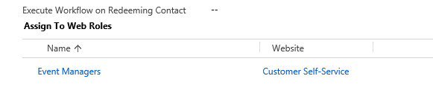  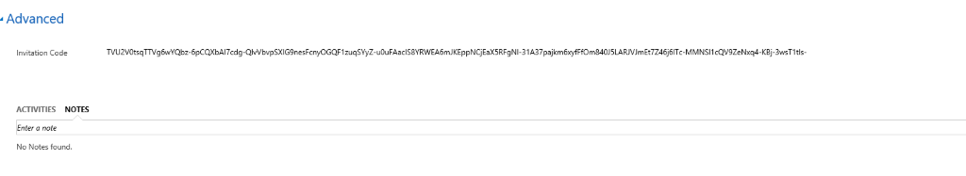  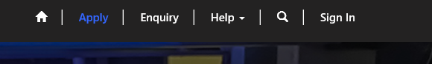  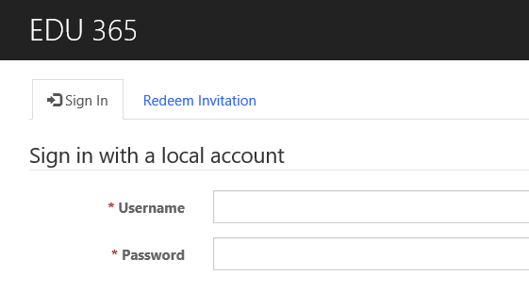  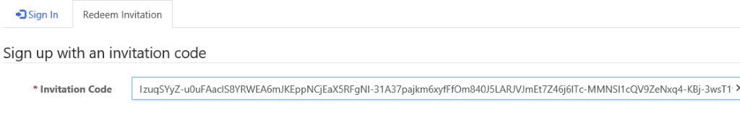  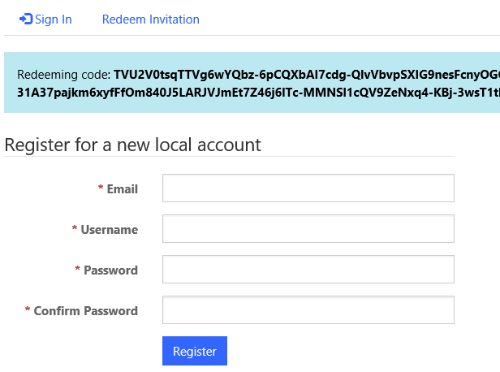  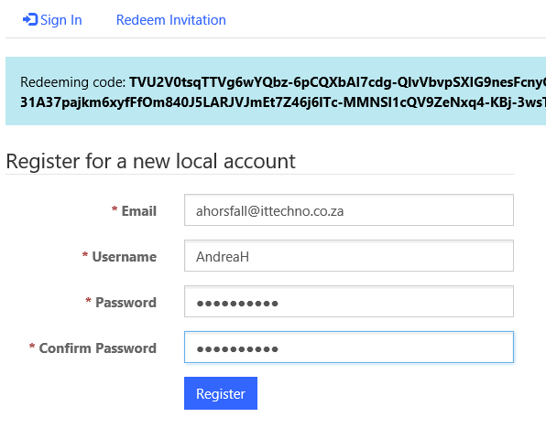  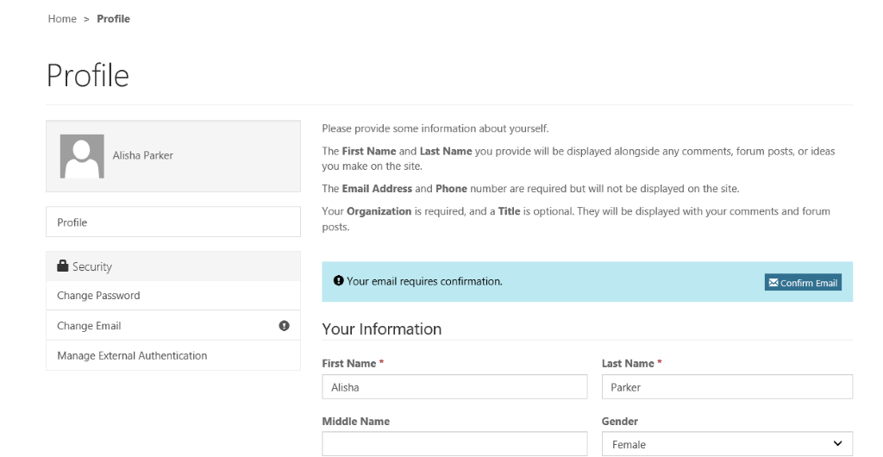
Developer:
Tester: | Andrea Horsfall
Important Notes: | New Invitation, Name should read ‘Heading’.  Hide: Expiry date and Inviter for the time being.  Expiry date should rather be start date and time plus End date and time.

The purpose of this Test Case is to provide evidence of the programme ability to match the User Story or Feature requirement.

Test Case ID: | TC008-1
Test Case Name: | Generating Reports
Created By: | Hlayisani Garrine | Original Test Case ID: | TC008-1
Date Created: | 02/10/2018 | Last Test Date: | 01/11/2018

Description: | The purpose of the test case is to describe how to generate a report.
Test Objective: | To generate a report.
Test Steps: | - The user navigates to the portal (URL: https://crmportal.crmtechnologies.co.za).  - The user clicks on Sign In  - In the Sign In tab, the user fills in the Username and Password.  - On the navigation menu, the user clicks the arrow next to the Help menu and clicks on My Support option  - The user clicks Open A New Case  - The user fills in the case form.  - The user clicks Submit.
Test Outcome: | Pass
Evidence: | 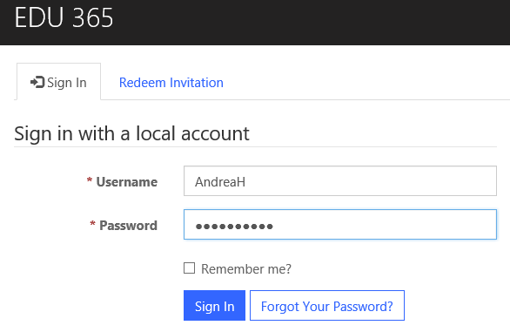  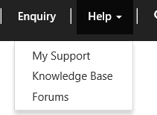  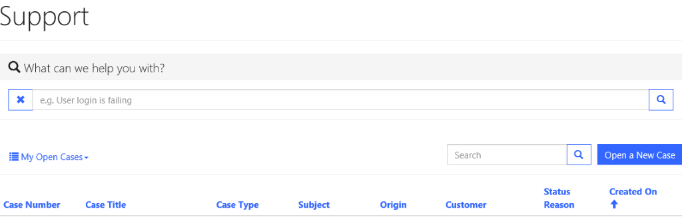  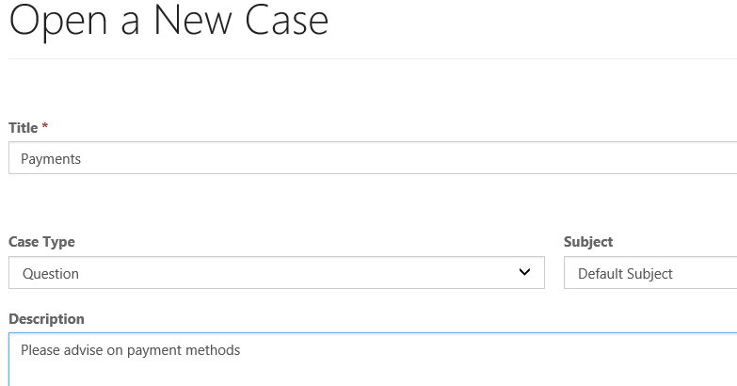  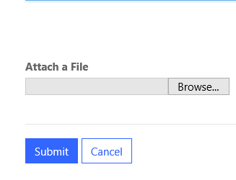  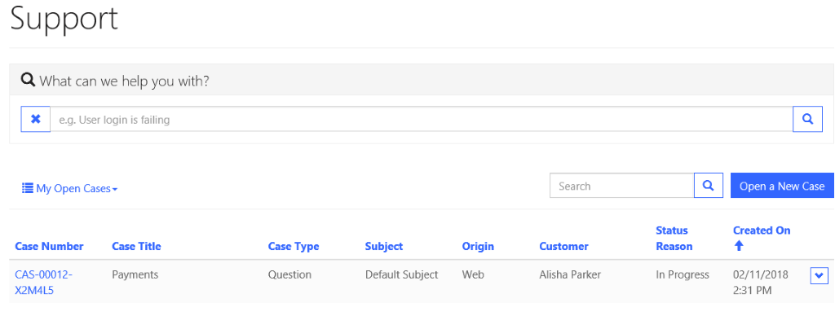
Developer:
Tester: | Andrea Horsfall
Important Notes:

The purpose of this Test Case is to provide evidence of the programme ability to match the User Story or Feature requirement.

Test Case ID: | TC009-1
Test Case Name: | Registering For A Module
Created By: | Hlayisani Garrine | Original Test Case ID: | TC009-1
Date Created: | 02/10/2018 | Last Test Date: | 01/11/2018

Description: | The purpose of the test case is to describe the steps for registering a module for a student.
Test Objective: | To register a module for a student
Test Steps: | - The user clicks on Sales.  - The user navigates to the EDU365 menu in the system.  - The user clicks on the Admissions entity in the menu.  - The user selects the admission  - Under the Requirements section, in Program/Module Requirements the user clicks the module they want to register.  - In the General section, the user clicks to tick Register field  - On the bottom right corner, the user click the Unsaved Changes Save button  - On the navigation bar at the top, the user click Activate.
Test Outcome: | Pass
Evidence: | 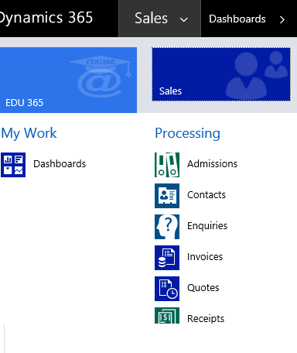  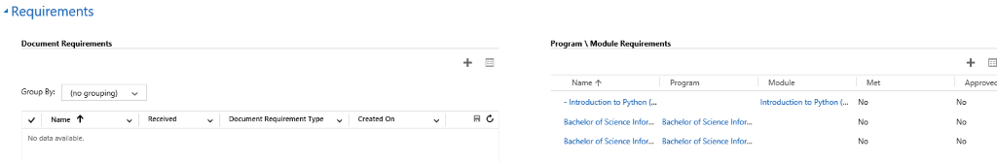  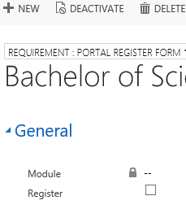  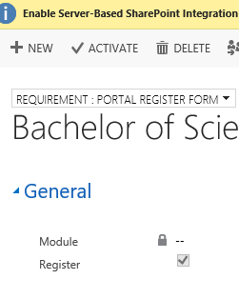
Developer:
Tester: | Andrea Horsfall
Important Notes:

The purpose of this Test Case is to provide evidence of the programme ability to match the User Story or Feature requirement.

Test Case ID: | TC012-1
Test Case Name: | Creating A Qualification
Created By: | Hlayisani Garrine | Original Test Case ID: | TC012-1
Date Created: | 02/10/2018 | Last Test Date: | 01/11/2018

Description: | The purpose of the test case is to describe the steps of creating a qualification
Test Objective: | To create a qualification
Test Steps: | - The user navigates to the EDU365 menu in the system.  - The user clicks on the Programs & Modules entity under the Settings Header in the menu.  - The user clicks Create Qualification  - The user fills in the form  - The user clicks Save.  - On the qualifications list, the user selects the qualification created  - The user fills in additional information on the form.  - On the navigation bar, the user clicks Publish  - In the popup box, the user clicks Publish
Test Outcome: | Conditional Pass.
Evidence: | 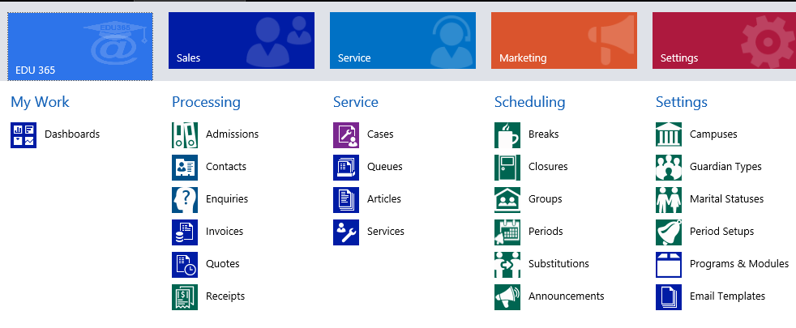  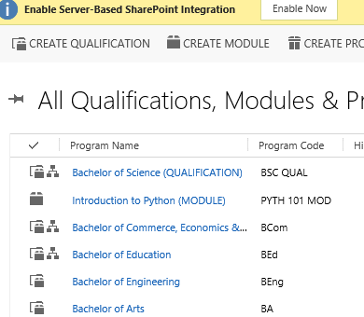  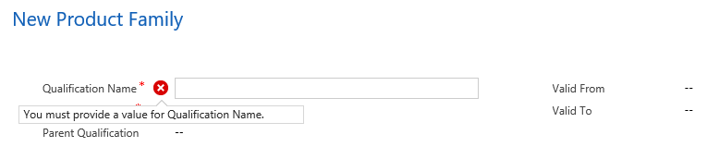  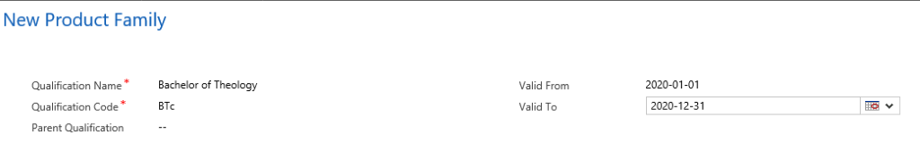  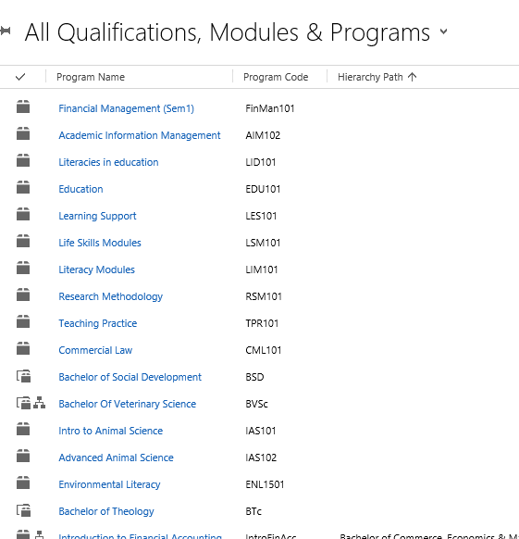  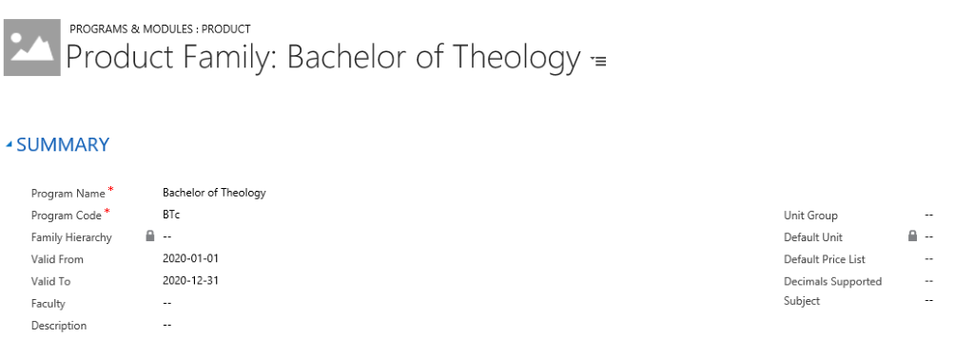  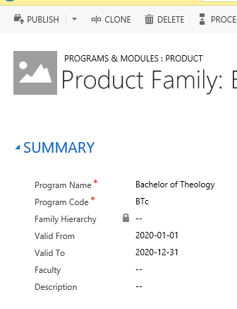  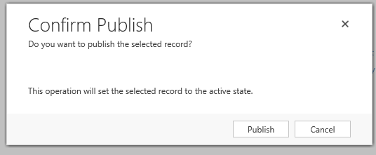
Developer:
Tester: | Andrea Horsfall
Important Notes: | Parent Qualification to be hidden.  Faculty to be hidden.  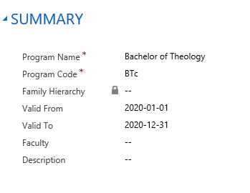  Do these need to be hidden????  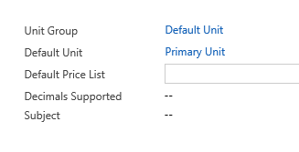

The purpose of this Test Case is to provide evidence of the programme ability to match the User Story or Feature requirement.

Test Case ID: | TC012-1
Test Case Name: | Creating A Qualification
Created By: | Hlayisani Garrine | Original Test Case ID: | TC012-1
Date Created: | 02/10/2018 | Last Test Date: | 01/11/2018

Description: | The purpose of the test case is to describe the steps of creating a qualification
Test Objective: | To create a qualification
Test Steps: | - The user navigates to the EDU365 menu in the system.  - The user clicks on the Programs & Modules entity under the Settings Header in the menu.  - The user clicks Create Qualification  - The user fills in the form  - The user clicks Save.  - On the qualifications list, the user selects the qualification created  - The user fills in additional information on the form.  - On the navigation bar, the user clicks Publish  - In the popup box, the user clicks Publish
Test Outcome: | Conditional Pass.
Evidence:
Developer:
Tester: | Andrea Horsfall
Important Notes: | Parent Qualification to be hidden.  Faculty to be hidden.  Do these need to be hidden????

The purpose of this Test Case is to provide evidence of the programme ability to match the User Story or Feature requirement.

Test Case ID: | TC016-1
Test Case Name: | Creating An Invoice
Created By: | Hlayisani Garrine | Original Test Case ID: | TC016-1
Date Created: | 02/10/2018 | Last Test Date: | 07/11/2018

Description: | The purpose of the test case is to describe the steps of creating an invoice
Test Objective: | To create an invoice
Test Steps: | - The user navigates to the EDU365 menu in the system  - The user clicks on the Admissions entity in the menu.  - The user selects the admission they want to create an invoice for.  - In the Billing section, the user clicks a quote.  - On the navigation bar, the user clicks Create Invoice  - In the popup box, the user clicks OK  - The user clicks the magnifier on the Quote field to lookup a primary quote  - The user selects the Use Payment Plan field to Yes  - The user clicks Save
Test Outcome: | Conditional Pass
Evidence: | Same as TC15.1 up to step4  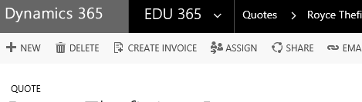  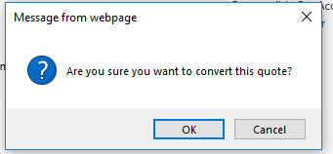
Developer:
Tester: | Andrea Horsfall
Important Notes: | Use Payment Plan – Currently askes Yes or No!  Suggest it defaults to what was selected on payment plan,  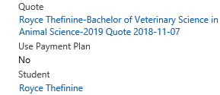

The purpose of this Test Case is to provide evidence of the programme ability to match the User Story or Feature requirement.

Test Case ID: | TC018-1
Test Case Name: | Creating A Lecture Group
Created By: | Hlayisani Garrine | Original Test Case ID: | TC018-1
Date Created: | 02/10/2018 | Last Test Date: | 31/10/2018

Description: | The purpose of the test case is to describe the steps of creating a lecture group for a module
Test Objective: | To create a lecture group
Test Steps: | - The user navigates to the EDU365 menu in the system.  - The user clicks on the Groups entity under scheduling header.  - The user clicks on New to create a group.  - The user fills in the Name, Module, Campus, Lecturer and Room for the group.  - The user clicks Save&Close.
Test Outcome: | Pass
Evidence: | 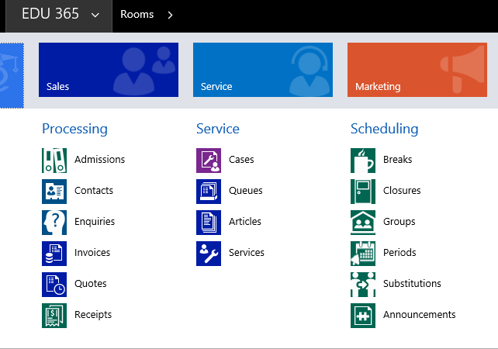  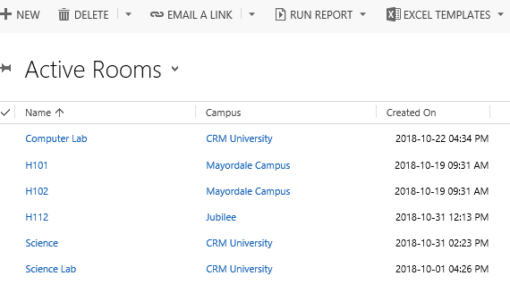  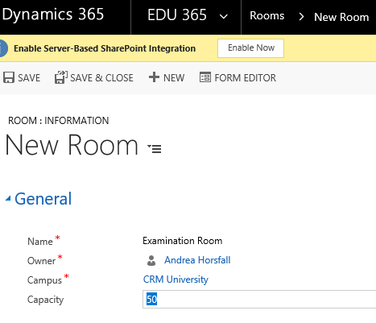
Developer:
Tester: | Andrea Horsfall
Important Notes:

The purpose of this Test Case is to provide evidence of the programme ability to match the User Story or Feature requirement.

Test Case ID: | TC019-1
Test Case Name: | Creating Lecture Rooms
Created By: | Hlayisani Garrine | Original Test Case ID: | TC019-1
Date Created: | 02/10/2018 | Last Test Date: | 31/10/2018

Description: | The purpose of the test case is to describe the steps of creating lecture rooms.
Test Objective: | To create a lecture room
Test Steps: | - The user clicks on EDU365 menu in the system.  - The user clicks on Rooms entity under the settings header  - The user clicks New to create a lecture room.  - The user fills in the Name, Campus and Capacity.  - The user clicks Save&Close.
Test Outcome: | Pass
Evidence: | 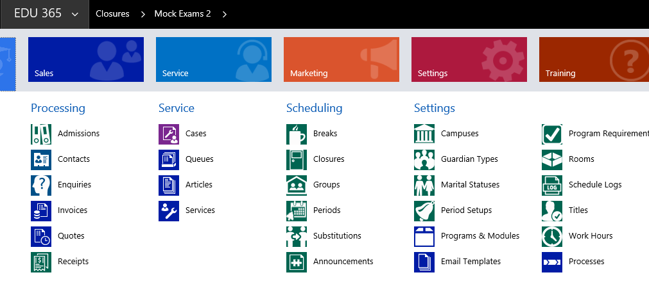  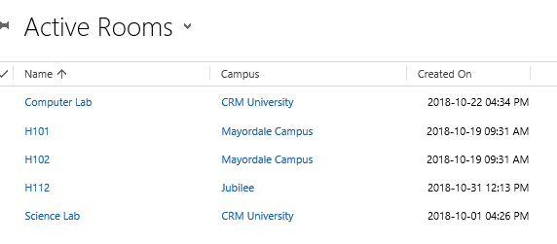  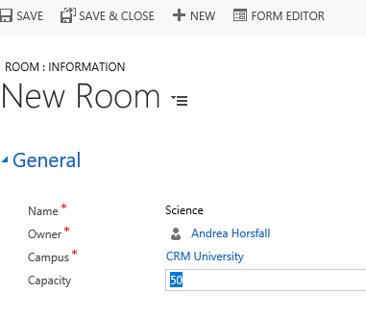
Developer:
Tester: | Andrea Horsfall
Important Notes:

The purpose of this Test Case is to provide evidence of the programme ability to match the User Story or Feature requirement.

Test Case ID: | TC023-1
Test Case Name: | Creating A Contact
Created By: | Hlayisani Garrine | Original Test Case ID: | TC023-1
Date Created: | 02/10/2018 | Last Test Date: | 31/10/2018

Description: | The purpose of the test case is to describe the steps of creating a contact in the system
Test Objective:
Test Steps: | - The user navigates to EDU365 in the system.  - The user clicks on the Contacts entity.  - The user clicks New to create a contact.  - The user fills in the contact information.  - The user clicks Save&Close.
Test Outcome: | Conditional Pass
Evidence: | - Preferences - Lecturer – drop down box should list lecturers  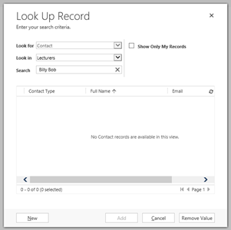
Developer:
Tester: | Andrea Horsfall
Important Notes: | Address & mobile number should be mandatory.

The purpose of this Test Case is to provide evidence of the programme ability to match the User Story or Feature requirement.

Test Case ID: | TC024-1
Test Case Name: | Creating A Campus
Created By: | Hlayisani Garrine | Original Test Case ID: | TC024-1
Date Created: | 02/10/2018 | Last Test Date: | 01/11/2018

Description: | The purpose of the test case is to describe the steps to create a campus
Test Objective: | To create a campus
Test Steps: | - The user clicks on Sales.  - The user clicks on EDU365 menu in the system.  - The user clicks on Campuses entity, under Settings header  - The user clicks New to create a campus.  - In the General section, the user fills in the information of the campus.  - The user clicks Save.  - In the Resources section, the user clicks on the plus sign (+) in the Rooms subgrid  - The user fills in the Name of the room.  - The user clicks Save.  - The user clicks on the plus sign (+) in the Group subgrid  - The user fills in the information of the group.  - The user clicks Save.  - The user clicks on the plus sign (+) in the Lecturers subgrid  - The user clicks on the magnifier  - To select a lecturer, the user clicks on the name of the lecturer..  - The user clicks on the plus sign (+) in the Registration Years sub-grid  - The user clicks +New to select a new registration year.  - The user clicks Save &Close.
Test Outcome: | Conditional Pass
Evidence: | 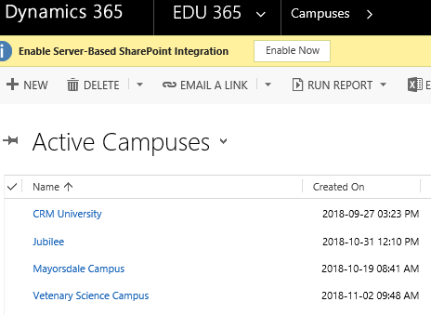  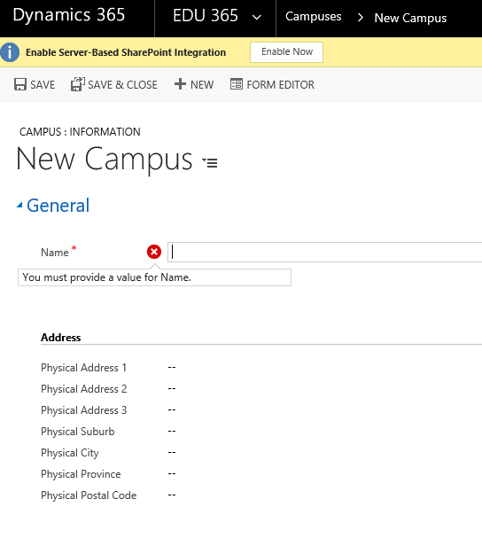  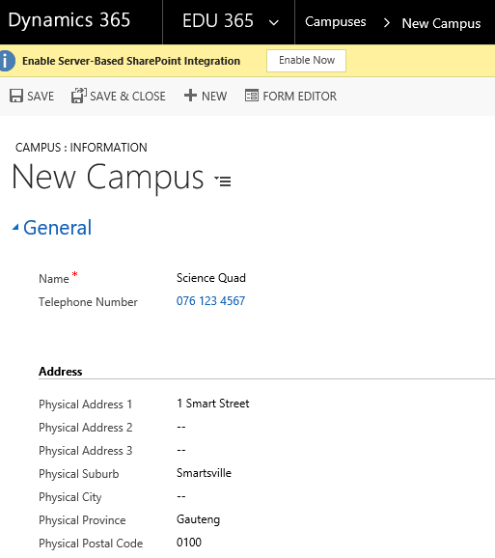  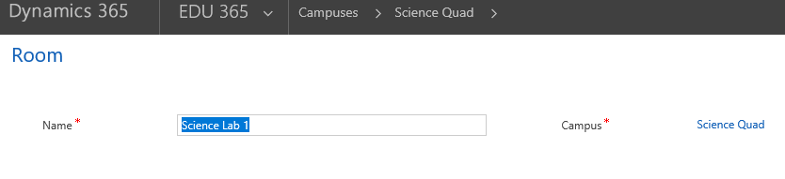  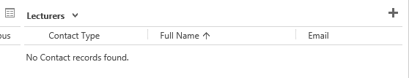  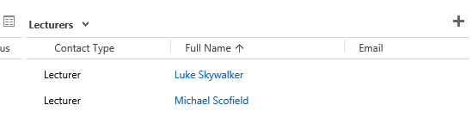
Developer:
Tester: | Andrea Horsfall
Important Notes: | When entering address, suggestion would be to set it out as follows:  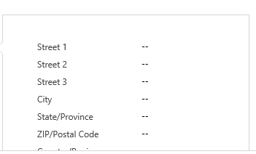  This should also be a mandatory field.  The Lecturers drop down box should only show the list of lectures.  I would expect to see a list of years to choose from.  We would then need to see a ‘Save & Close’ button.

The purpose of this Test Case is to provide evidence of the programme ability to match the User Story or Feature requirement.

Test Case ID: | TC025-1
Test Case Name: | Creating Work Hours
Created By: | Hlayisani Garrine | Original Test Case ID: | TC025-1
Date Created: | 02/10/2018 | Last Test Date: | 31/10/2018

Description: | The purpose of the test case is to describe the steps for creating work hours for a lecturer
Test Objective: | To create work hours
Test Steps: | - The user clicks on EDU365 menu in the system.  - The user clicks on Work Hours entity under Settings header.  - The user clicks New to create work hours.  - The user fills in the Name, Lecturer, Room, Start Time and End Time.  - In the Day section, the user clicks on the checkbox next to the days to select the preferred working days.  - The user clicks Save&Close.
Test Outcome: | Conditional Pass
Evidence: | 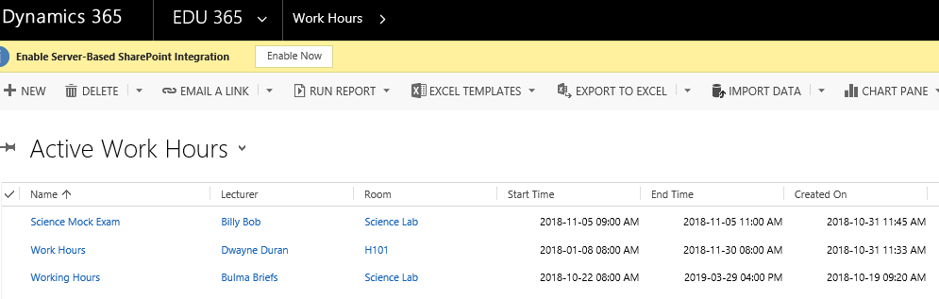  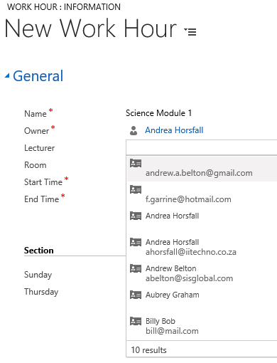  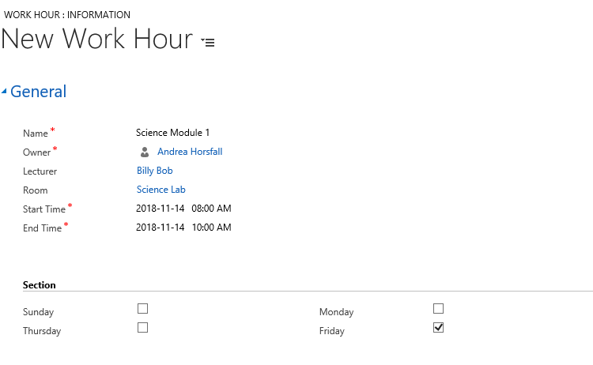
Developer:
Tester: | Andrea Horsfall
Important Notes: | Drop down box should only show lecturers that are associated with the Science faculty.

The purpose of this Test Case is to provide evidence of the programme ability to match the User Story or Feature requirement.

Test Case ID: | TC026-1
Test Case Name: | Creating Breaks
Created By: | Hlayisani Garrine | Original Test Case ID: | TC026-1
Date Created: | 02/10/2018 | Last Test Date: | 31/10/2018

Description: | The purpose of the test case is to describe the steps of creating breaks in between periods
Test Objective: | To create breaks
Test Steps: | - Click on Edu365  - Under Scheduling – Click on Breaks  - The user clicks New to create a break.  - The user fills in the Name, Start Time and End Time of the break.  - The user clicks Save & Close.
Test Outcome: | Conditional Pass
Evidence:
Developer:
Tester: | Andrea Horsfall
Important Notes: | - Calendar option needs to include the option of setting recurring days and times for the breaks like the outlook calendar.

The purpose of this Test Case is to provide evidence of the programme ability to match the User Story or Feature requirement.

Test Case ID: | TC027-1
Test Case Name: | Creating A Campus Closure
Created By: | Hlayisani Garrine | Original Test Case ID: | TC027-1
Date Created: | 02/10/2018 | Last Test Date: | 31/10/2018

Description: | The purpose of the test case is to describe the steps of creating closures for a campus.
Test Objective: | To create a campus closure
Test Steps: | - The user clicks on EDU365 menu in the system.  - The user clicks on Closures entity, under scheduling heading.  - The user clicks New to create a closure.  - The user fills in the Name, Campus, Start Date and End Date of the closure.  - The user clicks Save&Close.
Test Outcome: | Pass
Evidence: | 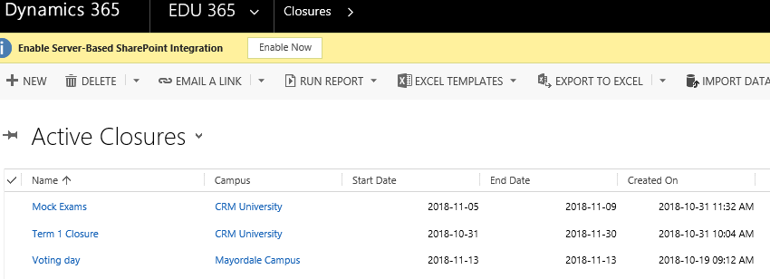  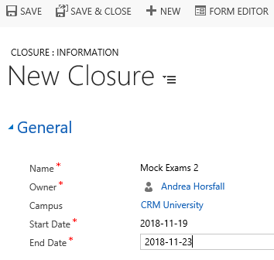  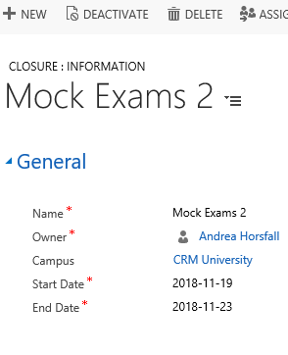
Developer:
Tester: | Andrea Horsfall
Important Notes:

The purpose of this Test Case is to provide evidence of the programme ability to match the User Story or Feature requirement.

Test Case ID: | TC028-1
Test Case Name: | Creating Announcements
Created By: | Hlayisani Garrine | Original Test Case ID: | TC028-1
Date Created: | 02/10/2018 | Last Test Date: | 31/10/2018

Description: | The purpose of the test case is to describe the steps to create an announcement
Test Objective: | To create an announcement
Test Steps: | - The user clicks on EDU365 menu in the system.  - The user clicks on Announcements entity  - The user clicks New to create an announcement.  - The user fills in the Topic, Campus, Start Date and End Date and the Description of the announcement.  - The user clicks Save&Close.
Test Outcome: | Pass
Evidence: | 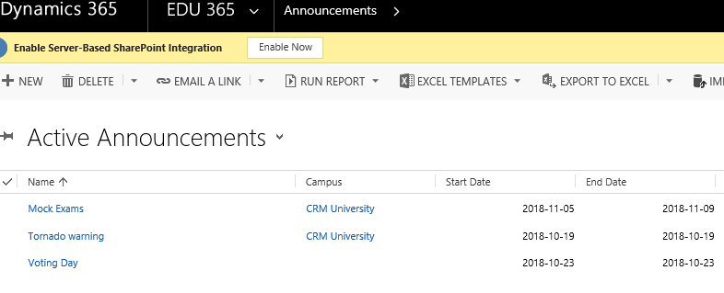  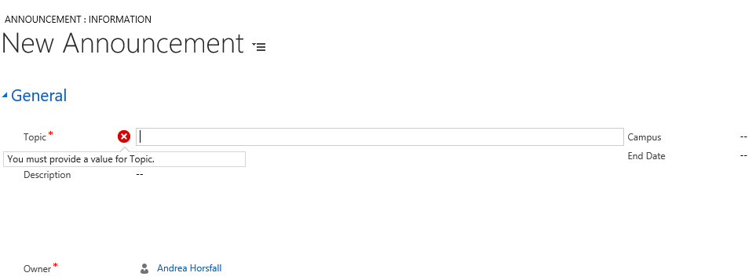
Developer:
Tester: | Andrea Horsfall
Important Notes:

