Deployment Guide
KPMG Disability – Enquiry Management

Microsoft Dynamics 365

KPMG Australia

Version 1.0
Date: 20th December 2018
kpmg.com.au

Overview
The purpose of this document is to serve as a guide to successfully deploy KPMG Community Care Enquiry Management solution.
The document defines the procedures and dependencies along with the proper sequence of deployment events.

Contents
Purpose 4
Pre Deployment 5
Dynamics 365 Environment Backup 5
Install Field Service on the Dynamics 365 Instance 5
Post Deployment 6
Add users to Enquiry “Triage Team” 6
Security 7
Assign Field Security Profile 7
Rollback 8

Purpose
This document will serve as a reference during the deployment process, and has been specifically developed for KPMG Community Care Enquiry Management Dynamics 365 solution which is a part of the KPMG Community Care solution.
Scope of the sections of this document:
- Pre-deployment procedures
These are the activities/steps that needs or ideally to be executed before the installation of Microsoft Dynamics 365 solutions.
Activities could be, but are not limited to preparation, setup, and configuration.
It is within the scope of this document to define the required resolution for any dependencies that will cause the solution to fail.

- Post deployment procedures
These are configuration/initialization steps, to be carried after the installation of the Microsoft Dynamics 365 solution.

- Security Setup procedures
The setup outlines procedures to create teams and queues necessary for enquiry routing.

Pre Deployment

Dynamics 365 Environment Backup
Coordinate with your IT admin to perform a backup of the Dynamics 265 instance that you wish to install the KPMG Community Care Enquiry Management solution.
**NOTE**: CRM Backup is only valid for 3 days. Consider this in case a rollback is required.

Install Field Service on the Dynamics 365 Instance
Field service capability is critical for the KPMG Community Care Enquiry Management solution to be installed.
- Log-in as the Global Administrator/Dynamcis Service Administrator into the Office 365 tenant.
- Navigate to the Dynamcis 365 admin page
- Select the solution icon for the instance you wish to install the KPMG Community Care Enquiry Management solution on.
- Install the latest Field Service Solution by clicking the install button
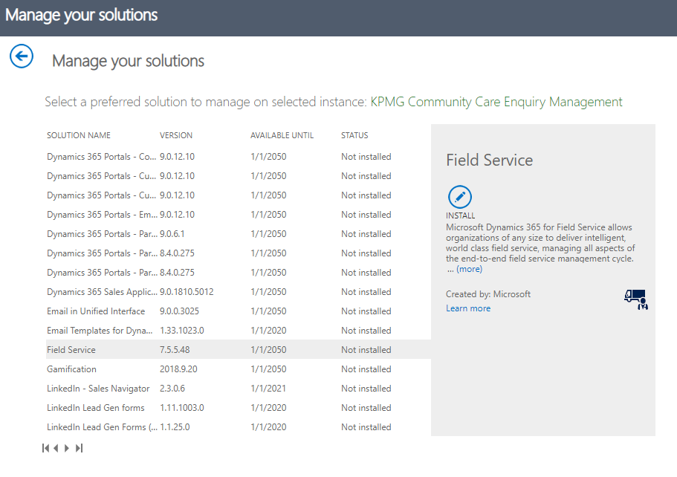
- Accept the Terms of Service and click “Install”

Post Deployment

Add users to Enquiry “Triage Team”
- Login as a Dynamics System Administrator
- Navigate to KPMG Enquiry Management > Teams
- Open the record; “Enquiry Triage ”
- Ensure that you are using the “KPMG – Team Form”
- Nominate an Administrator for the team
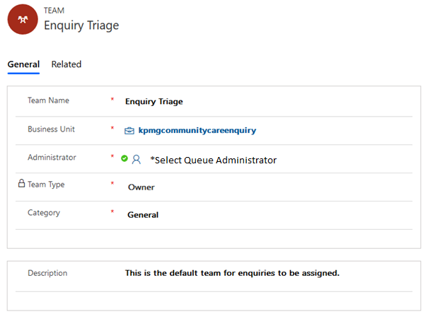

- Add users part of the “Enquiry Triage” team by clicking on the + button
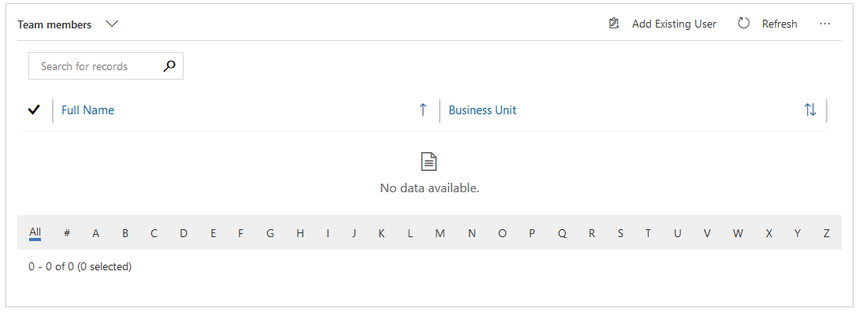
- Hit “Save & Close”
NOTE
New enquiries that are created are directed to the “Enquiry Triage” team.
Users of the “Enquiry Triage” team will be able to access Enquiry records and see records on the dashboards

Security

Assign Field Security Profile
- As part of the KPMG Community Care Enquiry Management, two new security roles are provisioned
  - KPMG – CEM Manager
  - KPMG – CSO/Area manager/Team manager
- Please apply the roles based on individual user profiles.

Rollback
The user of this document should execute the section “only” upon confirmation with the business.
Coordinate with organisation’s Office 365 Administrator, to “restore” the backup mentioned in Pre-Deployment steps or any backup that has been created during the deployment process.

© 2018 KPMG, an Australian partnership and a member firm of the KPMG network of independent member firms affiliated with KPMG International Cooperative (“KPMG International”), a Swiss entity. All rights reserved.
The KPMG name and logo are registered trademarks or trademarks of KPMG International.
Liability limited by a scheme approved under Professional Standards Legislation.
The information contained in this document is of a general nature and is not intended to address the objectives, financial situation or needs of any particular individual or entity. It is provided for information purposes only and does not constitute, nor should it be regarded in any manner whatsoever, as advice and is not intended to influence a person in making a decision, including, if applicable, in relation to any financial product or an interest in a financial product. Although we endeavour to provide accurate and timely information, there can be no guarantee that such information is accurate as of the date it is received or that it will continue to be accurate in the future. No one should act on such information without appropriate professional advice after a thorough examination of the particular situation.
To the extent permissible by law, KPMG and its associated entities shall not be liable for any errors, omissions, defects or misrepresentations in the information or for any loss or damage suffered by persons who use or rely on such information (including for reasons of negligence, negligent misstatement or otherwise).

