Autonumber Generator

Overview:
"This solution let user to enable autonumber for any entity in easy way with advance setup.

Features:
- Working for standard as well as custom entities
- Prefix and suffix are supported
- Auto number Setup can be done for specific time duration.
- Block feature of No series
- Set length of No.

Auto numbering is a common requirement for most CRM Implementations to generate a Unique Reference Number for new records, so they can easily be tracked, and is also useful for integrations.
Also, it enables admin to setup no. series financial year wise for any type of record.

Benefits:
- Admin can create no. series in Autonumber setup.
- It is custom workflow-based setup so that condition based generation of autonmuber can be possible.
- Admin can configure auto number functionality by selecting particular entity name from Autonumber setup form.
- Admin can have preview of his desired auto number pattern by adding prefix, suffix, counter & length of number.
- Apart from this, system can let Admin to block auto number functionality and Admin can also set specific start to end date for this Autonumber setup.

How to use this solution

Get the solution from App source and install it into your Dynamics 365 Instance.
One installation of the solution gets completed, you need to do setup of no. series for respective entities on which autonumber require. Please make sure that, if you are enabling autonumber for any entity, one custom field on that entity must be there in which we can capture the same.

Here you can create new setup.
Go to Advance find and select “Autonumber Configuration” entity.
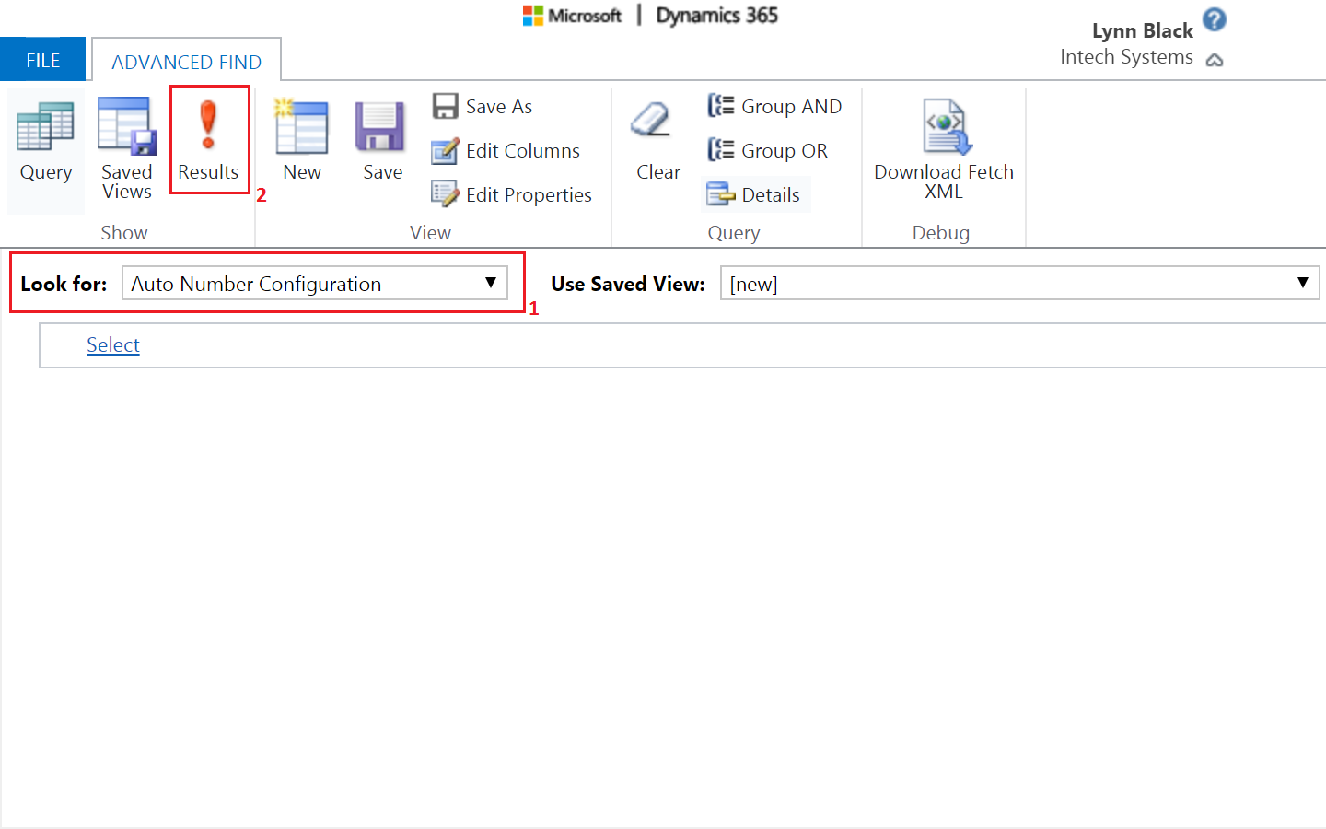

Click on Results and then below screen will get open click on New Auto Number configuration.

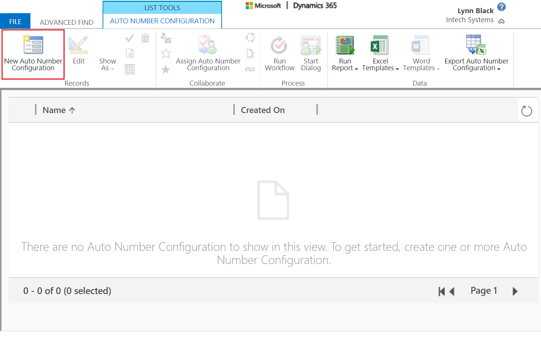

After clicking on New Auto Number Configuration, below form will appear and fill appropriate information as per requirements.
- First of all, select entity where you want to implement auto number feature from Entity List and then Name & Entity Name filed will be auto updated as from selected entity from list.
- Prefix (Optional)
- Suffix (Optional)
- Length of No.: It can be set for sequential no. length (Prefix and suffix will not be considered in length)
- Counter: Starting no.
- Start Date: Starting date of this no. series
- End Date: Ending date for this no. series
- Blocked: Yes/No option. For blocking no. series, set it as “Yes”

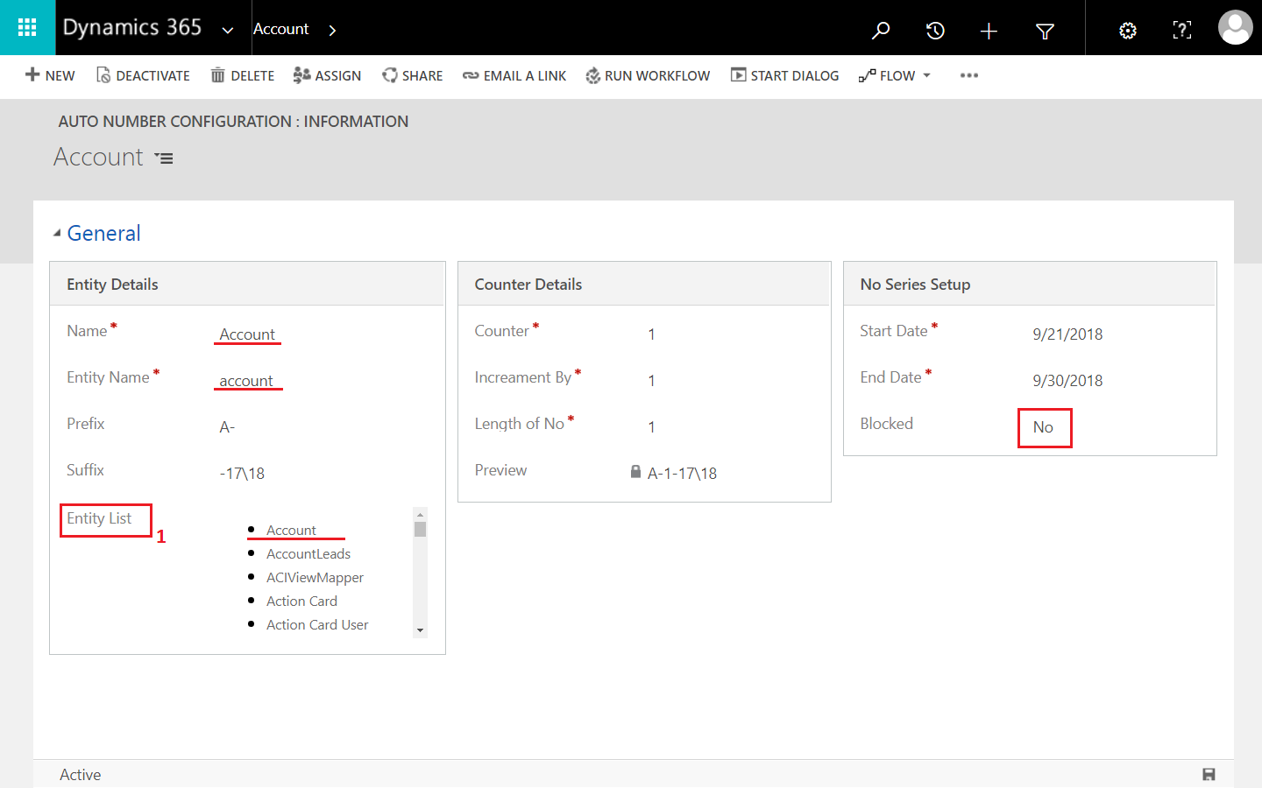

This setup will be used in Workflow which require to generate. Please note that, it should be real-time workflow

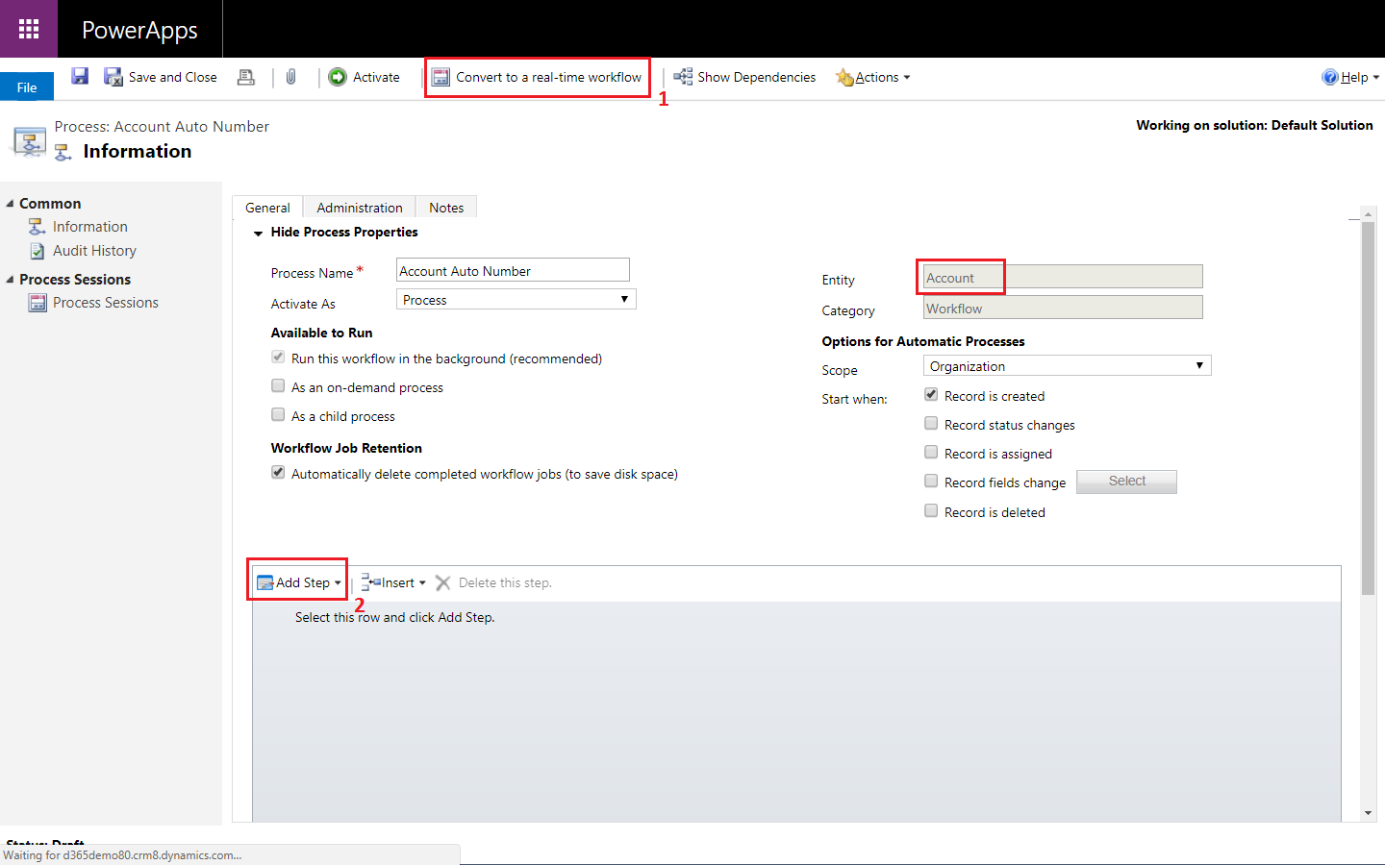

This is how you can generate workflow. It should trigger on Creation. (However, can be set for field change based on condition & requirements).

Click on Add Step and you can find below Autonumber_Setup and click on autonumber_setup_Autonumber
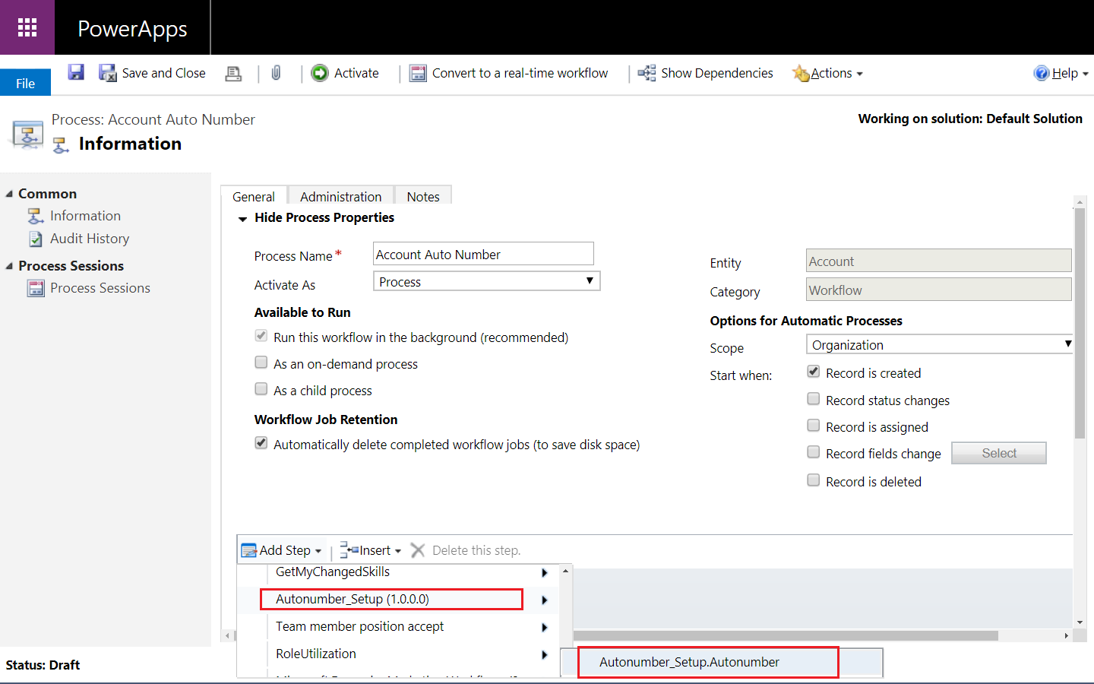

After that click on update record and select account entity, then below form will appear; look for
Autonumber_setup_Autonumber and set value where you want to generate auto number.
Save and activate work flow.
