Address Locator

It is important for you to keep a track of what your sales team is up to. Tracking their performance and progress is one of the ways to ensure that they are working on their assigned projects. Sometimes, you might also want to know the exact location of your salesperson.

In Microsoft Dynamics 365 for Sales, you won’t have to enter the addresses of the companies you visit. Intech has developed an add-on named ‘Address Locator’. Address locator lets you capture current location of visited company/customer through the mobile app.

Address Locator can:
- Support in Account & Lead entity
- Be used through mobile app and tablet app
- Reduce time to in entering address details in lead and account.
- Help you in tracking sales persons' actual visits

How it works:

Sales person can create new leads/accounts directly from prospect's location through their mobile device. On checking "Get Address", the system will collect information of current location and update address in lead or account. Hence, on-field sales executives don’t have to feed address when they are in market. It will save their time and increase their productivity. It will also reduce manual errors as the location will be fetched automatically.

Not only location, Address Locator will also record the date and time of the data entered. This helps you to keep a check on the daily work of sales persons too.

How to use Address Locator?
To leverage the benefits of this app, follow these steps:
- Download ‘Address Locator’ from app source.
- Import it in your Dynamics 365 instance and publish all customization.
- Make sure that lead and account entities are enabled for mobile and table app use.

To start getting location, configure the following settings in Dynamics 365 for Sales mobile app.

- On Dynamics 365 mobile and tablet app, navigate to Home --> Settings as show in below screen.
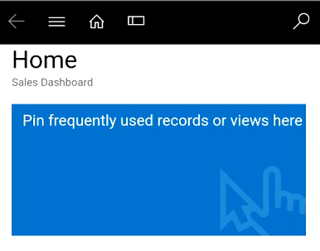
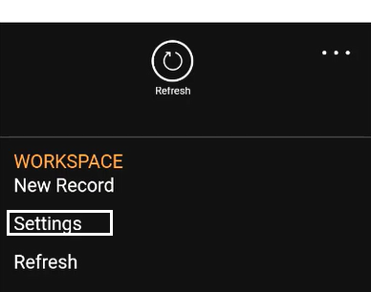

- Select “Device Integration Setting” and enable User content and location

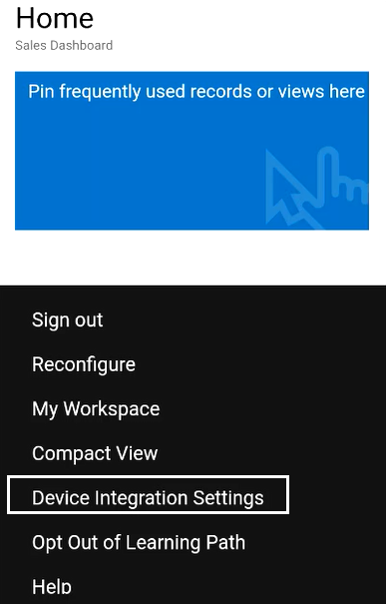
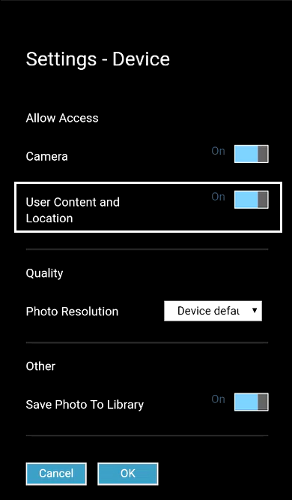

On completion of above setting, you may use this feature by navigating account/lead module in app
- Navigate to Lead/Account
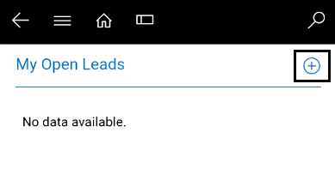
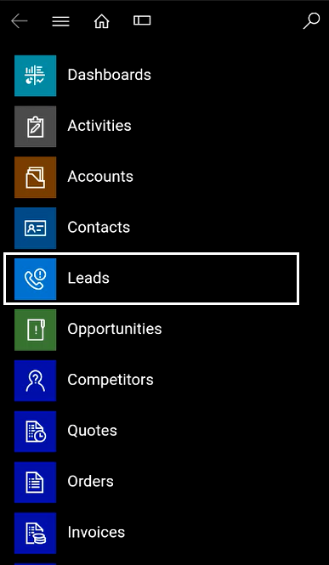

- Click on + button to create new Lead
- Fill require information in Lead quick create form.
- Select “Yes” option in field: “Get Address”.
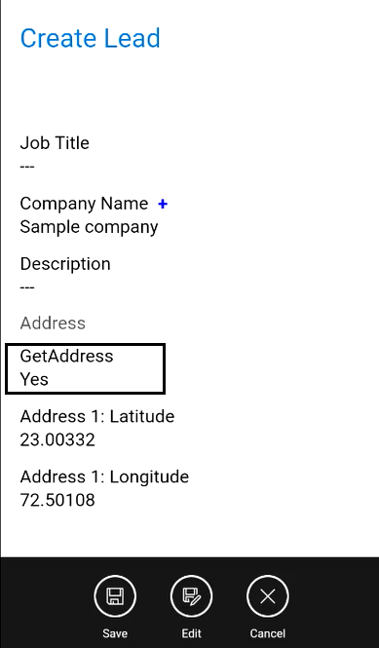
By this method, phone or tablet app will collect current location in form of longitude and latitude and fetch the address from the same.

