Cost Bands Quantity Update
Cost band records are created to control the BOM quantity and Routing Operation information for fabrics which are used repeatedly across several top selling items. Creating the data in this way allows efficient data maintenance of the core fabric component requirements and WIP estimated values.
To open the Cost Bands function, perform the below steps:
- Go to Sales and marketing > Setup > Prices and discounts > Cost Bands
the below Cost Bands form will then be displayed:
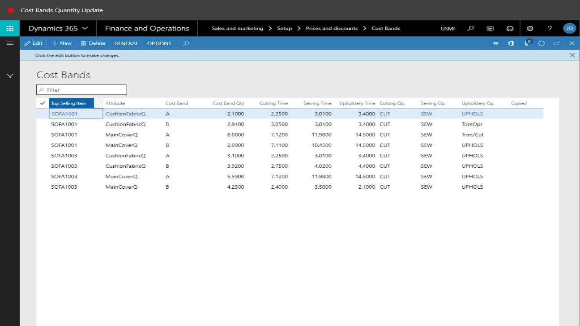
- To understand this form, the fabric from a sales order line can be checked; go to Sales and marketing > Sales orders > All sales orders and then click the link for the sales order.
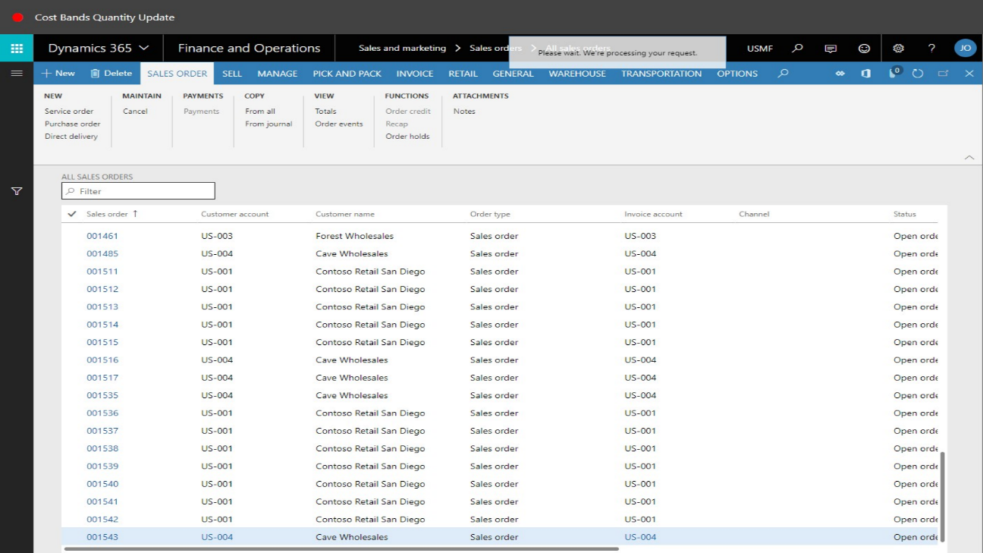
- Click the Product tab, followed by the link in the Sub-BOM field.
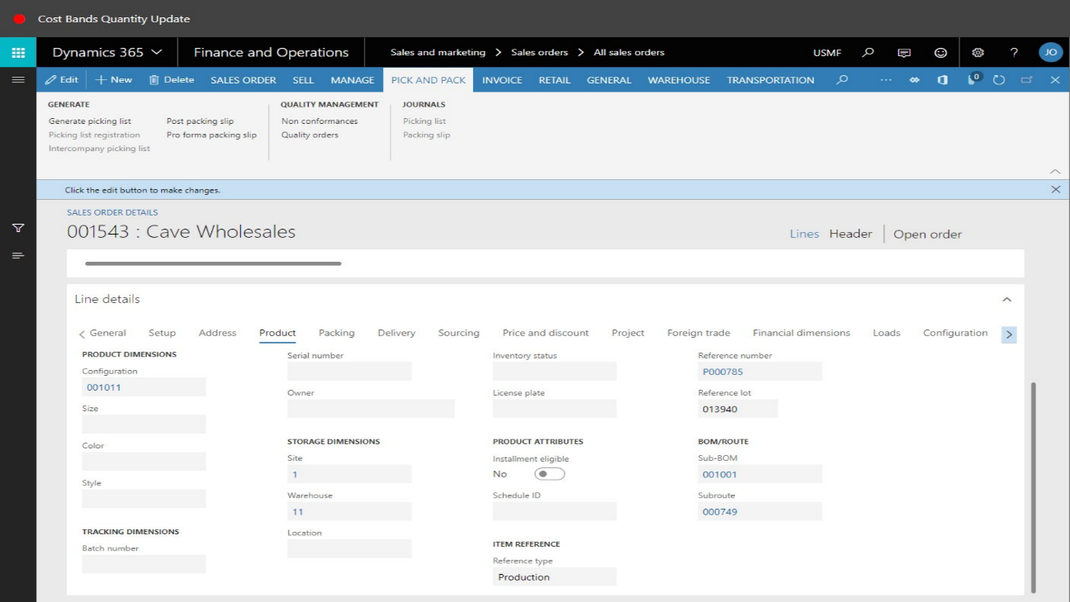
- The BOM components will now display. In the list, find and select the desired record – in this case the fabric item Fabric_Blue.
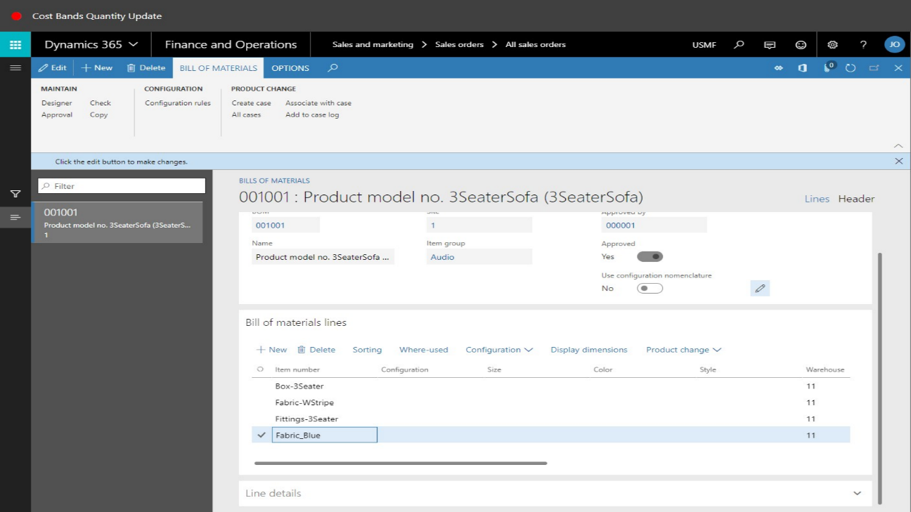
- The Cost Band value for the component needs to be found. This is stored against the Released Item information screen. To view this, click the link on the Item number field.
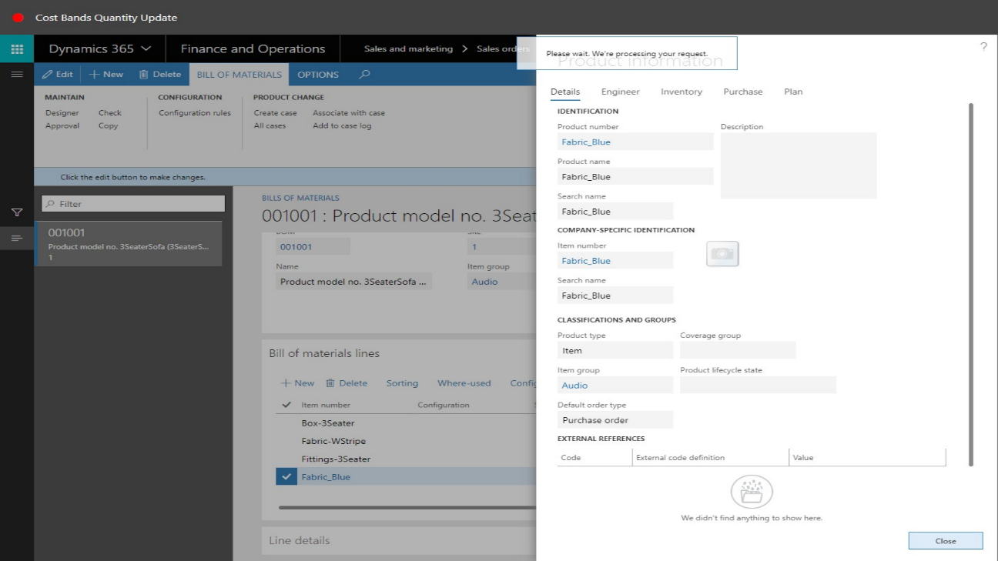
- The above information screen will then be displayed. From this position, click the Item number displayed underneath the Company-Specific Information section; this will load the Released Items form. When the Released Items form loads successfully, collapse the SFM Information section and expand the General section.
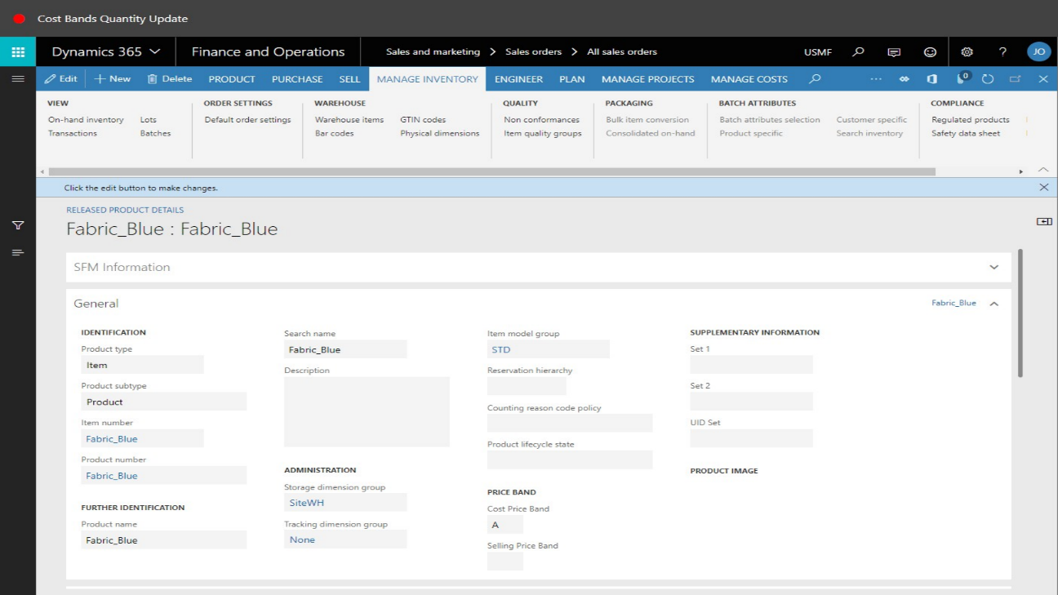
- In the General section, the Cost Price Band value is used to enable us to determine the correct Cost Band record to use for this component. In this example, the Cost Price Band value is equal to A. The forms can now be closed.

- Re-open the Cost Bands form. To achieve this, go to Sales and marketing > Setup > Prices and discounts > Cost Bands.
- Open Top Selling Item column filter to filter the records by the item ordered on the sales order line. In this example, this would be SOFA1001:
- The records will now be filtered to match Top Selling Item of “SOFA1001” only. From this position the data can be filtered further if required. The Cost Band column can be filtered. Enter the Cost Band value recorded from the Released Items screen for the main fabric component of the SOFA1001 item.
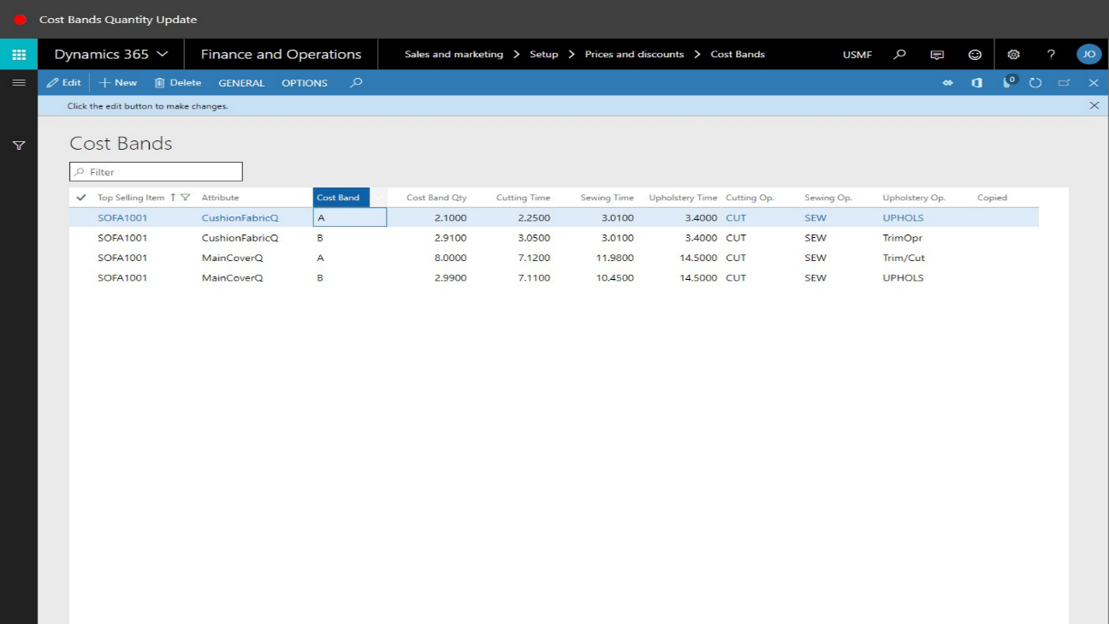
- The Cost Bands records will now be filtered on SOFA1001 top selling items with a Cost Band value of “A”.
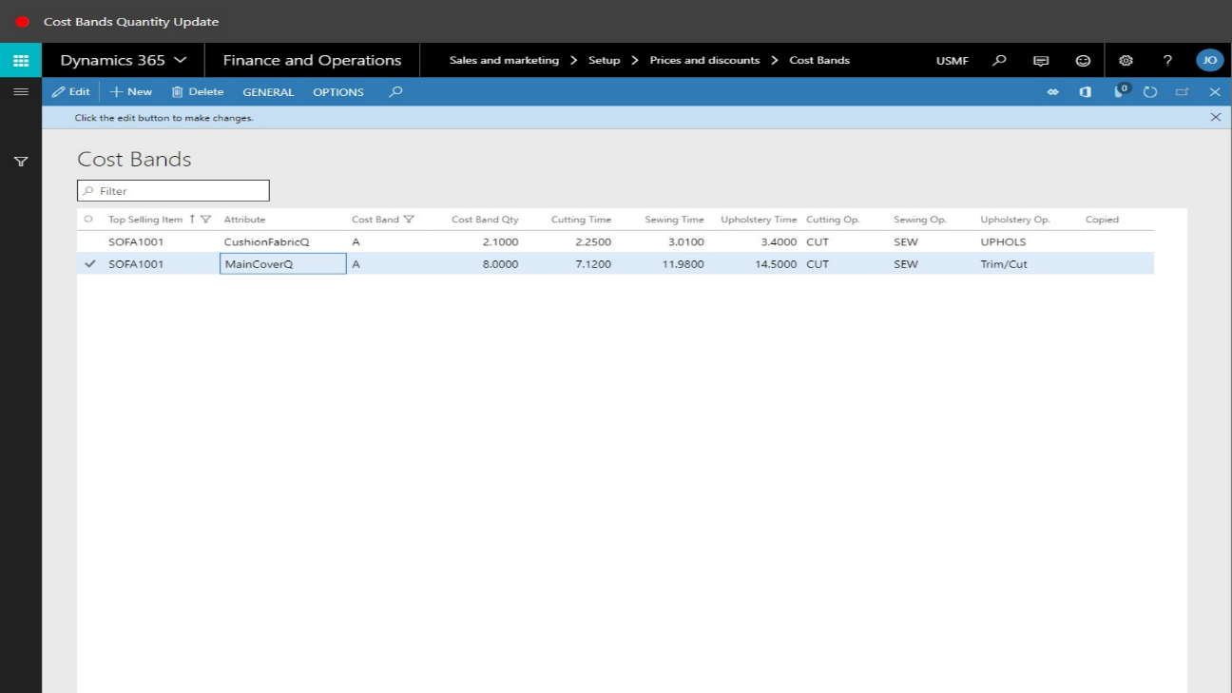
- From this screen it can be seen that the main cover fabric for SOFA1001, that is in the Cost Band grouping of “A”, has several default quantity values. The one that will be referenced here is the Cost Band Quantity value – i.e. 8.0000.
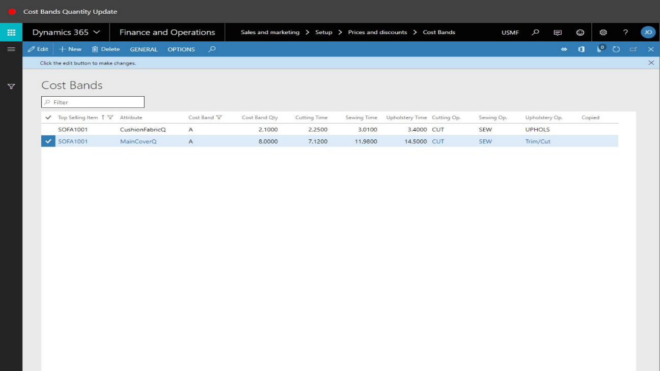
- The Cost Band Quantity can be amended in this one screen, and any new sales orders that require a BOM, will use this Cost Band Quantity as the consumption on the BOM line and also to determine the selling price of the end item. This calculation incorporates a price per meter value stored against the Released Item in a field called Price1.
- If the Cost Band Quantity is updated, then this value can also update existing sales order BOMs if their linked work order has not been released into the production process.
- To achieve an update of existing sales orders that have not started production, amend and save the Cost Band Quantity amount. Then, select the General button on the toolbar and click Update Product Information.

- When prompted to confirm the update, click Yes.
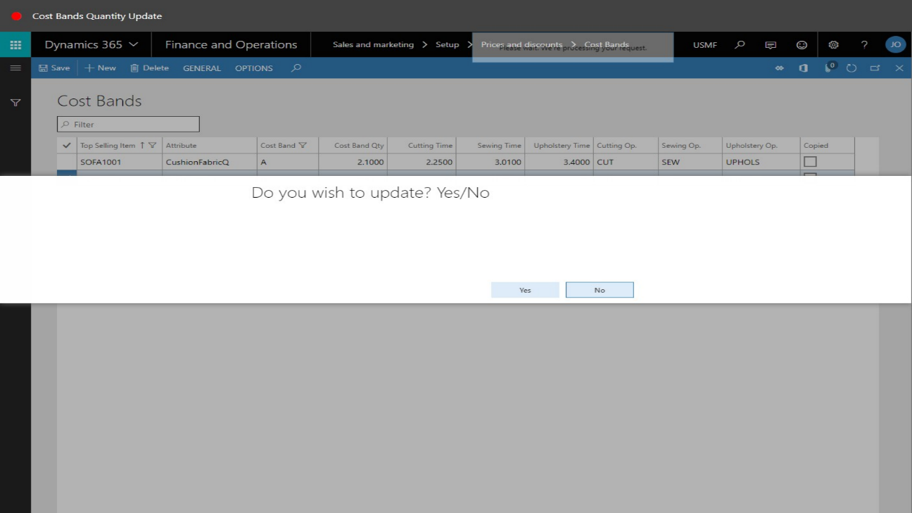
- When the update has completed, the Infolog area will display the updated sales order line information:
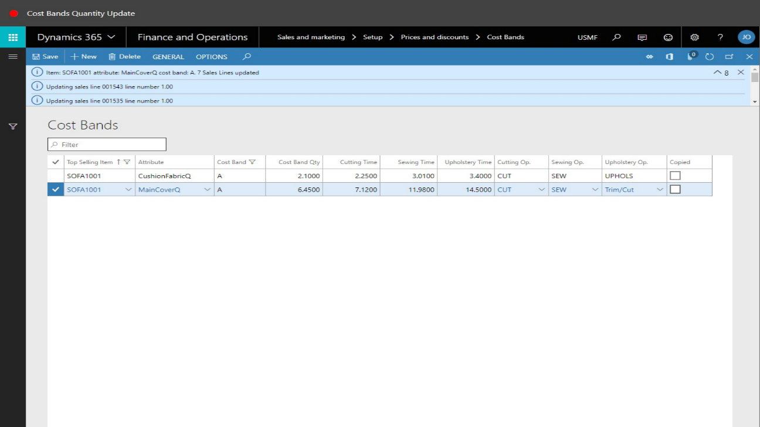
- Return to the original sales order line to view the new BOM component quantity and also the updated selling price.
- Click the Product tab for the selected sales order line, followed by the Sub-BOM link:
- In the list, select the fabric component and note the updated estimated consumption quantity.
- Returning to the sales order, on the toolbar, click Totals. Note that the total of the sales order has now been updated based on the new Cost Band Quantity consumption for the fabric component:
