EDI Sales Order Import
The EDI module allows users to import multiple sales orders, at one time, into Microsoft Dynamics 365 for Finance and Operations. The import file can contain orders for multiple customers, with one or more lines per sales order.
Once the EDI setup has been configured, the functionality can be used; to process an import, run through the below steps:
- Go to Sales and marketing > Periodic tasks > EDI > EDI File Upload.
- Select “Browse” and locate the import file. Once the import file has been selected, click the OK button to begin the EDI import.
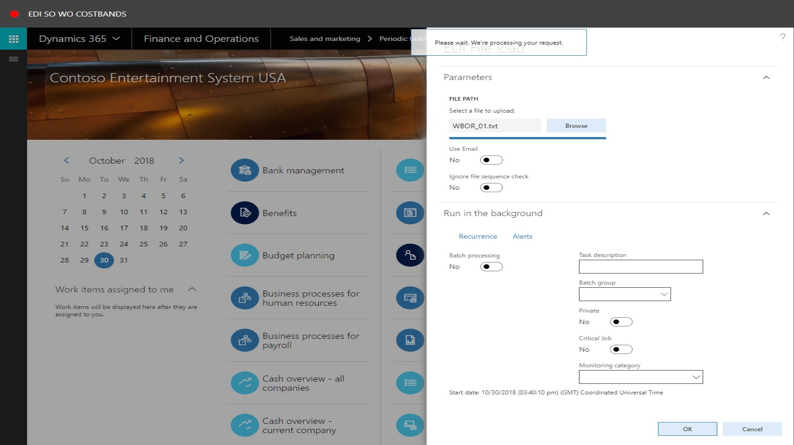
- When the import has processed, alert messages will be generated in the system. These will indicate whether the import generated any exception files, or whether the process completely successfully.

Sales Orders
- After a successful import, go to Sales and marketing > Sales orders > All sales orders to view the created sales orders. In the list, find and select the desired record(s).
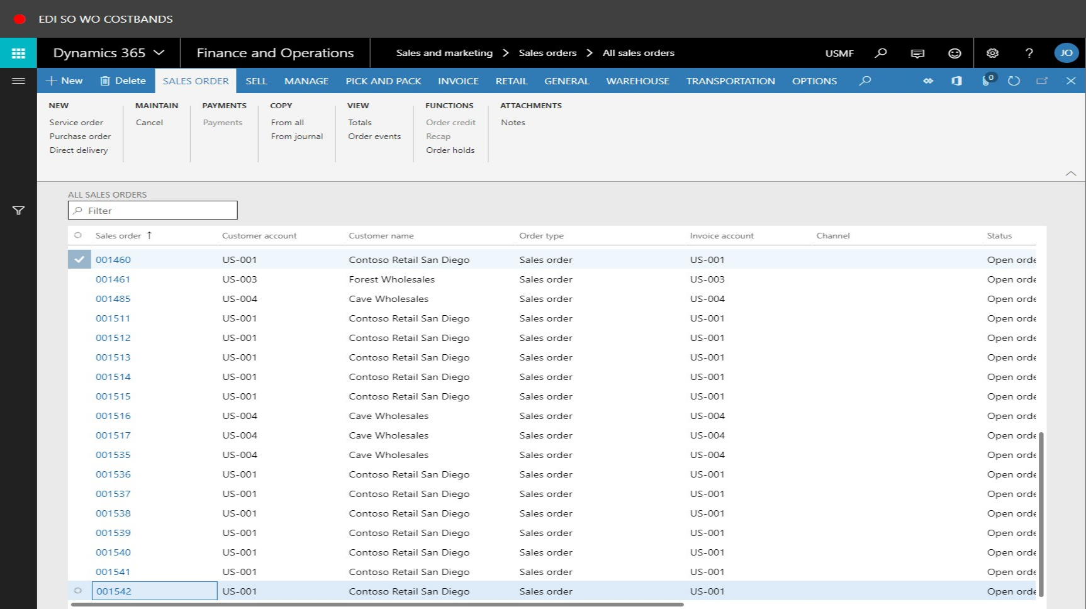
- To confirm that a production order, BOM and route have been created for the sales order line, click the Product tab and view the Reference, BOM and Route values:
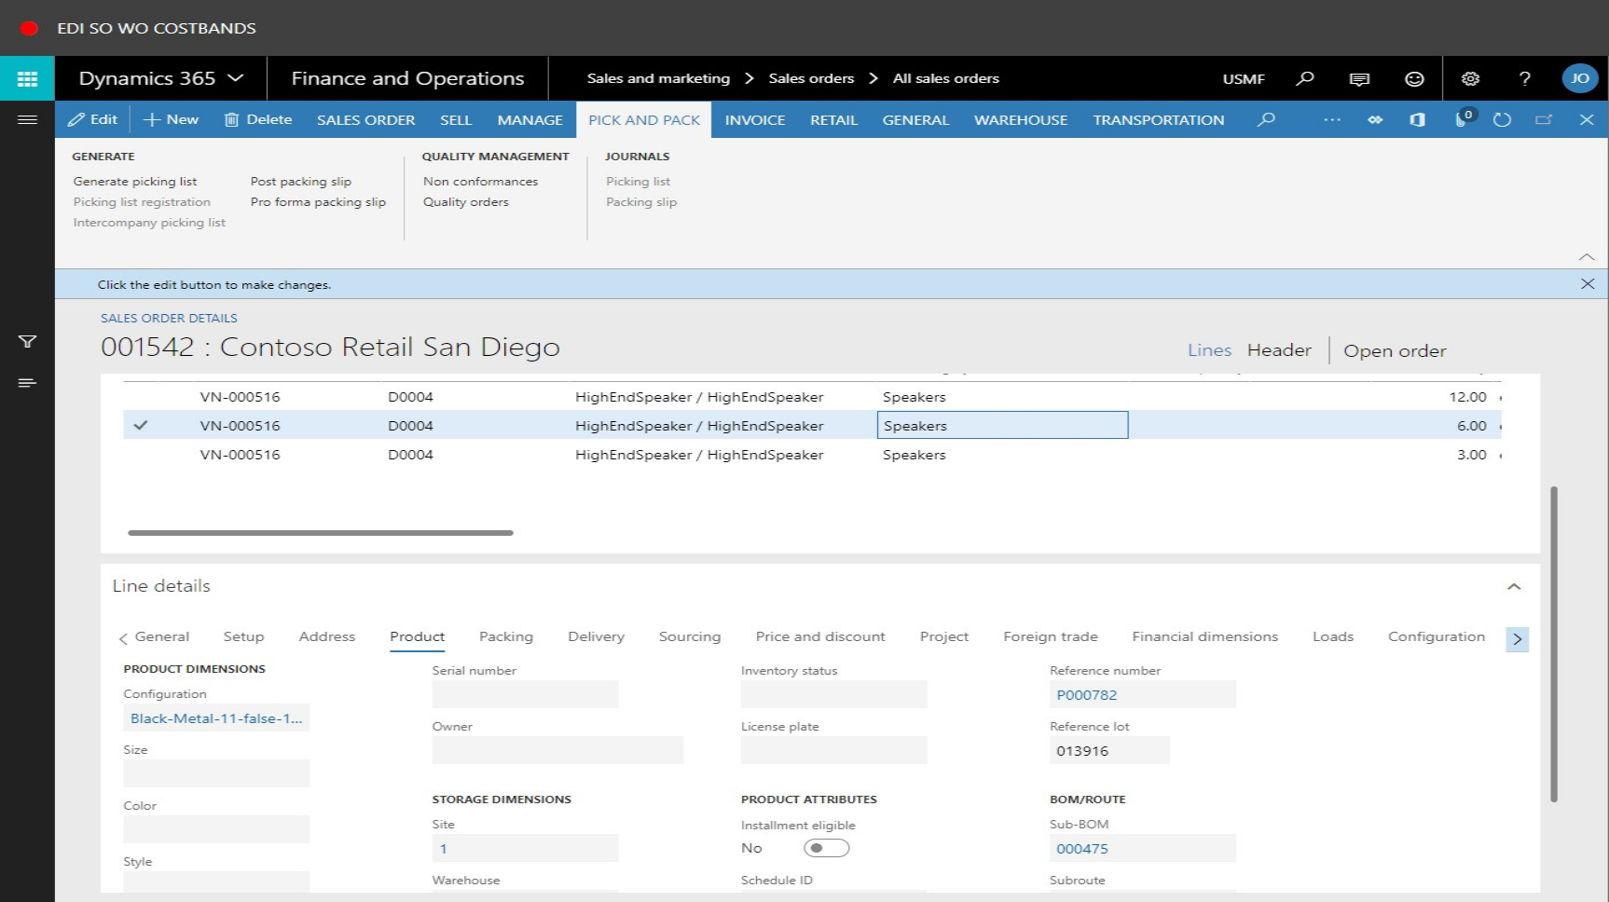
- To view one of the created production orders, click the link in the Reference number field. The production order will then be displayed:
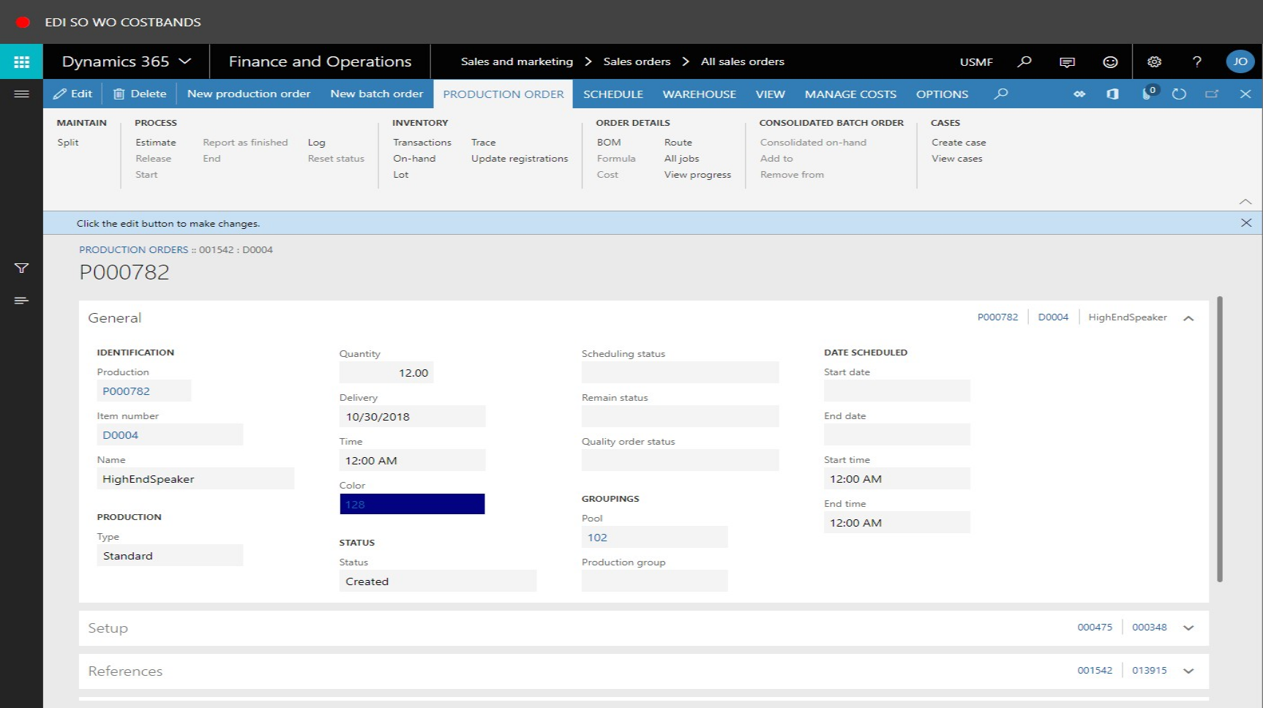

Production Orders
- Close the page and return to the main Microsoft Dynamics 365 home screen. From here, go to Production control > Production orders > All production orders to view all of the production orders created from the imported EDI information.
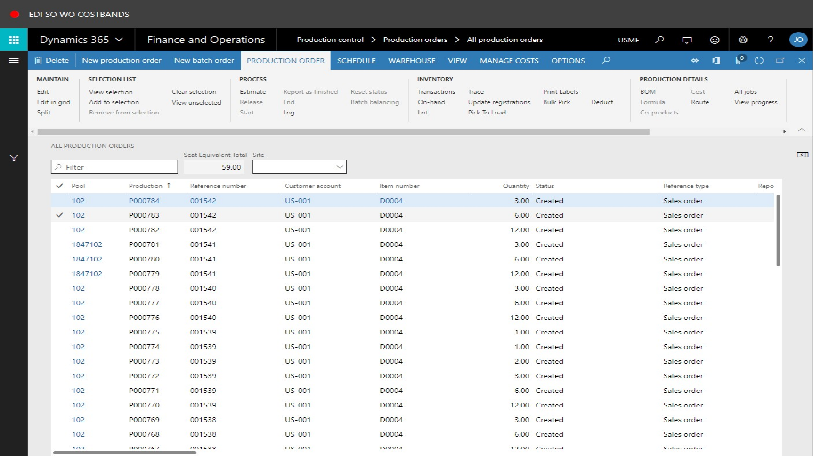
- At this point, the created production orders have not been assigned to a production week. This is part of the Furniture modifications available. To assign one or more production orders to a production week, click to select the appropriate orders:
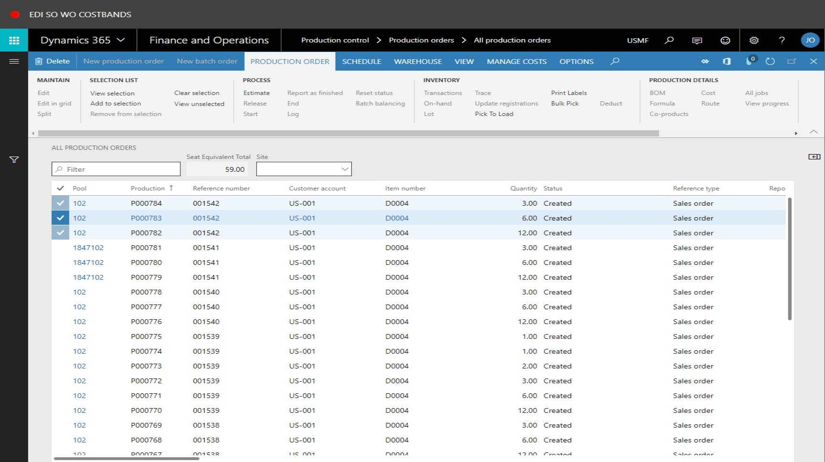

- In the above screen, production orders P000784, P000783 and P000782 have been selected. Now click the “Pick to Load” button. A new screen will be displayed.
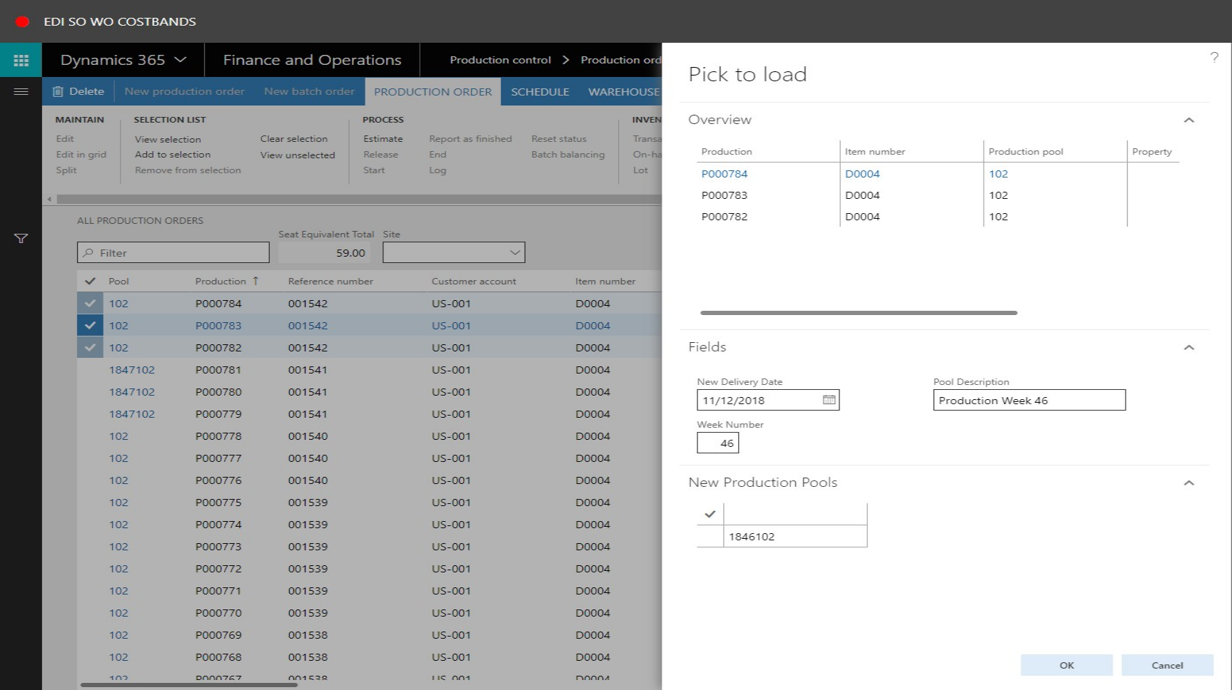
- In the new screen, modify the New Delivery Date value, if necessary to do so.
- In the Pool Description field, type a value, for example “Production Week 46”.
- In the Week Number field, enter the production week number.
- Click OK to update the selected production orders with this information.
- The all production orders form will now display. Refresh this page to view the recently updated information. The Pool values against the selected production orders will now be updated to reflect the entered production week, concatenated with the current year and original pool value:
