INSTALLATION & QUICK SETUP – IN Translate

These are the steps to follow to generate a complete cycle of the IN Translate solution.

Installation
When the solution is installed, the next actions to run are:
- IN Translate Profile is created.

Initial Setup
The first step is to assign the IN Translate Profile to the user.
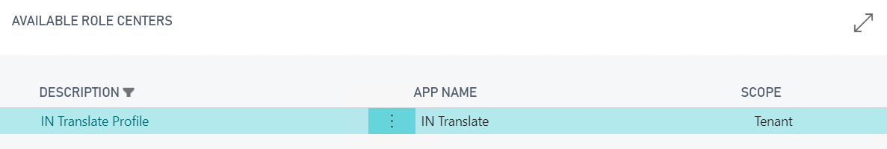
Once in the IN Translate Profile, we must configure the solution through the Install Wizard.
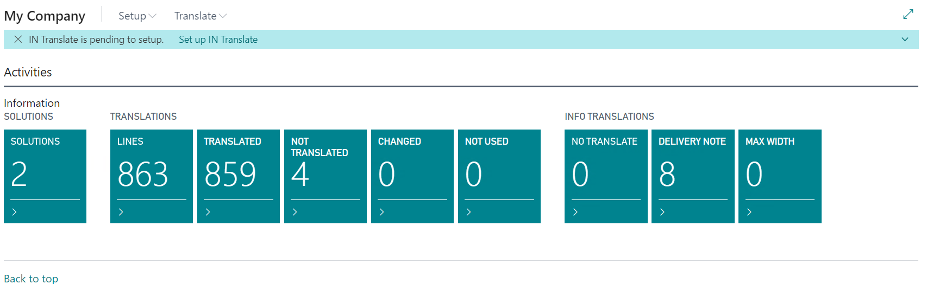
The Install Wizard has four steps to configure:
- Innova Online Setup: Data from Innova Online portal
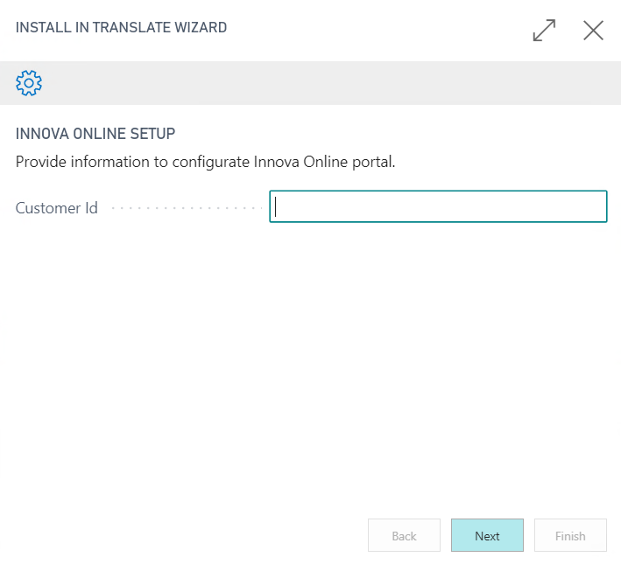

- Manual Steps: The steps to configure manually are: Languages
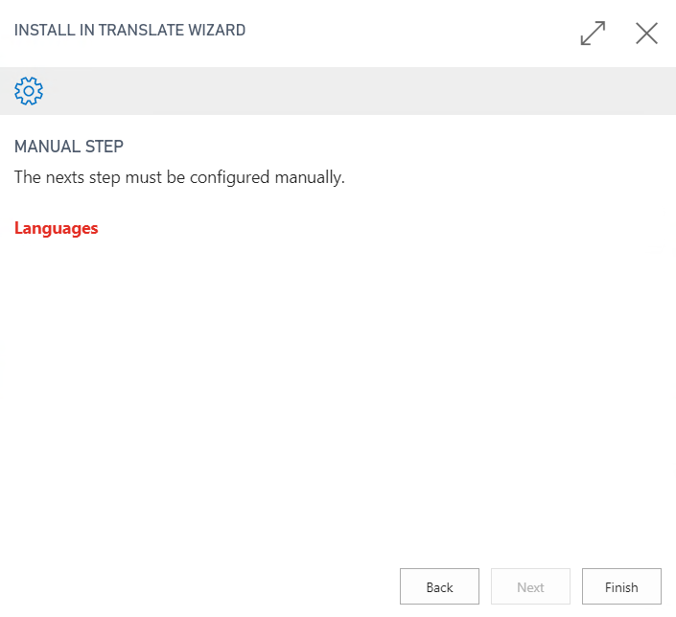
For configuring Languages, we must fill ISO 639-1 Code, es-ES for Spanish (Spain), en-US for English (United States), etc. You can execute the action Updata ISO 639-1 for update codes automatically.
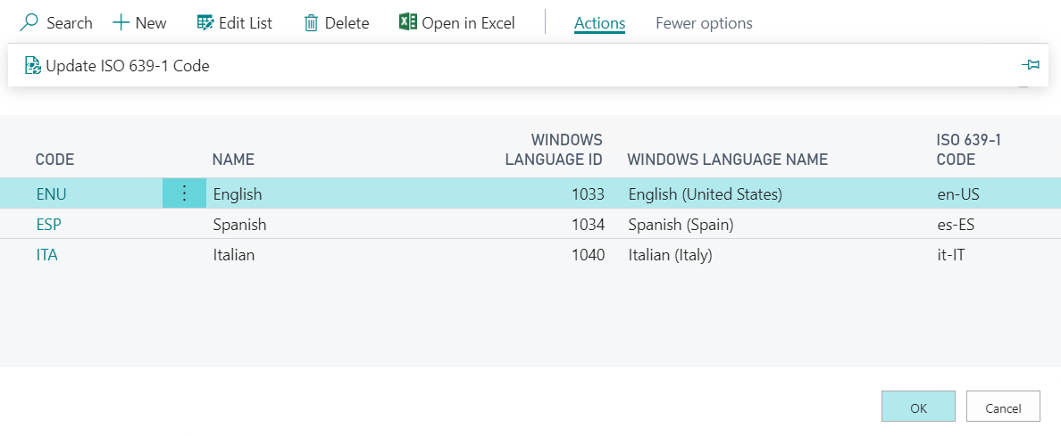

Translates
Once the solution is configured, you can start to translate your solutions.
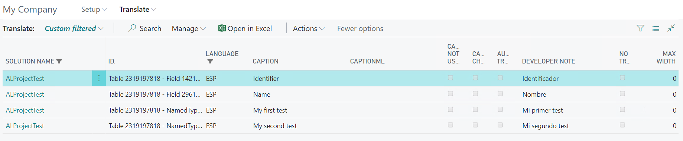
This page has the next actions.

Load Captions
This action allows loading an xlf file with translations (file es-ES, en-US, etc.).
You can use this action if you have translated solutions and you want use the IN Translate solution.
This action asks for language with ISO 639-1 code and file es-ES, en-US, etc.
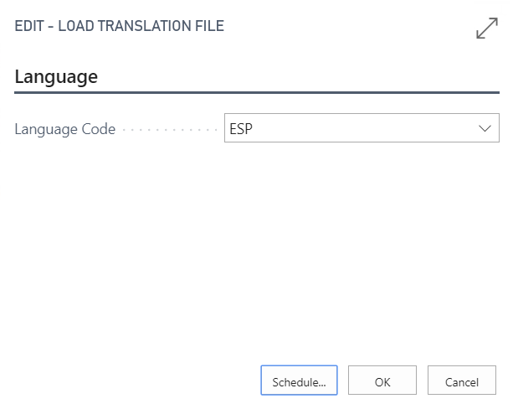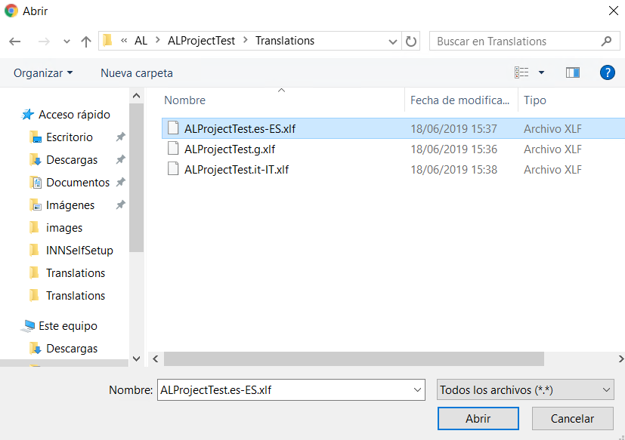

Update Captions
This action allows loading an xlf file without translations (file g). When publishing the solution, the file g is generated with nodes for captions, labels and tooltips. Every time the solution is generated, the file is updated. You can use this action to load a file g without translations.
You can use this action if you want to update the Caption ML (translation) manually or in automatic translation.
This action asks for language with ISO 639-1 code and file g.
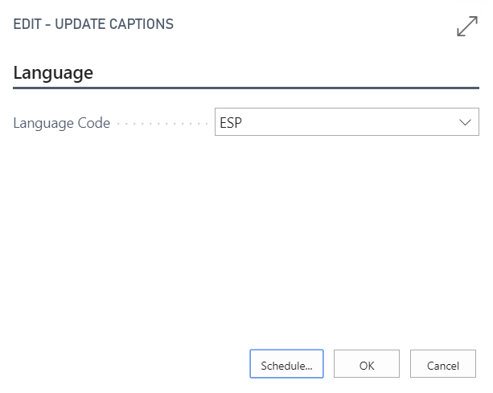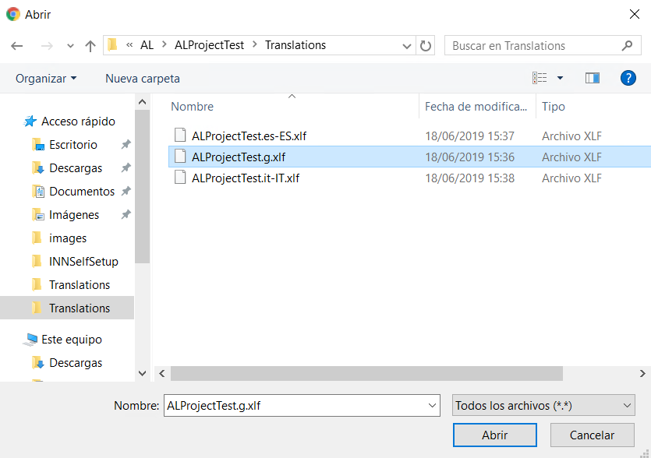

Update Captions with comments
This action is similar to Update Captions, with the difference that captions, labels and tooltips with comment parameters are copied to Caption ML field (translation).
You can use this action if you use comment property from captions, labels and tooltips to put translations in your native language.
This action asks for language and file.

Update Captions for localization
This action is similar to Update Captions, whit the difference that field Caption is copied to Caption ML field (translations).
You can use this action if you want generate localizations for same development language.
This action asks for language with ISO 639-1 code and file g.

Translate Captions
This action allows making the translations through the automatic translations system.
When using this action, the solution lines without Caption ML (translation) will be translated and marked as automatic translation.
You can use this action after the Update Captions.
This action asks for language with ISO 639-1 code and solution.
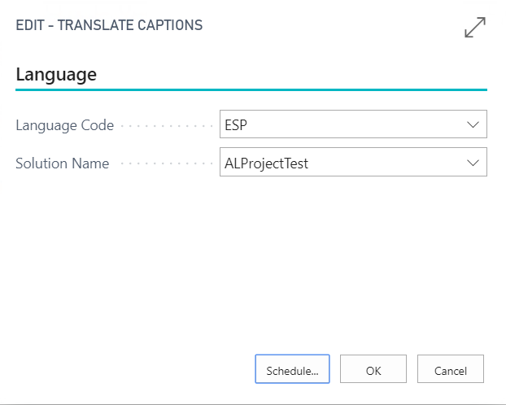

Create translation File
This action allows creating the translated files (file es-ES, en-US, etc.).
When all lines for a solution are translated, you can generate the file for your solution.
This action asks for language with ISO 639-1 code, file g and file es-ES, en-US, etc.
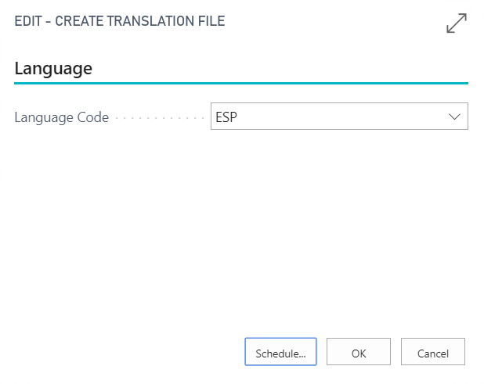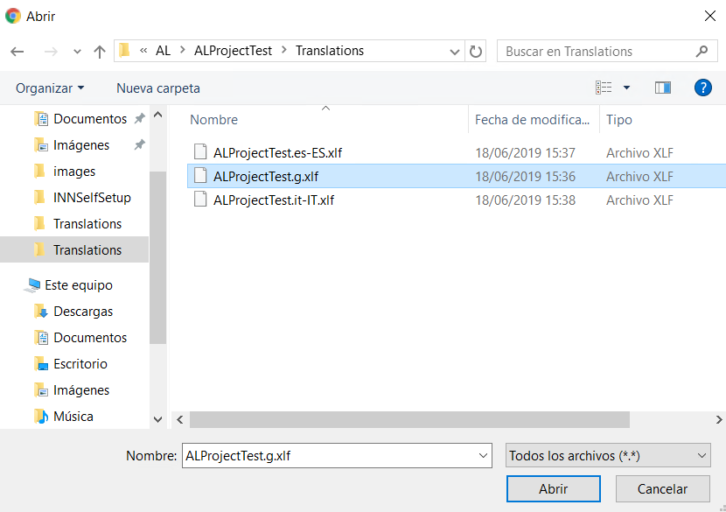
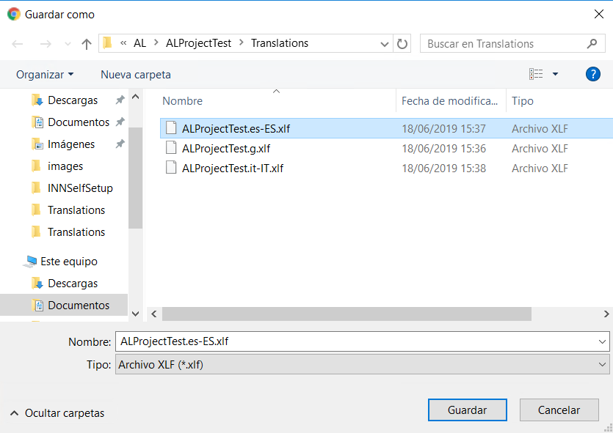

Delete Captions Not Used
This action allows deleting captions not used. When Update captions, it is possible that lines in file are distinct to lines in system. In this case, these lines in system are marked as Not Used.
You can delete this lines with this action for your convenience.

Solutions
In this page, you can see the grouped lines for each solution.
The solutions name is obtained from the file name, for example, file name is C:/test/mysolution.g.xlf and solution name will be mysolution.
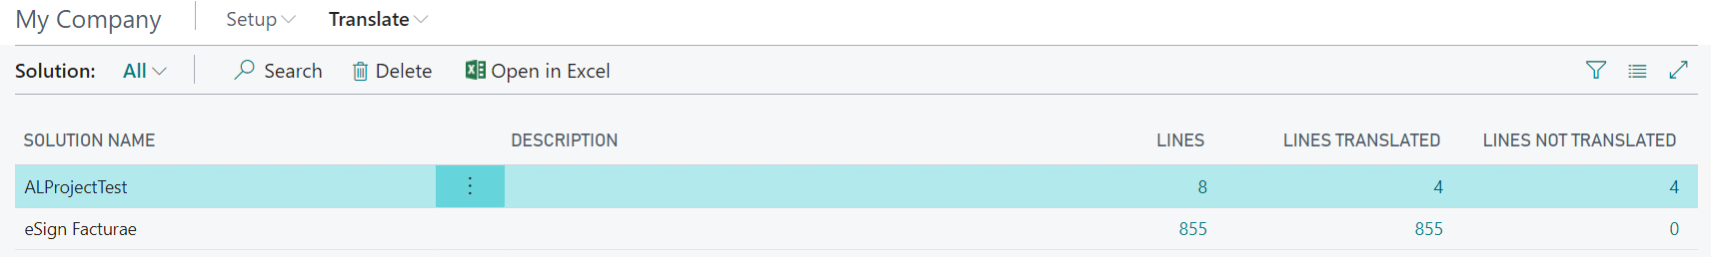
Note: The automatic translations and Create translation file can have limits in Innova Online portal depending of the selected plan.

