Dynamica Stripe Integration

User Guide

Contents
Stripe Integration Configuration 3
Add Credit Cards 5
Charge Payments 6
Track the Payment Request status 7
Payments Scheduling 8
Direct payment requests 10
Restrictions 11

Stripe Integration Configuration

To configure Stripe to Dynamics 365 integration complete the following steps:
1. Go to https://stripe.com and click “Dashboard”.
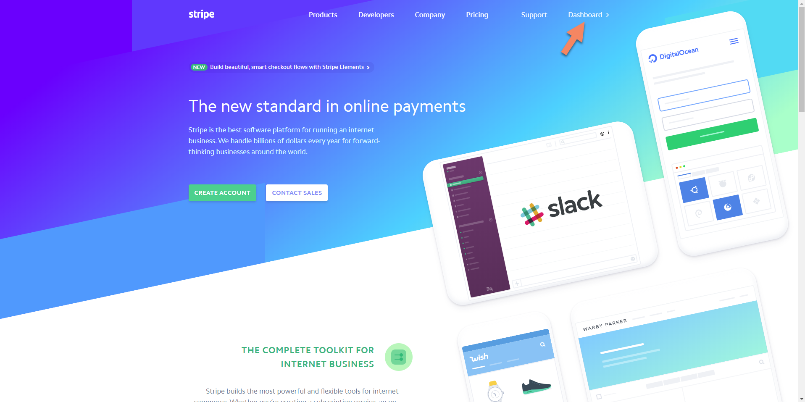

2. Find your API keys In the API section
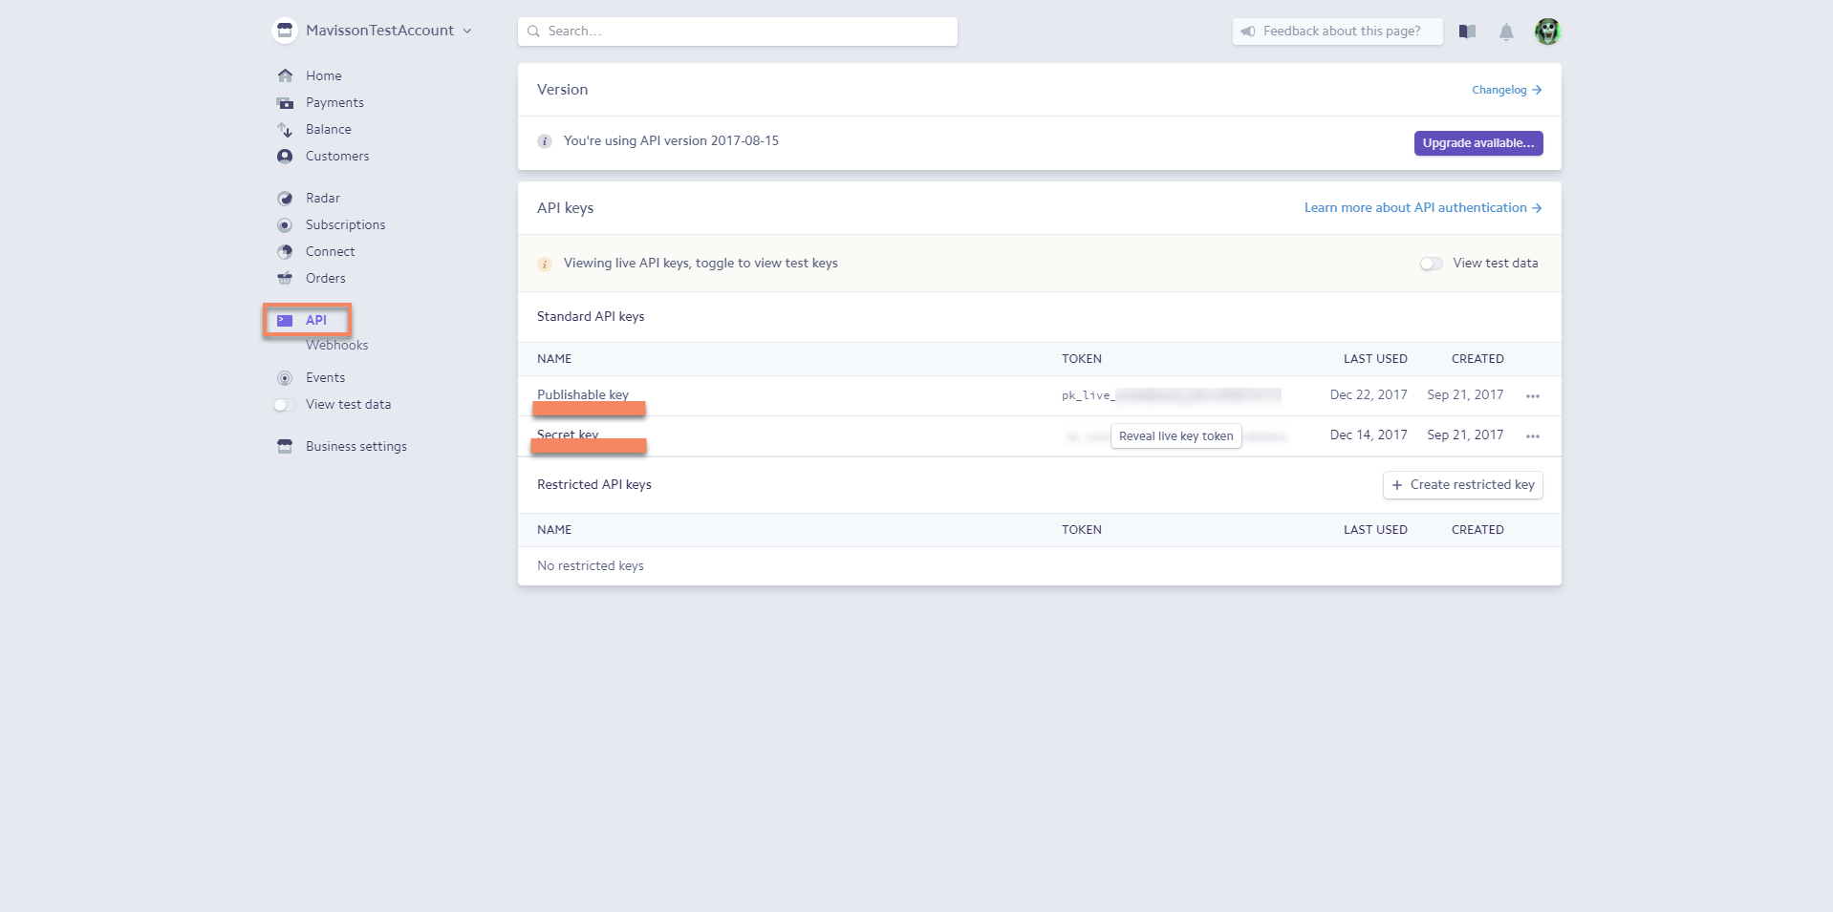

3. In Dynamics 365 go to Settings -> Solutions and double-click Dynamica Stripe Integration solution and switch to Configuration page
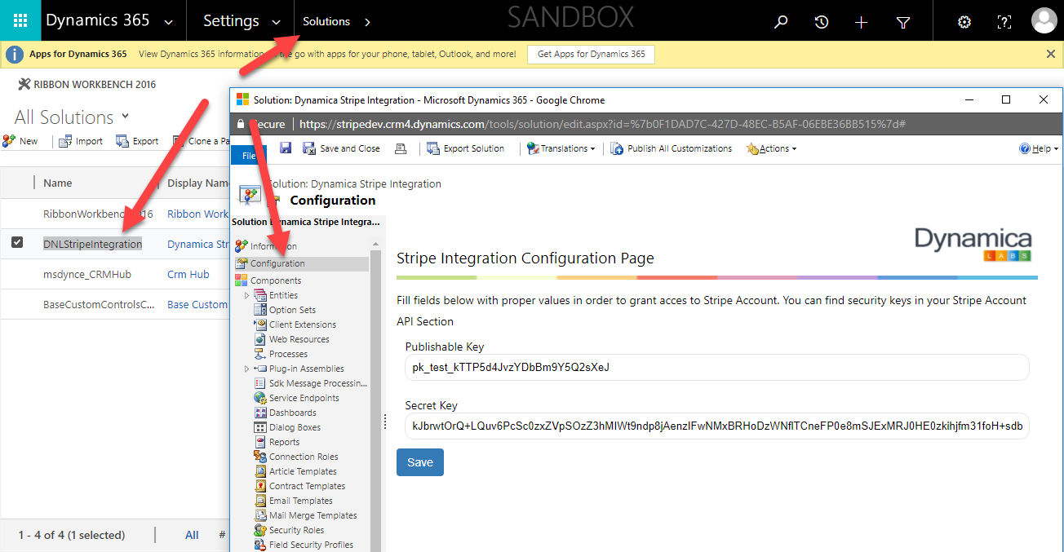

4. Copy Publishable and Secret keys into the form and Save it.
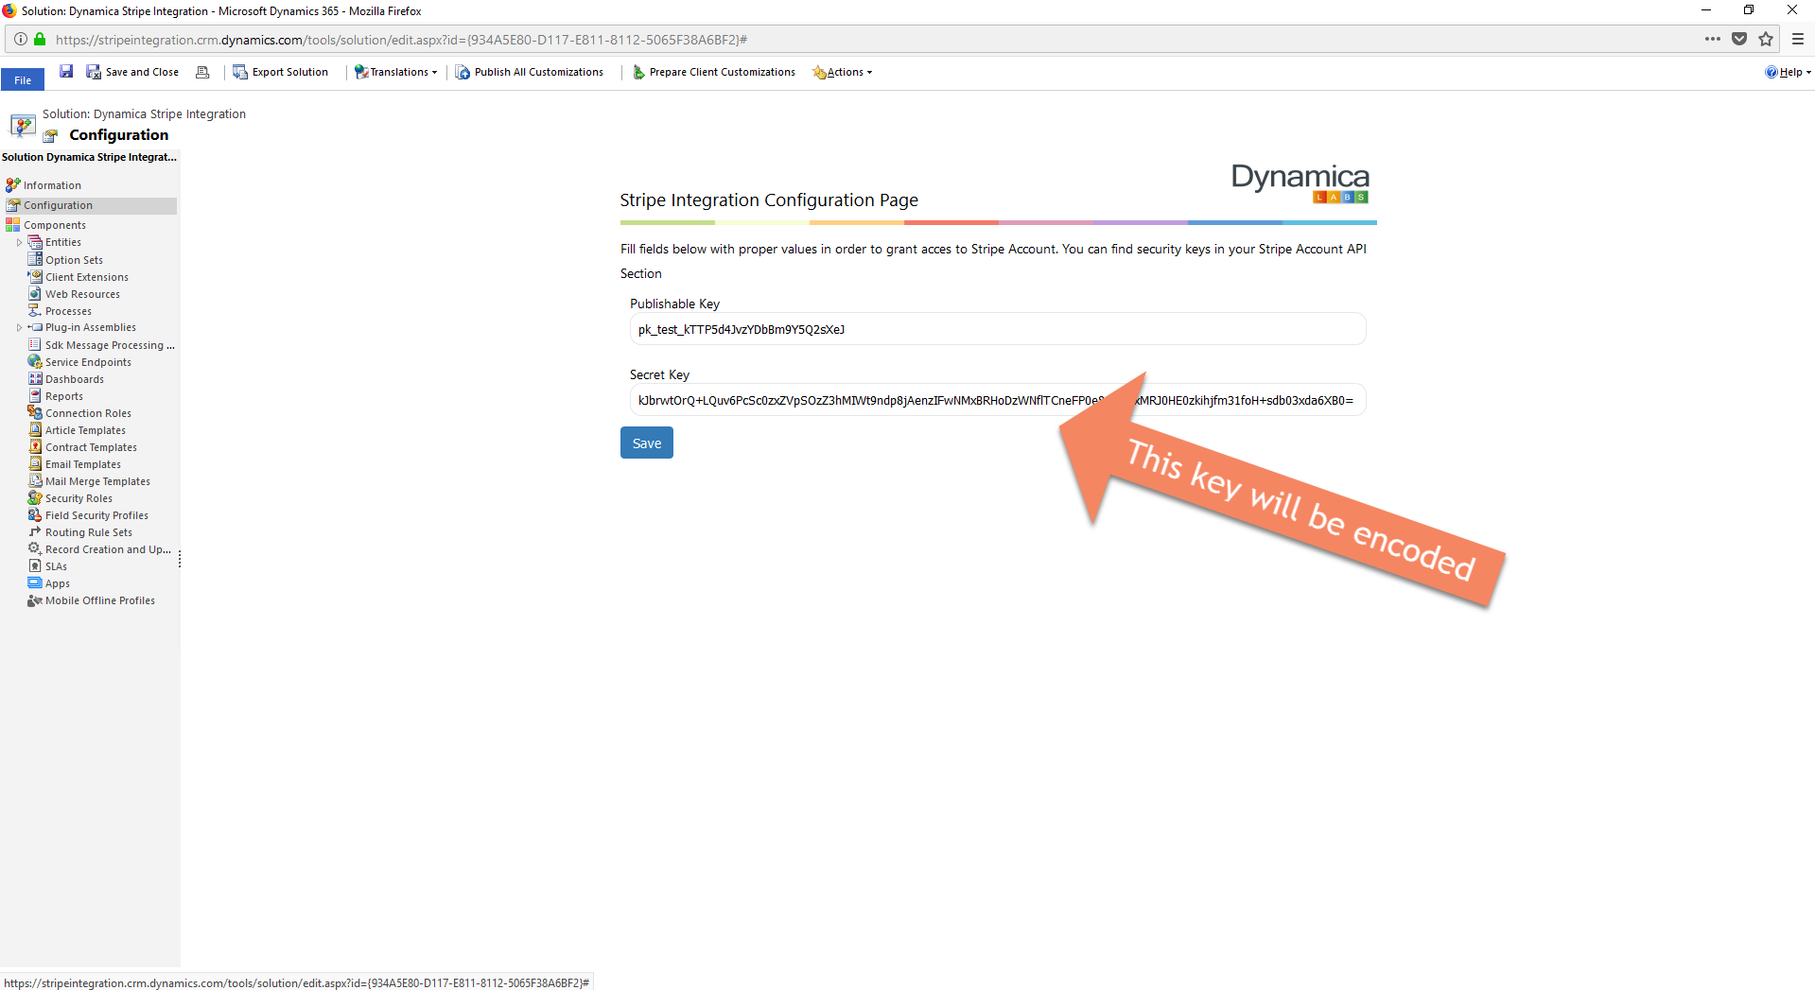
The configuration is done and the solution is ready to use.

Add Credit Cards

To add Credit Cards and associate them with a customer:
1. Open Contact or Account record of a customer;
2. On the ribbon of Contact or Account form find Create Stripe Card button;
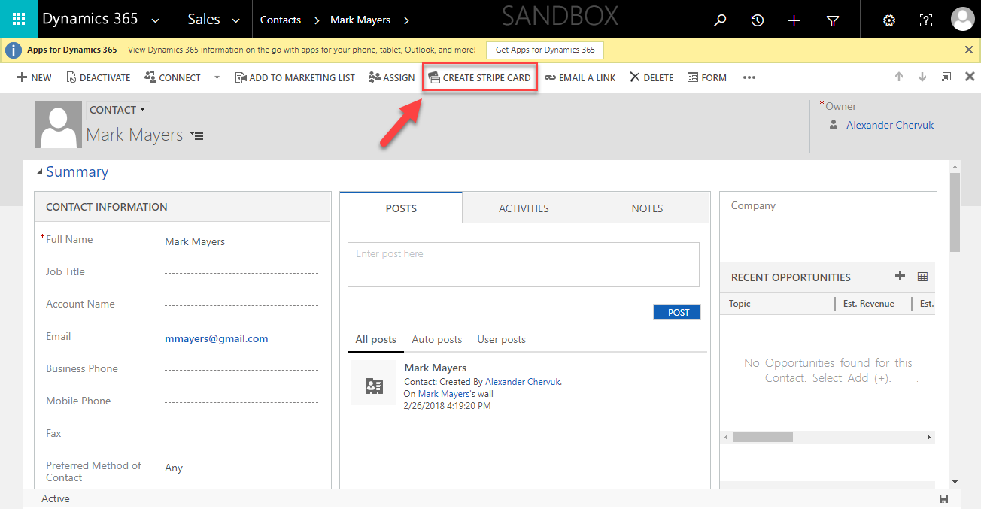

3. Input Card Number, MM/YY, CVV and click Create;
4. The system will process the request and if the credit card information is correct – it will show a message: Success. You have successfully added a card!
Important: customer must have email on the record in order to associate credit cards with him.

Charge Payments

To charge a customer:
1. Create an Invoice or Open existing one;
2. Find Charge button on the ribbon of Invoice form;
3. Select the customer’s Credit Card from the drop-down list and click OK.
Important: customer must have at least one card previously associated with him. See Add Card paragraph above;
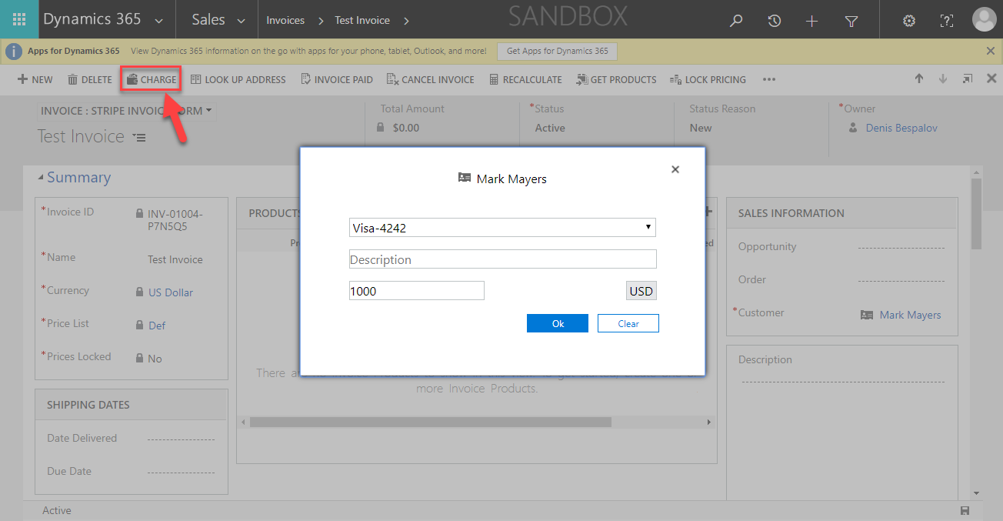

4. A payment request will be created. It may take some time to process the transaction.

Track the Payment Request status

1. Find the payment request in payment requests view: Stripe -> Payment Request;
2. Open a Payment Request record;
3. You can track the Payment Request status in Operation Details section
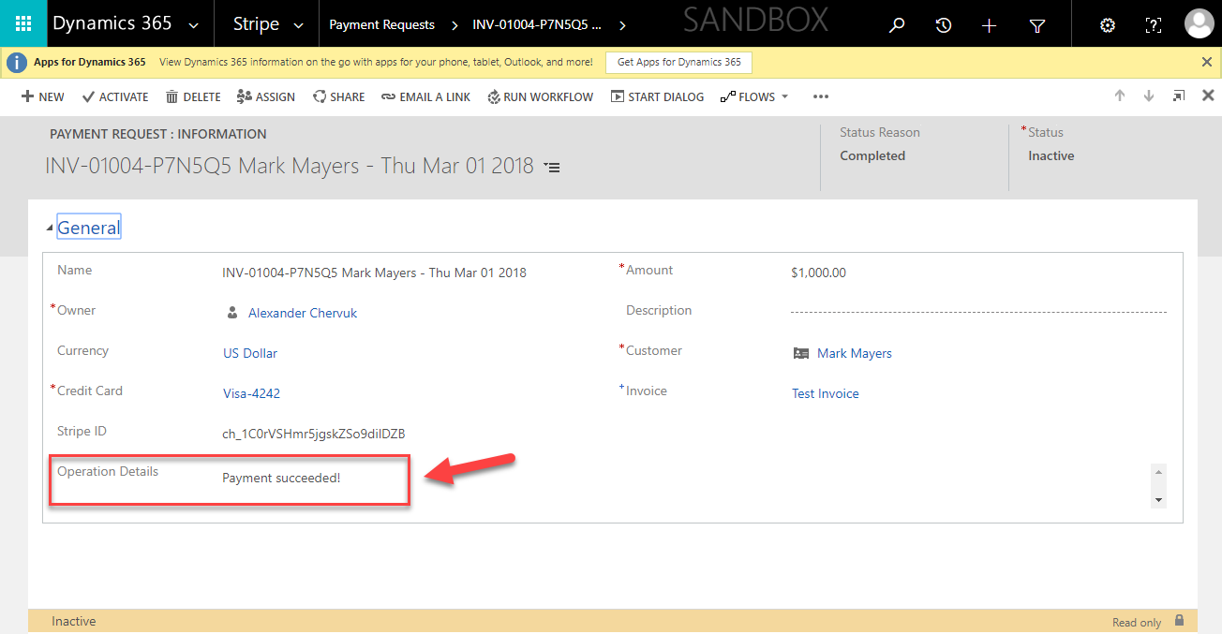

4. Payment requests associated with invoice can also be found on Invoice –> Stripe Invoice Form in Payments sub-grid;
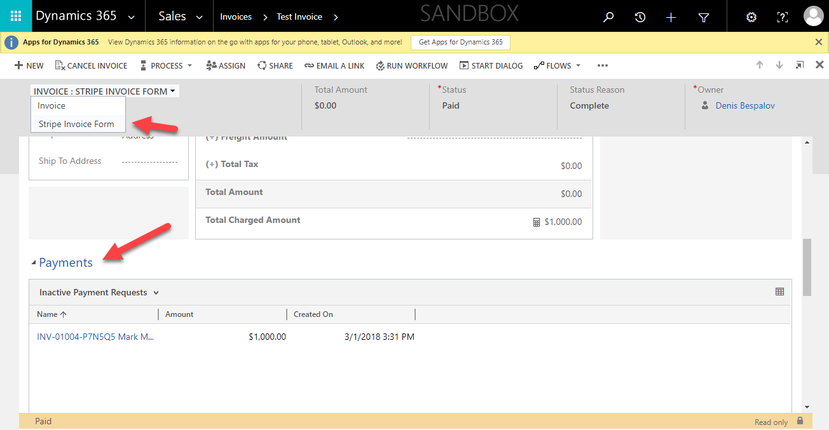

5. When the Payment is processed – it becomes Inactive;
6. If you want to see the Payments sub-grid on any other form – add it with Form Editor.
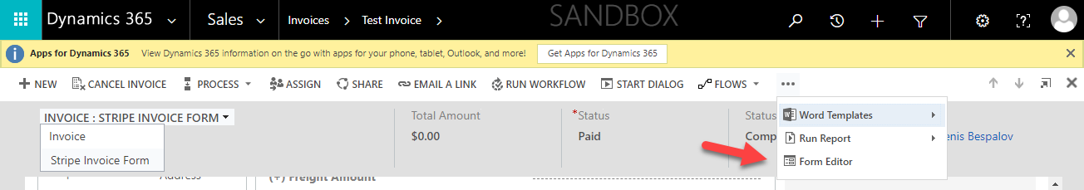

Payments Scheduling

The solution allows creating payments schedule (recurring payments).
To create payments schedule, go to Stripe -> Payment Schedule Requests and then select New to created new schedule.
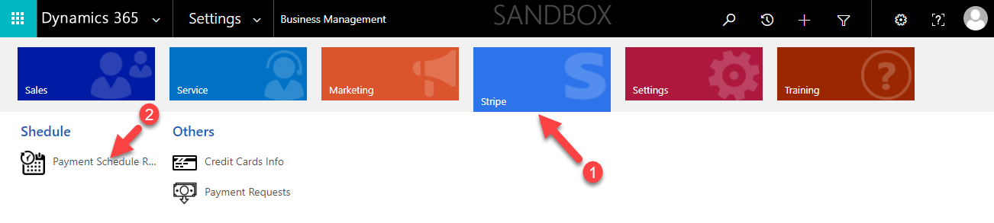

The Payment schedule request form has following fields:

Header section
Status | Active, Inactive
Status Reason | Draft, Scheduled, Inactive
Next Payment Date | The date of the next payment

General Fields and Settings
Name | The name of the schedule
Payment Frequency | Payment Frequency can be set to Daily, Weekly, BiWeekly, Monthly, BiMonthly, Quarterly
Frequency Configuration | Allows to specify the day of the period when the payment should be made
Start Date | Start Date of Payments Schedule (used as a start point in schedule calculation. If the day on which payments should be made is doesn’t match the start date – the actual date of the first payment after initial payment can be different
End Date | End Date of Payments Schedule (used for schedule calculation. Can be different from actual date of the last payment in the schedule
Description | Schedule description
Count | Total Count of Payments
Each Amount | Amount of each payment
Currency | Invoices Currency
Pricelist | Invoices Pricelist
Initial Amount | Amount of the Initial payment that should be made right after schedule creation
Total Amount | Total Amount of all payments (includes initial payment)
Total Charged Amount | Total Amount of already made payments (The field may take some time to update)
Total Pending Amount | Total Amount that remains to be paid

Other Fields and Settings
Customer | Lookup on customer record
Payment method | Customer Credit card
Auto-capture Initial Payment | Allows to automatically charge initial payment right after schedule creation
Auto-capture invoices | Allows to automatically charge payments on due dates

To create Payments Schedule – fill in the form and Save the record.
The solution will calculate and create payments schedule. Status Reason will be changed to Scheduled.
When a payment plan is scheduled – the solution will create invoices on due dates and automatically charge the customer if Auto-capture invoices option is set to Yes.

Direct payment requests

You can also create direct payment requests bypassing invoices.
1. Go to Stripe -> Payment Requests;
2. Click New;
3. Fill in the form and Save it;
4. Wait some time while the payment is processed
5. You can track the status in Operations Details section (you may need to refresh the page in order to see changes);

Note: currently there Is no Credit Card filter on Direct Request form: you can see all Credit Cards in Credit Card Lookup, not only associated with the customer. If you will select card which is not associated with the customer – it will be added to a request, but after processing, it will return an error
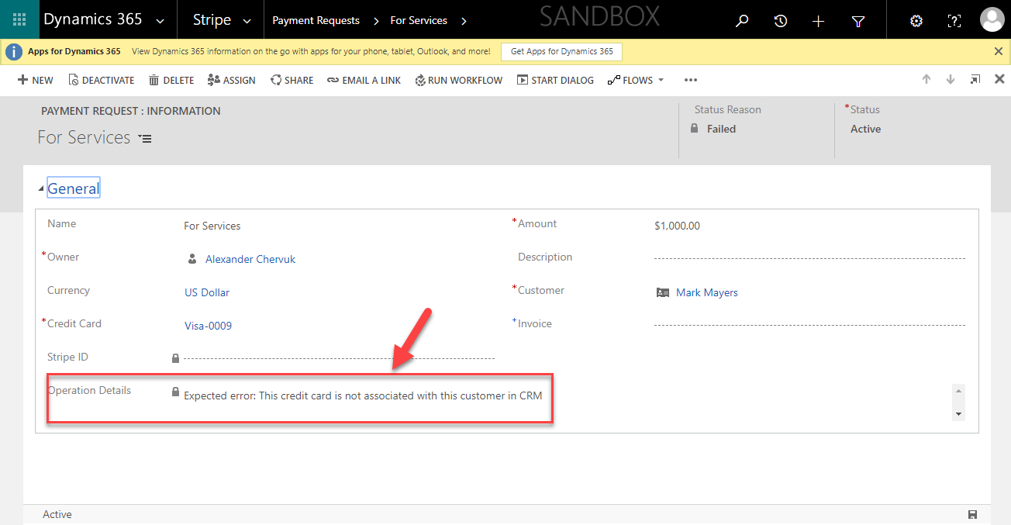

Restrictions

1. When adding credit card - The Solution doesn’t check credit cards for duplicates and allows you to add the same credit card several times to the same customer;
2. There is no Credit Cards filter by customer on Direct Payment Request (request created bypassing Invoice) – you are allowed to add any credit card existing in the system even not associated with the customer;

