E2E Scenarios Template

Primary Persona: | Sales
Configuration Settings | Client: Web Client (Browsers: Chrome, Edge)
Problem / Opportunity Statement: | If you’re managing or leasing some property you must be aware of the difficulties faced during the lease management process. Today lease management of commercial properties is gone beyond the paperwork or spreadsheets.
Pain Points: | - Diffcuality of lease management process  - Diffcuality of lease approvals  - Diffcuality of Maneging inventory (properties)  - Diffcuality of managing lease payments
User Goals: | - Increases the productivity of the Sales team  - Increase the productivity of manage the inventory
Business Goals: | - Improves the productivity of the team  - Improves data accuracy  - Manage your Sales Targets better, by monitoring actuals vs targets for Salespersons and Teams  - Monitor your Sales through daily Sales activities and assign tasks to your teams through online application and/or mobile app  - Improve your Customer Service through various after-sales modules to manage all your Customers’ requests  - Use special payment plans as Promotion, with validity duration  - Block Units/Models/Phases for Treasury, Restructure or else  - Free Social Media Analysis tool for different Social Media Channels in different languages  - Integration Capabilities (Call Center, Website, Customer Portal, Back Office)
Triggers: | - User Adoption of CRM Increases  - Improves Productivity of Users
Narrative Description (e.g., plans, evaluation, actions, objects, context, events): | Easy create company/individual profiles, leases and payments.  Easy manage customers and their leases and payments.
Detailed Steps | Home Page and then Property Managment  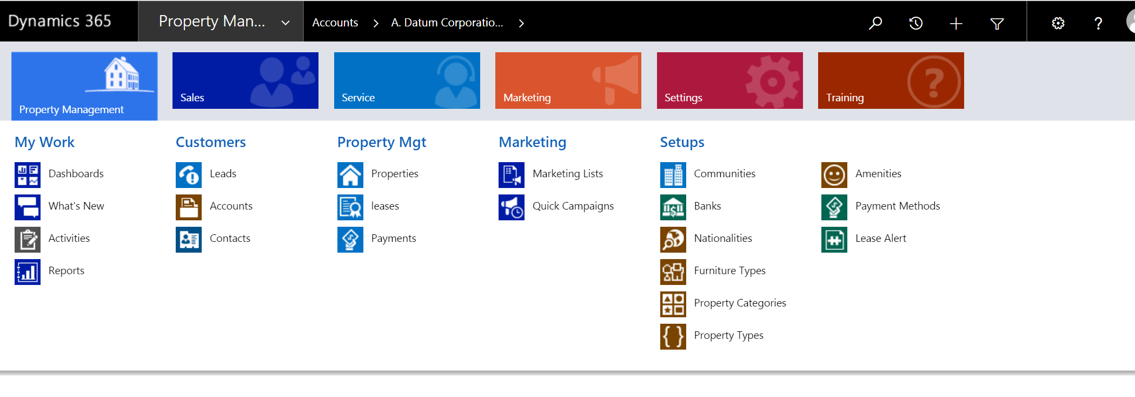  Go to Account  Create a New Account  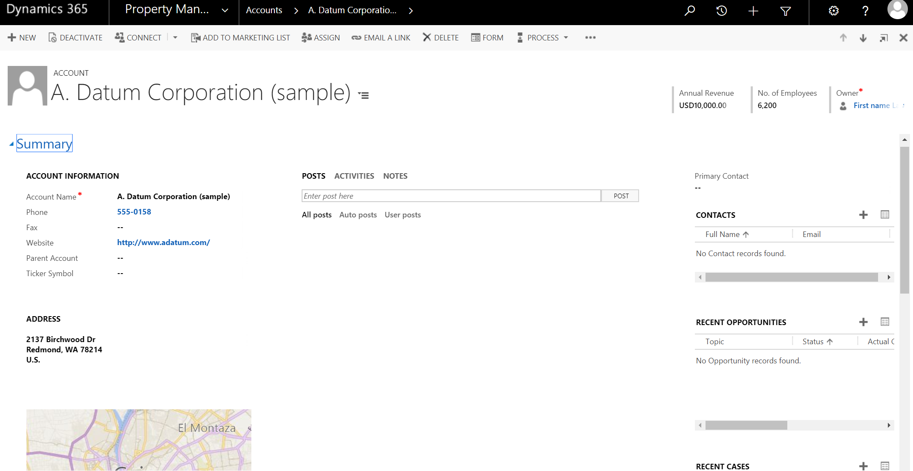  Go to lease  Create a new lease  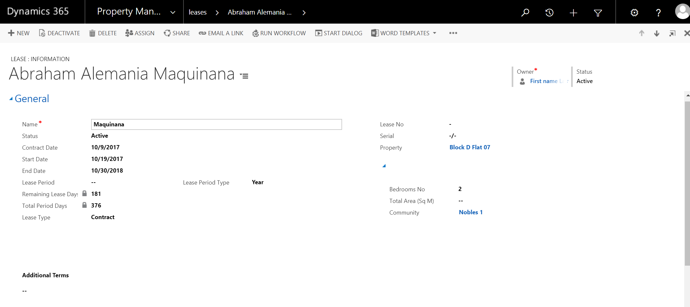
Success Metrics: | - Create Company/individual profile successfully  - Create lease successfully  - Create lease payments successfully  - Track payment

