About
The UAE localization around VAT is focused around getting the local regulatory compliance with Business Central.
One of the key aspect is the upload of the VAT information on the (Federal Tax Authority) FTA web portal. To cater to this requirement a similar form has been developed which segregates the information into sections that are similar to what the FTA required. Consequently the VAT Production Posting group and VAT Business Posting groups are classified into some pre-determined values.

VAT Filing
The VAT filing form presents the data in the exact format rendered by the FTA website. This enables an intuitive way to find the right data from the ERP system instead of trying to pull out different types to reports to compose the details required.
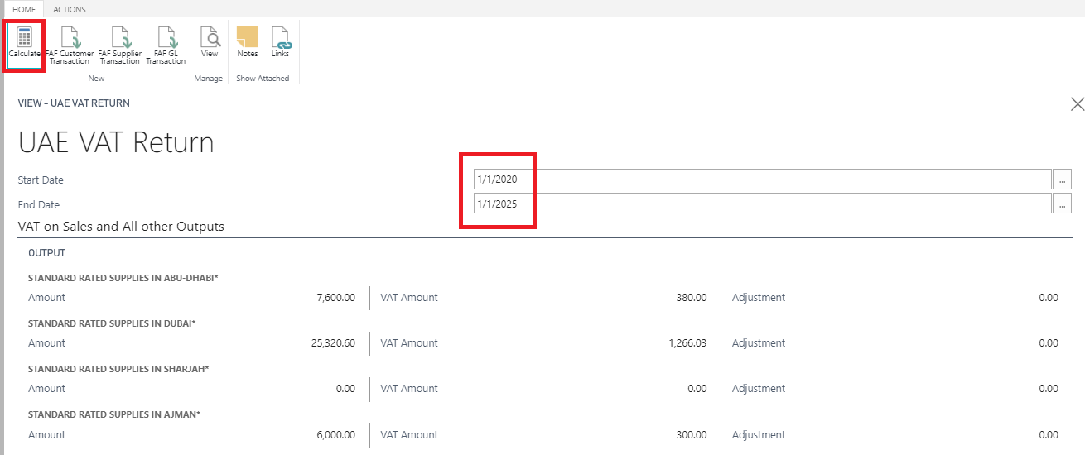

FAF Files
The system allow for generation of the popular FAF files required by the FTA. The files are exported with the required details in an excel format.

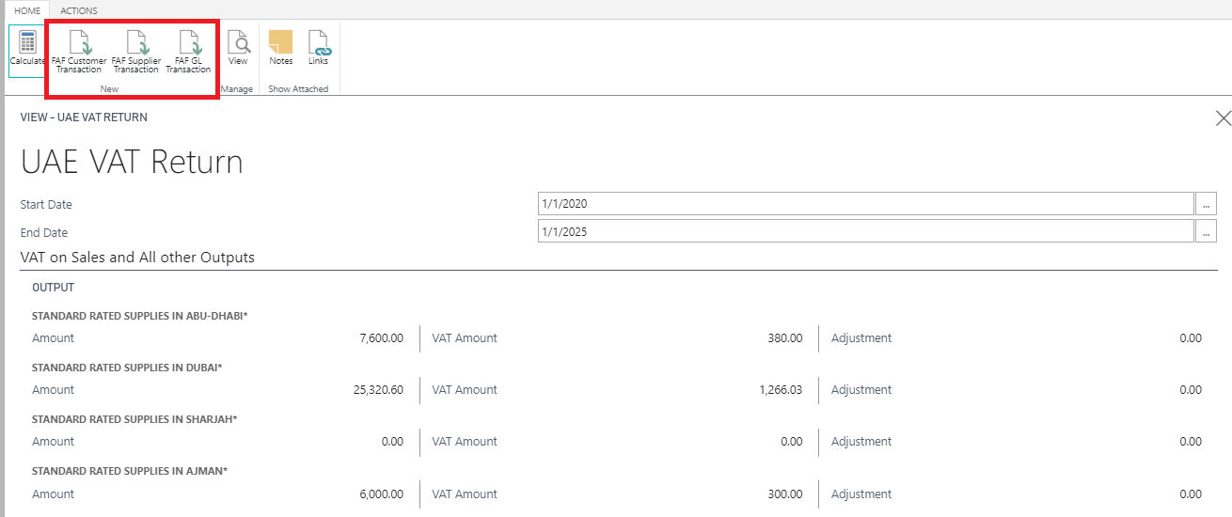

Report Layout Changes
With the VAT enabled, there are some modifications mandated on the outward document layouts of an organization. The documents layouts have been updated and the system ships with a fresh set of reports accommodating these changes. The reports that have been made VAT compliant for this release are listed below.
1. Sales order
2. Sales Invoice
3. Sales return order
4. Sales credit note
5. Purchase order
6. Purchase invoice
7. Purchase return order
8. Purchase debit note
9. Service orders
10. Service Invoice
11. Purchase quote
12. Sales Quote
13. General journal Test report and General journal print. (VAT amount to be shown separately)
14. Purchase prepayment invoice
15. Sales Prepayment invoice

