Greater Real Estate Solution
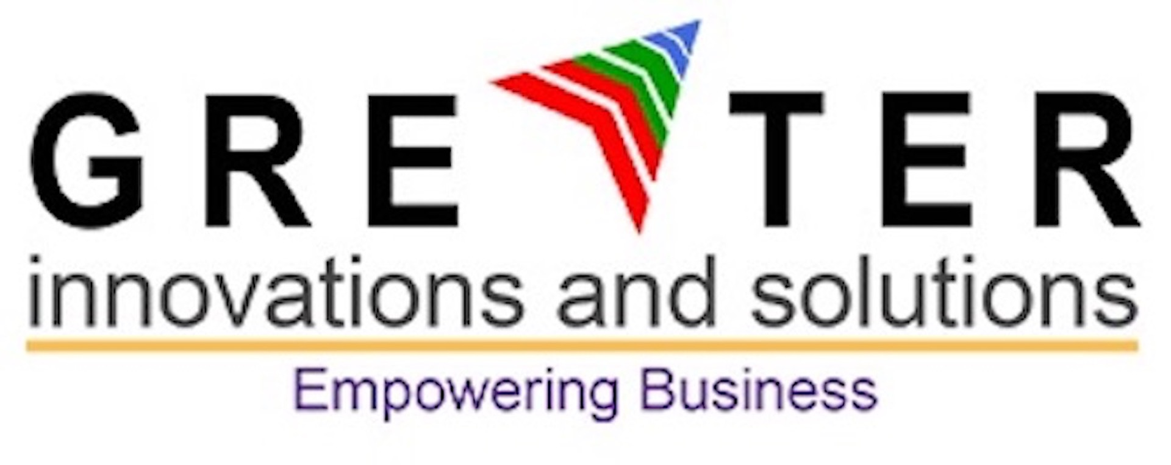
©2019 Greater Innovations and Solutions. All rights reserved.

Real Estate

Proposed Solution Brief
Greater Real Estate
A comprehensive real estate solution for digital transformation powered by Microsoft Dynamics 365
The way the customer decides on a property, starting from their enquiry to signing tenancy contract has dramatically changed. Customer expectation has moved into a new level of experience with clarity on next steps and convenient assistance on every stage of the customer journey.

Greater Real Estate solution is a best-in-class solution for real estate industry. It helps the organizations to drive their digital transformation and adapt to cutting edge digital solutions.
A better experience to the customer can be offered with existing amount of resources by utilizing industry best practices using Greater Real Estate.

Solution Benefits:
- A comprehensive real estate solution
- End to end automation empowers organization’s digital transformation
- Available on Microsoft Dynamics platform
- Utilizes the global solution echo system
- Utilizes Microsoft Dynamics modules such as sales, marketing, customer service, field service, project service automation, voice of customer, social engagement etc.

Solution Overview of Greater real estate
- Property Listing
List own properties or third-party properties for rental.
- Property Pricing
Define pricing rules and generate rent as per the rules defined or upload rent from Excel. Identify pricing trend in different region.
- Payment Term Management
Define payment term using templates to collect the payment from customer in Installments. Define different payment term template for each project/property.
- Print Template Management
Define various templates to print tenancy contract, receipt, statement of account etc.
- Property Rental Management
Lead tracking, inventory search based on customer preferences, quotation, token amount & property reservation, convert to rental, contract management, post rental such as contract renewal, termination, extension etc.
- Collection, PDC and Payable Management
Follow-ups on payments, receipt management, payables and receivables, complete check/PDC management.
- Tax Management
Setting up tax rules and auto calculation for tax and tax collection.
- Other Automations
Broker management, commission definition and auto calculations, document management and legal/dispute management.

