User guide – integration from BatchFlow4 to Business Central

Setup Guide
When getting started with the BatchFlow 4 integration you have to make some setup first
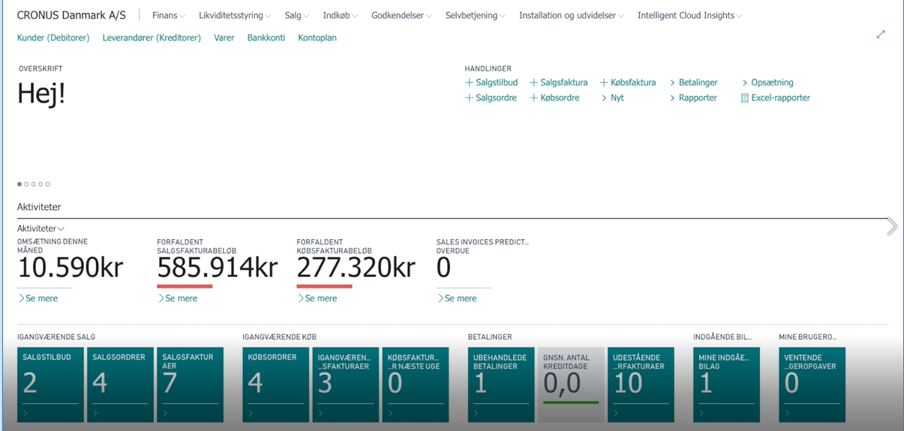
Choose ‘Search’ and type Batchflow
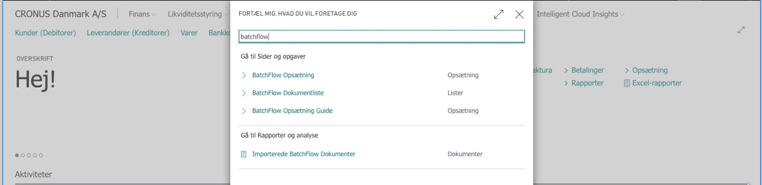
Choose Batchflow setup Guide
Follow the guide in all the steps
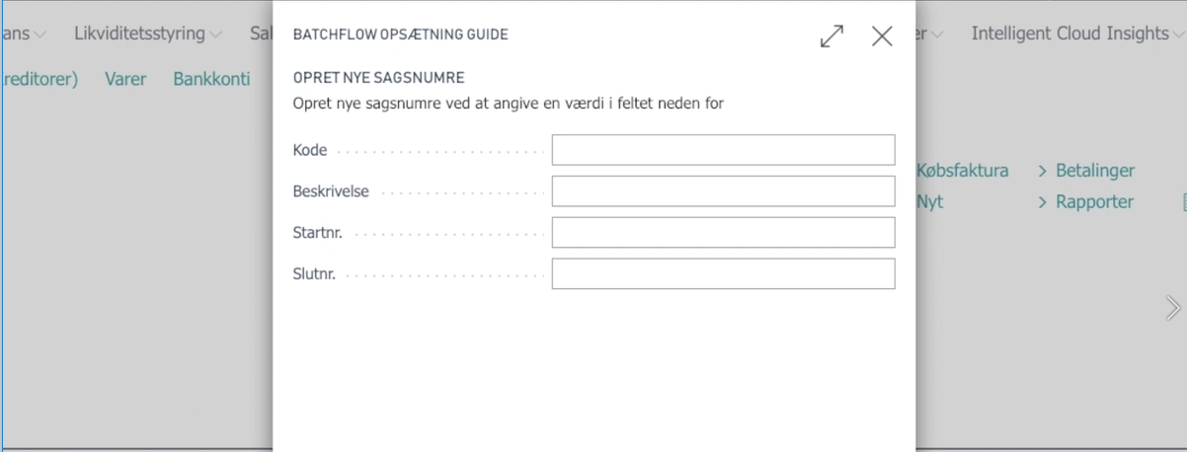
End the guide by choosing ‘End’

Use the integration
Use the seach function to find the Purchase Journal
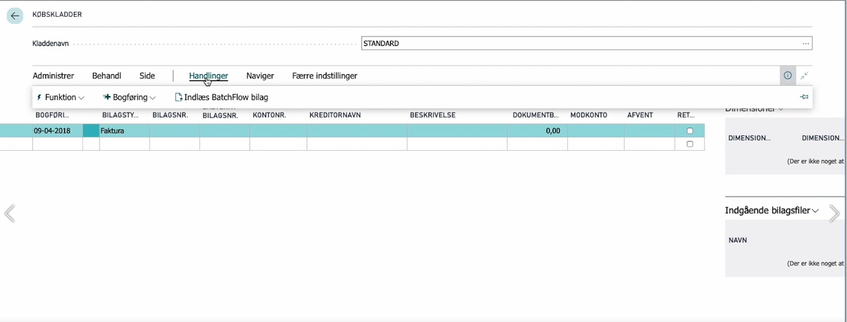
Choose Actions, and Import Batchflow Documents
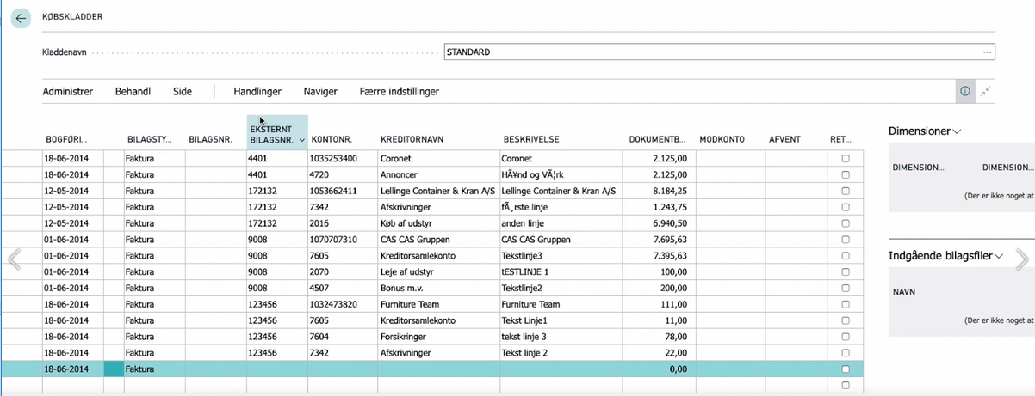
The journal will now contain documents from BatchFlow. You can choose to book the journal. If there is something you like to change, you can make the changes in the journal lines. You can also choose to delete the journal and import the entries again.

Lookup documents in BatchFlow from Business Central
When you have booked a journal and want to look into a document afterwards, you can find the booked entry in Business Central and look up the Document in Batchflow
Use the search function to find the vendor ledger entries.
Find a booked document

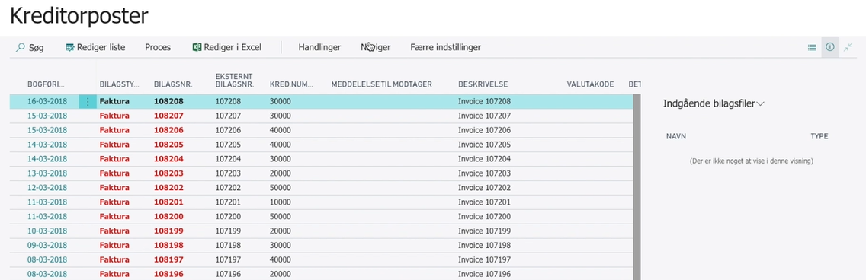
Use Navigate and choose Batchflow and Look-up document
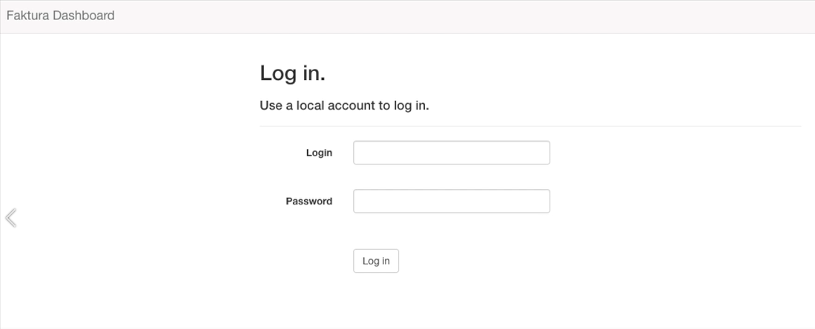

Use you username and password to BatchFlow to get access to the documents.

