App Name: Commercient SYNC for Sage and Microsoft Dynamics CRM
Commercient SYNC for Sage and Microsoft Dynamics CRM integrates your Sage system with Microsoft Dynamics CRM. The Commercient SYNC Agent is rapidly deployable and gives you access to your Sage customer and order information in Microsoft Dynamics CRM. We are compatible with Sage editions: 50, 100, 300, 500, X3, AccPac, US/UK/EU. Commercient is certified for use on the Microsoft Dynamics CRM mobile platform.
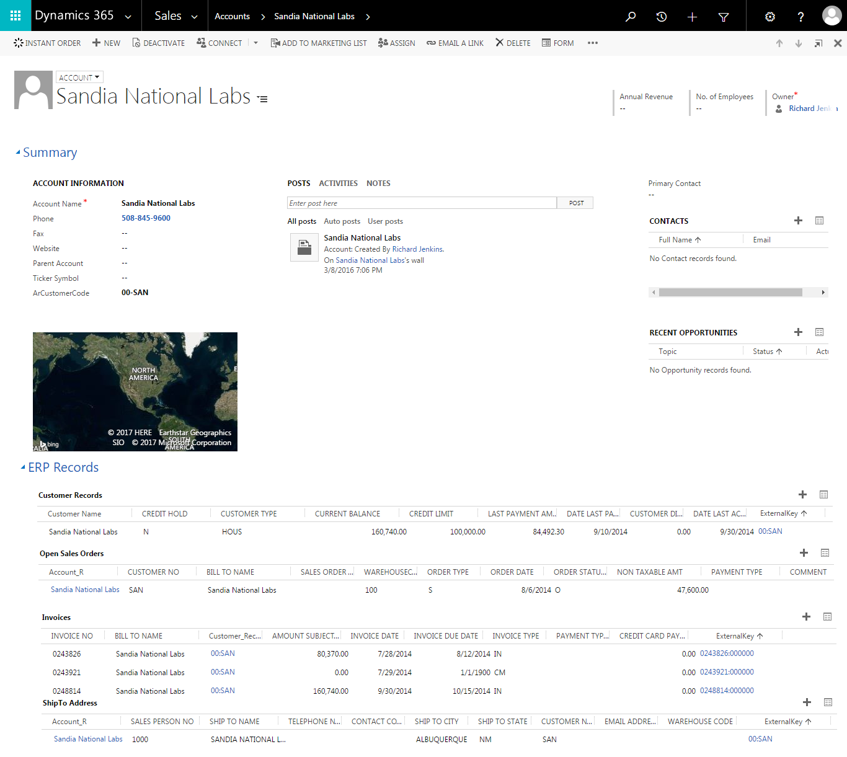
About the SYNC:
- Sage data is automatically mapped to Microsoft Dynamics CRM so you don’t have to program anything.
- Changes are reflected in Microsoft Dynamics CRM as the records in Sage change.
- Commercient SYNC is built by ERP integration experts.
- Commercient software provides Sage users with a “CRM in the cloud” experience.
- Any field synced from Sage can be displayed on the Microsoft Dynamics CRM screen. All of the data Commercient SYNCs to Microsoft Dynamics CRM becomes part of Microsoft Dynamics CRM’s native database. As such, you can perform any Microsoft Dynamics CRM function on the data—from graphing to dashboards to using third party apps that can make use of the data.
- Commercient has provided the means to make the data searchable in Microsoft Dynamics CRM. For instance, search for a serial number and find the Invoice Records and Sales Order records that pertain to it.
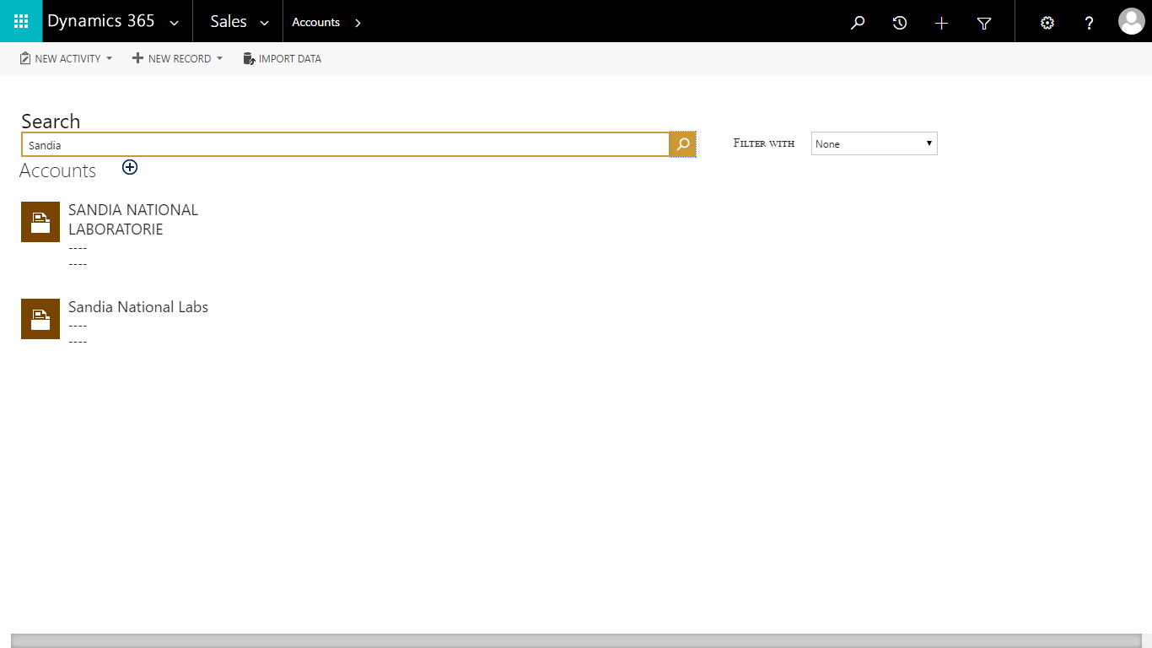
- The SYNC tool only uploads or updates data when it changes. Commercient has an eye for detail and has programmed its services to make efficient use of tracking changes and submitting records to the Microsoft Dynamics CRM API in a single call. The result is that Commercient significantly reduces the likelihood of exceeding the Microsoft Dynamics CRM AP usage limits. In the event that a daily limit is reached, which can occur during the initial SYNC of a large Sage system, Commercient will continue to SYNC where it left off on the following day.
What is synchronization?
The Sage AR Customer record is the first item to be synced. Customers in Sage are synchronized into Microsoft Dynamics CRM Account records. The Customer’s Ship To and Bill To addresses in Sage are mapped to Microsoft Dynamics CRM’s address fields using a mapping schema. The Sage Customer fields can be displayed on the Microsoft Dynamics CRM screen however you like—you may decide to show Credit Limit, Outstanding Invoice Value, and the On Hold status onto the screen while hiding other fields. By clicking on the Sage Customer Record, you can see all of the fields that are synchronized.
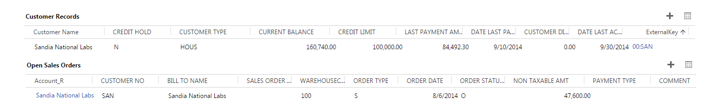
Once the Customer Record is in Microsoft Dynamics CRM, Commercient then SYNCs the Sales Orders and their Detail Lines and relates them to the corresponding Microsoft Dynamics CRM Account record. Commercient has consolidated the Sales Order data and the Invoiced Sales Order data into single merged objects in Microsoft Dynamics CRM in order to simplify the Microsoft Dynamics CRM screens. With this approach, a user can easily see Sales orders and Detail Lines with their Invoices, as well as viewing the status of Sales Orders as they change in Sage. Cleansing of Cancelled Sage Sales Order data from Microsoft Dynamics CRM is performed automatically.
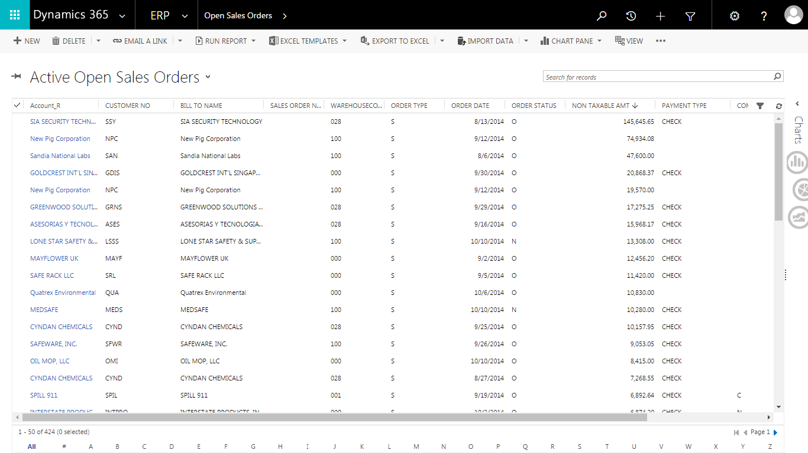
Commercient has crafted the relationships with the data objects in Microsoft Dynamics CRM so that you are able to decide which objects you would like to display onscreen. You are always able to click to other parent- or child-related objects. For example, an Admin user can remove the Sales Orders from the Account screen but leave their Detail Lines. This allows salespeople to see what was sold and shipped from the main Account screen without clicking anywhere; they can still click the Sales Order link on the detail line to open the full Sales Order Screen.
The AR Invoice records are synced and related to the Invoiced Sales Order Data, and the Invoice Payments.
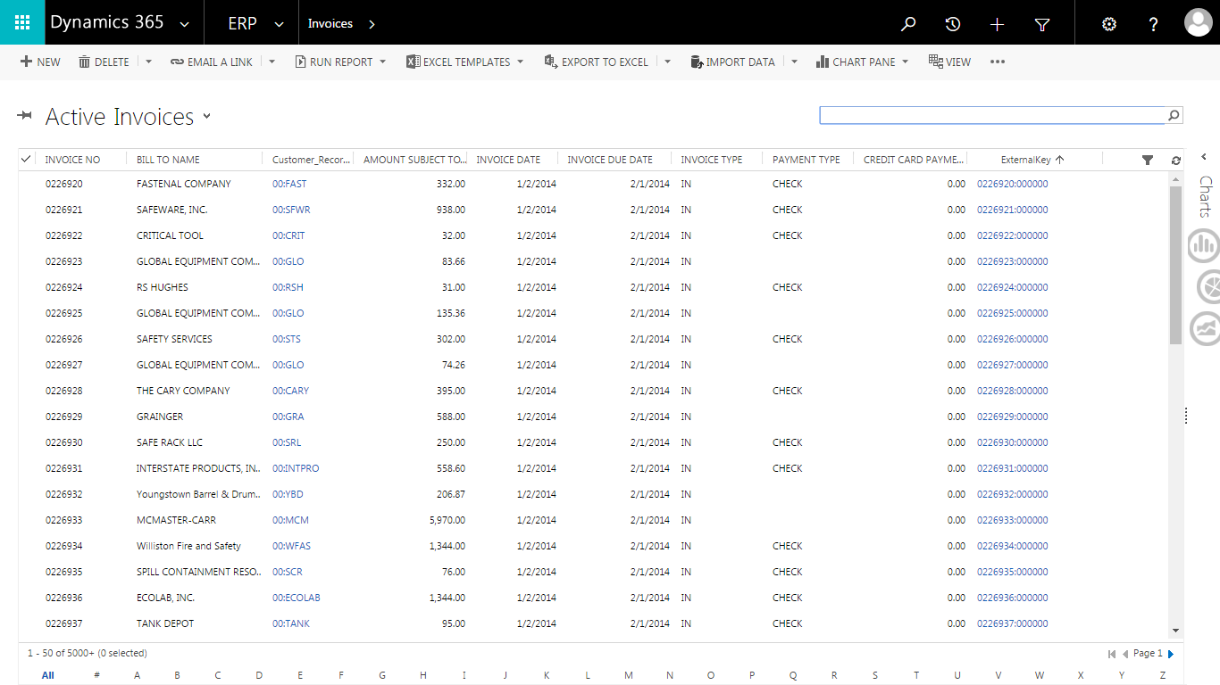
The AR Invoice data is useful for spotting unpaid invoices and being able to drill down into the data. The other records which are synchronized include the AR Customer Ship to Tax Exemptions, Item Master, and Item Warehouse. Commercient creates Microsoft Dynamics CRM Products from the Item Master and associates the entire Item and Warehouse records to the Product. This gives you the ability to have accurate product data and Inventory availability.
In addition, you can SYNC any Database, table, or view.
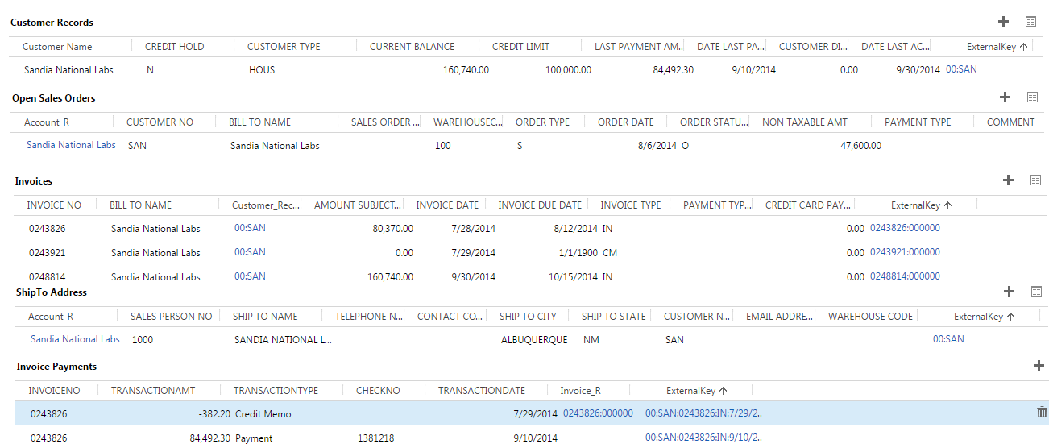
What if I have an existing Microsoft Dynamics CRM database?
Clients with existing records in both Sage and Microsoft Dynamics CRM must consult with the Commercient Professional Services team to perform a clean-up and match-up of records before the Commercient SYNC is enabled.
Can I limit or control the data that I SYNC?
Yes. Commercient has created an open methodology of allowing you to control filtering of data in the SQL WHERE statement while maintaining the integrity of relationship mapping and efficient syncing methodologies. Within the WHERE you can perform sub queries, filters, and cross-table and cross-database sub-queries to affect the rules. In addition, you can also map custom tables or views. (Charges may apply.)

What else does Commercient do with Microsoft Dynamics CRM?
Data synchronization is the first step towards a total solution. Ask about these additional modules for Sage:
- Quote Processing
- Web-based Product Configurator
- Opportunity and Quote -> Sales Order Conversion
- Products and Price Book SYNC
- Product Record Types
- Cases with Serial Numbers Invoiced and Service Orders
- Opportunity Commissions Calculations based on Sage Invoices
- Automatic Sage Sails Order Email Engine
- Automatic Invoice Email Engine
- Dealer/Wholesaler Self-Service Portal
- Custom Data synchronization
- SF Account Conversion to Sage AR Customer
System Requirements:
Microsoft Dynamics CRM Group, Professional, Enterprise editions or higher. Microsoft Dynamics CRM API is included at no charge.
Company Information:
Commercient is a Cloud-based company that connects Microsoft Dynamics CRM.com directly to your Sage ERP system. Our open SYNC Agent works with ERPs such as Epicor, SYSPRO, Traverse, and other ERP accounting systems. Commercient improves the efficiency of getting CRM, B2B, and B2C eCommerce orders directly into your accounting system in real time, with all of the associated business rules.
For more information, please use the Contact Us link on www.commercient.com.

