MANUAL OF USE

FOR

THE MAILCHIMP SYNCHRONIZATION SERVICE

&

CRM SOLUTION

BY VENDERE

Version 1.02

10/08/2017

Contents
1. Installation 1
1.1. Installation requirements 1
1.2. Installation components 1
1.3. Solution CRM installation 1
1.4. CRM solution configuration 2
1.5. Mailchimp Master List Setup 3
1.6. CRM solution user for service 3
1.7. Windows service for MC synchronization installation 5
1.8. Windows service for MC synchronization Registration 6
2. How to use our solution 8
2.1. Synchronization of contact/members 8
2.2. Un-synchronization of contact/members 9
2.3. Synchronization of lead/members 9
2.4. Synchronization of lead/members 9
2.5. Synchronization of account/members 10
2.6. Synchronization of account/members 10
2.7. Synchronization of lists/group 10
2.8. Un-synchronization of lists/group 11
2.9. Manual refresh of a synchronize list 12
2.10. View Campaign information in CRM 13
2.11. View Email send information in CRM 13
2.12. View Email Activity information in CRM 14
2.13. View the errors log 14
3. Uninstall procedure 15
3.1. Uninstall the service 15
3.2. Uninstall the solution 15
4. Synchronization Service Options 16
4.1. Send CRM contact fields into Mailchimp merge field 16
4.2. Log Mailchimp service events 17
4.3. Mailing 2015 18
4.4. Mailchimp double opt-in 18
4.5. Unsubscribed creates new member on an email change 18
4.6. Cleaned creates new member on an email change 18
4.7. Mailchimp double opt-in override link 18
5. Standard Mailchimp Operation 19
6. Error logging 19
7. Not supported functionality 19
ANNEX I 20
1. Contact 20
2. Lead 22
3. Account 24
4. Marketing List 25
5. Mailchimp Campaign 26
6. Mailchimp Configuration 27
7. Mailchimp Master List 28
8. Mailchimp Email 28
9. Mailchimp Email Activity 29
10. Mailchimp Error Log 29

Installation

Installation requirements
The following components are required for the product to function correctly:
- A Windows OS to host the Windows Service.
- A CRM Instance.
- Admin right on the instance.

Installation components
Inside your installation packaged you will find:
- One managed CRM solution.
- One Installer executable.

Solution CRM installation
You will need to import the CRM solution into your CRM instance.
Steps:
- Open and log-in your CRM instance.
- Find in your menu the setting tab and select it.
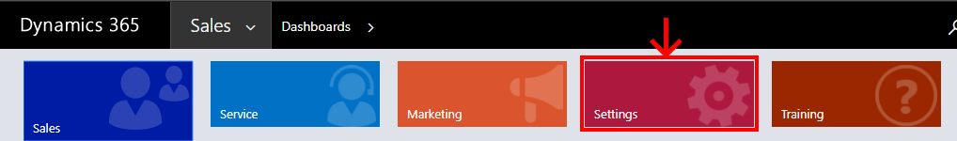
- Under the setting tab, under the customization section, select the Solutions link.
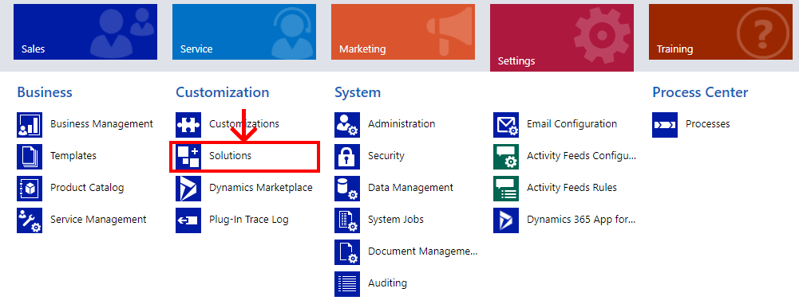

- Once inside the Solutions window, use the import button and select the CRM solution inside the installation package.
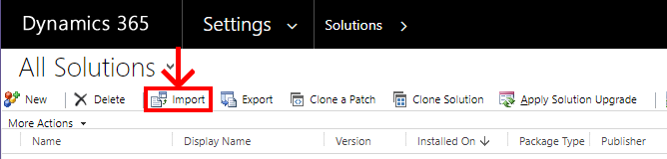
- Once the import is complete you should see our solution in the solution list.
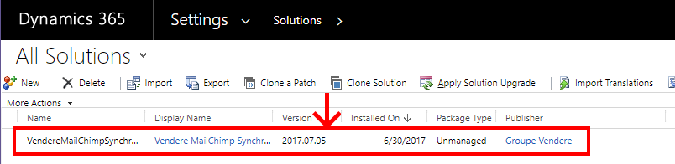

- You are now ready to configure the CRM solution of our product.

CRM solution configuration
- Open an advance find panel.
- Use the Look for: dropdown list to find and select the MailChimp configurations entity. (they are in alphabetical order)
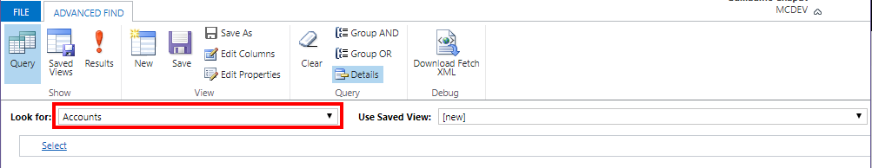
- Once selected click on the Result button, you should be transfer to a new tab called MAILCHIMP CONFIGURATION.
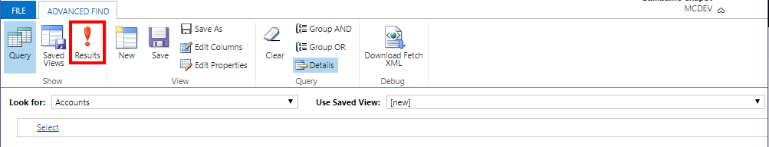
- Press the button New MailChimp configuration
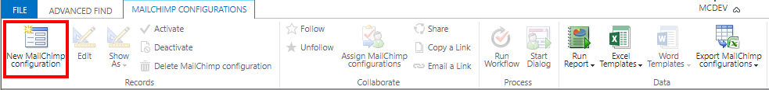

- Enter the required information’s:
  - Name
  - The License key
  - The Mailchimp API Key

Mailchimp Master List Setup
- Open an advance find panel.
- Use the Look for: dropdown list to find and select the Mailchimp Master Lists entity.
- Once selected click on the Result button, you should be transfer to a new tab called MAILCHIMP MASTER LISTS.
- Press the button New Mailchimp Master List
- Enter the required information’s:
  - Name (name with 50+ characters will be trunk to 50)
  - CRM Member Type

You can only have one master list of each type: one contact, one lead, one account. Add those you want to use.

CRM solution user for service
For the installation of the service you will need a user dedicated to it with the Mailchimp service security role provided by our solution
- Open the setting tab

- Select the Security link under the System section.
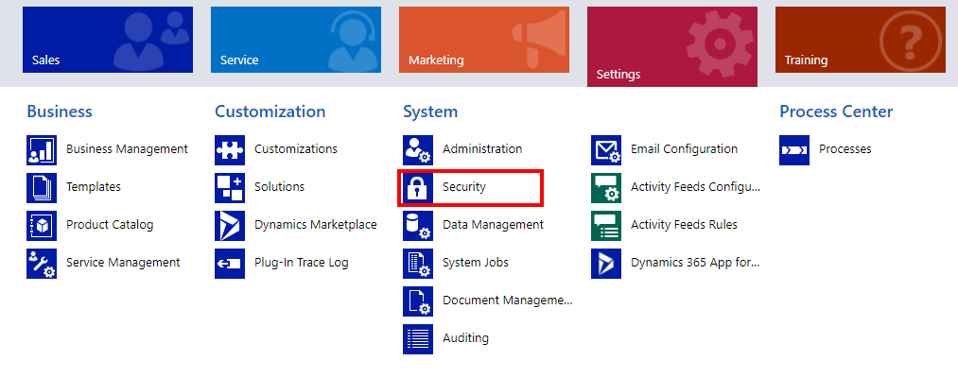
- Enter the Users window.
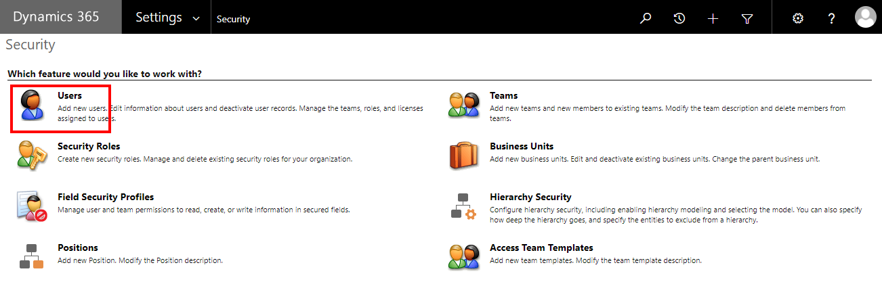
- Create a NEW user

- Select that new user then click on the MANAGE ROLES
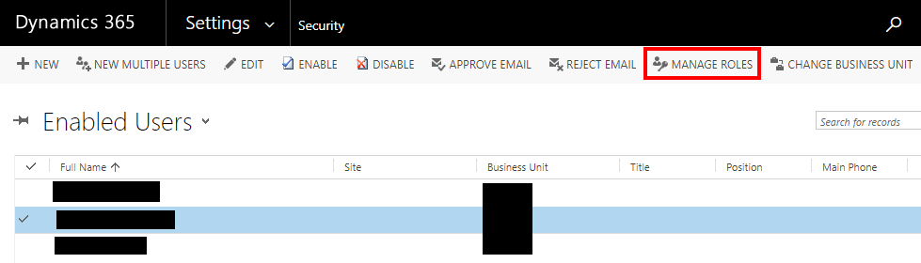

- Add the Mailchimp Service security role then click ok.
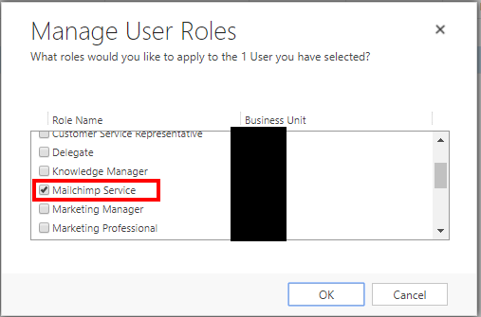

Windows service for MC synchronization installation
- Execute the Windows Service Installer inside the package.
- Choose the installation path of your choice and click install.
- That is all now we go to the registration of the service.

Windows service for MC synchronization Registration
- Open the folder where you installed the windows service.
- Execute Vendere.mailchimp.integration.service.exe as Administrator. (right click the mouse button on the exec and choose run as administrator)
- Enter the URL of your CRM.
- Enter the credential of the service user.
- Click on the Update configuration button.
- Click on the Register button.
You will now be able to see your service in the windows service list
- When you are asked to start the service, click yes.
If you click no, you will need to go in the windows service list and start the service manually.
- The service is operational.

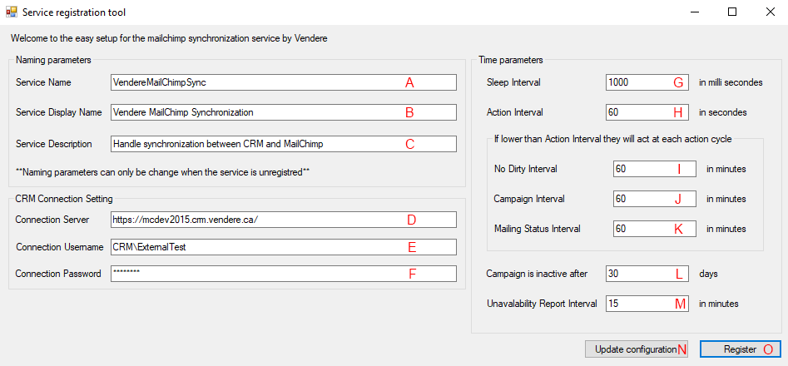

In this window, you can change many parameter of the service, the naming parameters will be how windows will see the service and how he will display it to you, just make sure that the service name is unique.

To the right, there is the time parameters, they can be change to a certain extend but we highly recommend to leave it by default.

And finally, the CRM connection string. Those will be empty on a new installation and must be fill with your CRM URL as well as the credentials for the user we have setup before, the one with the Mailchimp service security role.

*The config file is encrypted to ensure nobody can directly access password and other sensitive information that may be stored by the service.

Description of each field and button below.
- This field is the name the service will have for window. The name must be unique for each service, we recommend to keep the default and add something of your own. No space is allowed. Maximum 80 characters.
- This field is the name the service will have for the user. Maximum 80 characters.
- This field is a description of the service Maximum 80 characters.
- This field is the URL to your CRM. Exemple: https://foobar.crm.vendere.ca/
- This field is the username the service will log on. Example: Domain\foobar, foobar.
- This field is the password of the username used by the service entered just above. Example: ********
- This field is the interval of how much time the service will sleep after completing a work cycle. The service can wake up and do nothing and go back to sleep if there is nothing to do. Is set in milliseconds.
- This field is the interval of how much time the service will take before launching a work cycle. This interval is check each time the service wake up. Is set in seconds.
- This field is the interval of how much time must pass between execution of the non-dirty related action. (research of new unsubscribed members and new hard bounce members, these actions are always done if there is dirty actions)
- This field is the interval of how much time must pass between the research of campaign and the activities related to it. (this interval is check each action cycle)
- This field is the interval of how much time must pass between the updates for the mailing status in mode 2015 (selected in the Mailchimp configuration entity, this interval is check each action cycle)
- This field indicate how much time must pass since the last reported activity for a campaign to stop checking it.
- This field is the interval between each error report of CRM unavailability.
- This button will save the change you made.
- This button has two states, register if the service name saved is not in use and unregister if it is in use:
  - Register: Will install the service as a Windows service and then ask you for starting it.
  - Unregister: will stop the service if he is running, then he will uninstall it.

How to use our solution

Synchronization of contact/members
Any contact that was in a new synchronize list will be automatically synchronize. Any contact that are added to an already synchronize list will be automatically synchronize.
(You must have created the master list of contact for the synchronization to work)
- Go to Contacts from under the Service Tab.
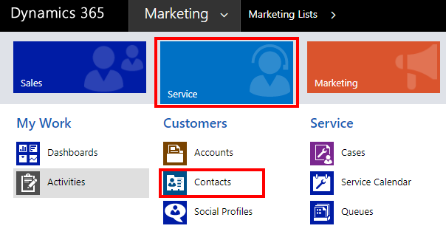
- Select the contact to synchronize to Mailchimp.
(No maximum but keep your eyes on your Mailchimp account since you pay for the amount of member you have)
- Open the Run workflow window.
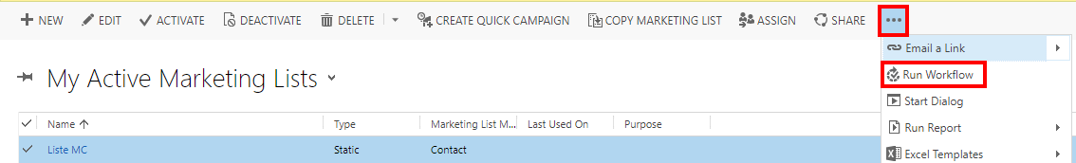
- Launch Envoyer vers MailChimp / Send to MailChimp.
- In the next cycle of the service your selected contact will be synchronize to Mailchimp as a member in the master list of Mailchimp.

Any contact can be in multiple list at the same time, you only need to add said member in each list you want him to be.

Un-synchronization of contact/members
- Go to Contacts from under the Service Tab.
- Select the synchronize contact to un-synchronize from Mailchimp.
- Open the Run workflow window.
- Launch Enlever de MailChimp / Remove from MailChimp.
- In the next cycle of the service your selected contact will be removed from Mailchimp.
*** Removing a contact from Mailchimp will not affect the contact membership inside his CRM marketing list but he won’t be in the Mailchimp group anymore.

Synchronization of lead/members
This operation is exactly the same as 2.1 Synchronization of contact/members to the exception that you will go in the Lead entity instead of the contact.
(You must have created the master list of lead for the synchronization to work)

Synchronization of lead/members
This operation is exactly the same as 2.2 Un-synchronization of contact/members to the exception that you will go in the Lead entity instead of the contact.

Synchronization of account/members
This operation is exactly the same as 2.1 Synchronization of contact/members to the exception that you will go in the Account entity instead of the contact.
(You must have created the master list of lead for the synchronization to work)

Synchronization of account/members
This operation is exactly the same as 2.2 Un-synchronization of contact/members to the exception that you will go in the Account entity instead of the contact.

Synchronization of lists/group
Each marketing list that is synchronized with Mailchimp are represented as group in Mailchimp.
- Go to Marketing List from under the Marketing tab.
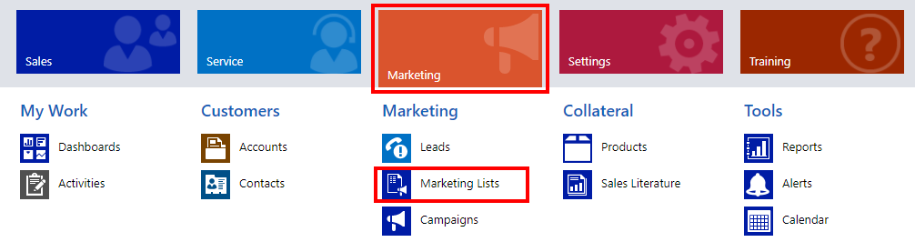
- Select the lists to synchronize to Mailchimp.
(Maximum 60 lists can be synchronized at the same time for each master list)
- Open the Run workflow window.
- Launch Envoyer vers MailChimp / Send to MailChimp.
- In the next cycle of the service your selected list will be synchronize to Mailchimp as a group in the master list of Mailchimp.

*** This action might take hours if done on a massive list be alert.

Un-synchronization of lists/group
- Go to Marketing List from under the Marketing tab.
- Select the synchronize list to un-synchronize from Mailchimp.
- Open the Run workflow window.
- Launch Enlever de MailChimp / Remove from MailChimp.
- In the next cycle of the service your selected list will be removed from Mailchimp.

*** Removing a list from Mailchimp will not remove the associated members, those members will remain in the master list as a no group affiliated members if the removed group was their only one.

Manual refresh of a synchronize list
In some cases, errors can be fixed by a manual refresh of a marketing list.
- Go to Marketing List from under the Marketing Tab.
- Select the synchronize list to refresh into Mailchimp.
- Open the Run workflow window.
- Launch Actualisation de la liste / Refresh of the list.
- In the next cycle of the service your selected list will be completely refresh by force.
*** This action might take hours if done on a massive list be alert.

View Campaign information in CRM
- Go open the Advance Find window.
- In the Look for field, select Mailchimp Campaigns.
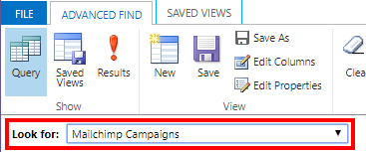
- Click the button Results.
*** This window will show you all the Mailchimp campaign you have send, the last time the info was updated, the number of open mail from the campaign and the number of click in the whole campaign.

View Email send information in CRM
- Go open the Advance Find window.
- In the Look for field, select Mailchimp Emails.
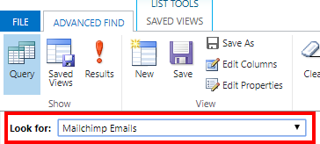
- Click the button Results.
*** This window will show you all email that have been send, from which campaign it come and to who it has been send.

View Email Activity information in CRM
- Go open the Advance Find window.
- In the Look for field, select Mailchimp Email Activities.
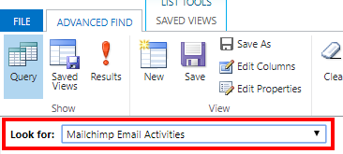
- Click the button Results.
*** This window will show you all email activities like an open or a click. It also informs you on who did it and for which campaign.

View the errors log
- Go open the Advance Find window.
- In the Look for field, select Mailchimp Errors Log.
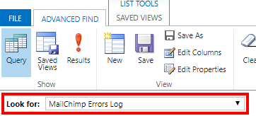
- Click the button Results.
*** This window will show you most of the errors and warnings that will be encounter by our service during its work. If you got to communicate with us about an error, please send the error message and the message inside the location field.

Uninstall procedure

Uninstall the service
    - Open the folder where the service is installed.
    - Execute Vendere.mailchimp.integration.service.exe as Administrator.
(image)
    - Click the unregister button, and wait.
    - You can now delete the installation folder and no trace should remain.

*** In rare case the uninstall might not work fully. To be sure it worked go into the windows menu and search for Services. A list of all the service should appears if you still find our service you will need to complete the uninstall manually. Return in your window menu and search for Regedit. You will see a folder tree. Go here: HKEY_LOCAL_MACHINE/SYSTEM/CurrentControlSet/Services in that folder there should be a folder name after the name you given our service. Find it and delete it. The last step is a computer restart and all is fixed.

Uninstall the solution
- Open the Solution menu in the Setting tab.
- Select Delete to remove the solution.

Synchronization Service Options

Send CRM contact fields into Mailchimp merge field
This option can be set in the Mailchimp Master List.
This option allows you to synchronize more than just the email, the first name and the last name of your CRM contact to Mailchimp. This will allow a better and easier customization for the email you send will your campaigns.
This option can be enable by writing xml into its field, the schema used will follow.
Each field must start by the field node “<field physicalName=”value” tag=”value”></field>”, this node will contain all the required information for a field to be synchronize like the physical name of the field in CRM and the tag that will be use by the Mailchimp system for identification. Some other node can be added as optional feature such as the display name node “<displayName> value </displayName>” and the display format node “<displayFormat> format </displayFormat>”.
Example of three fields synchronize with one with display option and a format:
<field physicalName=”ven_mailingstatus” tag=”mailstatus”>
<displayName>Mailing Status</displayName>
</field>
<field physicalName=”ven_mailchimpoptin” tag=”optin”>
</field>
<field physicalName=”birthdate” tag=”birthdate”>
<displayFormat>yyyy/MM/dd</displayFormat>
</field>
What it looks like in the field:
<field physicalName=”ven_mailingstatus” tag=”mailstatus”><displayName>Mailing Status</displayName></field><field physicalName=”ven_mailchimpoptin” tag=”optin”></field>
The attribute physicalName on the field node is mandatory. The physical name is how the system know which field you want to transfer. If you don’t know the physical name of the wanted field, you can find them in the window customization from under the settings tab. Don’t forget that only field from the Contact entity can be transfer.
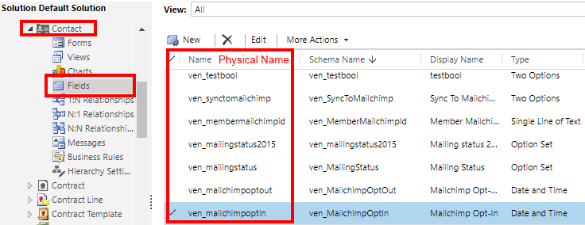
The attribute tag on the field node is mandatory. The tag is how the system know in which Mailchimp field to transfer into. The attribute has a maximum of 10 characters.

The displayName node is optional. This is how the field will be named inside of Mailchimp, if it is not specified, the physicalName attribute will be used instead.

The displayFormat node is optional. This node allows the user to format different type of field: Date and Time, Whole Number, Floating Number, Decimal and Currency. All other will not be affected by a format. Use the C# formatting to make your format.

Log Mailchimp service events
This option can be set in the Mailchimp configuration.
This Boolean field allow the service to log event type log inside the Mailchimp Error Log entity. This information is not crucial to know, however it is useful for debugging. This option is set to false by default since leaving it to true might flood the log with events.

Mailing 2015
This option can be set in the Mailchimp configuration.
This field must be set to yes if the solution and service are used with a CRM version of 2015 or under. The standard mailing status of the solution use 2016 functionality and won’t work on older version. With this field activated, the service will take on the responsibility of update the mailing status inside mailing status 2015 field of the contact entity.

Mailchimp double opt-in
This option can be set in the Mailchimp configuration.
This field allow you to use the double opt-in of the Mailchimp system or not.

Unsubscribed creates new member on an email change
This option can be set in the Mailchimp configuration.
When this field is on, any change of email detected on a synchronize unsubscribed contact will try to create a new member on Mailchimp side. If the field is off, any email change on unsubscribed member will be ignored.

Cleaned creates new member on an email change
This option can be set in the Mailchimp configuration.
When this field is on, any change of email detected on a synchronize cleaned contact will try to create a new member on Mailchimp side. If the field is off, any email change on cleaned member will be ignored.

Mailchimp double opt-in override link
This option can be set in the Mailchimp configuration.
This field contain a URL that will be consider a double opt-in confirmation when clicked. This allow to ask for a confirmation later than the original double opt-in of Mailchimp. This option been made for places like Canada where you can send email the first 2 years after the last transaction to any customer that had a transaction with your company.

Standard Mailchimp Operation
We are using Mailchimp because there are action and option that Mailchimp do well, here is a list of those options you will have to use inside Mailchimp. For more information on how to do these action, check out the Mailchimp documentation it is fully explained there.
- Creation of email template.
- Creation of Campaign.
- Sending of email in bulk via campaign.
There is also operation that you should not do inside Mailchimp interface, most if not all of these operations musts be done inside CRM instead. Not following these indications could break the synchronization between CRM and Mailchimp.
- Modification of a CRM member in any way. (the member with a CRM_ID fill)
- Creation of group inside of the CRM master list. (any other list is ok)
- Deletion of any list, group, member under CRM supervision.

Error logging
Error from the service are logged inside CRM custom entity Mailchimp Error Log however, from time to time CRM can be out of reach, for these cases the service will log itself on the machine it is installed on. You will find those logging file in the folder where you installed your service.

Not supported functionality
- The resubscription of an unsubscribed member without changing the email
- Format for the merge field.

ANNEX I
The custom field of our CRM solution
Many fields are added to your CRM when installing our Mailchimp Solution.

Contact
- ven_dirtymailchimp: this flag determines if there is change to apply in Mailchimp.
- ven_hasbouncemailchimp: this flag indicates if the Mailchimp member has hard bounce or not.
- ven_lastbouncemailchimp: this timestamp indicates when was the last hard bounce.
- ven_mailchimperrorreason: this option set indicate if an error occurs during the synchronization of the contact.
- ven_mailchimperrortimestamp: this timestamp indicates the last time an error occurs with the contact.
- ven_mailchimplastmassupdate: this timestamp indicates the last time the service updated the contact in the context of a mass update of contacts. Changing this field value could disrupt mass update operation.
- ven_mailchimplasttransaction: this timestamp should be fill with the last purchase of a contact. This field is used to calculate the mailing status based on Canadian law.
- ven_mailchimplasttransactionend: this timestamp is calculated by adding two years to ven_mailchimplasttransaction, this field is used to calculate the mailing status based on Canadian law.
- ven_mailchimpoptin: this timestamp indicates when a member explicitly express itself to want to be part of the mailing list by using a custom. This field is used to calculate the mailing status based on Canadian law.
- ven_mailchimpoptout: this timestamp indicates when a member explicitly express itself to be removed from the mailing list by using Mailchimp unsubscribe link. This field is used to calculate the mailing status based on Canadian law.
- ven_mailingstatus: this option value represents the status of the contact regarding mailing. Possible value: Undefined, Implicit Opt-In, Explicit Opt-In, Explicit Opt-Out, Expired. This field follow the Canadian law. (only work for dynamics CRM 2016+)

- ven_maillingstatus2015: this option value represents the status of the contact regarding mailing. Possible value: Undefined, Implicit Opt-In, Explicit Opt-In, Explicit Opt-Out, Expired. This field follow the Canadian law. (Will be fill if the option is activated, this option will might slow down the service process only activate it if you use CRM 2015 or lower)
- ven_membermailchimpid: this field contains the id of it corresponding Mailchimp member. This field is important for the service and only the service should modify it.
- ven_synctomailchimp: this flag determines if a contact should be synchronized with Mailchimp as a member. This field should only be modified by the service or the provided workflow.
- ven_today: this timestamp is calculated to be the current day. This field is used to calculate the mailing status.

Lead
- ven_dirtymailchimp: this flag determines if there is change to apply in Mailchimp.
- ven_hasbouncemailchimp: this flag indicates if the Mailchimp member has hard bounce or not.
- ven_lastbouncemailchimp: this timestamp indicates when was the last hard bounce.
- ven_mailchimperrorreason: this option set indicate if an error occurs during the synchronization of the contact.
- ven_mailchimperrortimestamp: this timestamp indicates the last time an error occurs with the contact.
- ven_mailchimplastmassupdate: this timestamp indicates the last time the service updated the contact in the context of a mass update of contacts. Changing this field value could disrupt mass update operation.
- ven_mailchimplasttransaction: this timestamp should be fill with the last purchase of a contact. This field is used to calculate the mailing status based on Canadian law.
- ven_mailchimplasttransactionend: this timestamp is calculated by adding two years to ven_mailchimplasttransaction, this field is used to calculate the mailing status based on Canadian law.
- ven_mailchimpoptin: this timestamp indicates when a member explicitly express itself to want to be part of the mailing list by using a custom. This field is used to calculate the mailing status based on Canadian law.
- ven_mailchimpoptout: this timestamp indicates when a member explicitly express itself to be removed from the mailing list by using Mailchimp unsubscribe link. This field is used to calculate the mailing status based on Canadian law.
- ven_mailingstatus: this option value represents the status of the contact regarding mailing. Possible value: Undefined, Implicit Opt-In, Explicit Opt-In, Explicit Opt-Out, Expired. This field follow the Canadian law. (only work for dynamics CRM 2016+)

- ven_maillingstatus2015: this option value represents the status of the contact regarding mailing. Possible value: Undefined, Implicit Opt-In, Explicit Opt-In, Explicit Opt-Out, Expired. This field follow the Canadian law. (Will be fill if the option is activated, this option will might slow down the service process only activate it if you use CRM 2015 or lower)
- ven_membermailchimpid: this field contains the id of it corresponding Mailchimp member. This field is important for the service and only the service should modify it.
- ven_synctomailchimp: this flag determines if a contact should be synchronized with Mailchimp as a member. This field should only be modified by the service or the provided workflow.
- ven_today: this timestamp is calculated to be the current day. This field is used to calculate the mailing status.

Account
- ven_dirtymailchimp: this flag determines if there is change to apply in Mailchimp.
- ven_hasbouncemailchimp: this flag indicates if the Mailchimp member has hard bounce or not.
- ven_lastbouncemailchimp: this timestamp indicates when was the last hard bounce.
- ven_mailchimperrorreason: this option set indicate if an error occurs during the synchronization of the contact.
- ven_mailchimperrortimestamp: this timestamp indicates the last time an error occurs with the contact.
- ven_mailchimplastmassupdate: this timestamp indicates the last time the service updated the contact in the context of a mass update of contacts. Changing this field value could disrupt mass update operation.
- ven_mailchimplasttransaction: this timestamp should be fill with the last purchase of a contact. This field is used to calculate the mailing status based on Canadian law.
- ven_mailchimplasttransactionend: this timestamp is calculated by adding two years to ven_mailchimplasttransaction, this field is used to calculate the mailing status based on Canadian law.
- ven_mailchimpoptin: this timestamp indicates when a member explicitly express itself to want to be part of the mailing list by using a custom. This field is used to calculate the mailing status based on Canadian law.
- ven_mailchimpoptout: this timestamp indicates when a member explicitly express itself to be removed from the mailing list by using Mailchimp unsubscribe link. This field is used to calculate the mailing status based on Canadian law.
- ven_mailingstatus: this option value represents the status of the contact regarding mailing. Possible value: Undefined, Implicit Opt-In, Explicit Opt-In, Explicit Opt-Out, Expired. This field follow the Canadian law. (only work for dynamics CRM 2016+)

- ven_maillingstatus2015: this option value represents the status of the contact regarding mailing. Possible value: Undefined, Implicit Opt-In, Explicit Opt-In, Explicit Opt-Out, Expired. This field follow the Canadian law. (Will be fill if the option is activated, this option will might slow down the service process only activate it if you use CRM 2015 or lower)
- ven_membermailchimpid: this field contains the id of it corresponding Mailchimp member. This field is important for the service and only the service should modify it.
- ven_synctomailchimp: this flag determines if a contact should be synchronized with Mailchimp as a member. This field should only be modified by the service or the provided workflow.
- ven_today: this timestamp is calculated to be the current day. This field is used to calculate the mailing status.

Marketing List
- ven_dirtymailchimp: this flag determines if there is change to apply in Mailchimp.
- ven_interestmailchimpid: this field contains the id of it corresponding Mailchimp group. This field is important for the service and only the service should modify it.
- ven_mailchimpmassupdateinprogress: this timestamp is set when a mass insert/update is being made by the service so that if an error occur it can continue were it was. Once finish it is set back to null. This should only be modified by the service.
- ven_syncallmember: this flag is set so that the service make a refresh of the whole list and contacts inside it. This action provokes a mass insert/update. Should be set by the service or the provided workflow.
- ven_synctomailchimp: this flag determines if a marketing list should be synchronized with Mailchimp as a group. This field should only be modified by the service or the provided workflow.

Mailchimp Campaign
- ven_mailchimpupdatedsince: this timestamp indicates when was the last time an update was done by the service based on the Mailchimp campaign.
- ven_mailchimpsidecampaignid: this field indicate the id of it Mailchimp campaign counterpart.
- ven_mailchimpopencount: this field contains the count of email opening that happened since the campaign have been send.
- ven_mailchimpclickcount: this field contains the count of link clicked inside the email since the campaign have been send.
- ven_mailchimpautomation: this field indicate if the Mailchimp campaign have been create by a Mailchimp automation.
- ven_mailchimpmasterlistid: this field contains the mailchimp list id associated with the campaign.

Mailchimp Configuration
- ven_mailchimpunsubscribeemailchange: this flag change the behavior of the service upon an email change of an unsubscribe member. If set to No, the service will ignore all changes done to unsubscribed members, if set to yes, the service will update the member as long as an email change is part of the changes.
- ven_mailchimplanguage: this option set indicate the language of the errors reported by the service. Some error are system error and those will not be affected by the selection of the language.
- ven_mailchimpdoubleoptinoverridelink: this field will contain the link on which a member should click to explicitly opt-in onto your list.
- ven_mailchimpdoubleoptin: this flag indicates if the service will pass through Mailchimp double opt-in process when adding member or if it will subscribe them directly.
- ven_mailing2015: this flag activate the process to verify mailing status for the service (this should only be activated on crm 2015 or under)
- ven_mailchimpcleanedemailchange: this flag change the behavior of the service upon an email change of a cleaned member. If set to No, the service will ignore all changes done to cleaned members, if set to yes, the service will update the member as long as an email change is part of the changes.
- ven_mailchimpapikey: this field must contain your Mailchimp API key otherwise the service won’t be able to function.
- ven_mailchimplicensekey: this field must contain your license key from the solution/service of the Vendere product.

Mailchimp Master List
- ven_mailchimplastcheckunsubscribe: this timestamp indicates when the last check for unsubscribe member been done by the service. This field should be only modified by the service.
- ven_mailchimplastcheckcleaned: this timestamp indicates when the last check for hard bounce member been done by the service. This field should be only modified by the service.
- ven_mailchimplastcheckcampaign: this timestamp indicates when the last check for the recent campaigns been done by the service. This field should be only modified by the service.
- ven_mailchimplistid: this field will be fill by the service upon the creation of the master list, it will contain the id of the master list inside Mailchimp. If you fill this field manually with the id of a Mailchimp list, this list will become the service master list. Caution, if you do the group inside it will be flushed out to be replace by those inside CRM.
- ven_mailchimpcategoryid: this field will be fill by the service upon the creation of the master list, it will contain the id of the main category inside Mailchimp. This field should only be modified by the service.
- ven_mergefielddirty: this field indicate if the merge field has changed.
- ven_contactfieldasmergefield: this field will contain a xml file that will indicate which field from contact will be send to Mailchimp alongside the email, the first name and the last name.
Example:
<field physicalName=” ven_mailingstatus” tag=”mailstatus”></field>
- ven_executionpriority: this field indicate the priority for the master list execution. The higher number is the most prioritize and the not set are the lowest.
- ven_crmmembertype: determine the member type that will be inside the master list. Only one of each type is allowed.

Mailchimp Email
- ven_mailchimpcampaign: this lookup indicates which campaign send the email.
- regardingobjectid: this lookup is a vanilla field that is used to indicate who the email was send to.

Mailchimp Email Activity
- ven_timestamp: this timestamp indicates when the activity occurs.
- ven_mailchimpurl: this field will contain the URL clicked if the activity would be a click.
- ven_mailchimpidaddress: this field contain the IP address from where the action was detected.
- ven_mailchimpemail: this lookup indicates for which email send this activity has occur
- ven_action: this field indicate which type of action was detected.

Mailchimp Error Log
- ven_timestamp: this timestamp indicates when the error occurs.
- ven_errortype: this field is legacy.
- ven_errormessage: this field contains the errors message.
- ven_errorlocation: this field contains information useful for support to help. fixing your error.
- ven_errorlevel: this field contains the gravity level of the error.

