Pragma Case Management (Customer Service Management) User Guide

Version 1.0.0

Contents
1. Introduction 3
2. Master data setup of new service type 4
3. Master data setup of stages and stage status for flow 6
4. Case configuration for new service type 7
5. Case Steps for new service type (i.e. configuration (assignment, TAT, next step, etc.) 8
6. Create a Service Request (Case) 9

Pragma Case Management

Introduction
Ready to Deploy Master Data Driven Customer Service Workflow Automation Solution
- In this era of consumer dominated world it’s not the business but the customers are deciding the ‘Customer Centricity’ of the business. Hence operational efficiencies and differentiated service has become necessity but that is just not sufficient – consistent customer experience has also become the key. Continuous innovation in products, services and processes raise demand for rapid changes in customer service flows further increasing the challenges faced by customer service organizations. Pragmasys offers a configurable Customer Service Workflow Automation Solution which transfers the control of setting up the support process flows from developers to business users. It provides comprehensive case management capabilities including ability to define multiple flows based on different criteria, multistep sequential processes with defined SLAs.
Business users can:
- Define masters for various stages of process flow and associated statuses.
- Define different service processes flows based on products / business lines or any other criteria and set up stages and their transition based on different statuses.
- Define assignment rule for each stage with flexibility to assign the Case either to individual or Queue or team.
- Define Service Level Agreement / Turn Around Time at case level as well as at each stage of resolution process flow.
- Define the communication/notification template for internal and external SMS/Email communication. This helps in providing timely update to customer on progress of the service request.
- Predefined Case Management Dashboards.
How does it Benefit an Organization?
- Pragmasys Customer Service Workflow Automation solution routes the case / service request based on defined process, so 100% compliance is achieved without any lapses. Users are free from assigning it to others and can focus only on their task while system takes care of the routing needs.
- Due to tracking of time to accomplish a task (SLA / TAT) resolution times are improved.
- Eliminates customer call backs for status updates with up-to-date status information on resolution progress.
- Overall this solution provides a consistent and differentiated experience to customers there by improves customer satisfaction.
- Real time changes to the process flows which enables Organizations to focus on continuously optimizing the business process without worrying about the development time required for IT teams and reduces dependency on IT teams.
- This also helps in providing consistent user experience across business lines thus improving the user adoption.

Master data setup of new service type
For configuration of new service request, add master data for Case Process, Case SR and Case Sub SR. To add master data in these 3 entities, follow below step.

- To view Case Process, Case SR and Case Sub SR entities, go Pragma Case Management Group inside Setting Area.

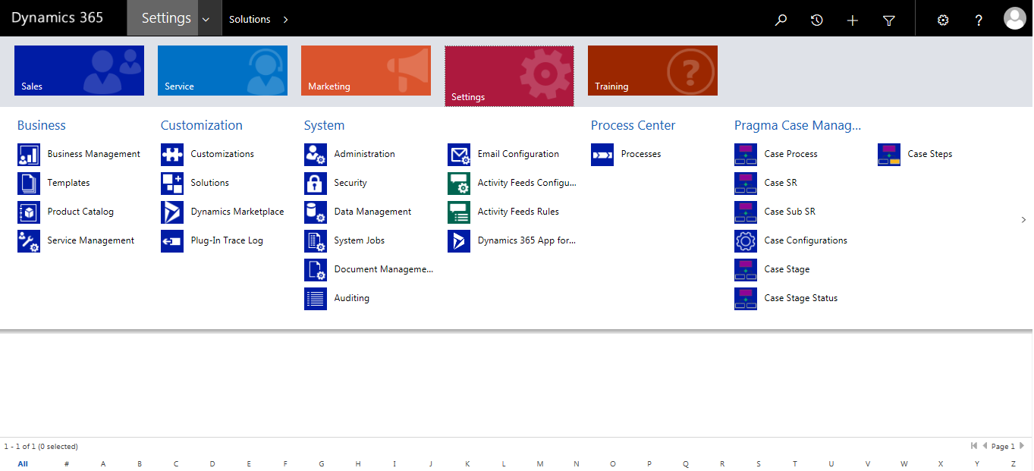

- Click on Case Process, then Click on New (+) on top left corner, below screen will open. Enter Process name. e.g. Servicing – Alterations. In the bottom-right corner of the page, click to Save Process Name.

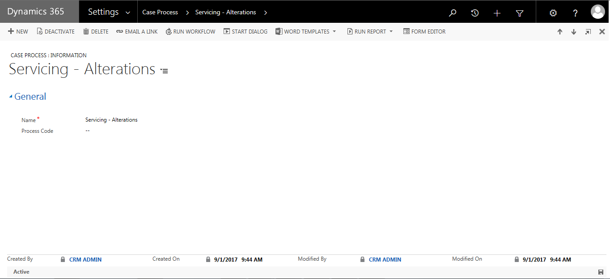

- Click on Case SR, then Click on New (+) on top left corner, below screen will open. Enter SR (Service Request) name. e.g. Alteration - Client level. In the bottom-right corner of the page, click to save SR Name.
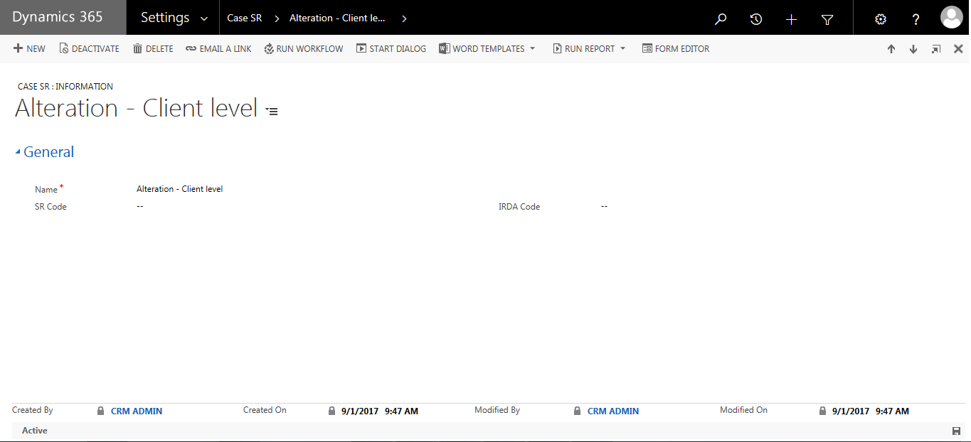

- Click on Case Sub SR, then Click on New (+) on top left corner, below screen will open. Enter Sub SR (Service Request) name. e.g. Contact No Change. In the bottom-right corner of the page, click to save Sub SR name.

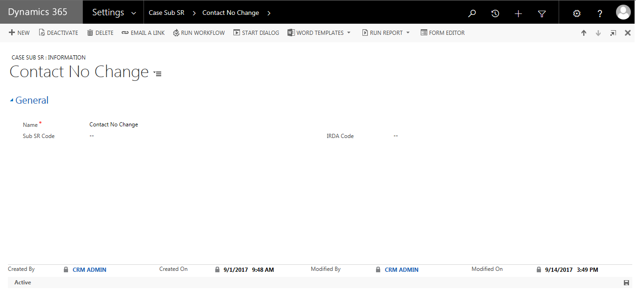

Master data setup of stages and stage status for flow
To routes the case / service request based on defined process, add process stages and stage status.

- Click on Case Stage, then Click on New (+) on top left corner, below screen will open. Enter Stage name. e.g. Case Registration. In the bottom-right corner of the page, click to Save Stage Name.

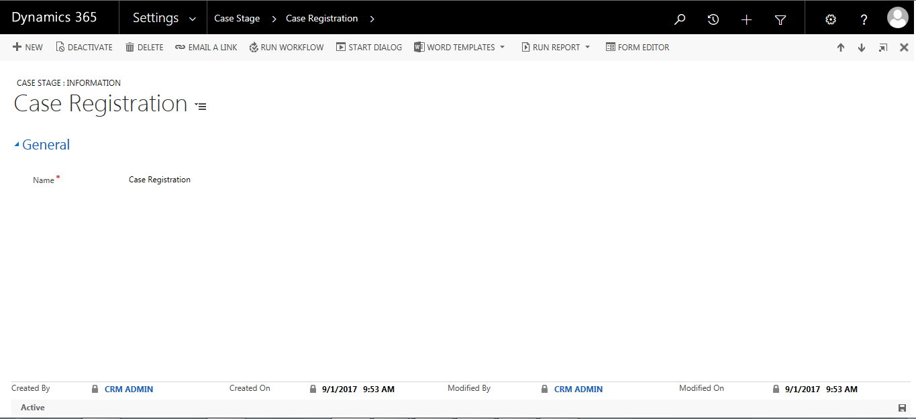

- Click on Case Stage Status, then Click on New (+) on top left corner, below screen will open. Enter Stage Status name. e.g. New. In the bottom-right corner of the page, click to Save Stage Name.

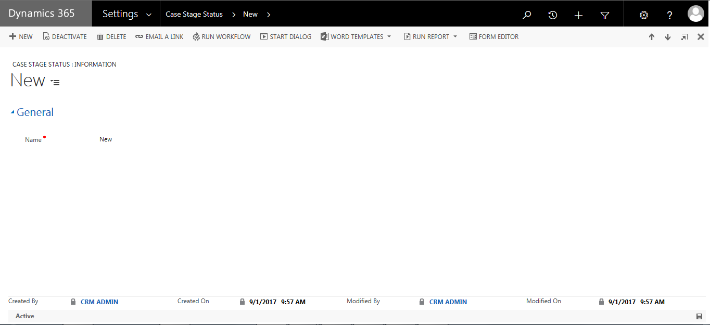

Case configuration for new service type
Case Configuration is a combination of Case Process, Case SR and Sub SR.

- To add Case configuration, Click on Case configuration, then Click on New (+) on top left corner, below screen will open. Enter the detail explained below. In the bottom-right corner of the page, click to Save Case configuration.

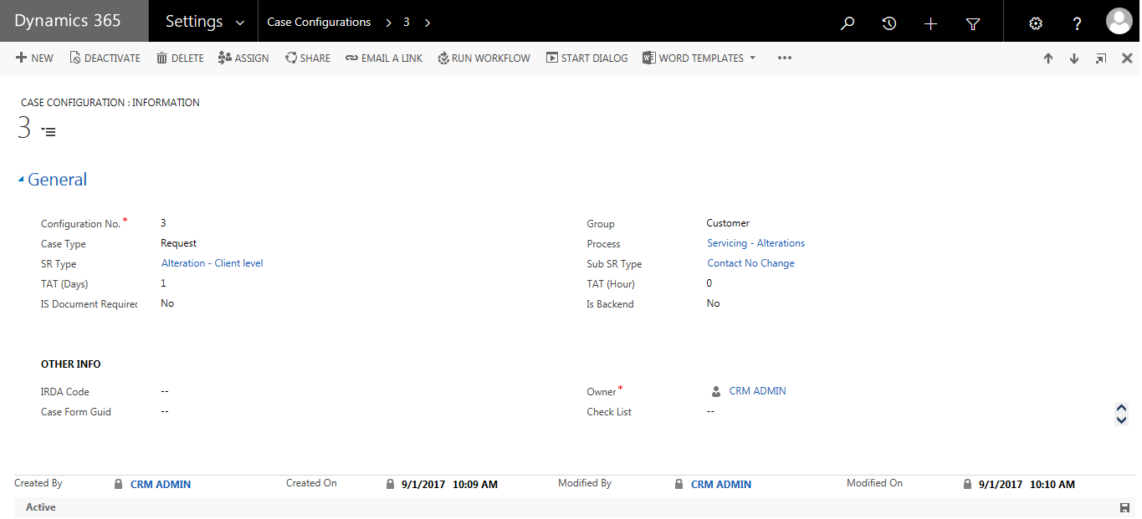

- Enter case configuration no. which is running sequence no.
- Select Service Requests Group. i.e. Customer or Advisor
- Select Service Request type i.e. Request, Complaint etc.
- Select Process, SR Type, Sub SR Type.
- Enter the Turnaround time /SLA required to resolve this service request in days and hour.

Case Steps for new service type (i.e. configuration (assignment, TAT, next step, etc.)
Case step is nothing but steps required to resolve case. Steps can be differing case to case, business to business.
As per service request flow configure all required case step as below.

- To add Case Step, Click on Case Step, then Click on New (+) on top left corner, below screen will open. Enter the detail explained below. In the bottom-right corner of the page, click to Save Case Step.

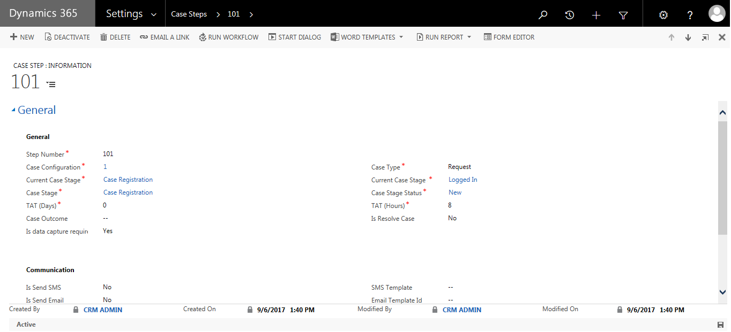

- In New Case Step, enter the applicable details for the step. * denotes mandatory.
- Step Number is running sequence number.
- Select Case stage and Case Stage Status.
- Based selected case stage enter next stage to be moved in current case stage field.
- Enter standard TAT/SLA required to complete stage.
- Enter sms/email template which will be triggered on stage change.
- Enter User or team to which case will be assigned for further evaluation.

Create a Service Request (Case)
- To Create New Case, go to Service -> Cases -> New Case (+)

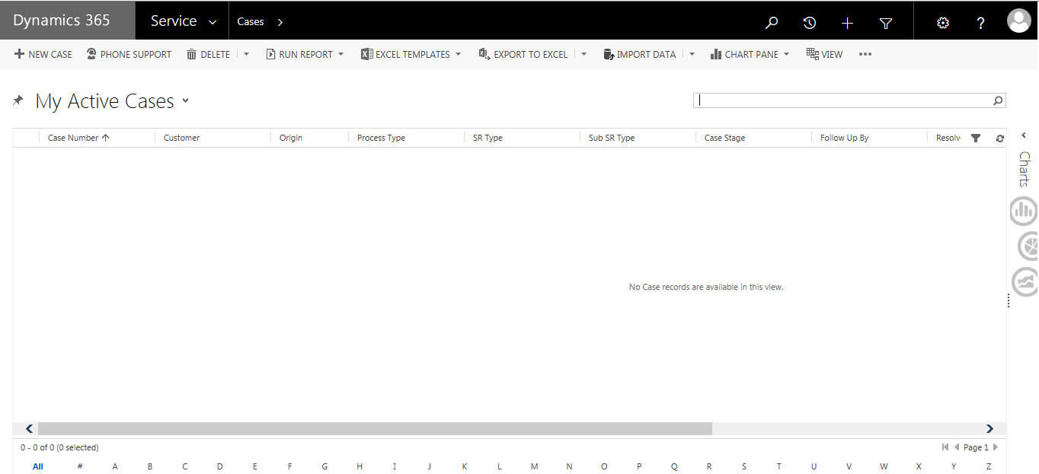

- In New Case, enter the applicable details for the SR.* denotes mandatory.

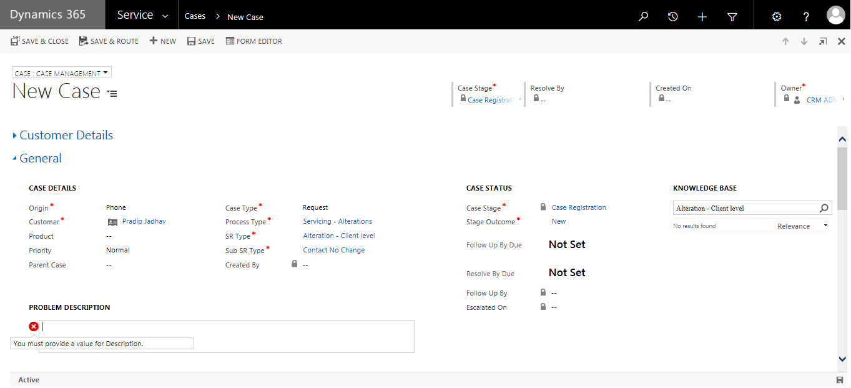

- Enter mandatory fields like Case Type, Process Type, SR Type, Sub SR Type, Problem Description and Click on Save.
- As soon as case gets save TAT/SLA for Stage and TAT/SLA for SR will be calculated automatically as per defined in configuration and in case status section you able to see count down.
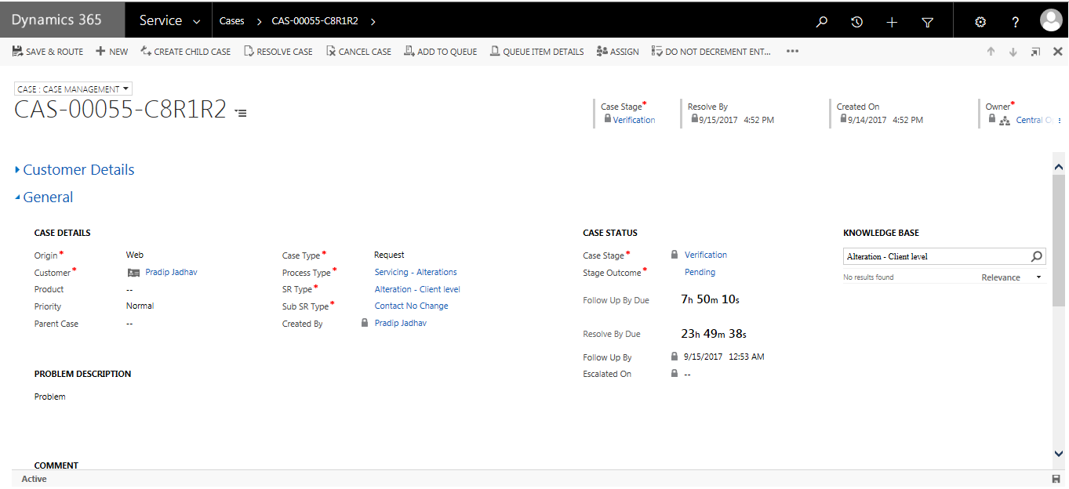

- Also, case form will show all available (configured) knowledge base available for service request.
- As per CRM standard a unique id (ticket number) will get generated for case. for generating unique id as per your business standard use Pragma Auto Number solution which is available on Microsoft app source.
- After entering all required detail click on stage outcome and select Completed and Click on save to move for next process flow.
- To view communication sent to customer click on tab Additional detail.

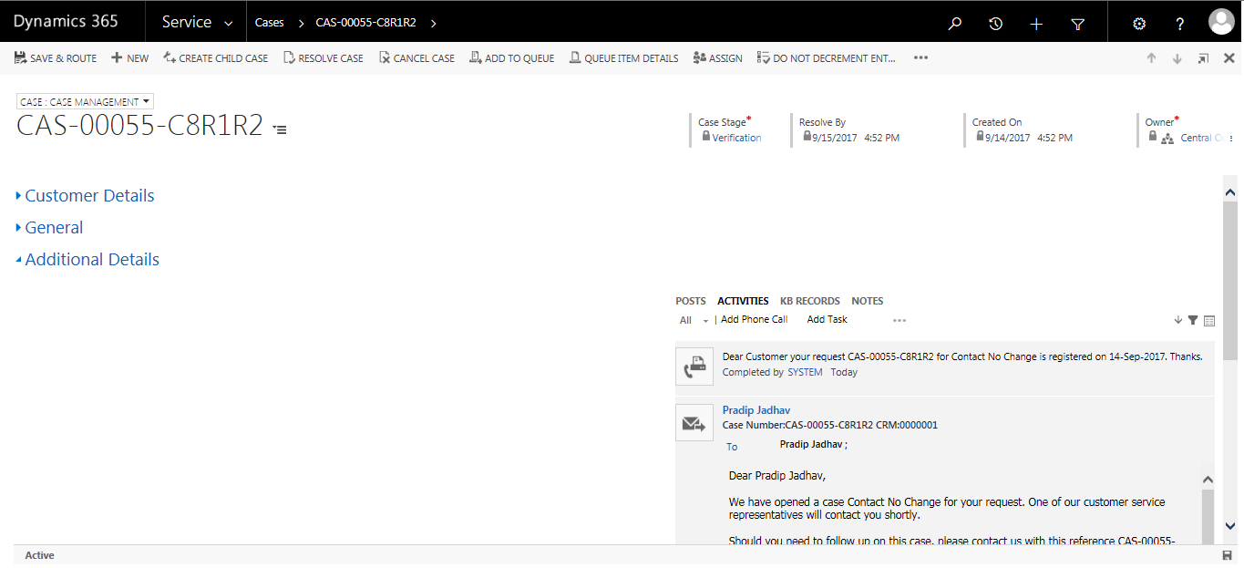

- To view attached document, click on tab Case Document.

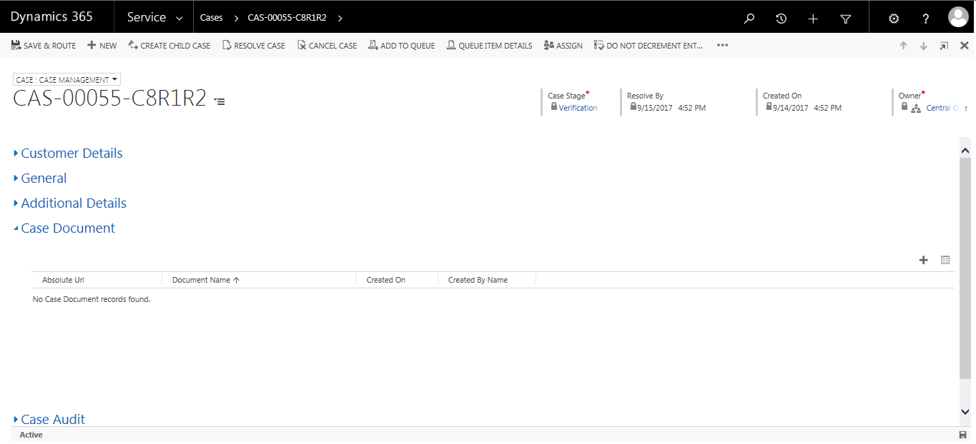

- To view Audit, click on tab Case Audit.

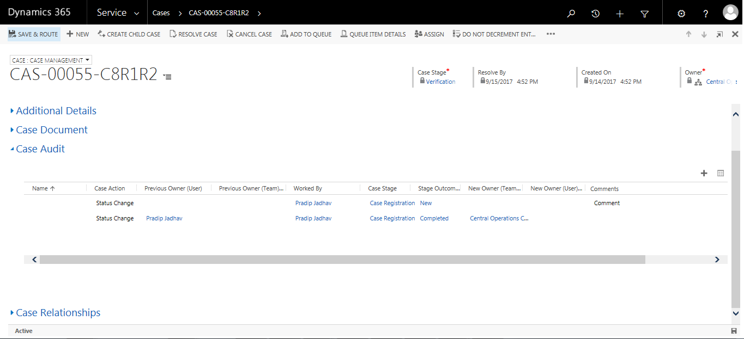

- To view Relationship such as child cases, click on tab Case Relationship.

