MultiSelect Option Set
Current limitation for MultiSelect Option Set:
- For all versions of Microsoft Dynamics CRM, the option-set field doesn’t allow users to select multiple values. At present selecting multiple values isn’t supported.
- Dynamics 365 does provide multi-select option-set but any existing or earlier dynamics CRM solution even if upgraded, the field would not support multi-select option set and would still require creating a new field.
MCT IT Solution helps:
- The solution is built in a way that Dynamics CRM 2016 system or upgraded 365 system is compatible to use this multi-select option-set feature easily, by just importing this solution in the CRM system.
Importing Dynamics CRM Solution
- Log on to the Microsoft Dynamics CRM server website as an administrator.
- From the menu, click SETTINGS > Solutions.
- On the All Solutions page, click Import.
- On the Select Solution Package page, click Browse to locate the Dynamics CRM MultiSelectOptionset solution.
- Click Next on the Select Solution Package and Solution Information page, and then click Import on the Import Options page.
- By default, the Enable any SDK message processing steps included in the solution check box is selected.
- In the Importing Solution dialog, click Close.
- And click publish all customizations.

Configure the MultiSelect Option set setting:
- On the All Solutions page, double-click MultiSelectOptionSet to open the Configuration page.
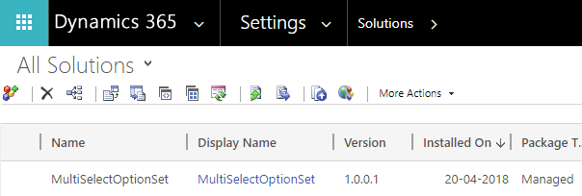

- On this page, select entity dropdown to select the entity and also select option set field from select field name for which you need to use multi-select control.

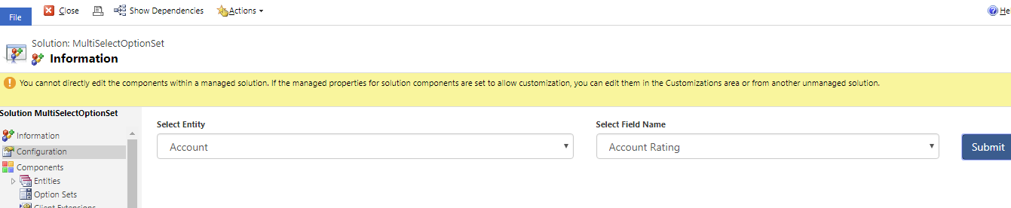

- After selecting an entity and selecting field name, click the submit button.

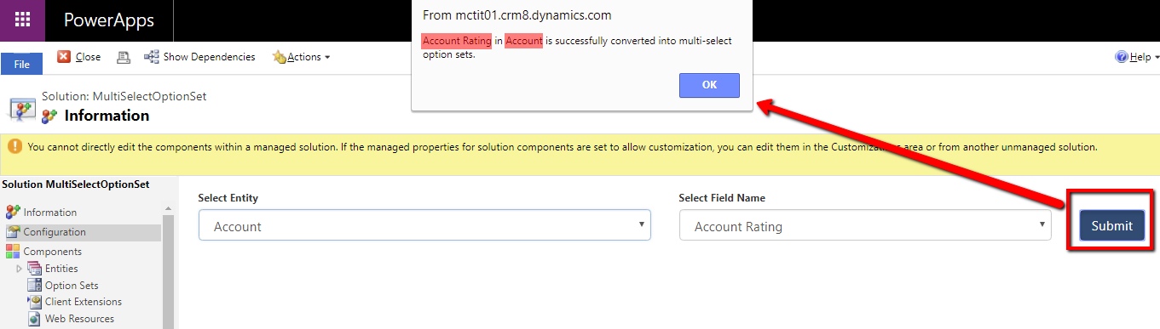

- In this page, it will not allow selection of the field for the second time.

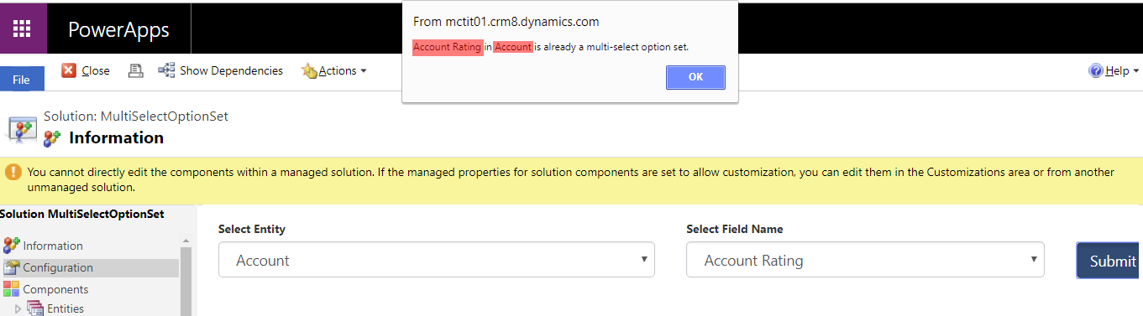

- After the success message, close the solution and check the selected entity to find custom multi-select control in Custom Attribute Tab.
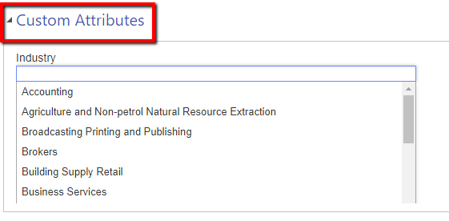

- Now you can freely use this control. 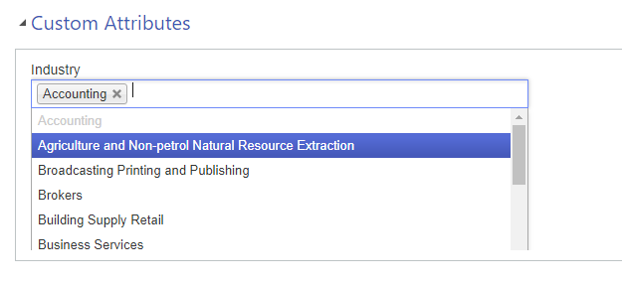

- After submitting, this feature will create two new fields in the selected entity in CRM like Available (your options set field name) and chosen (your option set field name). E.g. Available Industry and Chosen Industry.
- It is also possible to query data using Advanced find, by selecting those values that are selected in the control and query these values in the Chosen (your options set field name).
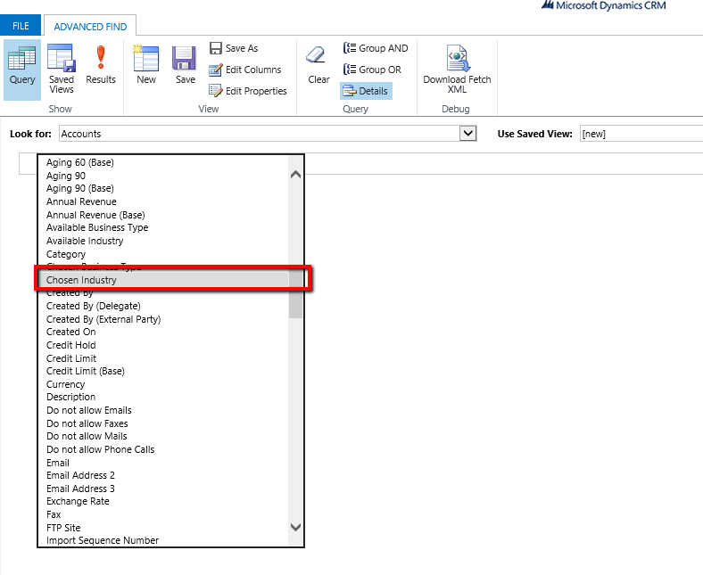

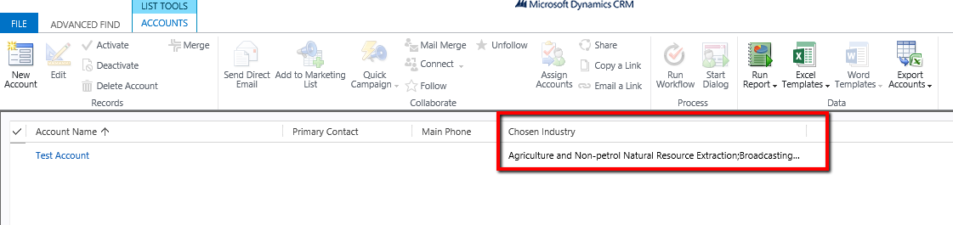

For any query write to us: mct@miraclecloud-technology.com

