Bulk Pick Process
Generating production picking lists for fabric has been streamlined by using the Furniture Module functionality. The Furniture module allows a single ‘Bulk Pick’ journal to be generated covering multiple production orders. The Furniture module also allows production orders to be filtered by a production week and also by a specific configured attribute value – such as fabric.
The following steps should be taken create a process a Bulk Pick journal within Microsoft Dynamics 365:

- Go to Production control > Production orders > All production orders to view the production orders in the current legal entity.
- Apply a filter to the First Attribute column. In the below example, this column relates to the fabric of the configured product. Enter a value relating to the fabric item to be bulk picked.
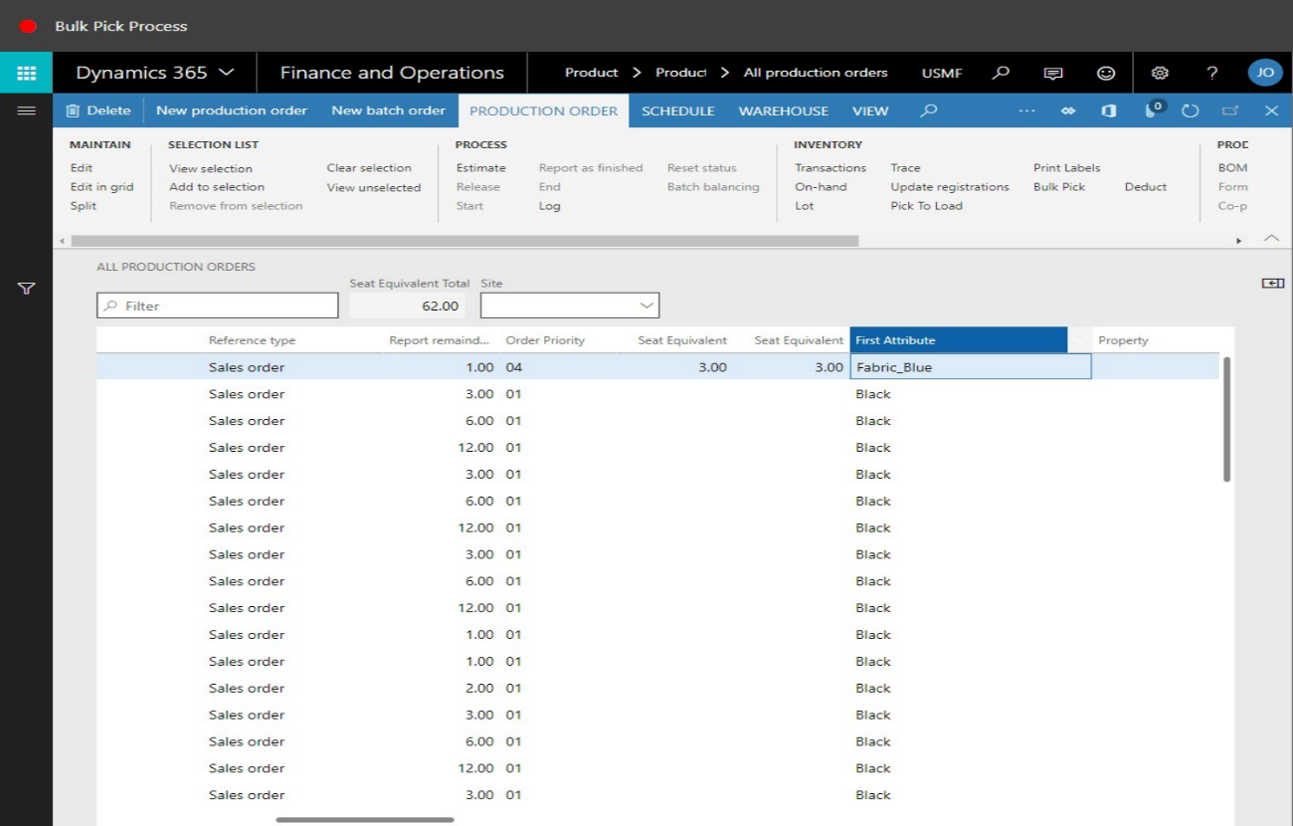

- The production orders will be filtered to display only records that match the first attribute value entered. In this example, this is the fabric item of Fabric_Blue.
- Now filter the production orders by the production week. To achieve this, filter the Pool column by entering the year and production week required – for example: 1846:
- In the list, mark the selected row.
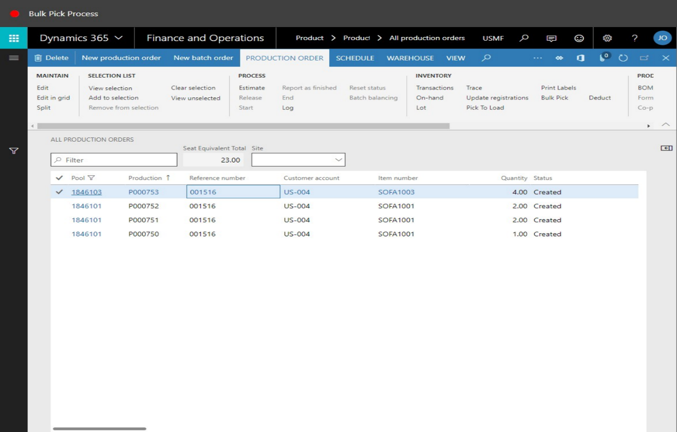
- Tick the remaining filtered rows as these production orders share the same main fabric, and are to be processed within the production week of 46:
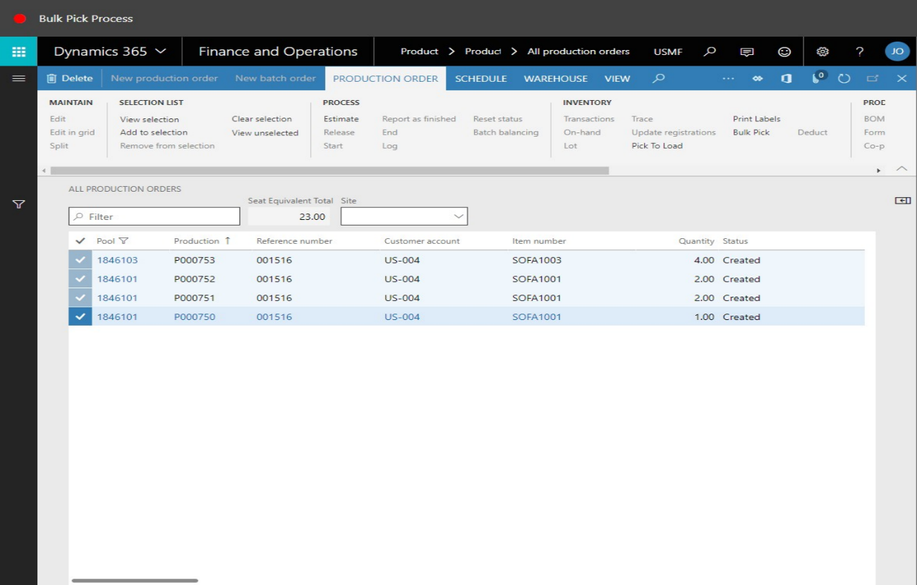
- At this point a Bulk Pick journal can be created for the selected production orders. One consolidated journal will be created for all fabric requirements on the selected production orders.
- Click Bulk Pick in the Fast Tabs section. A new window will open prompting for an Item Group range and a Bulk Pick Reference number.
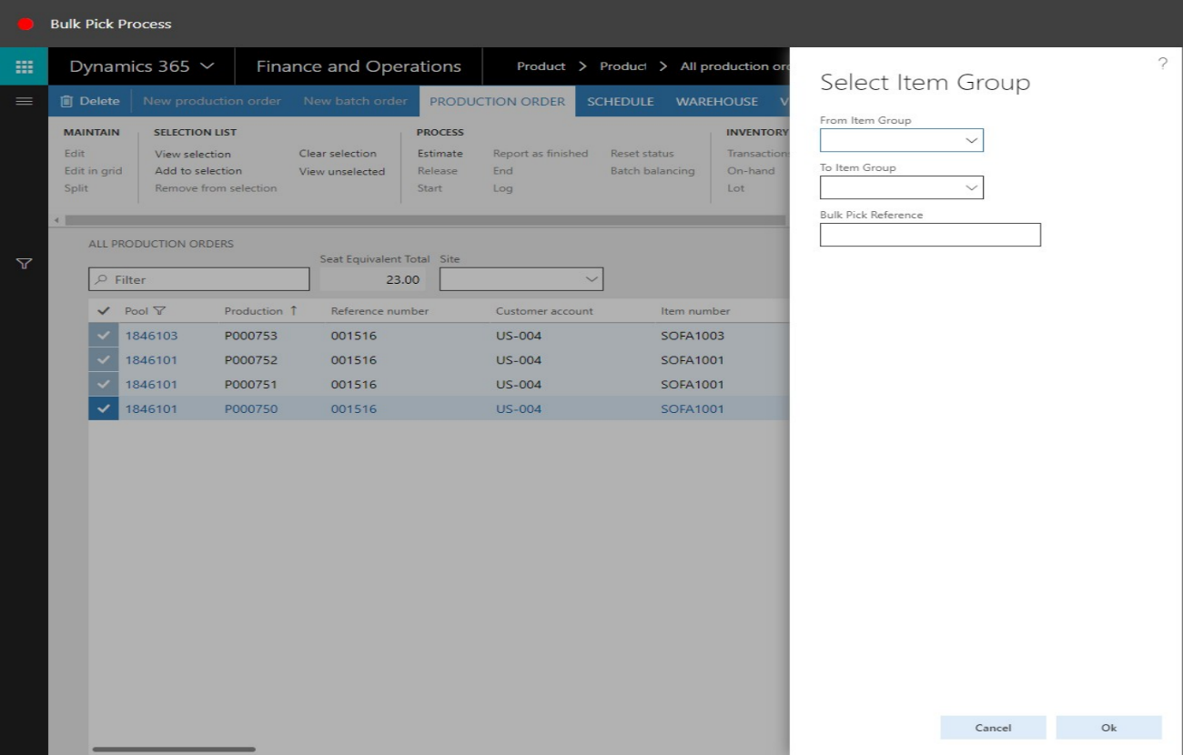
- Enter the item Group names that scan the production items to be processed.
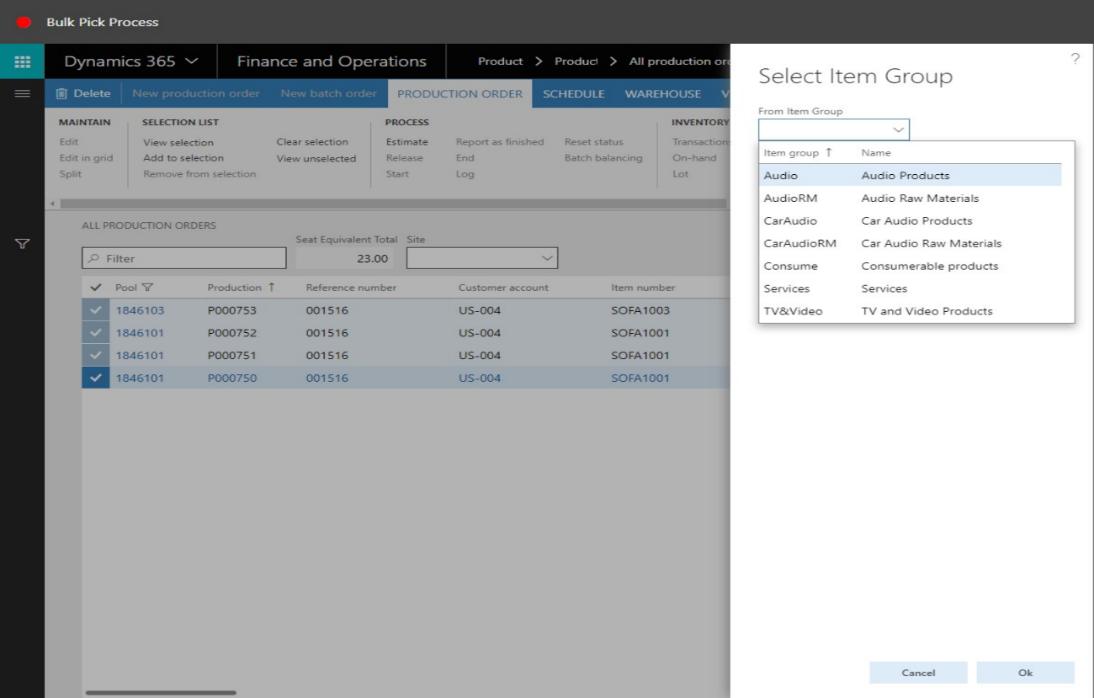
- In the Bulk Pick Reference field enter a value to be assigned to the Bulk Pick journal. In this example “Bulk Pick Week 46” will be entered.
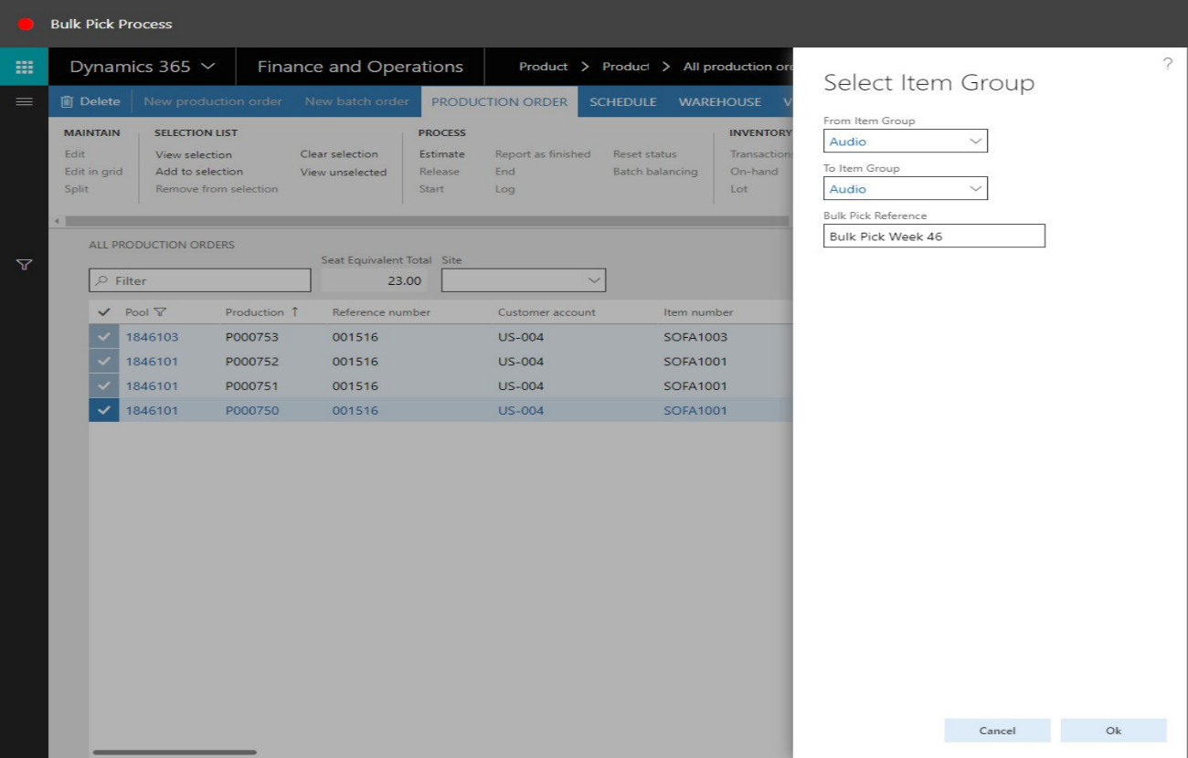
- Click OK to start the Bulk Pick process.
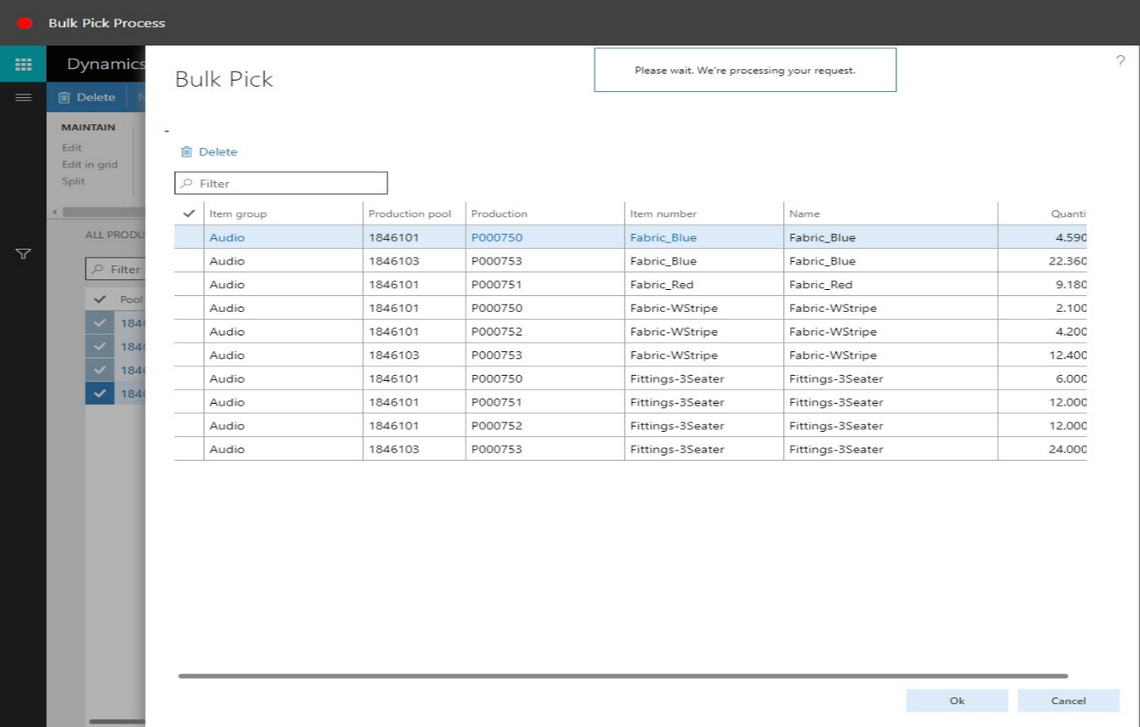
- A summary form will then be displayed containing the items and the production orders that will be consolidated onto one journal for picking. Click OK to confirm and create the journal.
- The journal is now created and a journal number is displayed on-screen in a Infolog box. Click OK and return to the all production orders form:
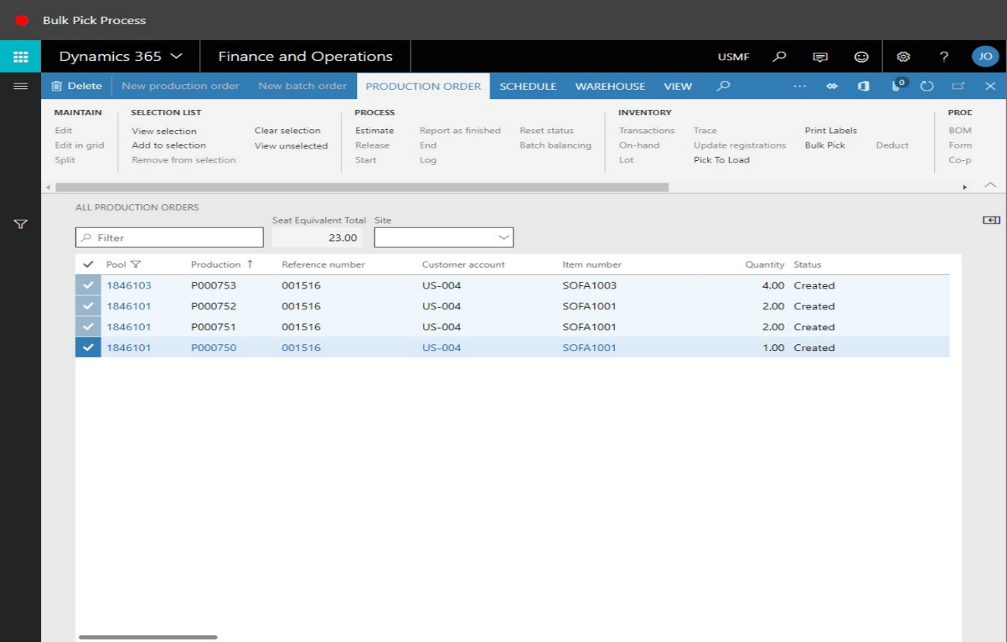
- To view and transact on the Bulk Pick journal, go to Production control > Adjustments > Picking list. The created Bulk Pick journal will reside in this area:
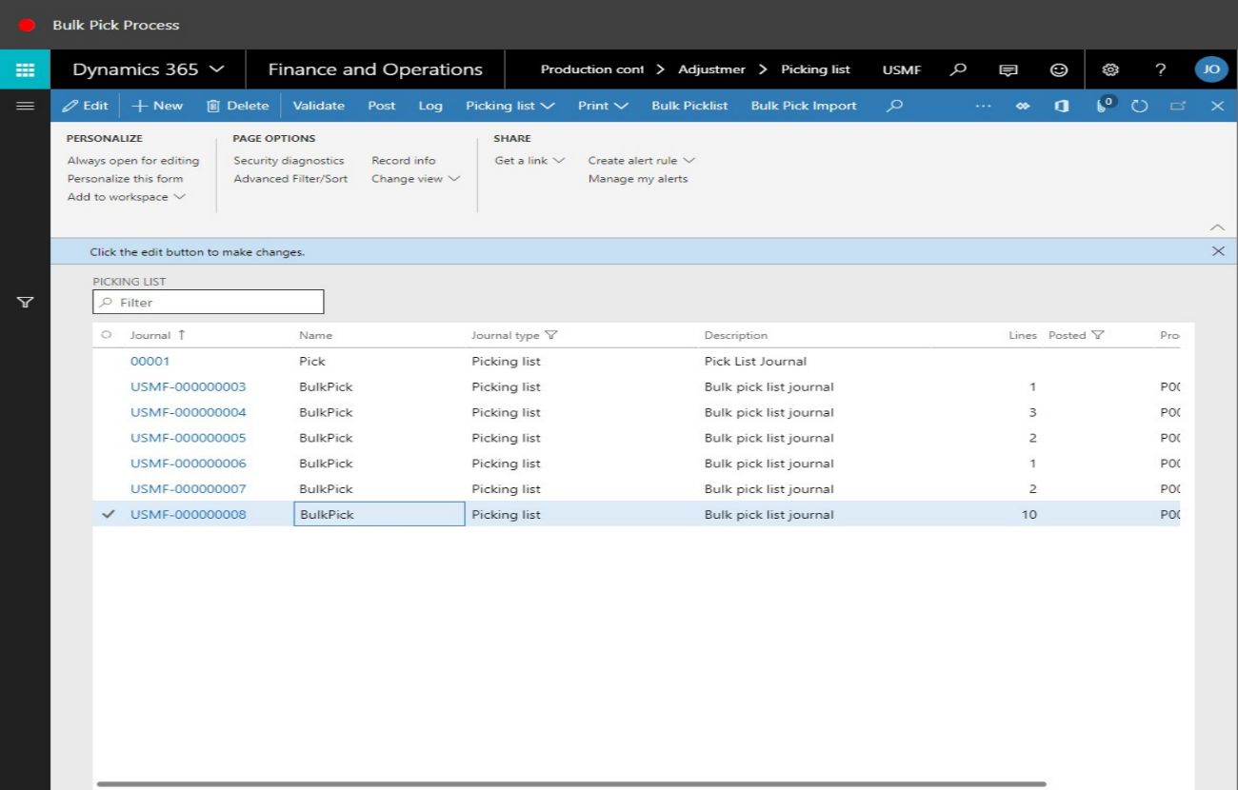
- In the list, click the link to the Bulk Pick journal. The journal will open and the journal lines will be displayed. Each journal line is now a consolidated quantity for each specific item code on the journal.
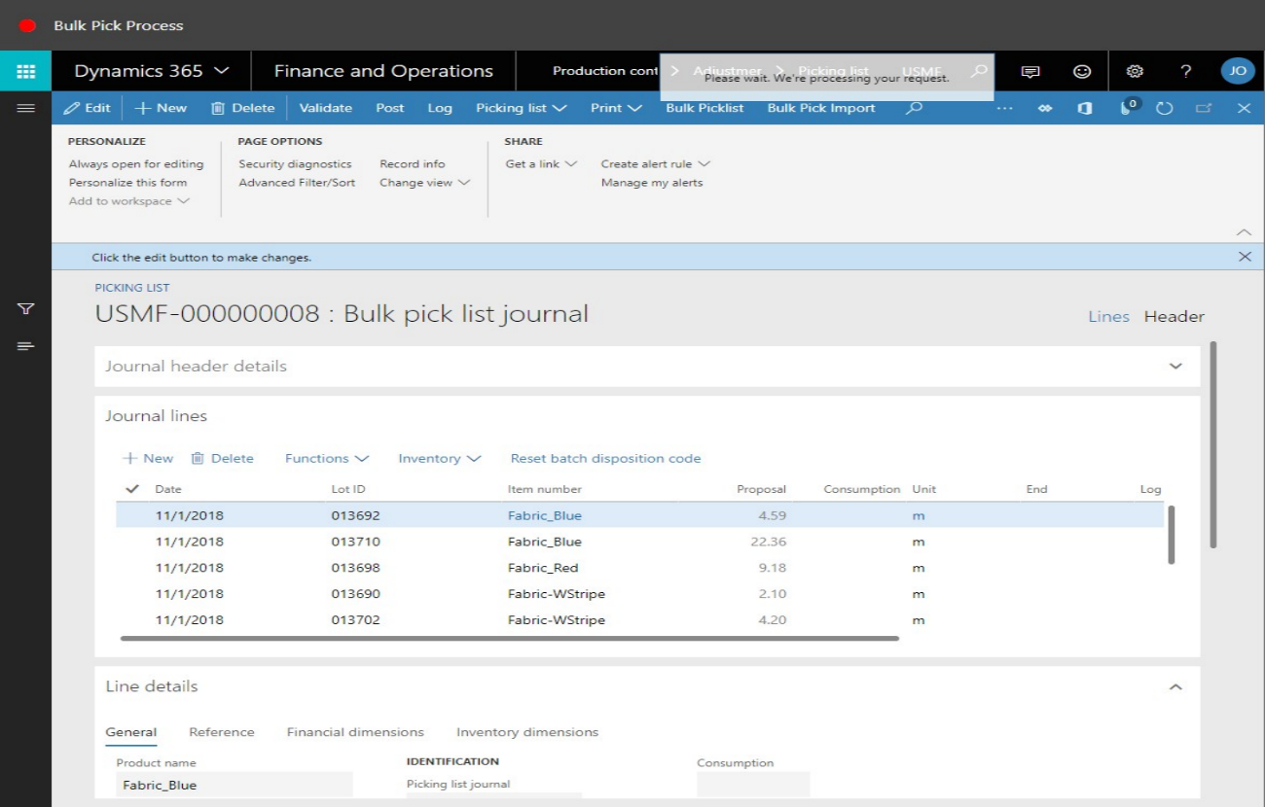
- Functionality exists to process the picking of the Bulk Pick journal within the system. An import file can be imported into Microsoft Dynamics 365 which needs to the batch numbers of the fabric that has been picked to satisfy the Bulk Pick requirement.
- The import file is a flat text file containing the bundle numbers only. The Bulk Pick Import button is used, on the Fast Tabs, to enable this file to be imported:
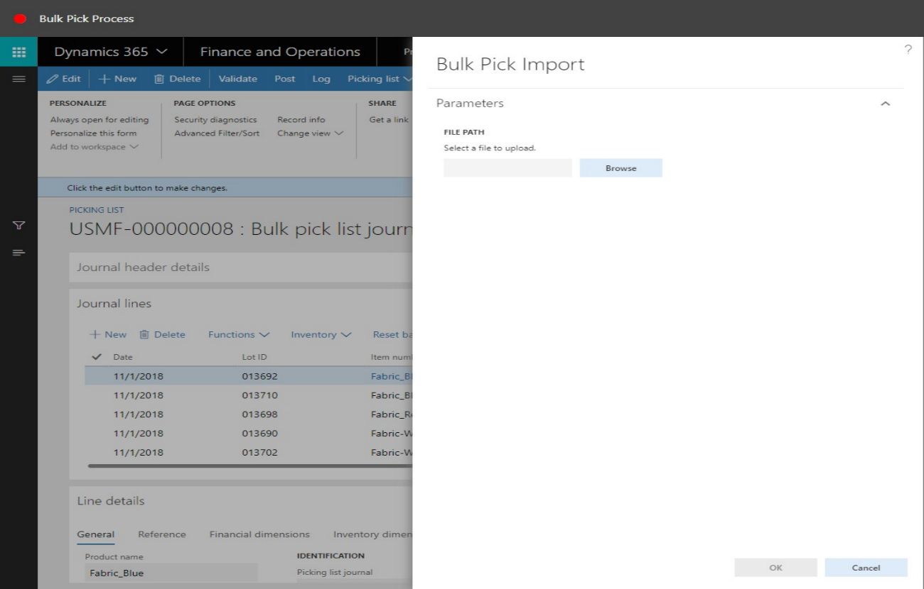
- On import of the file, the actual consumption is recorded by the user against each specific item. The journal is then updated and posted. As part of this process, a stock UID label is generated indicating the remaining quantity of fabric on each batch that was scanned and processed through the Bulk Pick Import. This stock UID label is then placed on the batch for stock counting purposes.

