www.eos-solutions.it/en/electronic-vat-settlement-en.html
Electronic VAT Settlement For Italy
Send the document for the periodic VAT settlement
in Microsoft Dynamics 365 Business Central
Electronic VAT Settlement For Italy
App for Microsoft Dynamics 365 Business Central
Send the document for the periodic VAT settlement
in Dynamics 365 Business Central.
Do you need to fill in and send the document for the periodic VAT settlement? Do you want help to manage the completion and the submission of the module to the Revenue Agency? Do you need to create the XML file according to the requirements fixed by the Revenue Agency?

How it works

Quick Guide
Ready to go in 4 steps
- Fill in the setup with the Company information
- Setup specific VAT setup to be summarized in VP fields or not, if necessary
- Make the system calculate VAT amounts
- Save and check the XML file
The App allows you to manage the completion and the submission, to the Revenue Agency, of the document for the periodic VAT settlement for Companies that operate in Italy.

Communication VAT Clearance - Entries
Go to the page Communication VAT Clearance - Entries and select New to create a new communication form:
In the Entry Card, insert the data (the fields on this page correspond exactly to the fields of the VAT Settlement Communication Model).
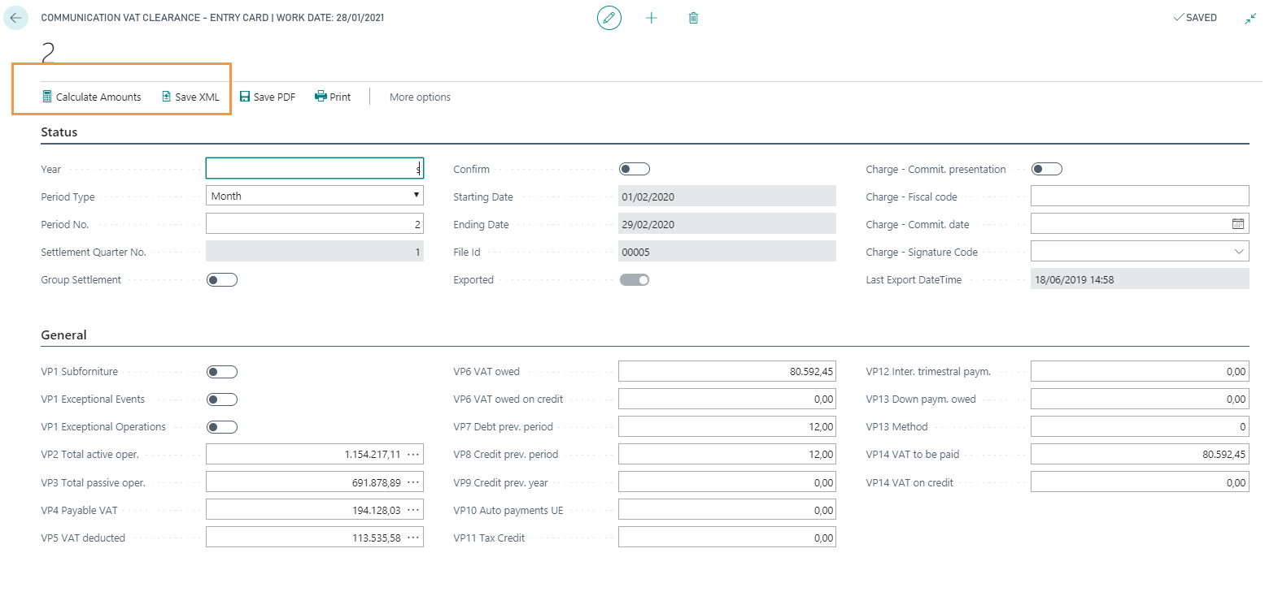
FIELD | DESCRIPTION
Year  Period Type  Period No.  Settlement Quarter No.  VP1 Subforniture  VP1 Exceptional events / operations | enter the reference year. The system automatically completes starting and ending date  if the VAT Settlement is quarterly, it is necessary to fill in only one Communication Card with the Period Type = QUARTER. If the VAT Settlement is monthly, it is necessary to fill in three different forms, each with Type period = MONTH and Period No. equal to the relevant month.  indicate the reference month (values ​​from 1 to 12) or the reference quarter (values ​​from 1 to 4). NB Taxpayers who make quarterly settlements, pursuant to art. 7, d.P.R 14, 1999, n. 542, must indicate the value "5" with reference to the fourth solar quarter  field filled in automatically by the system  indicates that the taxpayer makes use of the facilities provided for by the art. 74, paragraph 5  for taxpayers who have made use of tax benefits (for the reference period, for VAT purposes) issued following natural disasters or other exceptional events / operations
Pressing Calculate Amounts the following fields (except VP10, VP11 and VP12) will be automatically populated (calculated by date of operation). They can however be changed manually:
FIELD | DESCRIPTION
VP2 Total active oper  VP3 Total passive oper.  VP4 Payable VAT / VP5 VAT Deducted  VP6 VAT owed  VP6 VAT owed on credit  VP7 Debt prev. period  VP8 Credit prev. period  VP9 Credit prev. year  VP10 Auto payments UE  VP11 Tax Credit  VP12 Inter. trimestral paym.  VP13 Down paym. owed  VP13 Method  VP14 VAT to be paid  VP14 VAT on credit | total amount of active transactions (sales of goods and services) net of VAT, carried out in the reference period By pressing on the amount, it is possible to view the VAT entries that contribute to the total.  total amount of internal, intra-community purchases and imports, relating to goods and services resulting from invoices and import customs bills, net of VAT, issued in the reference period. By pressing on the amount, you can view the VAT entries that contribute to the total.  VAT Total of Purchase and Sales invoices. By pressing on the amounts, you can view the VAT entries that contribute to the total.  corresponds to the difference between the VP4 field and the VP5 field if positive  corresponds to the difference between the VP4 field and the VP5 field if negative (credit VAT for the following period)  debt amount not paid in the previous period (since it does not exceed € 25.82)  amount of VAT credit deducted, resulting from the previous communication the same solar year  amount of the countervailable VAT credit that is deducted in the settlement of the period, resulting from the annual declaration of the previous year  total amount of payments relating to the tax due for the first internal sale of vehicles  amount of the special tax credits used in the reference period to deduct the payment  amount of interest due in relation to the settlement of the quarter  amount of the advance payment due, even if not actually paid. The row must be completed by taxpayers obliged to make deposit payments pursuant to art. 6 of Law n. 405 of 29 December 1990, and successive amendments. When the amount of the deposit is less than €103.29, the payment should not be made, and therefore no amount should be indicated in the row.  the method box must be filled in indicating the code relating to the method used to determine the down payment:  • "1" historical;  • "2" forecasts;  • "3" analytical - effective;  • "4" subjects operating in the telecommunications sectors, water supply, electricity, waste collection and disposal, etc.  amount of VAT to be paid, or to be transferred to the controlling Entity or Company adhering to the group VAT settlement procedure  amount of VAT on credit, or to be transferred to the controlling Entity or Company adhering to the group VAT settlement procedure

Press Save XML to generate and download the XML file. Once you have saved the XML file, check it before the submission.
Print example of the PDF file:

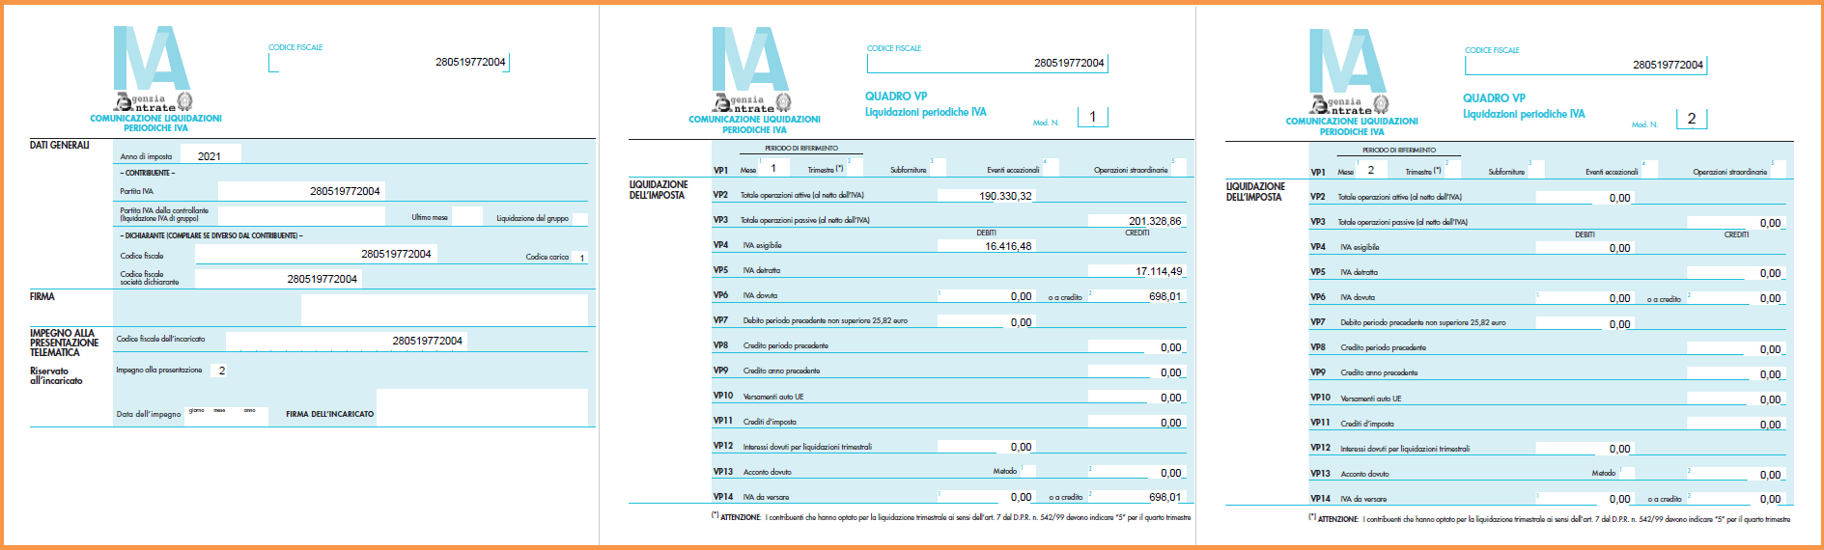

Communication VAT Clearance – Setup
Go to the page Communication VAT Clearance Setup and fill in the data. It is possible to use the function “Copy from Company Information”.
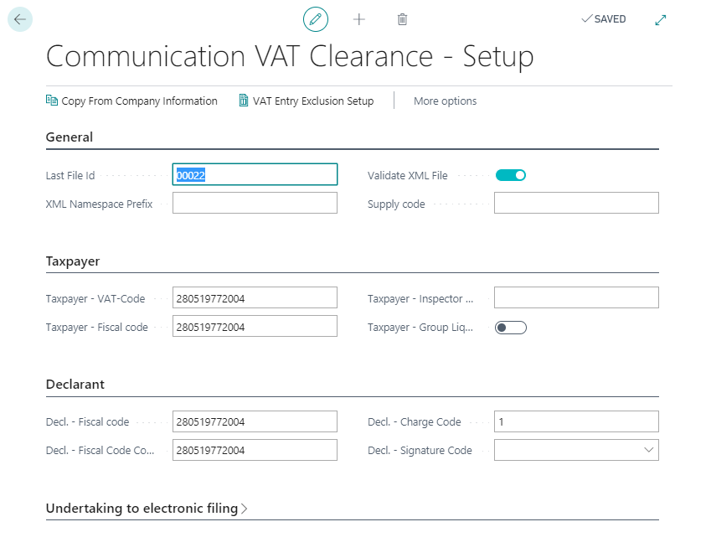

You can Setup specific VAT setup to be summarized in VP fields or not by pressing VAT Entry Exclusion Setup.

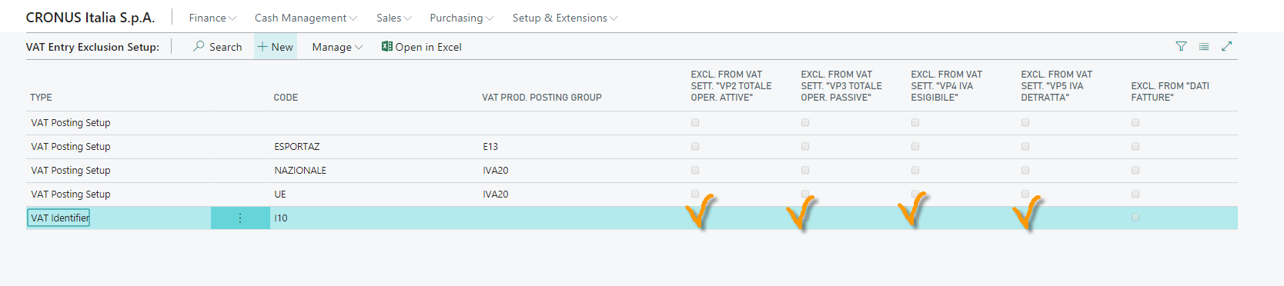

Subscription
Some features of the Electronic VAT Settlement For Italy require a subscription.
The subscription can be activated from Subscription control panel or directly from the notification messages that the system proposes, by clicking on the link that allows you to start the subscription wizard.

In particular:
- FREE Version:
the user is not allowed to create neither the XML file, nor the PDF file.
- PRO Version:
the user is allowed to manage all features

