Abstract
This document list the high level platform capabilities, features and processes.
Rubicon
Product Document – High Level Features v0.1

Contents
1. Rubicon Platform 2
a. Introduction 2
b. Sales Channels 3
c. Fulfilment Channels 3
d. Brand System Integration 3
2. Dashboards 4
3. Inventory Management 4
4. Logistics Management 5
5. Catalogue Management 5
6. Order Management 5
a. Order creation 6
b. Order Allocation 6
c. Order Processing 6
d. Reports 6
7. Roles & Users 7
8. Omni Channel Features 7
a. Click and Collect 7
b. Ship from Store 7
c. Endless Aisle 7

Rubicon Platform

Introduction

RUBICON - Ace Turtle’s proprietary fulfilment platform provides a seamless omni-channel fulfilment experience by bringing together both online and offline channels. The platform powers omni-channel use-cases and provides a holistic approach to provide a great customer experience.
Rubicon is a technology, device and channel agnostic platform which can seamlessly integrate to Brand’s tech eco system and deliver an enriched single view of Inventory, Catalogue, Price and Order Management. The system provides simple interfaces to the Brand to simplify the fulfilment process.

The four important aspects of the platform are as below.

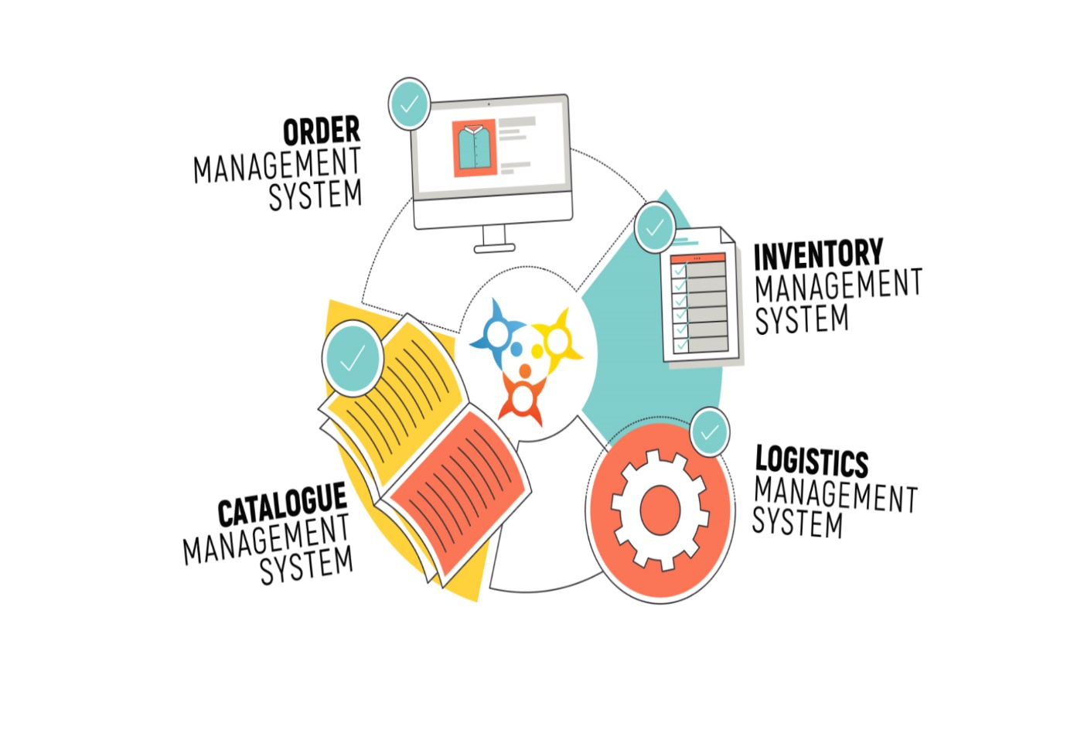
The Rubicon platform offers capabilities to manage catalogue and price, publish inventory and manage orders from various sales channels and fulfil through various stock points.
[Note: The capabilities are discussed in detail in the subsequent sections.]

Sales Channels

Rubicon is Sales channel agnostic platform and can support various channels as below-
- Market Places (Amazon, Flipkart, Myntra, Jabong, PayTM, Shop Clues, Lime Road, etc.)
- Mono Brand. Com
- Mobile applications – (Android, iOS, Windows, etc.)
- Kiosks
- Digital Magazines, etc.
- Store POS system- This channel is leveraged to provide a one stop solution to view all retail related data.

Fulfilment Channels

- Rubicon platform can support fulfilment from various stock points like Warehouse, Stores and any other stock point.
- To configure the stock points, user can go to the user panel to add warehouses, stores and other stock points on the platform to allocate the order for fulfilment.
- The platform provides a Web Panel to the store representative and another panel for the warehouses for fulfilment operations personals to facilitate the fulfilment process.
- The Platform can seamlessly integrate and publish orders to store POS systems for store representatives and WMS systems for the warehouse operations to process the order as well.

Brand System Integration

The platform integrates to the Brand’s tech eco-system primarily to get catalogue, Inventory and Price data to publish to various sales channels. Further, the platform also publishes status update and reports to the brand systems.
Rubicon is technology agnostic and can seamlessly integrate to any system using APIs, SFTP, EDIs etc.

Dashboards

Rubicon system hosts a Dashboard section which has several important charts to highlight major numbers. Some are as below-
- Total sales
- Total Orders
- Failed orders
- Number of orders from omnichannel use cases – Click & Collect, Ship from store etc.
- Refunds
- SLA Breach, etc.
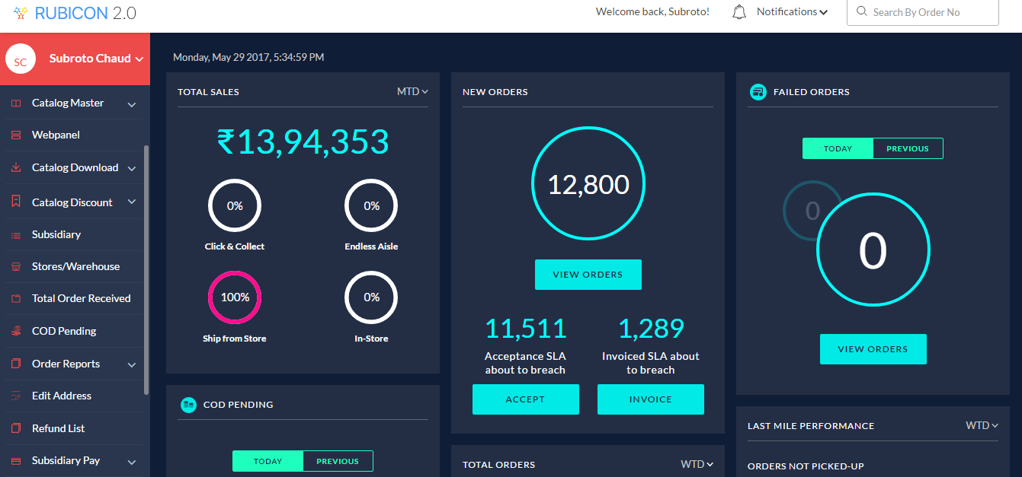

Inventory Management

Rubicon platform hosts a Global inventory system which provides the following major features:
- Single view of inventory- Single module and view to add / manage and publish inventory to all channels from single platform.
- Global inventory – The system supports dedicated as well as shared inventory across all channels to target more potential sales.
- Real Time changes – The system publishes and updates inventory for each sales happening from any channel to keep other channels in sync in the real time.

Logistics Management

- Rubicon integrates to various logistics partners and provides an eco-system to the Brands to leverage a partner based on the goals the Brand wants to achieve.
- There is a host of last mile logistics partners available in the pre-integrated eco-system like Aramex, Xpressbees, Ecom Express, Bluedart, Delhivary etc, and growing.
- The system while allocating the order to a last mile partner checks the cost, serviceability, performance to allocate the order dynamically to a last mile partner and automatically create the ticket in the last mile partner’s Logistics Management System.
- Rubicon provides an end to end tracking of the order from allocation to customer delivery through real time status exchanges. For Marketplaces, who support seller ship, similar approach is used.
- Further, for market places who allocate their own last mile partners, Rubicon is updated with the latest status till the point the order is delivered to the customer.

Catalogue Management

Rubicon hosts a set of capabilities around managing catalogue for all the channels like marketplace and .com sites.
- User can create the relevant set of Attributes, Attributes groups to generate the templates.
- The catalogue data can be uploaded into the system to manage the catalogue in the platform.
- The platform provides download capabilities for sales channels for data publish.
- The platform maintains the mapping of brand EAN and channel SKU numbers for a seamless communication between various channels like .com and market places with Rubicon.
- The platform also hosts capabilities to manage digital assets like product images, videos, 360-degree product videos etc.

Order Management

Rubicon platform provides end to end capabilities to manage orders across all channels and fulfil from any fulfilment point.
The major features available in this context are as below:

Order creation

- The Rubicon system receives orders over integration from traditional channels .COM, marketplaces, customer care placed orders and also supports any other channel like kiosks, digital magazines etc. and places them in a single view for the user.
- If the order cannot be fulfilled due to exceptional scenarios like inventory mismatch, then the system will send cancellation to relevant channel.
- For cash on delivery (COD) orders, the Rubicon system integrates to CRM applications and cloud telephony systems to automatically call the customer can confirm the order. Once, confirmed the order is allowed for processing.
- Similarly, a customer can call and an integrated IVR system will inform the customer of the current status without manual interventation.

Order Allocation

- The order once placed is allocated to the most preferable fulfilment point. The system considers the availability of inventory, proximity to customer, serviceability of logistics, SLA adherence and allocate the order to the most preferable stock point.
- The order at this point can be allocated to a dedicated channel based on priority of the sales channel as well.
- The system provides a configurable time window to the stock point to pick the order and initiate fulfilment.
- If the order is not picked up, the system automatically takes the order back and allocates the order to the next best stock point.
- If the order is not getting picked up within a stipulated timeframe, then the system allocates to a default stock point – 999 and flags the case to the relevant team for closure.

Order Processing
- The store representatives can use the Rubicon web Panel or through integration can leverage their own POS system to process the order.
- Similarly, warehouse operations can use Rubicon Warehouse web panel or leverage their WMS (warehouse management system) to process the order.
- Either ways, the platform seamless ensure marketplace and .COM sites are in sync with the milestones achieved during processing of each order.

Reports
Rubicon hosts a large set of reports. Some of the important one are as below-
- Order report to track the progress at each milestone level
- Order to be fulfilled tomorrow
- Order breach reports – For orders which have breached the fulfilment SLA
- Orders to breach the SLA

Returns Management
The system provides one stop solution for managing returns as well. Some salient features of the platform are as below:
- The returns from integrated channels (.COM, market places) will automatically be available in the panel in the real time.
- In case a customer calls customer care and requests for a return request to be placed, the CRM team can leverage ‘Create Returns’ feature to initiate a return on behalf of the customer.
- The system supports outcomes of quality check to be captured and tag returned items as sellable or non-sellable with process reasons.
- The trigger or refunds and closure of refunds can be managed in the system and tracked accordingly.
- For market places, the SPF process can be managed from the panel for logical closure and tracking.

Roles & Users

Rubicon system allows to brand to create and manage Roles and add users to the roles. Based on the roles, the access to the system can be provided.
Typical Roles and users configured out of the box are as below:
FUNCTION | ROLES
ADMIN | ADMIN
STORE | STORE MANAGER, WAREHOUSE MANAGER, REGIONAL MANAGER
CATALOGUE MANG. | CATALOGUE MANAGER
LOGISTICS | LOGISTICS MANAGER
FINANCE | FINANCE MANAGER
CUSTOMER SUPPORT | CUSTOMER SUPPORT MANAGER
ECOMMERCE | ECOMMERCE OPS MANAGER, ECOMMERCE MANAGER
CXO | CXO

Omni Channel Features

Apart from traditional approach of order being shipped from warehouse as a fulfilment point to the customer, the Rubicon system can be leveraged for the following omni-channel fulfilment use cases.

Click and Collect
The system supports the user to buy from a sales channel (say .COM) and choose a store from where the buyer wants to pick the item from. The order will be packed and be ready to be picked up by the customer at the designated store.

Ship from Store
The Rubicon system can fulfil orders from stores by allocating orders to the stores and providing various mechanisms to fulfil the order as discussed in previous sections.
The order will be packed and last mile partner will pick the item from the store and deliver the order to the customer.

Endless Aisle

Rubicon system with a custom-built application / site can host the extended catalogue on a kiosk where a customer can place the order (with or without assistance) and the order will be fulfilled based on assigned rules in the system.

