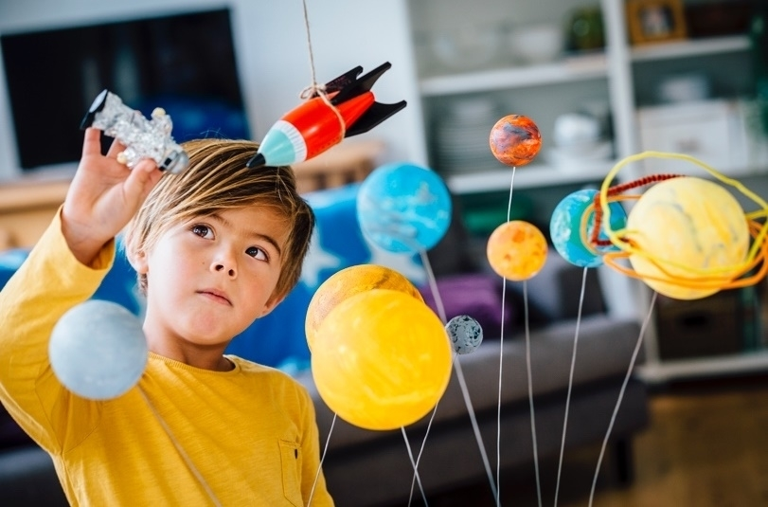

Science Fair Planner



A successful competitive science fair project takes planning and organization. Complete this page as soon as you learn of the assignment, post it in a prominent place, and use it as a guide for pacing and contents.

# Three Components of a Competitive Science Fair Project:

|  |  |  |  |  |  |  |  |
| --- | --- | --- | --- | --- | --- | --- | --- |
|  | Science Journal | Closed Book | Research Report | Pencil | Presentation Board | Scissors |  |

**Due Date (all components):** <enter due date here>

|  |  |  |  |  |  |  |
| --- | --- | --- | --- | --- | --- | --- |
| Brainstorm | Determine Problem | Compose Hypothesis | Conduct Experiment | Collect Data | Analyze Data | Draw Conclusions |

|  |  |  |
| --- | --- | --- |
|  | **Complete by** | Each BOLD word represents a page in your Research Report and Board. |
| □ | <insert date 6 wks before Due Date> | Prepare a Science Journal in which you will keep notes about all thoughts, actions, and data for the entirety of your project. |
| □ | <insert date 7 wks before Due Date> | Brainstorm topic or subject in which you are interested (life science, earth science?) Is there a question or problem that interests you? Research via Bing, classmates, adults, library. |
| □ | <insert date 7 wks before Due Date> | Determine the PROBLEM you wish to solve. What is the purpose of your experiment? Have the PROBLEM approved by your teacher. |
| □ | <insert date 6 wks before Due Date> | Compose a HYPOTHESIS that clarifies what you think will happen when you conduct your experiment. This is your “If I ___, then___ will happen because ___” statement. |
| □ | <insert date 5 wks before Due Date> | Design your experiment in detail. Generate a MATERIALS LIST. |
| □ | <insert date 5 wks before Due Date> | Conduct your experiment. Write and check step-by-step directions. These will be your PROCEDURES. (Adjust timing here if project is more time-consuming). |
| □ | <insert date 5 wks before Due Date> | As you are conducting your experiment, take note of all possible quantitative data in your Science Journal (measuring, timing, weighing). This data will prove or disprove your hypothesis. |
| □ | <insert date 4 wks before Due Date> | Once your experiment is complete, organize your data and choose a graphic that will best illustrate the change that took place. These are your RESULTS. |
| □ | <insert date 3 wks before Due Date> | Analyze your results, then compose a clear DATA ANALYSIS. |
| □ | <insert date 3 wks before Due Date> | Write your CONCLUSION, which is your interpretation of the data (why did the results occur?) |

|  |  |  |  |  |  |
| --- | --- | --- | --- | --- | --- |
| Type | Edit/Proofread | Print for Report | Print for Presentation Board | Assemble & Construct Presentation Board | Turn in Your Science Fair Project! |

|  |  |  |
| --- | --- | --- |
|  | Complete by |  |
| □ | <insert date 3 wks before Due Date> | Write, compose, and design supporting pages for your report**:** TITLE PAGE, ABSTRACT, ACKNOWLEDGMENTS, TABLE OF CONTENTS, RESEARCH SUMMARY, GLOSSARY, and CITED SOURCES. |
| □ | <insert date 2 wks before Due Date> | Type all pages of your report. You have been writing them all along. Pay close attention to parameters set by your teacher or science fair director. |
| □ | <insert date 2 wks before Due Date> | Proofread and edit all typed pages and graphics. |
| □ | <insert date 2 wks before Due Date> | Print pages for your report. Assemble. Bind. |
| □ | <insert date 10 wks before Due Date> | Print PROBLEM, HYPOTHESIS, MATERIALS LIST, PROCEDURE, DATA GRAPHICS, DATA ANALYSIS, and CONCLUSION in larger text size to fit presentation board. |
| □ | <insert date 7 wks before Due Date> | Assemble components onto Presentation Board according to parameters set by your teacher or science fair director. Add photographs and title. Be neat |
| □ | <insert date 5 wks before Due Date> | Review Science Journal and check for completeness. |
| □ | <insert Due Date> | You are finished with all three components of your competitive science project!  Science Journal Closed Book Research Report Pencil Presentation Board Scissors |

## Parent Acknowledgment for <enter student name>

### I, ______________________ (parent), am aware my child is participating in an important project, and I am committed to supporting him/her with advice and encouragement. I have noted the Due Date, planning dates, and subject area, and will aid in having all three components at <location to be turned in> by <insert due date>. (Once signed, copy this page for teacher and parent.)