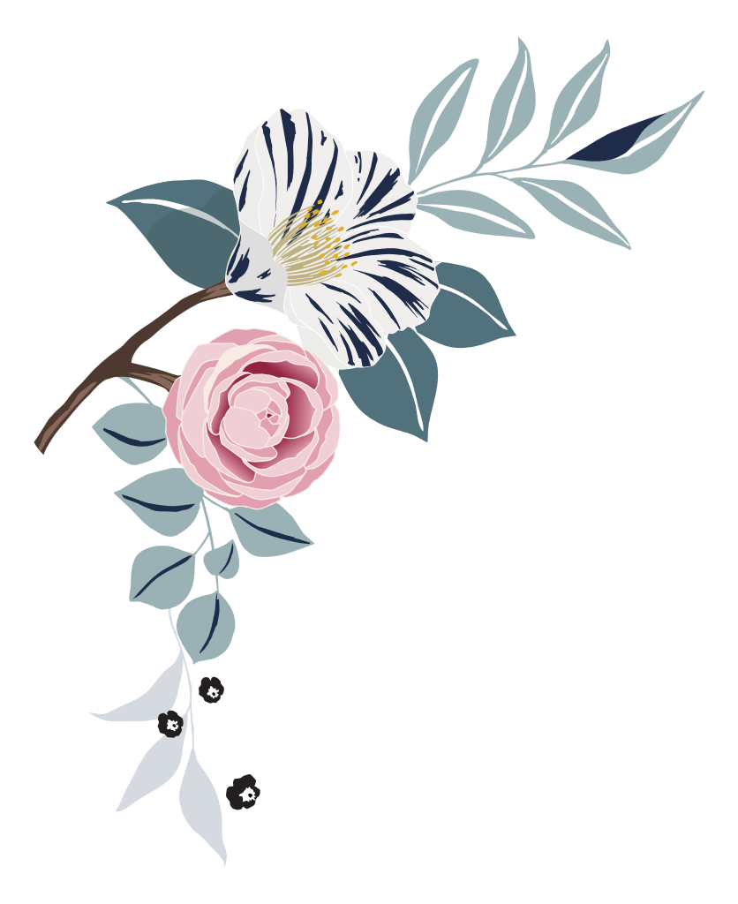

Wedding

photo checklist

|  |
| --- |
| Pre-ceremony |

|  |  |  |  |
| --- | --- | --- | --- |
| bride | | | |
|  | Bride hairstyling |  | Zip or buttoning of wedding gown |
|  | Bride makeup application |  | Bride putting on veil |
|  | Wedding dress (hanging, draped) |  | Bride looking in mirror |
|  | Something old/new/borrowed/blue |  | Bride with bouquet |
|  | Wedding shoes, jewelry, veil displayed |  | Click or tap here to enter text. |

|  |  |  |  |
| --- | --- | --- | --- |
| Wedding party | | | |
|  | Bridesmaids’ hair and makeup |  | Flower girls or junior bridesmaids with bride |
|  | Bride and bridesmaids pre-wedding outfits |  | Bridesmaids with bouquets |
|  | Bride with Maid of Honor |  | Flower girls with flower baskets |
|  | Candid photos of bridesmaids dressing |  | Candid photos of wedding party leaving for ceremony |

|  |  |  |  |
| --- | --- | --- | --- |
| Bride’s family | | | |
|  | Bride with mother |  | Bride pinning mother’s corsage |
|  | Mother of bride adjusting veil |  | Bride pinning father’s boutonniere |
|  | Bride with father |  | Candid photos of bride’s family leaving for ceremony |

|  |  |  |  |
| --- | --- | --- | --- |
| Groom | | | |
|  | Groom tying tie |  | Groom with father |
|  | Groom putting on boutonniere |  | Groom with groomsmen |
|  | Groom looking in mirror |  | Groom with ring bearer |
|  | Groom with best man |  | Groomsmen putting on boutonnieres |
|  | Groom with mother |  | Candid photos of groom and groomsmen leaving for ceremony |

|  |
| --- |
| at the ceremony |

|  |  |  |  |
| --- | --- | --- | --- |
|  | Church/venue exterior |  | Groom’s first sight of bride |
|  | Church/venue interior (empty) |  | Bride and escort entering |
|  | Officiant with groom |  | Bride and escort from rear of venue |
|  | Guests arriving |  | Bride “given away” |
|  | Bride arriving |  | Musical performances and special readings |
|  | Groom arriving |  | Unity ceremonies or memorials |

|  |  |  |  |
| --- | --- | --- | --- |
|  | Musicians and soloists |  | Communion, eucharist, or other religious ceremonies |
|  | Seating of grandparents |  | Exchange of vows |
|  | Seating of parents |  | Exchange of rings |
|  | Groom and officiant entering |  | Candid photos of children in wedding party |
|  | Entrance of children |  | The kiss |
|  | Entrance of wedding party |  | Introduction and applause |
|  | Guests standing for bride |  | Recessional |
|  | Bride and escort framed in doorway |  | Wedding couple with attendants after ceremony |

# 

|  |
| --- |
| Formal photos |

|  |  |  |  |
| --- | --- | --- | --- |
|  | Wedding musician’s close-up |  | Groom alone |
|  | Invitation close-up |  | Wedding couple together |
|  | Altar or chuppah |  | Wedding couple with officiant |
|  | Bride alone |  | Rings close-up |

|  |  |  |  |
| --- | --- | --- | --- |
| Family photos | | | |
|  | Bride with bride’s family |  | Wedding couple with bride’s parents |
|  | Bride with groom’s family |  | Bride with bride’s grandparents |
|  | Groom with bride’s family |  | Wedding couple with bride’s grandparents |

|  |  |  |  |
| --- | --- | --- | --- |
|  | Groom with groom’s family |  | Groom with groom’s parents |
|  | Wedding couple with bride’s family |  | Groom with mother |
|  | Wedding couple with groom’s family |  | Groom with father |
|  | Wedding couple with both families |  | Groom with groom’s grandparents |
|  | Bride with bride’s parents |  | Wedding couple with groom’s parents |
|  | Bride with mother |  | Wedding couple with groom’s grandparents |
|  | Bride with father |  | Couple with siblings |

|  |  |  |  |
| --- | --- | --- | --- |
| Attendants | | | |
|  | Bride with maid of honor |  | Groom with groomsmen |
|  | Groom with best man |  | Wedding couple with groomsmen |
|  | Bride with wedding attendants |  | Bride with child attendants |
|  | Groom with wedding attendants |  | Groom with child attendants |
|  | Wedding couple with wedding attendants |  | Wedding couple with child attendants |
|  | Bride with groomsmen |  | Lorem ipsum dolor sit amet |

|  |
| --- |
| Reception photos |

|  |  |  |  |
| --- | --- | --- | --- |
|  | Exterior of reception venue (empty) |  | Groom’s dance with mother |
|  | Interior of reception venue (empty) |  | Parents dancing |

|  |  |  |  |
| --- | --- | --- | --- |
|  | Arrival at reception venue |  | Grandparents dancing |
|  | Wedding cake |  | Guests dancing |
|  | Bar setup |  | Wedding couple greeting guests |
|  | Groom’s cake |  | Cake cutting |
|  | Buffet and servers |  | Cake feeding |
|  | Band or DJ |  | Speeches/toasts |
|  | Gift table |  | Bride tossing bouquet |
|  | Centerpieces |  | Groom removing garter |
|  | Floral arrangements |  | Groom throwing garter |
|  | Favors |  | Bouquet and garter catchers dancing |
|  | Entrance of wedding party |  | Bride and groom’s last dance |
|  | Entrance of wedding couple |  | Decorated “just married” car |
|  | Bride and groom’s first dance |  | Wedding couple exiting venue |
|  | Bride’s dance with father |  | Guests at exit (throwing birdseed, blowing bubbles, etc.) |
|  | Centerpieces |  | Wedding couple in car waving goodbye |