

|  |  |
| --- | --- |
|  | Happy  Mother’s  **Day** |

|  |  |
| --- | --- |
|  | Thanks for making home the  happiest place to be. |



|  |  |
| --- | --- |
|  | Happy  Mother’s  **Day** |

|  |  |  |
| --- | --- | --- |
|  | Thanks for making home the  happiest place to be. |  |

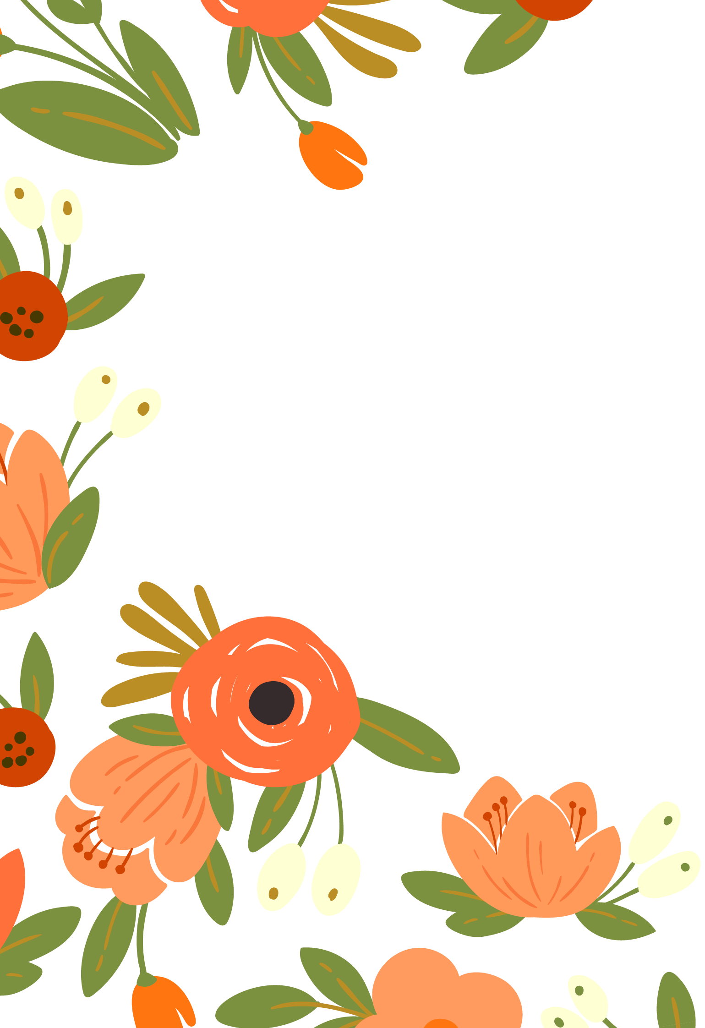

|  |  |
| --- | --- |
|  | Happy  Mother’s  **Day** |

|  |  |  |
| --- | --- | --- |
|  | Thanks for making home the  happiest place to be. |  |