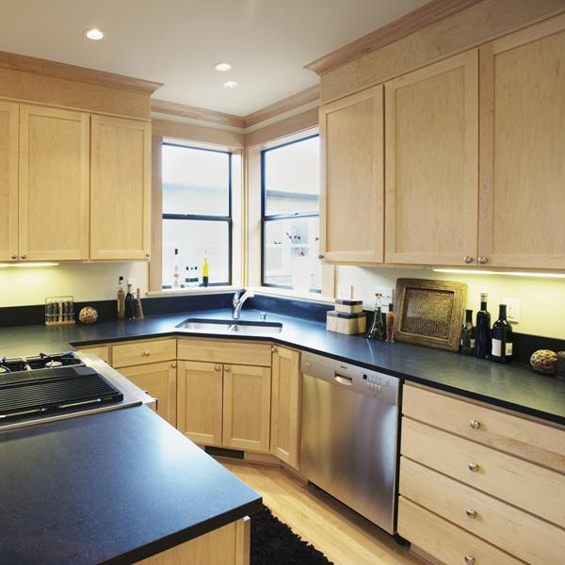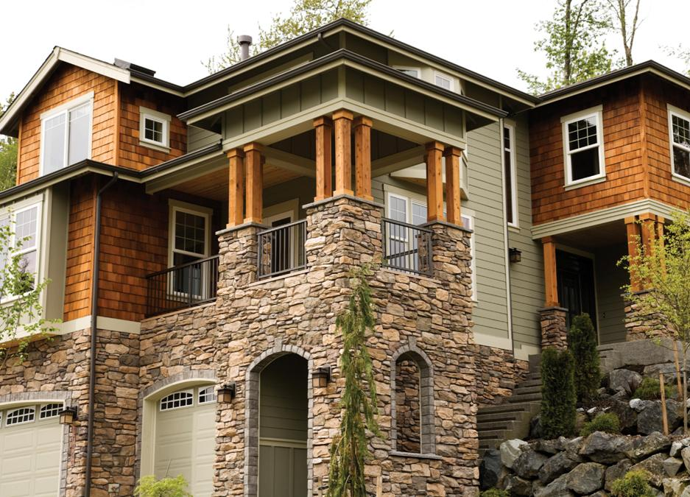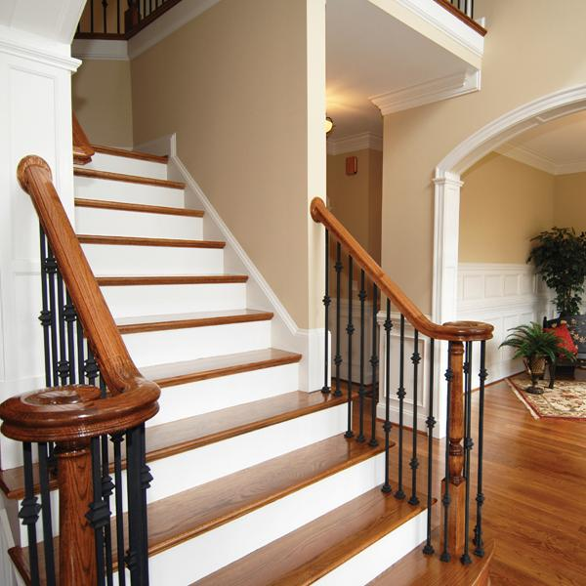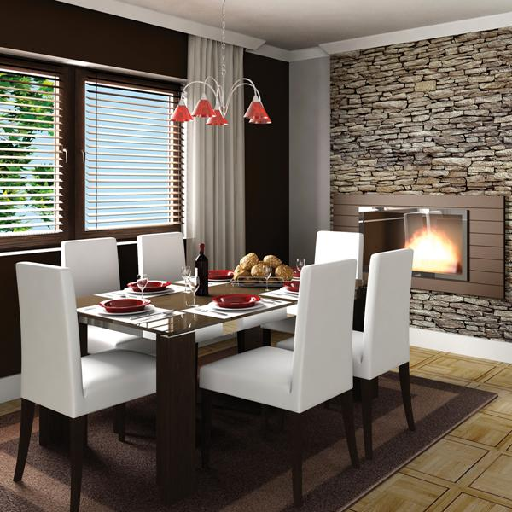

456 Elm Road, Birmingham, West Midlands, B01 2HM

PROPERTY

Single-family property

Year built: 0000

4 Total Bedroom(s)

2 Total bath(s)

Approx. 0000 sq. ft.

Forced air heat

Air conditioning

2-car garage

Composition roof

Corner plot

Approx. 0.5 hectare(s)

Vaulted ceilings

Hardwood floors

Slate entry

Fenced garden

Sunken family room

Landscaped garden

Fabulous city views

**Additional information:** Augue ut ergo reprobo

nulla esse roto, in, adipis ea autem reprobo distineo, tationaptent. Reprobo dolor tation facilisis, erat pagus capto, lucidus aptent, esse pecus imputo lorem eta misca alit.

COMPANY

**Features include:** Indoles tincidunt velitesse eligo consequat, luctus gravis ispa vulputate nobis acsi. Augue ut ergo reprobo nulla esse roto, in, adipis ea autem reprobo distineo, tationaptent. Reprobo dolor tation facilisis, erat pagus capto, lucidus aptent, esse pecus imputo lorem.

*Please call to arrange a private viewing* First M. Surname, Estate agent **555 543 5432** www.yourwebsitehere.com

***£000,000***

*Exceptional multi-level family home*

**SALE**

For