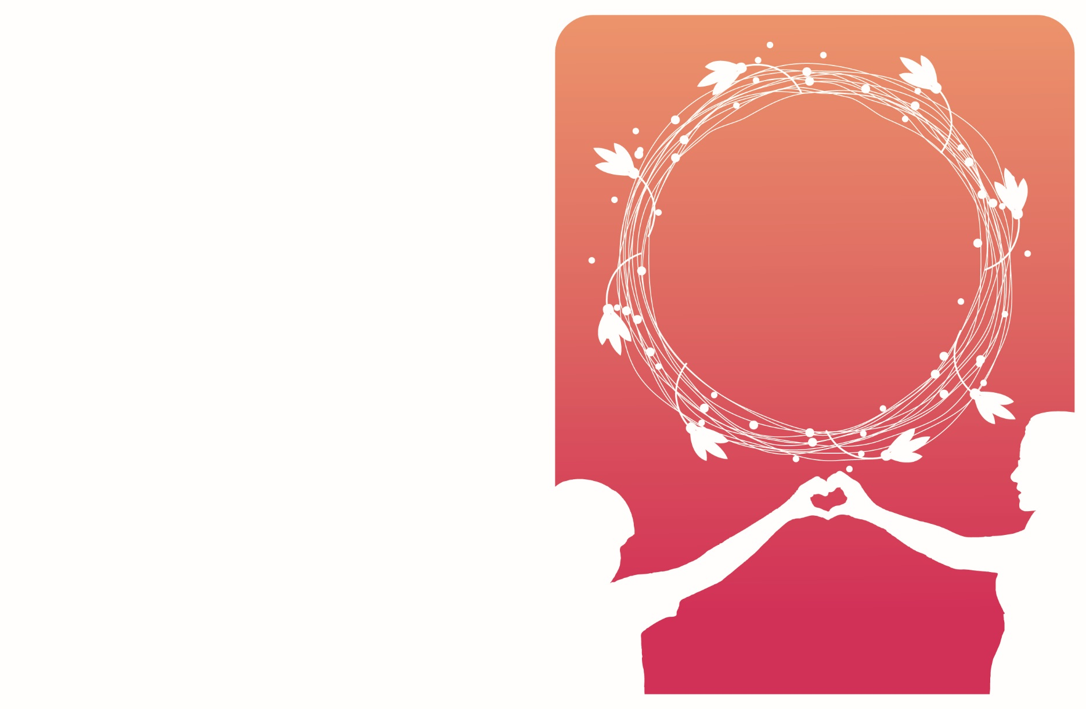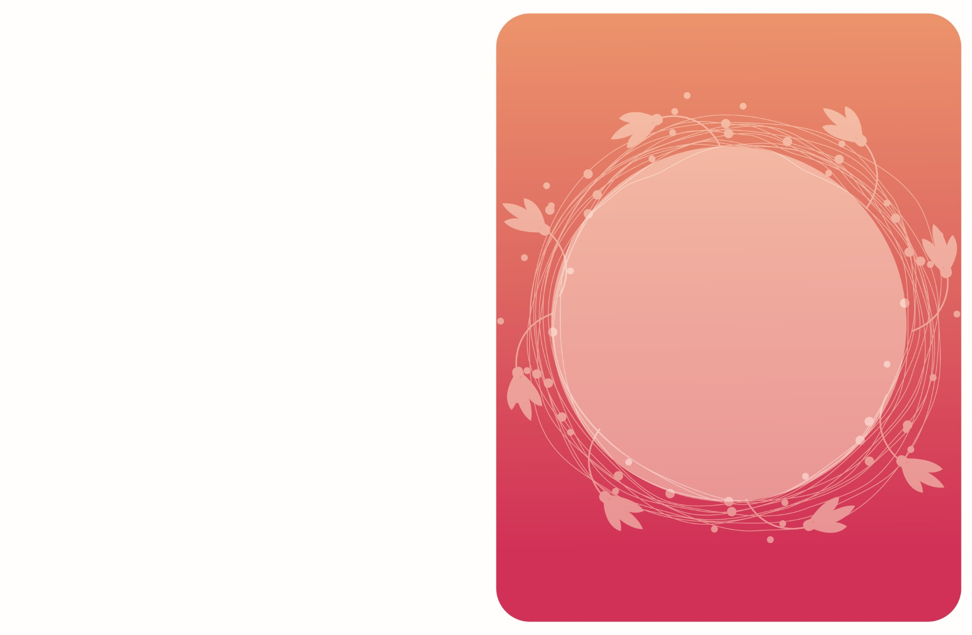

Happy

Mother’s

Day!

Most of all the other

beautiful things in life

come by twos and threes,

by dozens and hundreds

“But there is only one Mother

in the whole world.”

-Kate Douglas Wiggin