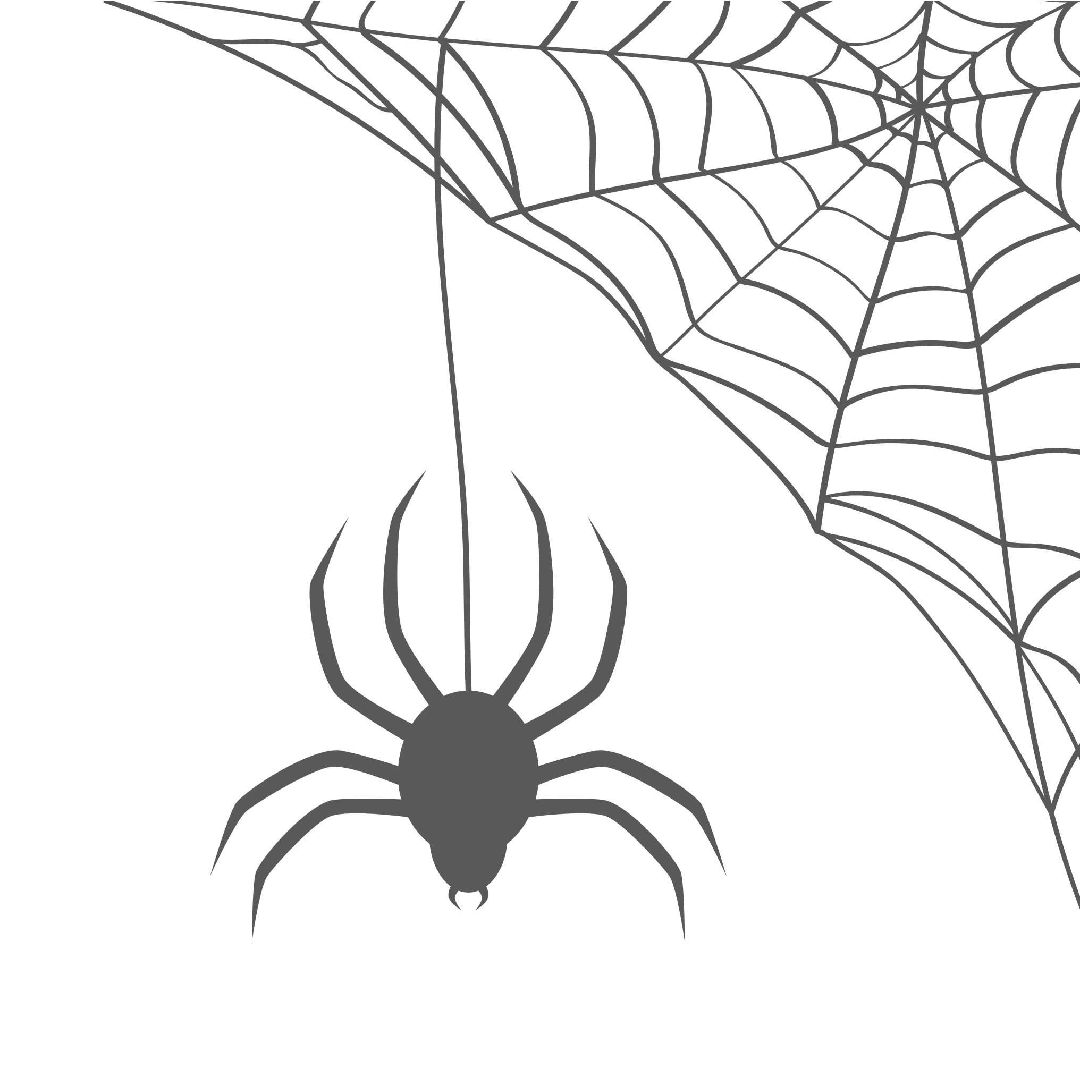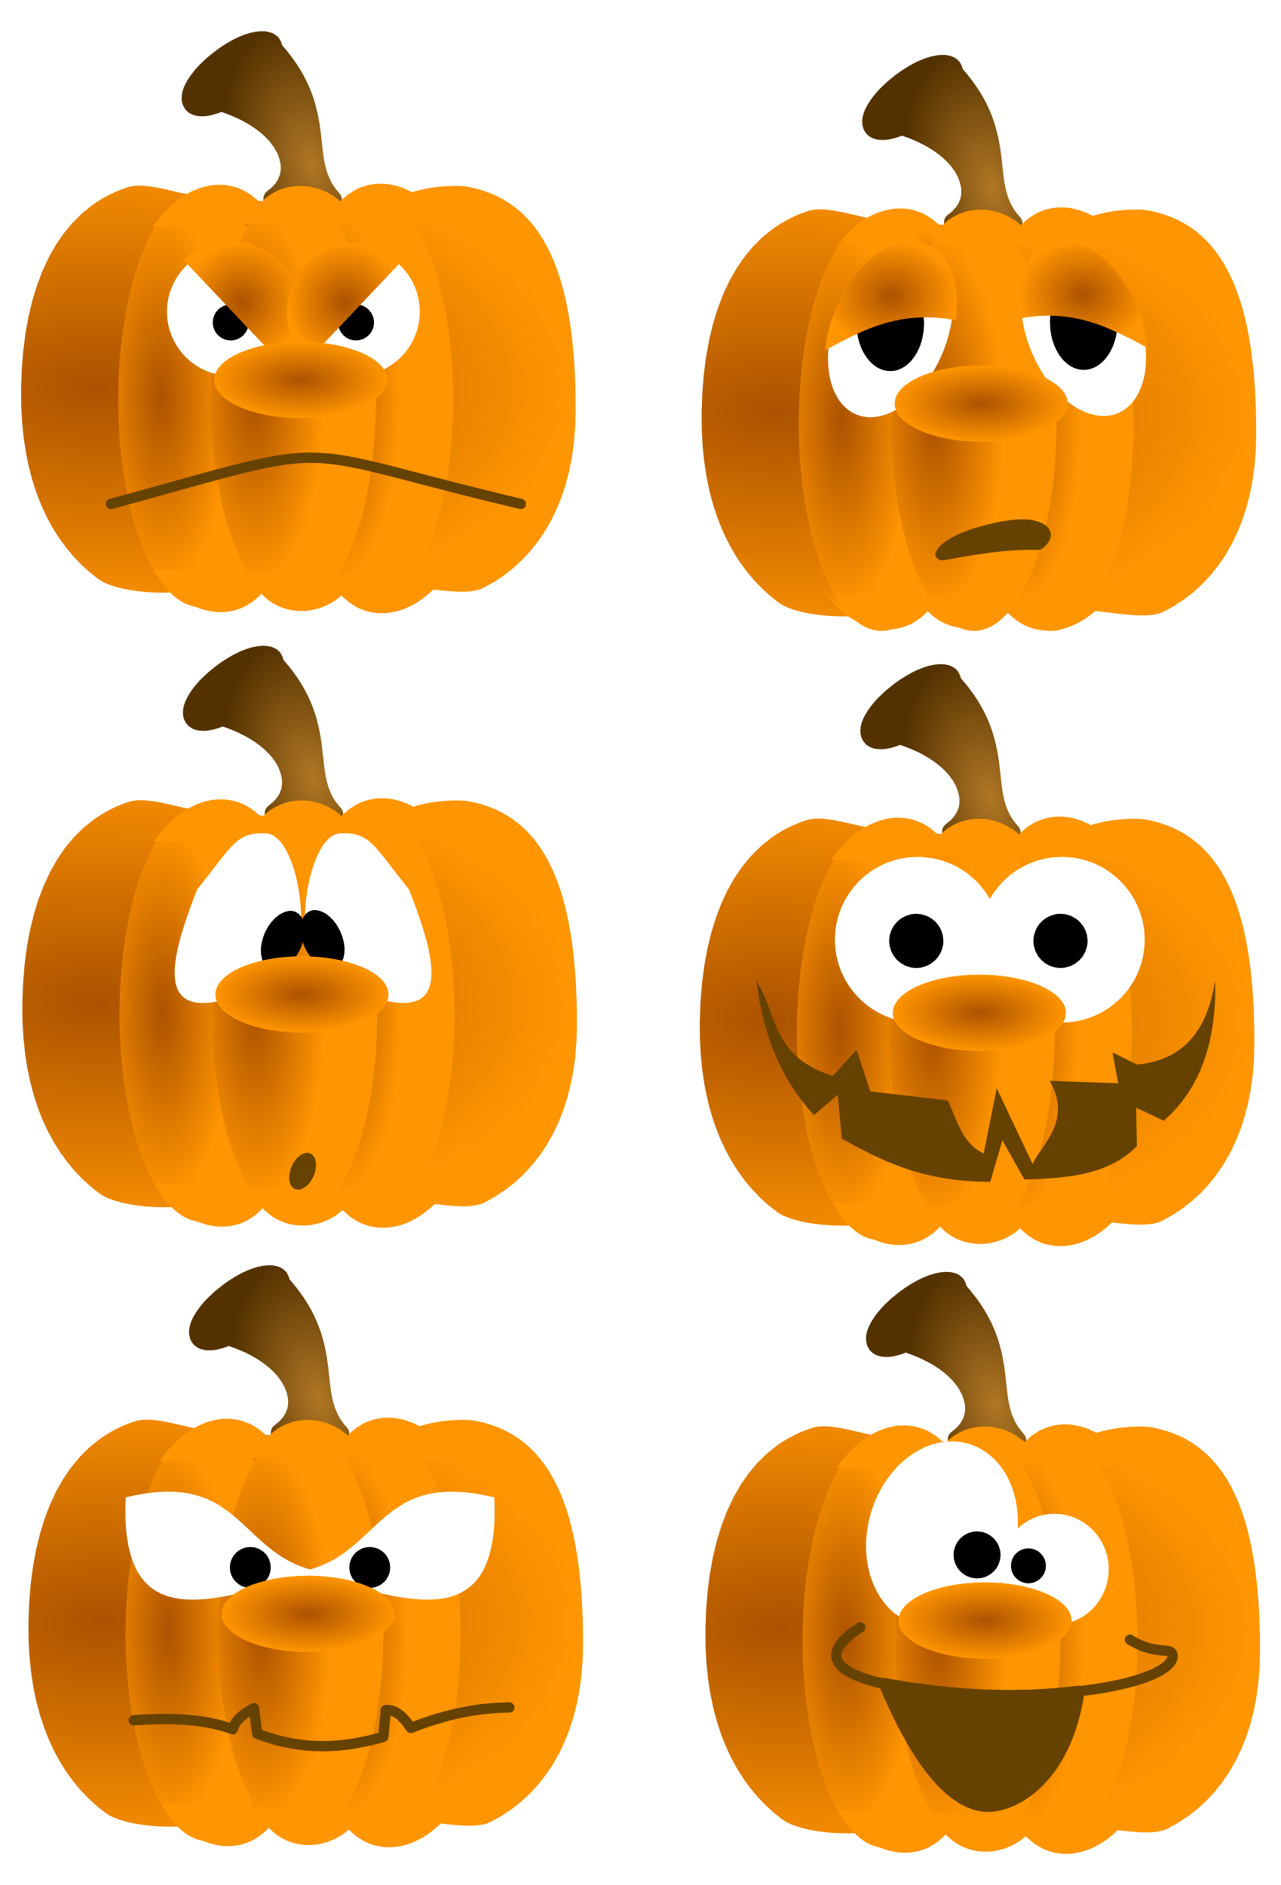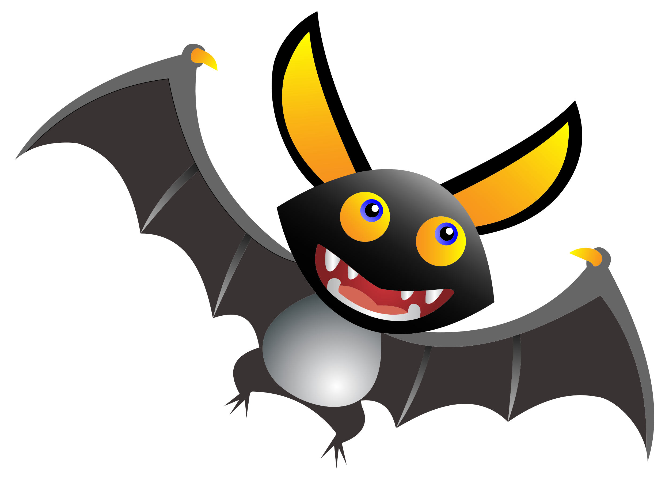

|  |
| --- |
|  |
| You’re Invited to a |
| HALLOWEEN |
| PARTY |
| October 31st, 3pm |
| Mystery Mansion, 123 Spooky Lane |
| Costumes Required |
| RSVP: The Witch |
|  |