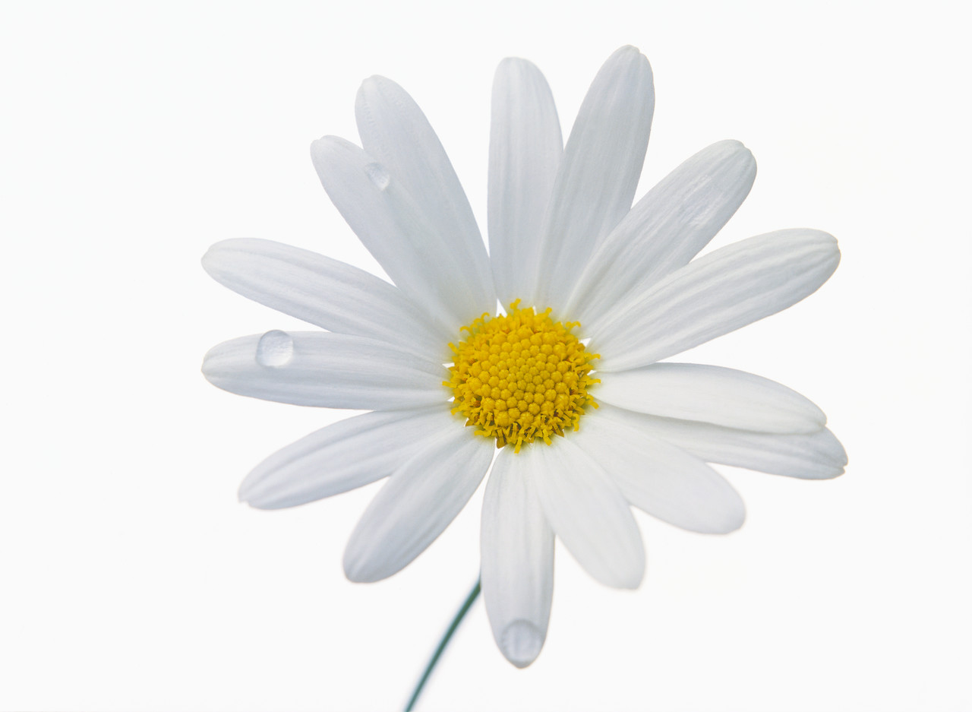

Welcome to our Wedding Reception

Taro & Hanako

2008.00.00