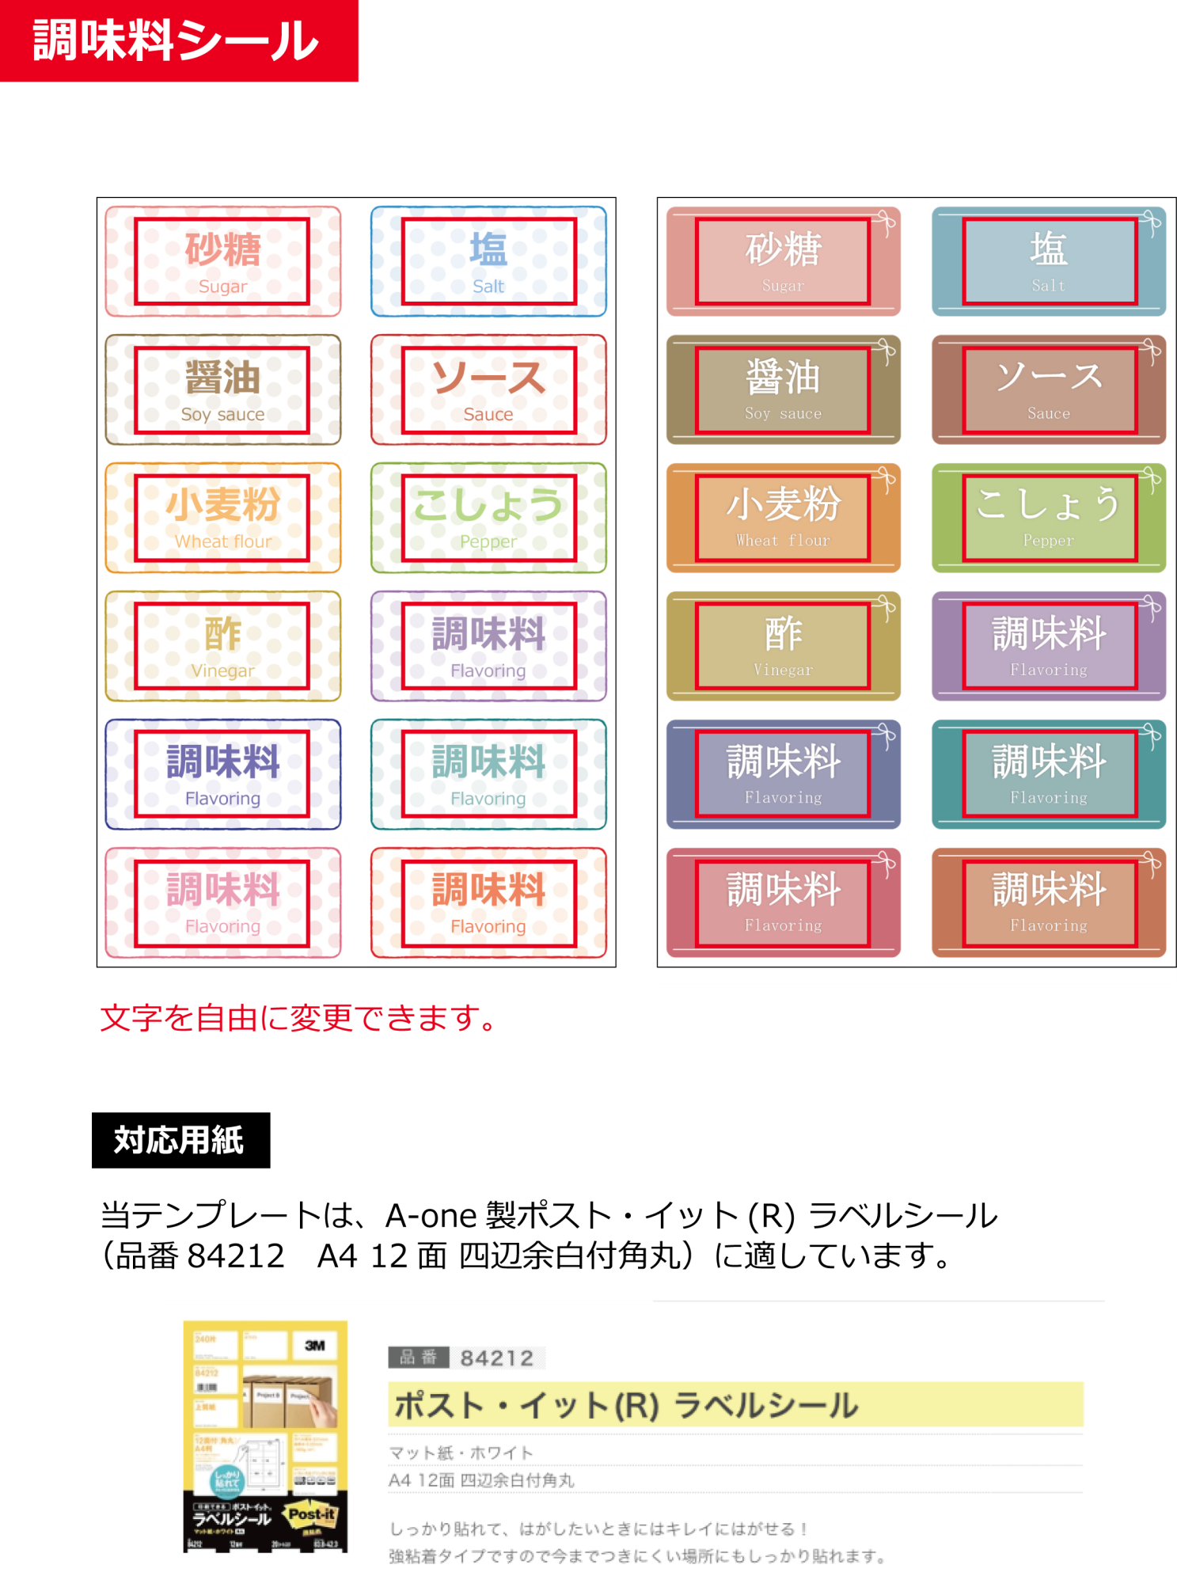

参考URL:

http://www.a-one.co.jp/product/search/detail.php?id=84212

|  |  |  |
| --- | --- | --- |
| **砂糖**  Sugar |  | **塩**  Salt |
| **醤油**  Soy sauce  **ソース**  Sauce |  |  |
| **小麦粉**  Wheat flour  **こしょう**  Pepper |  |  |
| **酢**  Vinegar  **調味料**  Flavoring |  |  |
| **調味料**  Flavoring |  | **調味料**  Flavoring |
| **調味料**  Flavoring  **調味料**  Flavoring |  |  |

|  |  |  |
| --- | --- | --- |
| **砂糖**  Sugar |  | **塩**  Salt |
| **醤油**  Soy sauce |  | **調味料**  Flavoring  **調味料**  Flavoring  **こしょう**  Pepper  **ソース**  Sauce |
| **小麦粉**  Wheat flour |  |  |
| **酢**  Vinegar |  |  |
| **調味料**  Flavoring |  | **調味料**  Flavoring |
| **調味料**  Flavoring |  |  |