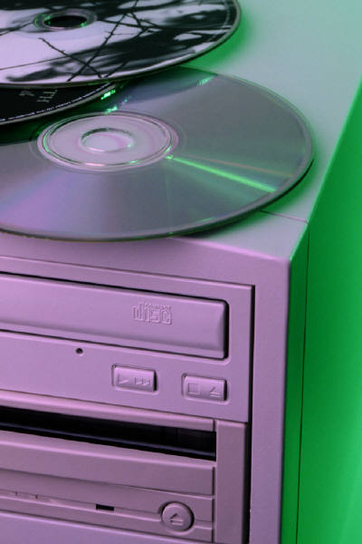

Data Back-up

Files from July 2001:

Visual Basic project for file automation

Data Back-up

Files from July 2001:

Visual Basic project for file automation

Data Back-up: File automation (July 2001)

Data Back-up: File automation (July 2001)

*Front*

*Back and sides*

*Front*