|  |  |  |  |  |  |  |  |
| --- | --- | --- | --- | --- | --- | --- | --- |
| Styczeń 2010 | | | | | | | |
| Poniedziałek | Wtorek | Środa | Czwartek | Piątek | | Sobota | Niedziela |
|  |  |  |  | 1 | | 2 | 3 |
| 4 | 5 | 6 | 7    Ostatniakwadra  10:39 CU | 8 | | 9 | 10 |
| 11 | 12 | 13 | 14 | 15    Nów  07:11 CU | Obrączkowe zaćmienie słońca | 16 | 17 |
| 18 | 19 | 20    Wodnik | 21 | 22 | | 23    Pierwsza kwadra  10:53 CU | 24 |
| 25 | 26 | 27 | 28 | 29 | | 30    Pełnia  06:18 CU | 31 |

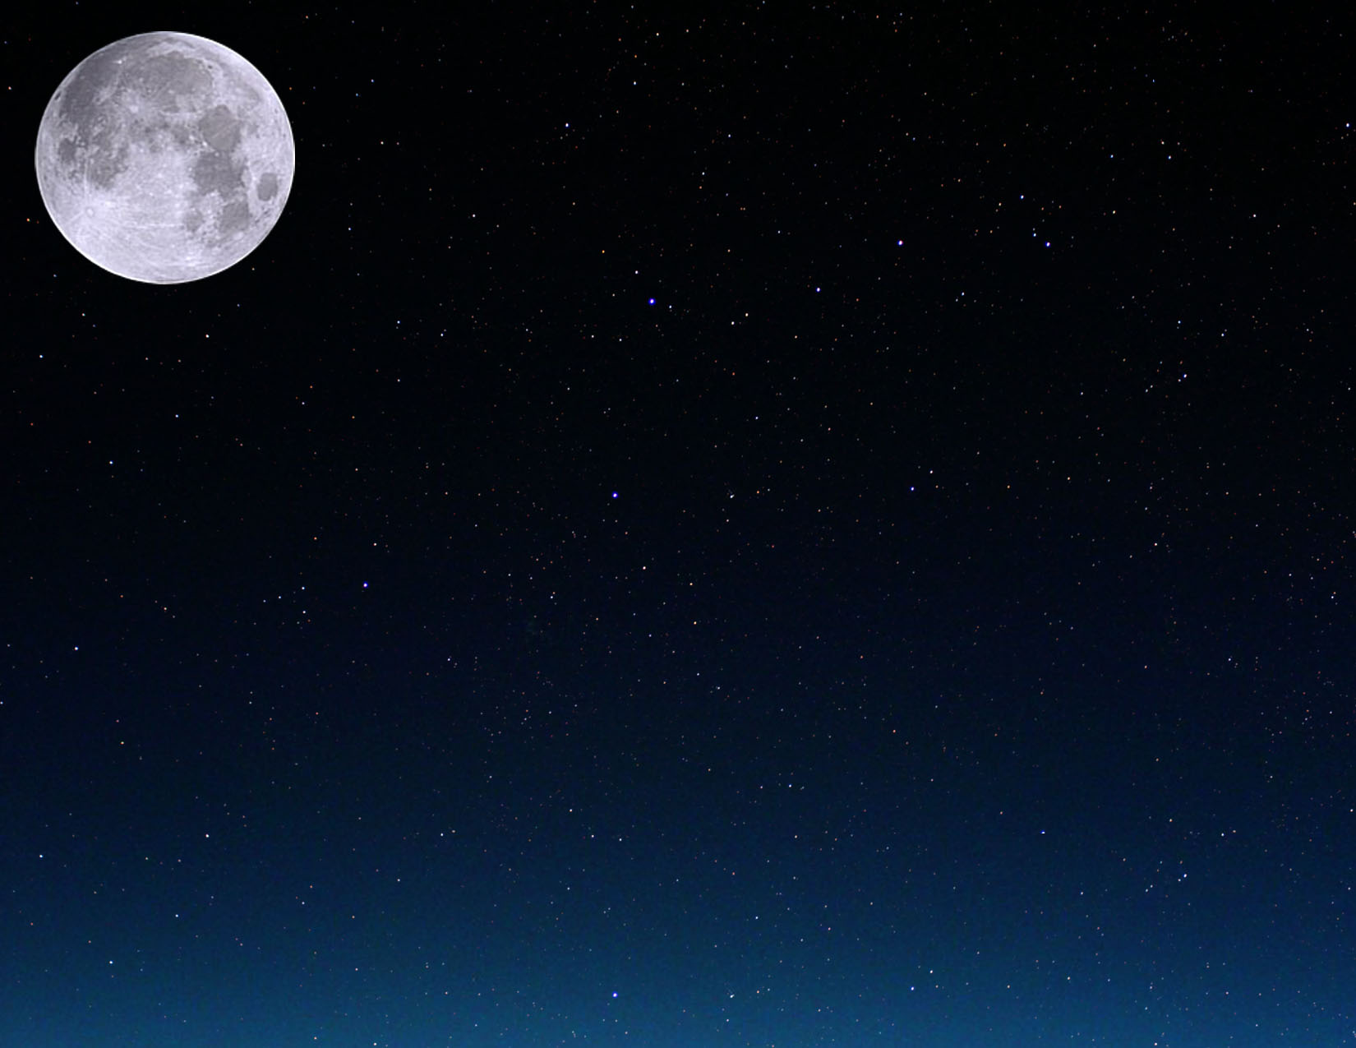

|  |  |  |  |  |  |  |
| --- | --- | --- | --- | --- | --- | --- |
| Luty 2010 | | | | | | |
| Poniedziałek | Wtorek | Środa | Czwartek | Piątek | Sobota | Niedziela |
| 1 | 2 | 3 | 4 | 5    Ostatniakwadra  23:48 CU | 6 | 7 |
| 8 | 9 | 10 | 11 | 12 | 13 | 14    Nów  02:51 CU |
| 15 | 16 | 17 | 18 | 19    Ryby | 20 | 21 |
| 22    Pierwsza kwadra  00:42 CU | 23 | 24 | 25 | 26 | 27 | 28    Pełnia  16:38 CU |

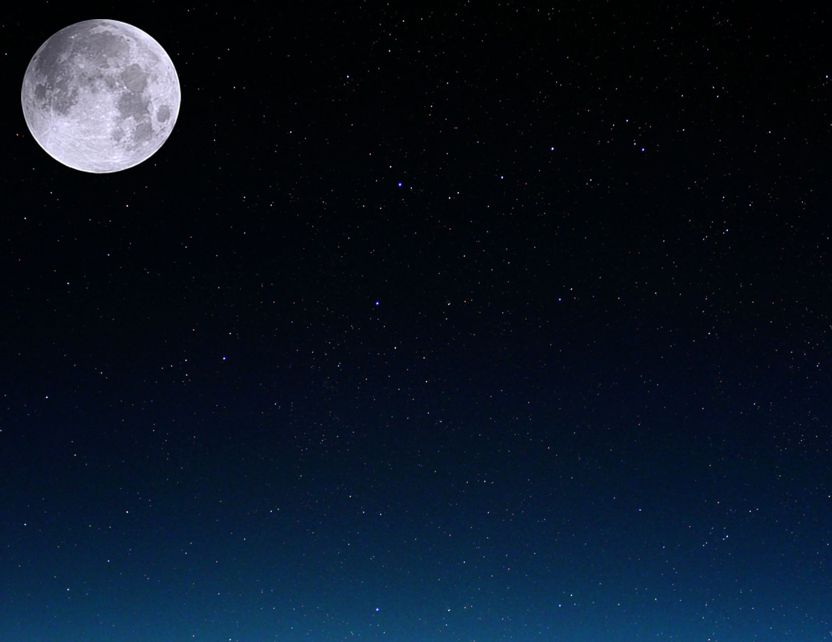

|  |  |  |  |  |  |  |
| --- | --- | --- | --- | --- | --- | --- |
| Marzec2010 | | | | | | |
| Poniedziałek | Wtorek | Środa | Czwartek | Piątek | Sobota | Niedziela |
| 1 | 2 | 3 | 4 | 5 | 6 | 7    Ostatniakwadra  15:42 CU |
| 8 | 9 | 10 | 11 | 12 | 13 | 14 |
| 15    Nów  21:01 CU | 16 | 17 | 18 | 19 | 20  Równonoc wiosenna  17:32 CU | 21    Baran |
| 22 | 23    Pierwsza kwadra  11:00 CU | 24 | 25 | 26 | 27 | 28 |
| 29 | 30    Pełnia  02:25 CU | 31 |  |  |  |  |

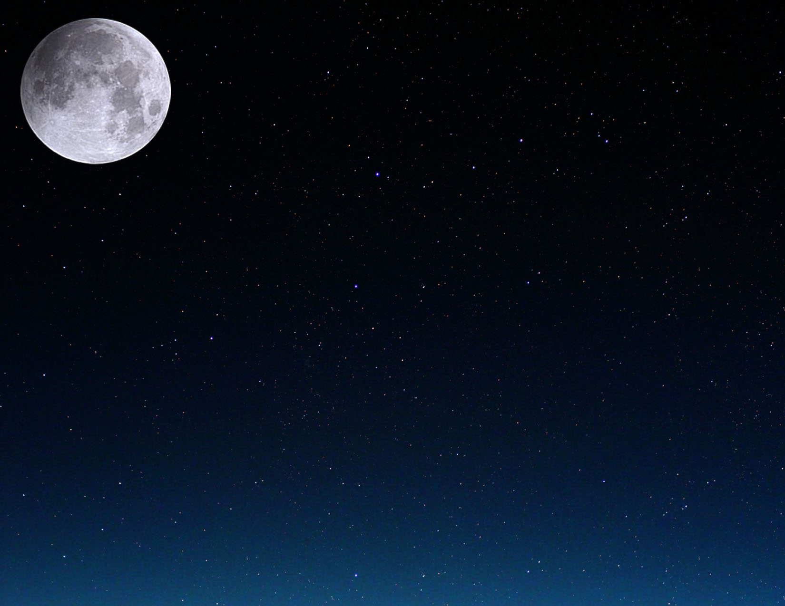

|  |  |  |  |  |  |  |
| --- | --- | --- | --- | --- | --- | --- |
| Kwiecień 2010 | | | | | | |
| Poniedziałek | Wtorek | Środa | Czwartek | Piątek | Sobota | Niedziela |
|  |  |  | 1 | 2 | 3 | 4 |
| 5 | 6    Ostatniakwadra  09:37 CU | 7 | 8 | 9 | 10 | 11 |
| 12 | 13 | 14    Nów  12:29 CU | 15 | 16 | 17 | 18 |
| 19 | 20    Byk | 21    Pierwsza kwadra  18:20 CU | 22 | 23 | 24 | 25 |
| 26 | 27 | 28    Pełnia  12:18 CU | 29 | 30 |  |  |

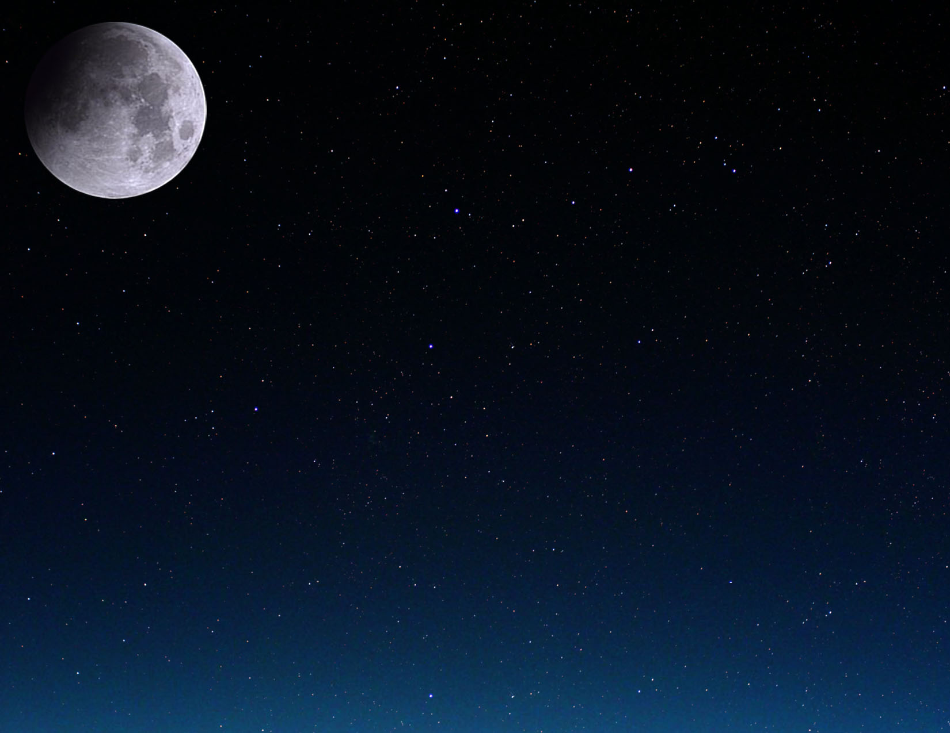

|  |  |  |  |  |  |  |
| --- | --- | --- | --- | --- | --- | --- |
| Maj 2010 | | | | | | |
| Poniedziałek | Wtorek | Środa | Czwartek | Piątek | Sobota | Niedziela |
|  |  |  |  |  | 1 | 2 |
| 3 | 4 | 5 | 6    Ostatniakwadra  04:15 CU | 7 | 8 | 9 |
| 10 | 11 | 12 | 13 | 14    Nów  01:04 CU | 15 | 16 |
| 17 | 18 | 19 | 20    Pierwsza kwadra  23:43 CU | 21    Bliźnięta | 22 | 23 |
| 24 | 25 | 26 | 27    Pełnia  23:07 CU | 28 | 29 | 30 |
| 31 |  |  |  |  |  |  |

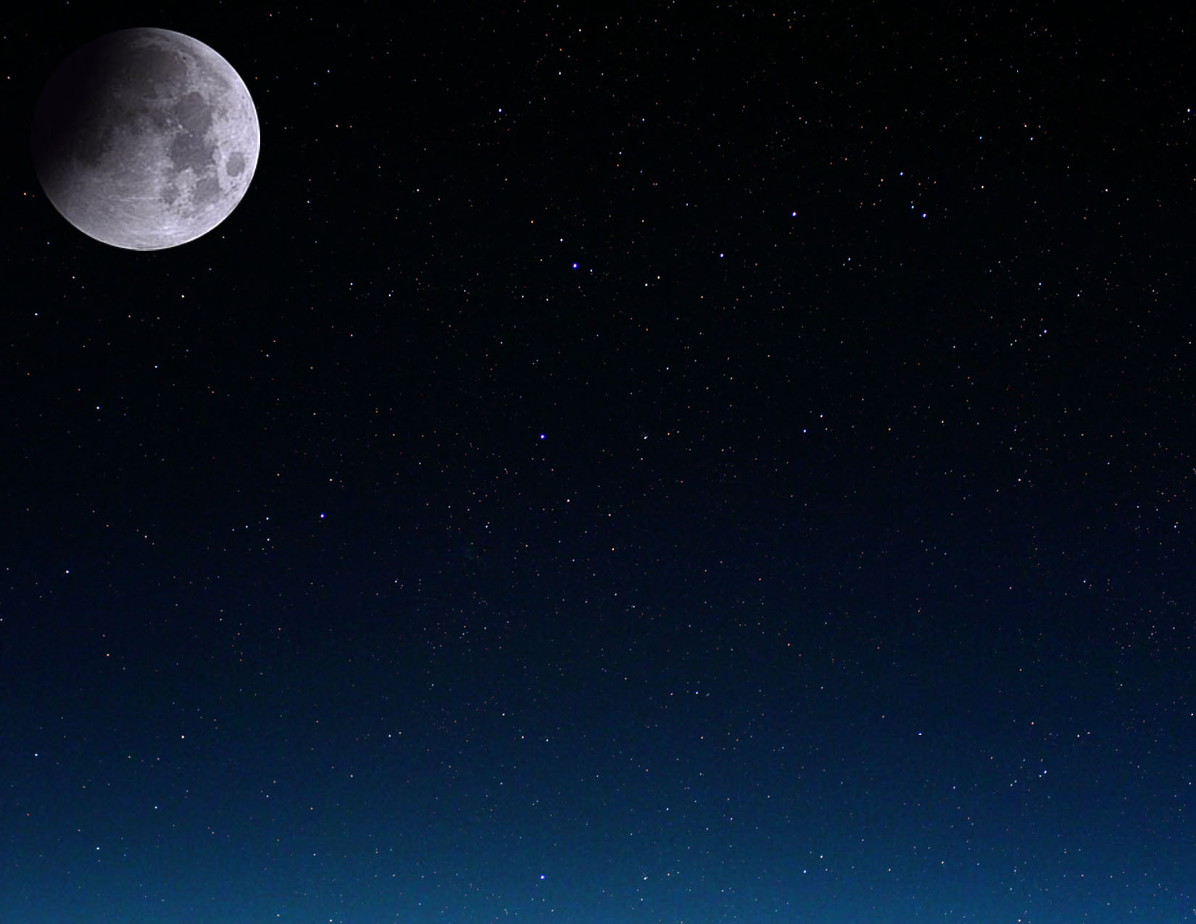

|  |  |  |  |  |  |  |  |
| --- | --- | --- | --- | --- | --- | --- | --- |
| Czerwiec 2010 | | | | | | | |
| Poniedziałek | Wtorek | Środa | Czwartek | Piątek | Sobota | | Niedziela |
|  | 1 | 2 | 3 | 4    Ostatniakwadra  22:13 CU | 5 | | 6 |
| 7 | 8 | 9 | 10 | 11 | 12    Nów  11:15 CU | | 13 |
| 14 | 15 | 16 | 17 | 18 | 19    Pierwsza kwadra  04:29 CU | | 20 |
| 21  Przesilenie letnie  11:28 CU | 22    Rak | 23 | 24 | 25 | 26    Pełnia  11:30 CU | Częściowe zaćmienie księżyca | 27 |
| 28 | 29 | 30 |  |  |  | |  |

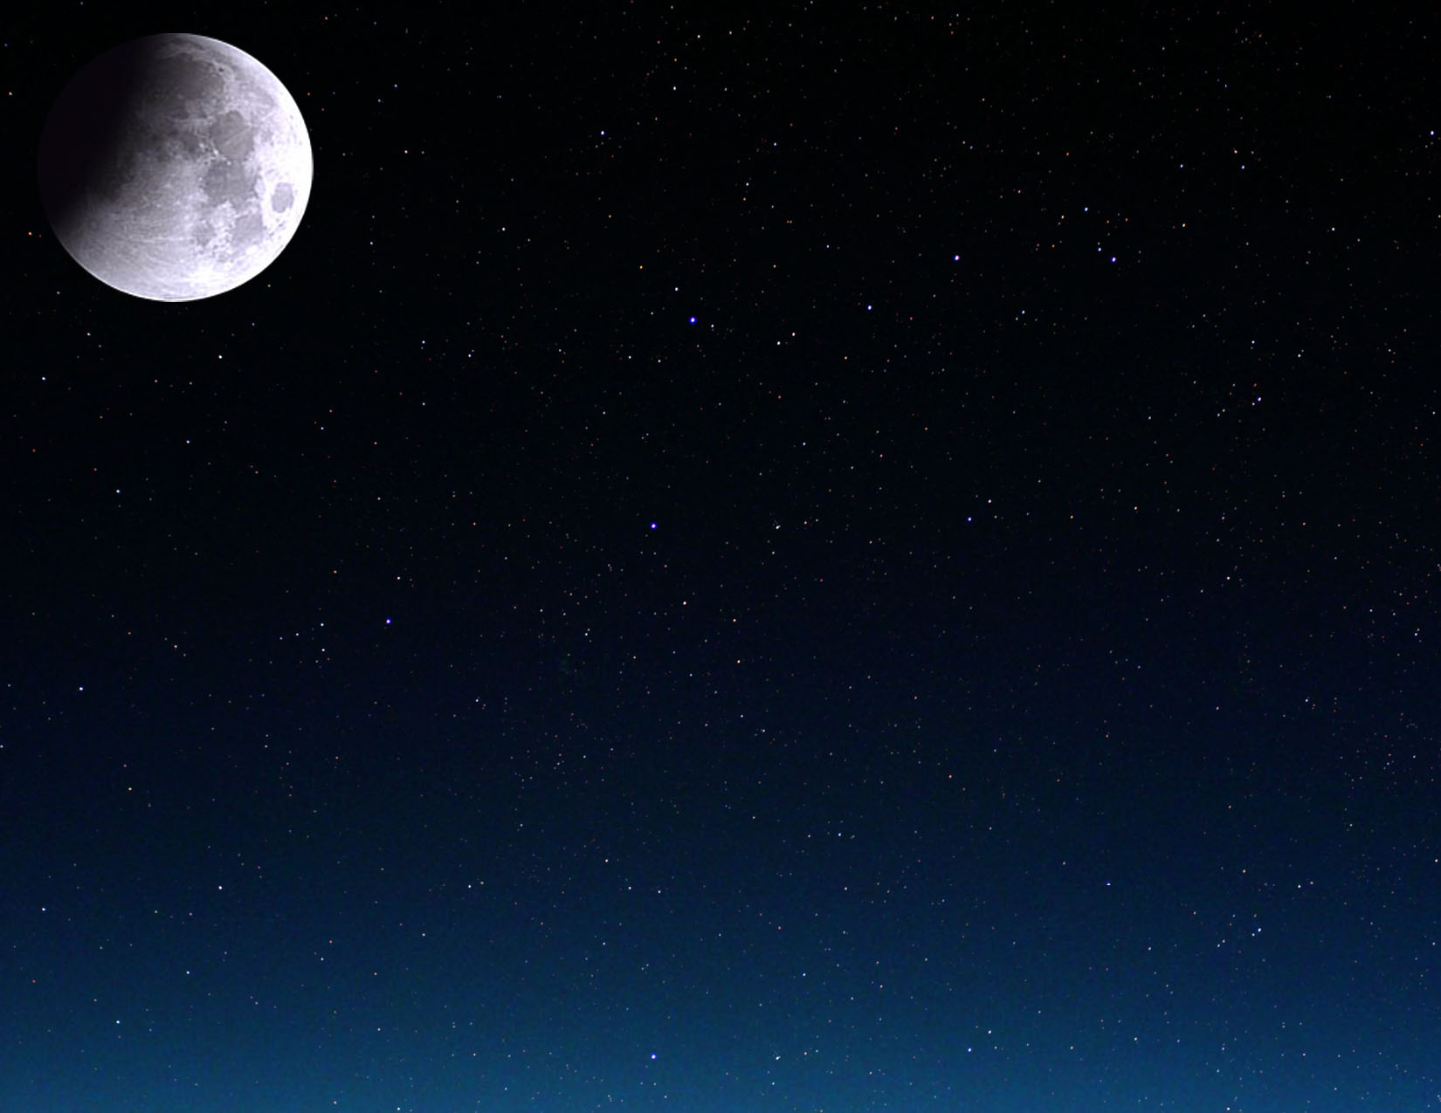

|  |  |  |  |  |  |  |  |
| --- | --- | --- | --- | --- | --- | --- | --- |
| Lipiec 2010 | | | | | | | |
| Poniedziałek | Wtorek | Środa | Czwartek | Piątek | Sobota | Niedziela | |
|  |  |  | 1 | 2 | 3 | 4    Ostatniakwadra  14:35 CU | |
| 5 | 6 | 7 | 8 | 9 | 10 | 11    Nów  19:40 CU | Całkowite zaćmienie słońca |
| 12 | 13 | 14 | 15 | 16 | 17 | 18    Pierwsza kwadra  10:11 CU | |
| 19 | 20 | 21 | 22 | 23    Lew | 24 | 25 | |
| 26    Pełnia  01:37 CU | 27 | 28 | 29 | 30 | 31 |  | |

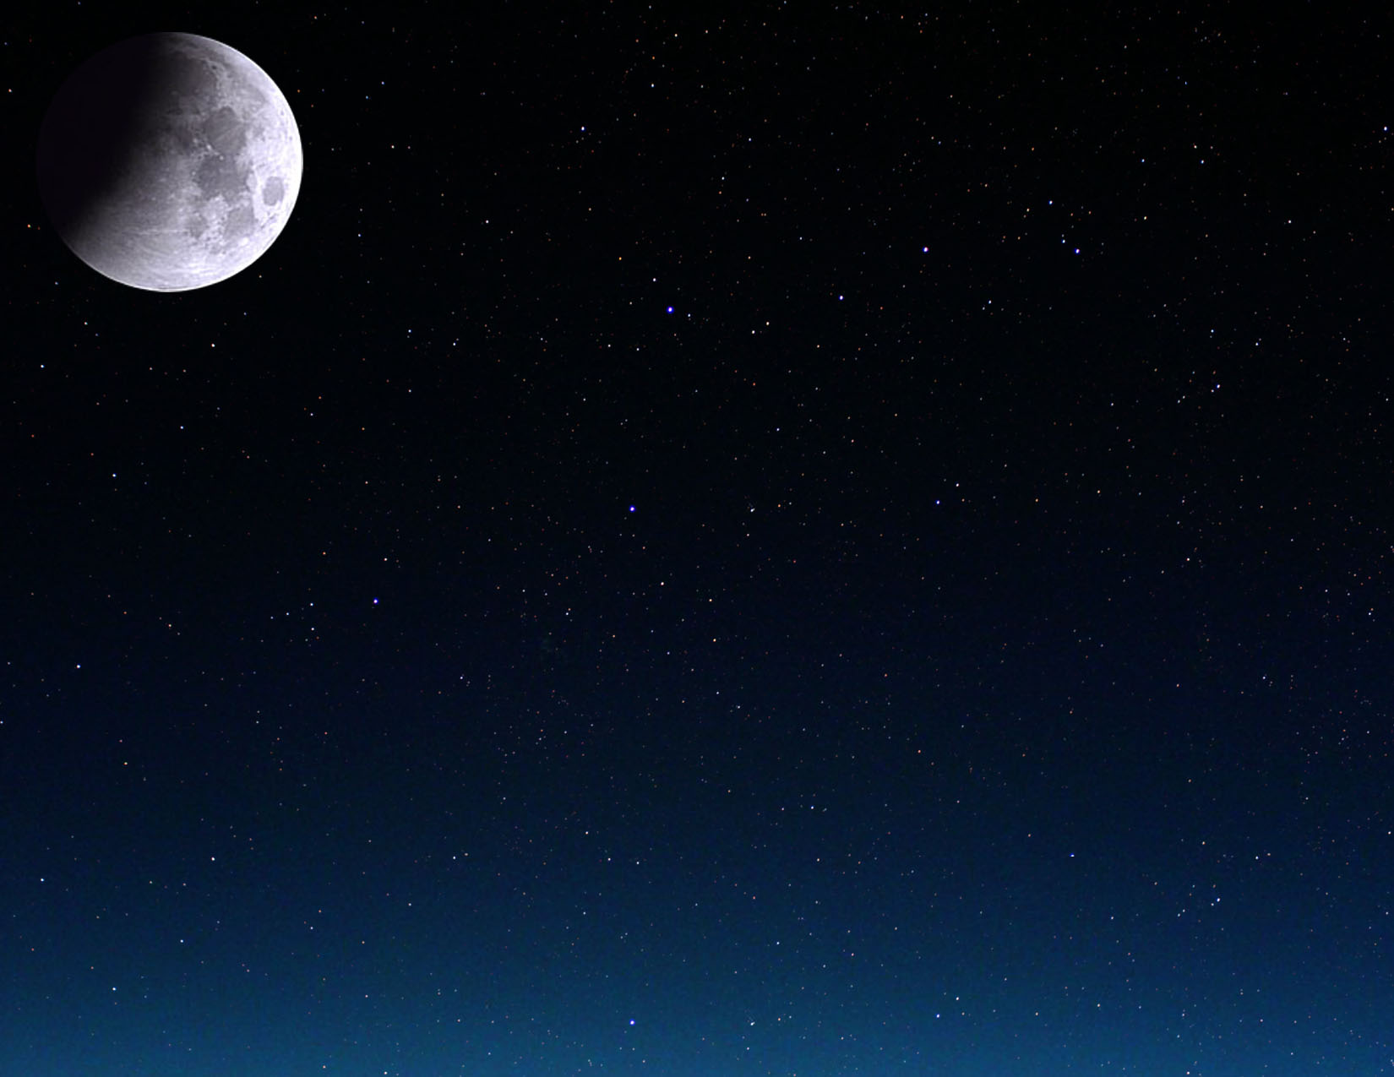

|  |  |  |  |  |  |  |
| --- | --- | --- | --- | --- | --- | --- |
| Sierpień 2010 | | | | | | |
| Poniedziałek | Wtorek | Środa | Czwartek | Piątek | Sobota | Niedziela |
|  |  |  |  |  |  | 1 |
| 2 | 3    Ostatniakwadra  04:59 CU | 4 | 5 | 6 | 7 | 8 |
| 9 | 10    Nów  03:08 CU | 11 | 12 | 13 | 14 | 15 |
| 16    Pierwsza kwadra  18:14 CU | 17 | 18 | 19 | 20 | 21 | 22 |
| 23    Panna | 24    Pełnia  17:05 CU | 25 | 26 | 27 | 28 | 29 |
| 30 | 31 |  |  |  |  |  |

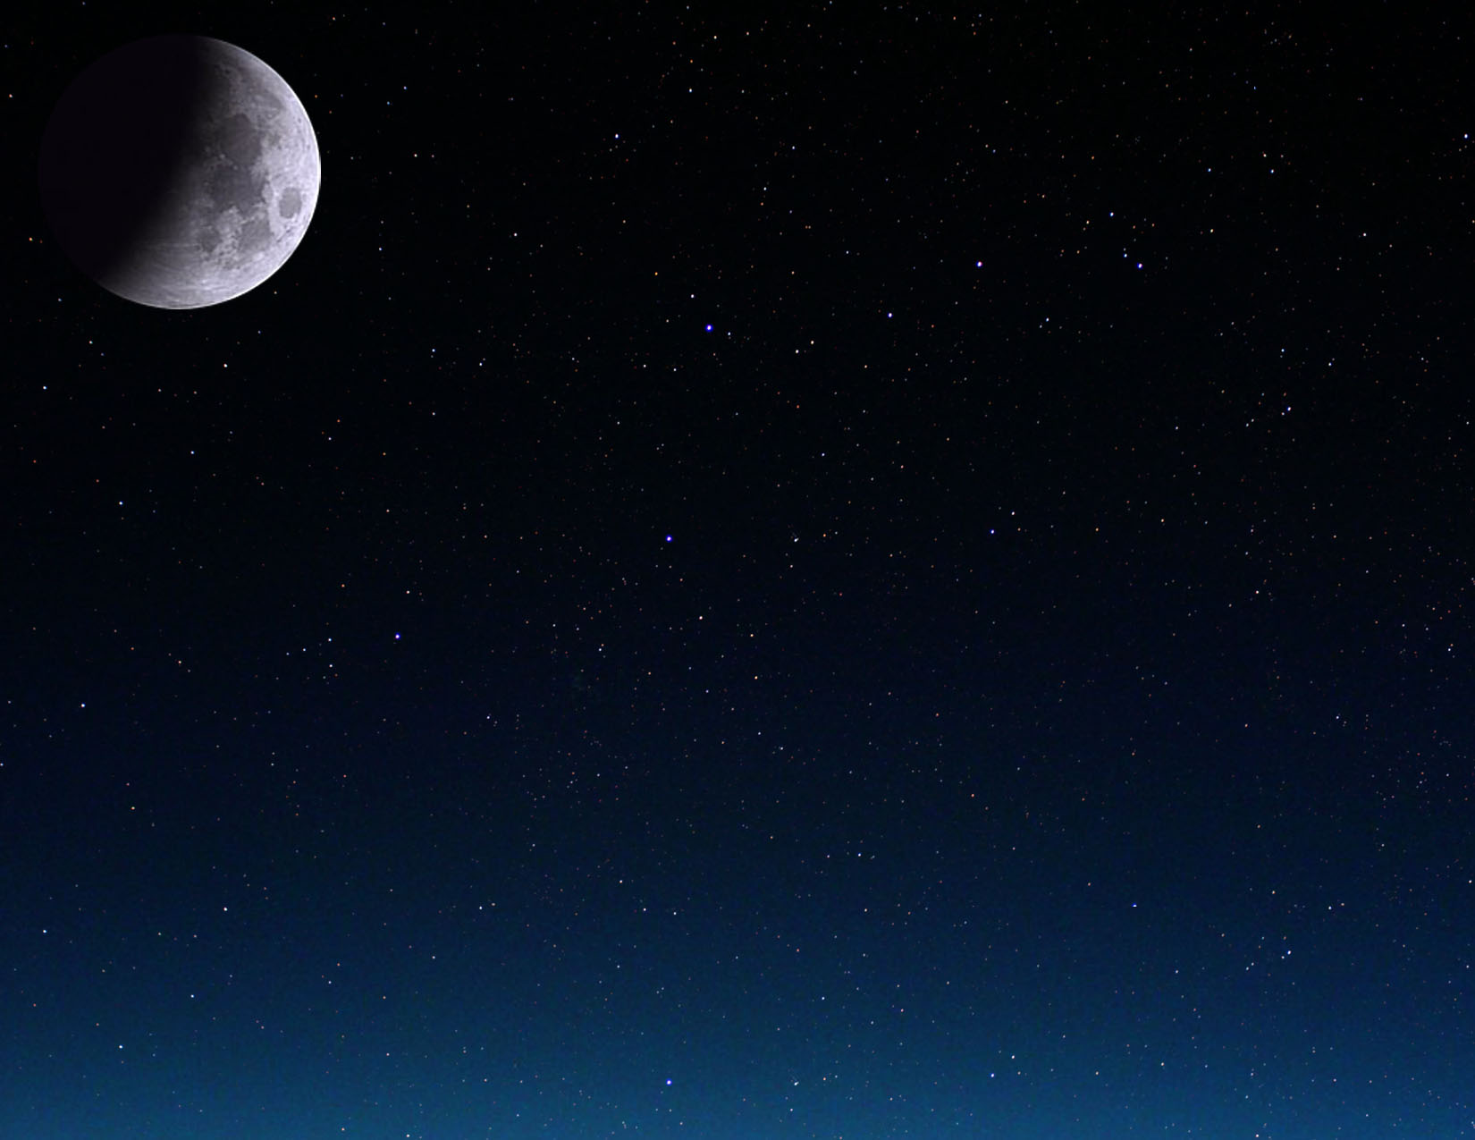

|  |  |  |  |  |  |  |  |
| --- | --- | --- | --- | --- | --- | --- | --- |
| Wrzesień 2010 | | | | | | | |
| Poniedziałek | Wtorek | Środa | Czwartek | | Piątek | Sobota | Niedziela |
|  |  | 1    Ostatniakwadra  17:22 CU | 2 | | 3 | 4 | 5 |
| 6 | 7 | 8    Nów  10:30 CU | 9 | | 10 | 11 | 12 |
| 13 | 14 | 15    Pierwsza kwadra  05:50 CU | 16 | | 17 | 18 | 19 |
| 20 | 21 | 22  Równonoc jesienna  03:09 CU | 23    Pełnia  09:17 CU | Waga | 24 | 25 | 26 |
| 27 | 28 | 29 | 30 | |  |  |  |



|  |  |  |  |  |  |  |  |
| --- | --- | --- | --- | --- | --- | --- | --- |
| Październik 2010 | | | | | | | |
| Poniedziałek | Wtorek | Środa | Czwartek | Piątek | Sobota | | Niedziela |
|  |  |  |  | 1    Ostatniakwadra  03:52 CU | 2 | | 3 |
| 4 | 5 | 6 | 7    Nów  18:44 CU | 8 | 9 | | 10 |
| 11 | 12 | 13 | 14    Pierwsza kwadra  21:27 CU | 15 | 16 | | 17 |
| 18 | 19 | 20 | 21 | 22 | 23    Pełnia  01:36 CU | Skorpion | 24 |
| 25 | 26 | 27 | 28 | 29 | 30    Ostatniakwadra  12:46 CU | | 31 |

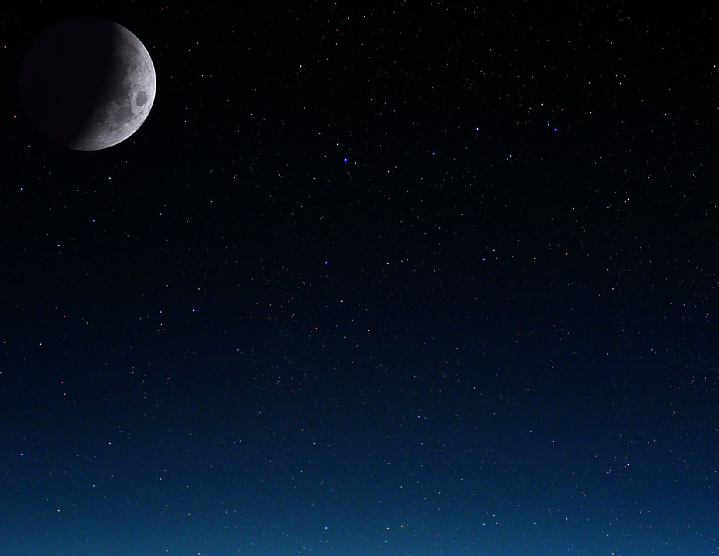

|  |  |  |  |  |  |  |
| --- | --- | --- | --- | --- | --- | --- |
| Listopad 2010 | | | | | | |
| Poniedziałek | Wtorek | Środa | Czwartek | Piątek | Sobota | Niedziela |
| 1 | 2 | 3 | 4 | 5 | 6    Nów  04:52 CU | 7 |
| 8 | 9 | 10 | 11 | 12 | 13    Pierwsza kwadra  16:39 CU | 14 |
| 15 | 16 | 17 | 18 | 19 | 20 | 21    Pełnia  17:27 CU |
| 22    Strzelec | 23 | 24 | 25 | 26 | 27 | 28    Ostatniakwadra  20:36 CU |
| 29 | 30 |  |  |  |  |  |

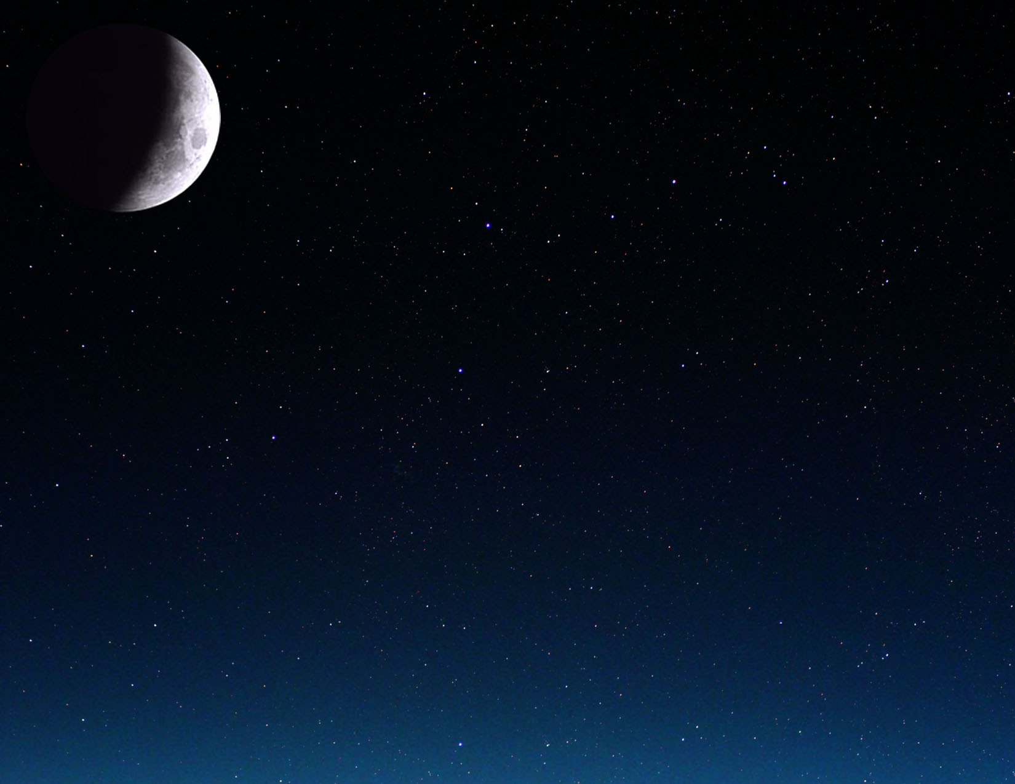

|  |  |  |  |  |  |  |  |
| --- | --- | --- | --- | --- | --- | --- | --- |
| Grudzień 2010 | | | | | | | |
| Poniedziałek | Wtorek | | Środa | Czwartek | Piątek | Sobota | Niedziela |
|  |  | | 1 | 2 | 3 | 4 | 5    Nów  17:36 CU |
| 6 | 7 | | 8 | 9 | 10 | 11 | 12 |
| 13    Pierwsza kwadra  13:59 CU | 14 | | 15 | 16 | 17 | 18 | 19 |
| 20 | 21    Pełnia  08:13 CU | Przesilenie zimowe  23:38 CU  Całkowite zaćmienie księżyca | 22    Koziorożec | 23 | 24 | 25 | 26 |
| 27 | 28    Ostatniakwadra  04:18 CU | | 29 | 30 | 31 |  |  |

