|  |
| --- |
|  |

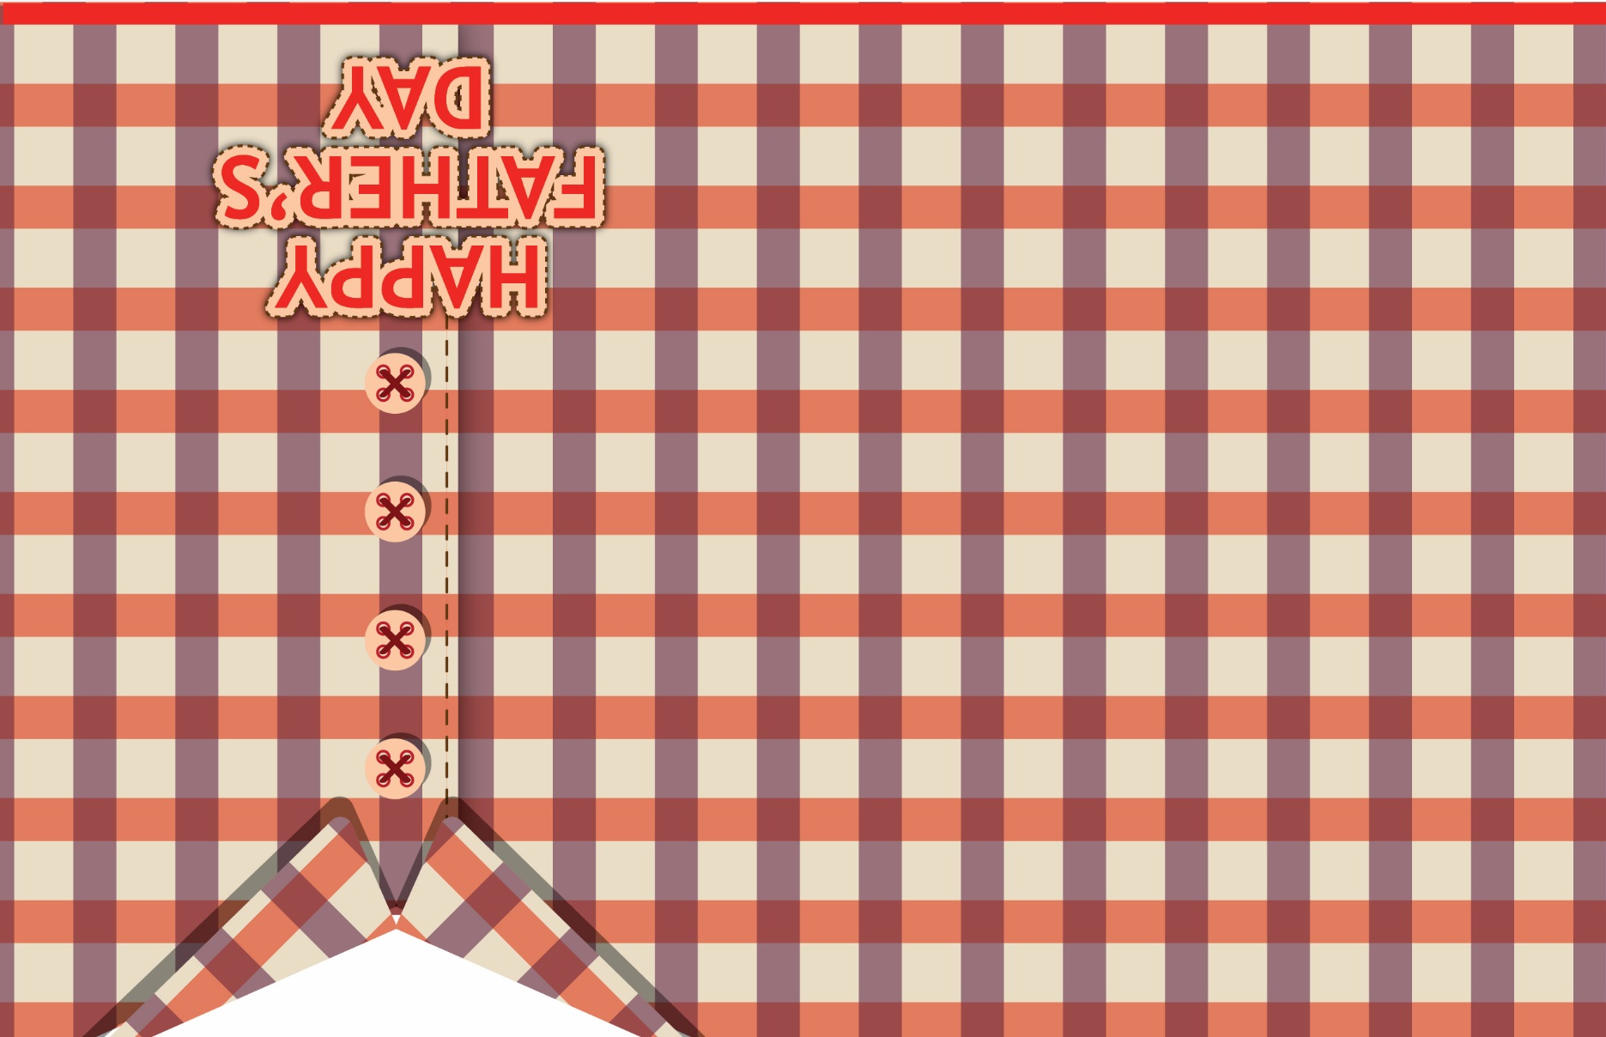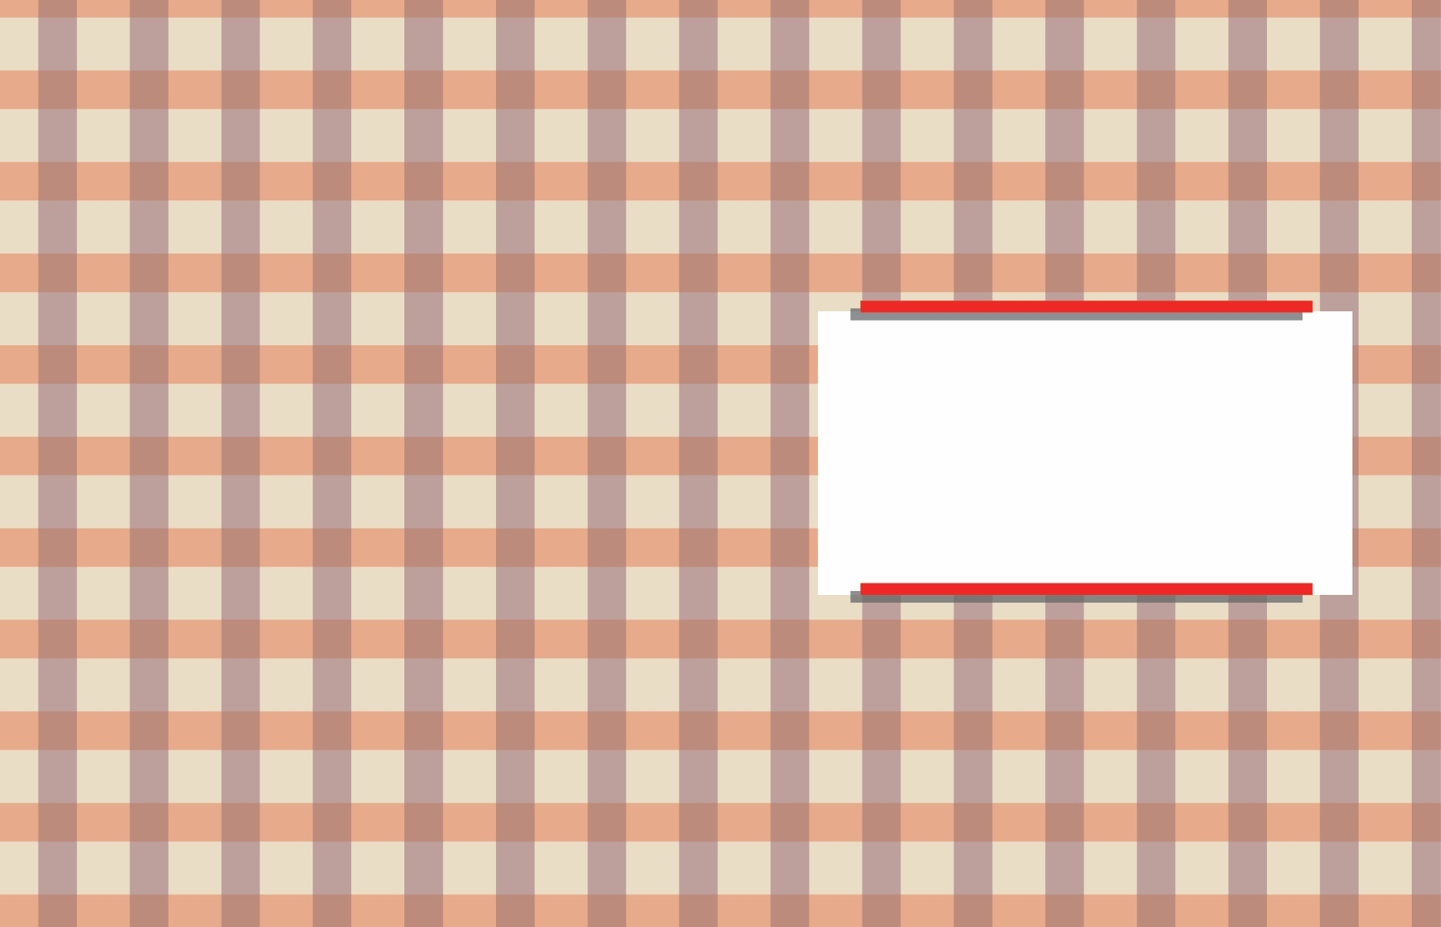

# For You, Daddy!

It’s your special day.

I’m so glad we can

spend it together.