**Digital Civility Index (DCI) – Russia**



Microsoft conducted research among adults and teenagers in 14 countries to study the level of civility across various online interactions. These results expand on the behavioral component of Microsoft’s Computer Safety Index (MCSI) by examining the extent of negative civil and personal safety interactions and their consequences.

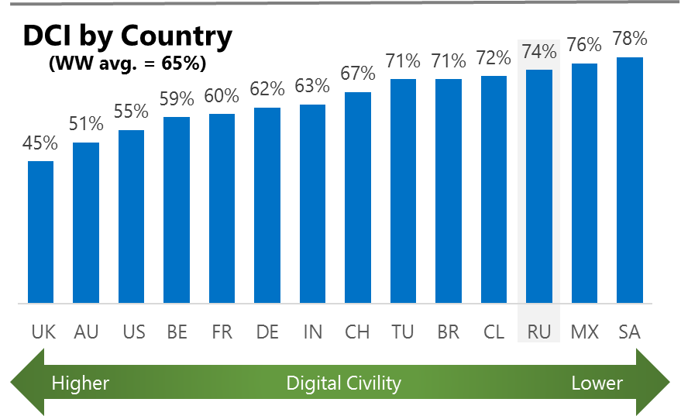The Digital Civility Index (DCI) measures consumers’ lifetime exposure to online risks. Online risks were divided into four categories: Behavioral, Intrusive, Reputational and Sexual. Each category consisted of several individual risks. DCI scores were calculated by using the percentage of consumers who were exposed at some point in time to at least one of 17 different online risk(s). **Lower scores equate to lower online risk exposure and a higher Digital Civility**.

**Russia ranked 12th in DCI**

74% reported having ever been exposed to an online risk. Russia exceeded the international averages on Behavioral and Intrusive risks and was below average on Sexual risks.

**Behavioral**

* Treated mean (47%) and Online harassment (44%) were the primary drivers of Behavioral risks. This category of risks was significantly higher than the international average (+24%).

**Intrusive**

* Unwanted contact (47%) was tied for the highest incident risk with Treated mean. Hate speech was the fourth highest risk overall and was significantly above the international average (32%, 15%).

**Sexual**

* Russians Australians had a lower chance of experiencing any Sexual online risk compared to international (24%, 30%).
* Unwanted sexting (received or sent, 19%) and Sexual Sextortion (4%) were the most common sexual risks.

**Reputational**

* People in Russia encountered Reputational risks at a significantly higher rate vs. international (11% vs. 19%) led by Doxing (17%).

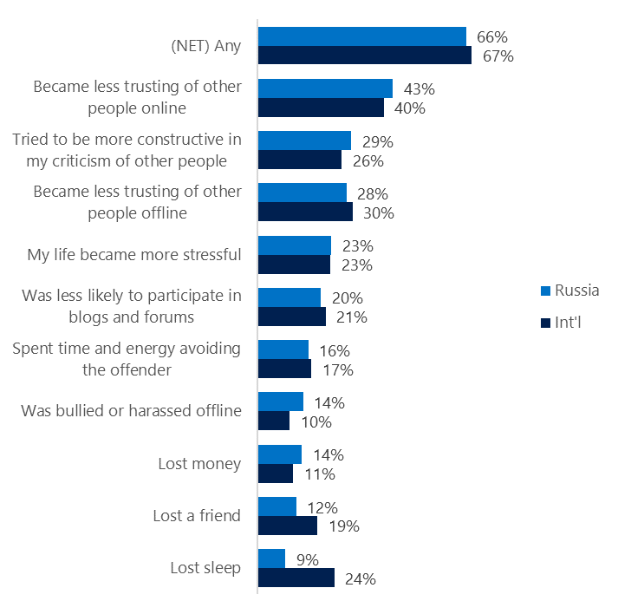**People became less trusting of others**

**Top 10 consequences**

**(Happened to me)**

Two-thirds of Russians reported a consequence from exposure to an online risk matching the international average.

* The most likely consequence from online risk exposure was a loss of trust both online (43%) and offline (28%). Thus, people tended to become more stressed and withdrawn.
* 29% tried to counterbalance negative outcomes by being more constructive in their criticism of others. These attempts at constructive criticism were close to international average (26%).
* Russians were much less likely to report losing a friend (12%, 19%) or losing sleep (9%, 24%) as the result of an online risk.

**Online risks prompted strong concerns**

40% of Russians expressed concern about online risks overall compared to 50% internationally. Concern was consistently lower across all four risk categories.

Reputational risks (49%) were the most worrisome in Russia virtually tied with Intrusive (48%) and Behavioral risks (47%).

* Doxing (42%) was the most frequently reported concern in Russia followed by Terrorism recruiting (37%), Online harassment (31%) and Sextortion (31%).
* Russians reported lower incidence rates for all risks compared to international. Risks having the largest gaps with international incidence rates were Discrimination (-13%), Cyberbullying (-13%) and Hate speech (-11).

**Nearly four in ten experienced an online risk within the past month**

* 39% of Russians experienced their most recent online risk within the past month.
* 13% said the most recent online risk happened within the past week which mirrored international.
* 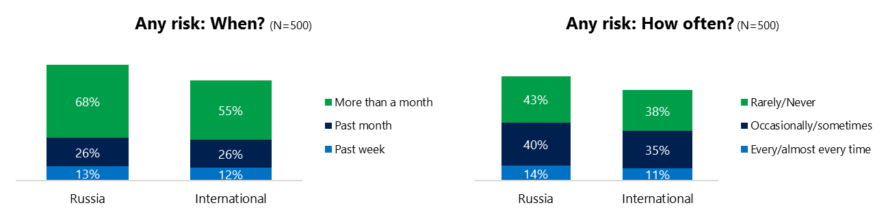14% reported online risks happened every/almost every time compared to 11% internationally.

**Demographics**

**Age**: Unsurprisingly, youth (ages 13-17) were found to have a greater number of interactions online than adults (170, 121).[1] Higher interaction levels by youth did not translate into higher rates of online risk than adults (73%, 75%). Sexual risks were higher for adults (28%, 19%) while youth experienced higher rates of Behavioral risks (65, 57%).

Youth were less confident than adults in managing uncivil behavior, (27%, 23%) but were more knowledgeable about where to find help (37%, 23%) if needed.**Gender**:Males reported slightly higher exposure to risks than females (77%, 72%) with Behavioral risks (65%, 56%) being significantly higher for males.

Females were more likely to have met in person the party responsible for the online risk (58%, 45%). Males were more confident in managing risks (29%, 21%).

Males and females shared a similar outlook for the future of civility and personal safety. Both genders felt civility would improve but were pessimistic about the trend for personal safety.



1. Past year interactions (% more minus % less x 100 +100)

   2 Lower scores = felt more civil, safer (% worse - % better) x 100+100

   3 Ibid.