**Digital Civility Index (DCI) – Mexico**



Microsoft conducted research among adults and teenagers in 14 countries to study the level of civility across various online interactions. These results expand on the behavioral component of Microsoft’s Computer Safety Index (MCSI) by examining the extent of negative civil and personal safety interactions and their consequences.

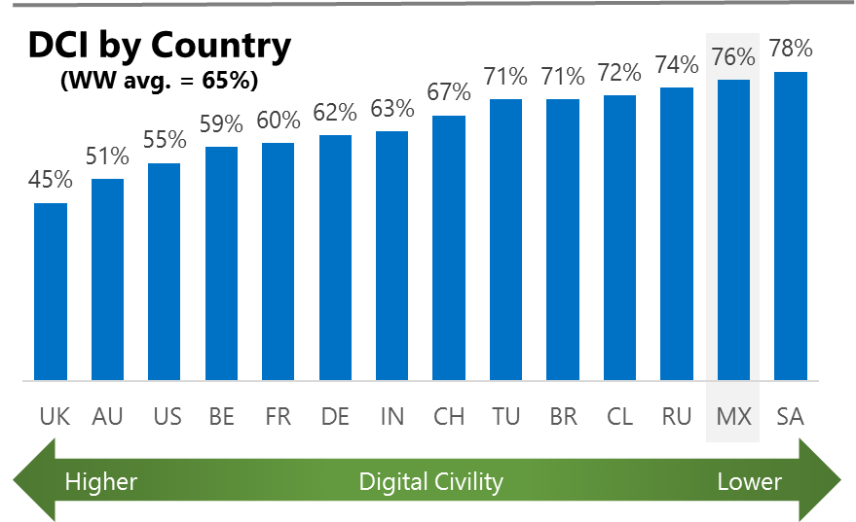The Digital Civility Index (DCI) measures consumers’ lifetime exposure to online risks. Online risks were divided into four categories: Behavioral, Intrusive, Reputational and Sexual. Each category consisted of several individual risks. DCI scores were calculated by using the percentage of consumers who were exposed at some point in time to at least one of 17 different online risk(s). **Lower scores equate to lower online risk exposure and a higher Digital Civility**.

**Mexico ranked 13th in DCI**

76% reported having ever been exposed to an online risk. Mexico exceeded the international averages for Sexual and Intrusive risks.

**Intrusive**

* Unwanted contact (54%) was the primary driver of Intrusive risks and had the highest incidence of any risk. Intrusive risks were significantly higher than the international average (59%, 50%).

**Sexual**

* People in Mexico reported a much higher chance of Sexual risks than their international counterparts (46%, 29%).
* Unwanted sexting (received or sent, 39%) and Sexual solicitation (25%) were the most common sexual risks.

**Behavioral**

* Mexicans experienced similar rates of Behavioral risks as those outside the country (41%, 39%).
* Trolling (24%) and Treated mean (21%) were the twin drivers of Behavioral risks.

**Reputational**

* People encountered Reputational risks at a slightly higher rate vs. international (23% vs. 18%) led by Doxing (13%) and Damage to personal reputation (11%).

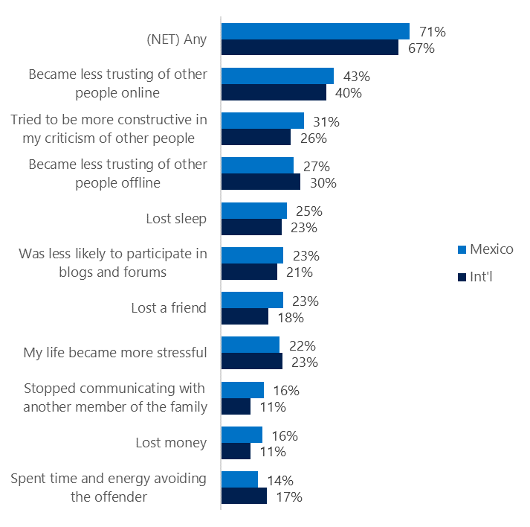**People became less trusting of others**

**Top 10 consequences**

**(Happened to me)**

71% of Mexicans reported a consequence from exposure to an online risk. This was similar to the international average.

* The most likely consequence from online risk exposure was a loss of trust both online (43%) and offline (27%). As a result, people tended to become more stressed and withdrawn.
* 31% tried to counterbalance negative outcomes by being more constructive in their criticism of others. These attempts at constructive criticism were a bit higher vs. international (26%).

**Online risks prompted strong concerns**

People in Mexico expressed the second highest level of overall concern (66%) behind India. This concern was echoed much less strongly compared to the international average (48%).

The high level of concern was reflected across all online risks led by Reputational (75%) and Behavioral (74%) risks. Mexico outpaced the international averages by double digits with Sexual risks (+24) showing the largest difference.

* Doxing (62%) caused most concern in Mexico followed by Damage to personal reputation (57%) and Cyberbullying (54%).
* Among all risks, Damage to work reputation (+22) showed the largest difference between Mexico and international.

**Over half experienced an online risk within the past month**

* 51% of Mexicans experienced their most recent online risk within the past month.
* 16% said the most recent online risk happened within the past week.
* 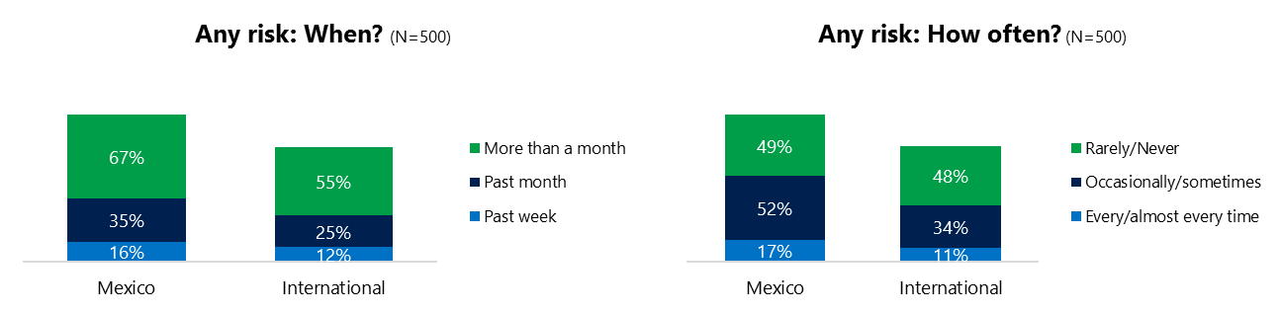17% reported online risks happened every/almost every time compared to 11% internationally.

**Demographics**

**Age**: Unsurprisingly, youth (ages 13-17) were found to have about the same number of interactions online as adults (166, 162).[1] but adults experienced higher rates of online risk (81%, 71%) driven by Intrusive and Sexual risks.

Youth reported higher incidence of risks among family and friends (85%, 80%) than adults. This suggested that youth were more willing to share their negative online experiences and may have underreported their online risk exposure. Adults and youth were equally confident in managing risks (53%, 50%) but youth were more knowledgeable about where to seek help (43%, 26%) if needed.**Gender**:Males reported higher exposure to Intrusive and Sexual risks than females although the difference in risk exposure was not significant (78%, 74%)

Males and females acted in response to risks in equal measure (87%, 86%) but males felt more confident in managing risks (56%, 47%).

Females were much more pessimistic about the future of personal safety (117, 93).[2]

1. Past year interactions (% more minus % less x 100 +100)

   2 Lower scores = felt more civil, safer (% worse - % better) x 100+100

   3 Ibid.
2.