**Digital Civility Index (DCI) – France**



Microsoft conducted research among adults and teenagers in 14 countries to study the level of civility across various online interactions. These results expand on the behavioral component of Microsoft’s Computer Safety Index (MCSI) by examining the extent of negative civil and personal safety interactions and their consequences.

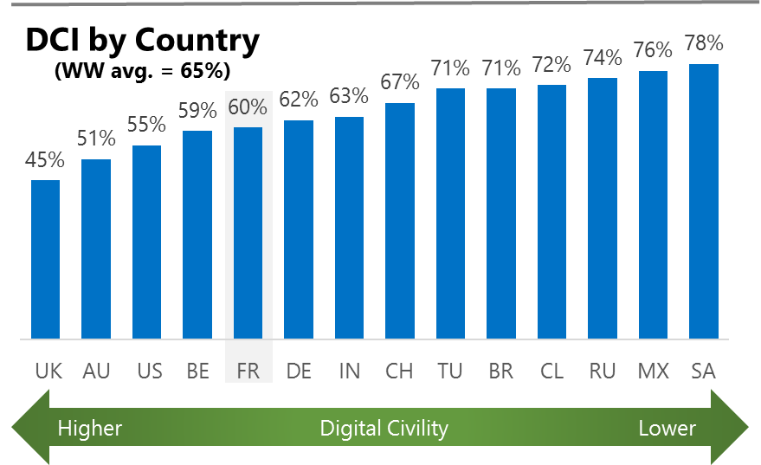The Digital Civility Index (DCI) measures consumers’ lifetime exposure to online risks. Online risks were divided into four categories: Behavioral, Intrusive, Reputational and Sexual. Each category consisted of several individual risks. DCI scores were calculated by using the percentage of consumers who were exposed at some point in time to at least one of 17 different online risk(s). **Lower scores equate to lower online risk exposure and a higher Digital Civility**.

**France ranked 5th in DCI**

60% reported having ever been exposed to an online risk. France was significantly lower the international averages on Behavioral and Reputational risks.

**Intrusive**

* Unwanted contact (46%) was the primary driver of Intrusive risks and had the highest incidence of any risk. Intrusive risk exposure was nearly equal to the international average (52%, 50%).

**Sexual**

* Unwanted sexting (received or sent - 21%) and Sexual solicitation (16%) were the most common Sexual risks.
* Exposure to Sexual risks (30%) in France matched the international averages.

**Behavioral**

* Behavioral risks in France were 27 points lower than the international average (14%, 41%). Treated mean showed the greatest difference between France and international (-20%).
* The incidence of all Behavioral risks was less than ten percent led by Trolling (9%).

**Reputational**

* People encountered Reputational risks at a lower rate vs. international (9% vs. 19%) led by Doxing (5%) and Damage to personal reputation (5%).



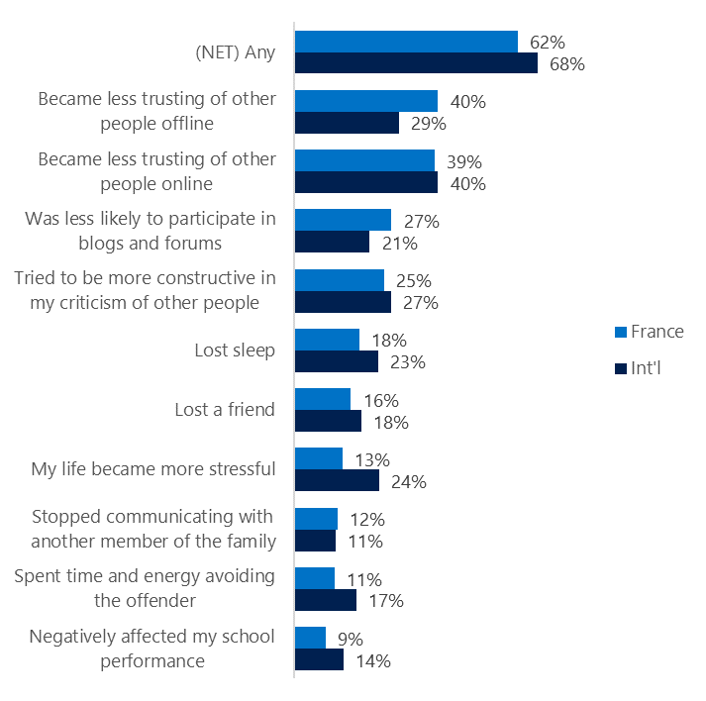**People became less trusting of others**

**Top 10 consequences**

**(Happened to me)**

Over six in ten French reported a consequence from exposure to an online risk. This was slightly lower than the international average.

* The most likely consequence from online risk exposure was a loss of trust both online (40%) and offline (39%). Thus, people tended to become more withdrawn, lost sleep or lost a friend.
* 25% tried to counterbalance negative outcomes by being more constructive in their criticism of others. These attempts at constructive criticism were about the same as international (27%).
* French consumers were less likely to suffer from stress from exposure to an online risk than their international counterparts (13%, 24%).

 **Online risks prompted strong concerns**

41% of consumers in France were much more or more concerned about online risks overall. This concern was echoed more strongly outside the country. (International, 50%).

Intrusive risks (47%) were ranked the most worrisome in France although this trailed the international average by 10-points (47%, 57%). The other three risk categories showed even greater differences with international most notably Behavioral 17-points (38%, 55%).

* Terrorism recruiting (35%) was the most frequently cited concern in France followed closely by Doxing (34%) and Damage to personal reputation (31%).
* In general, people in France said they had lower concerns across nearly all online risks compared to international. Cyberbullying (-15%) and Discrimination (-14%) showed the largest differences between France and international.

**Over one-third experienced an online risk within the past month**

* 35% of French experienced their most recent online risk within the past month.
* 13% said the most recent online risk happened within the past week which was nearly equal to international.
* 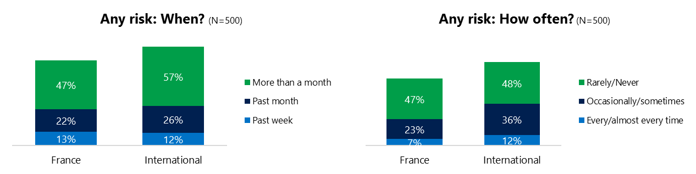7% reported online risks happened every/almost every time compared to 12% internationally.

**Demographics**

**Age**: Unsurprisingly, youth (ages 13-17) were found to have a greater number of interactions online than adults (131, 89)[1]. Despite lower interaction levels, adults reported higher rates of online risk (68%, 51%) than youth. Youth reported higher incidence of risks among family and friends (49%, 27%) than adults. This suggested that youth were more willing to share their negative online experiences and may have underreported their online risk exposure.

Youth were less confident than adults in managing uncivil behavior, (34%, 27%) but youth were more sure of themselves about where to get help (37%, 15%), if needed.**Gender**:Males reported higher exposure to risks than females (65%, 55%). All categories of risk were higher for males led by 12-point difference on Sexual risks (36%, 24%).

Females were more likely to have acted (63%, 57%) in response to an online risk but felt less confident in managing risks (25%, 36%) than males.

Males and females shared a similar outlook for the future of civility and personal safety online.

1. Past year interactions (% more minus % less x 100 +100)

   2 Lower scores = felt more civil, safer (% worse - % better) x 100+100

   3 Ibid.