**Digital Civility Index (DCI) – Germany**



Microsoft conducted research among adults and teenagers in 14 countries to study the level of civility across various online interactions. These results expand on the behavioral component of Microsoft’s Computer Safety Index (MCSI) by examining the extent of negative civil and personal safety interactions and their consequences.

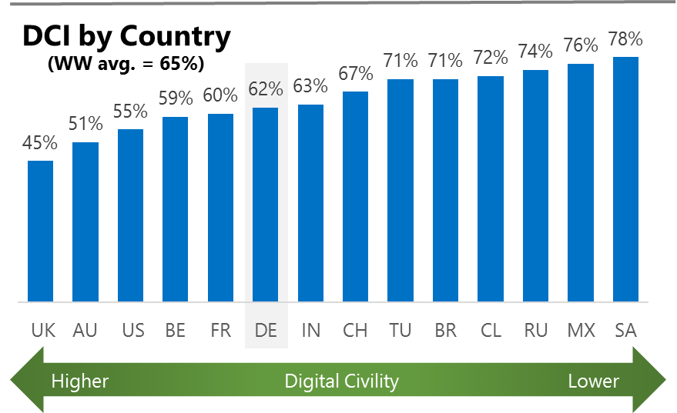The Digital Civility Index (DCI) measures consumers’ lifetime exposure to online risks. Online risks were divided into four categories: Behavioral, Intrusive, Reputational and Sexual. Each category consisted of several individual risks. DCI scores were calculated by using the percentage of consumers who were exposed at some point in time to at least one of 17 different online risk(s). **Lower scores equate to lower online risk exposure and a higher Digital Civility**.

**Germany ranked 6th in DCI**

62% reported having ever been exposed to an online risk. Germany had similar levels of exposure to most online risks when compared to the international averages.

**Intrusive**

* Unwanted contact (43%) was the primary driver of Intrusive risks and had the highest incidence of any risk.

**Behavioral**

* Behavioral (35%) was the second most common reported risk category. Treated mean (21%) and Online harassment (17%) were among the top five risks across all categories and in line with the international averages.
* Trolling (13%, 22%) was significantly lower in Germany than outside the country.

**Sexual**

* Germans had a similar chance of experiencing any Sexual online risk compared to international (33%, 30%).
* Sexual solicitation (26%) drove the Sexual risk category and was much higher than the international average. Unwanted sexting (received or sent, 23%) ranked a close second.

**Reputational**

* The rate of Reputational risks was lower in Germany vs. international (13% vs. 19%) led by Doxing (8%) and Damage to personal reputation (6%).



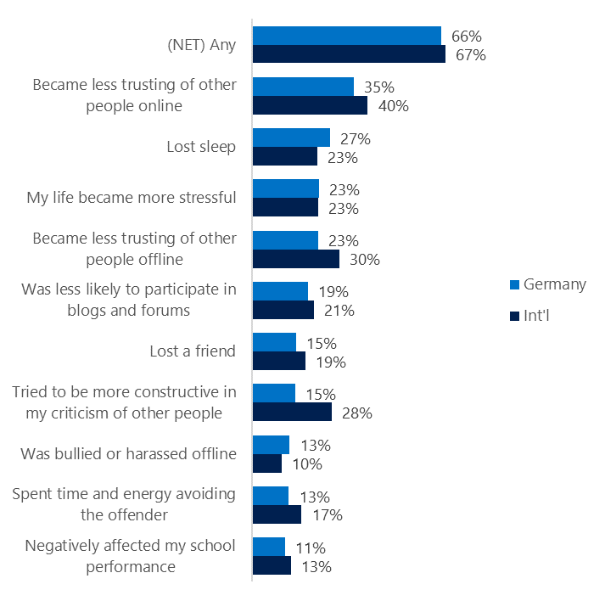**People became less trusting of others**

**Top 10 consequences**

**(Happened to me)**

Two-thirds of Germans reported a consequence from exposure to an online risk. This was like the international average.

* The most likely consequence from online risk exposure was a loss of trust online (35%). The most common consequences resulted in people becoming more stressed and withdrawn.
* Losing trust in people offline was lower in Germany than international (23%, 30%).
* 15% tried to counterbalance negative outcomes by being more constructive in their criticism of others. These attempts at constructive criticism were much lower in Germany vs. international (28%).

**Online risks prompted strong concerns**

40% of Germans were much more or more concerned about online risks overall. This concern was echoed more strongly outside the country. (International, 50%).

Consumers in Germany had less concerns for all online risks compared to the international averages by a wide margin. The largest differences between concerns inside and outside of Germany were with Sexual (-19%) and Behavioral risks (-18%).

* Among Sexual risks, people in Germany were much less concerned about Non-consensual pornography (14%, 34%,”revenge porn”) and Sextortion (14%, 34%) and.
* Among Behavioral risks, consumers were much less concerned about Trolling (16%, 34%) and Swatting (14%, 31%).
* Doxing (29%) was the most frequently reported concern followed by Terrorism recruiting (28%) and Cyberbullying (25%).

**Three in ten experienced an online risk within the past month**

* 31% of Germans experienced their most recent online risk within the past month.
* 8% said the most recent online risk happened within the past week which was lower than international.
* 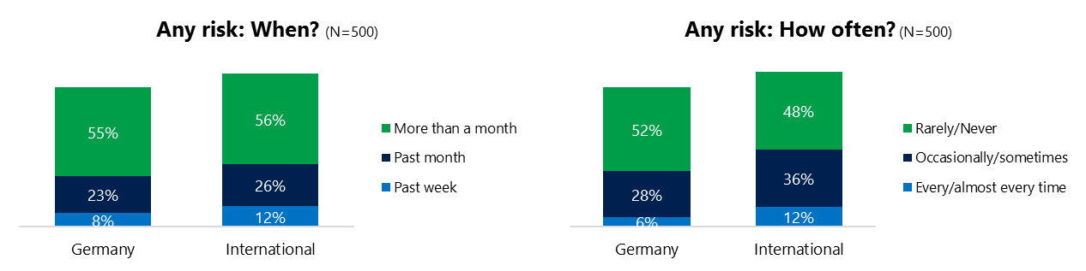6% reported online risks happened every/almost every time compared to 12% internationally.

**Demographics**

**Age**: Unsurprisingly, youth (ages 13-17) were found to have a greater number of interactions online than adults (146, 79)[1]. Despite lower interaction levels, adults reported higher rates of online risk (68%, 56%) than youth. Youth reported higher incidence of risks among family and friends (54%, 42%) than adults. This suggested that youth were more willing to share their negative online experiences and may have underreported their online risk exposure.

Adults were more confident than youth in managing uncivil behavior, (45%, 32%) but youth were more sure of themselves about where to get help (60%, 32%) if needed.**Gender**:Males reported higher exposure to risks than females (65%, 59%). All categories of risk were higher for males led by an 8-point difference on Behavioral risks (39%, 31%).

Females were slightly more likely to have met the perpetrator (44%, 38%) but felt less confident in managing risks (32%, 45%) than males.

Males and females expressed nearly identical sentiments about the future of civility (107, 106) and personal safety (125, 124).



1. Past year interactions (% more minus % less x 100 +100)

   2 Lower scores = felt more civil, safer (% worse - % better) x 100+100

   3 Ibid.