**Digital Civility Index (DCI) – Chile**



Microsoft conducted research among adults and teenagers in 14 countries to study the level of civility across various online interactions. These results expand on the behavioral component of Microsoft’s Computer Safety Index (MCSI) by examining the extent of negative civil and personal safety interactions and their consequences.

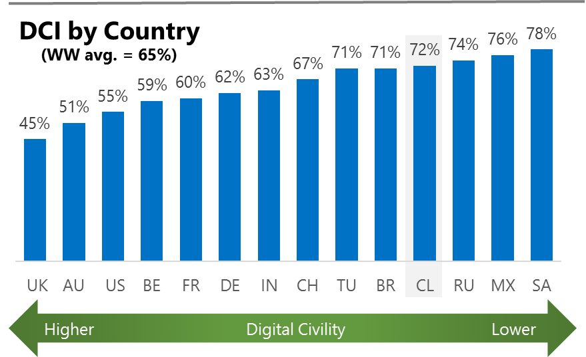The Digital Civility Index (DCI) measures consumers’ lifetime exposure to online risks. Online risks were divided into four categories: Behavioral, Intrusive, Reputational and Sexual. Each category consisted of several individual risks. DCI scores were calculated by using the percentage of consumers who were exposed at some point in time to at least one of 17 different online risk(s). **Lower scores equate to lower online risk exposure and a higher Digital Civility**.

**Chile ranked 11th in DCI**

72% reported having ever been exposed to an online risk. Chile exceeded the international averages on Intrusive and Sexual risks.

**Intrusive**

* Unwanted contact (52%) was the primary driver of Intrusive risks and had the highest incidence of any risk by a wide margin.

**Sexual**

* Chileans had a higher chance of experiencing Sexual risks compared to international (38%, 29%).
* Unwanted sexting (received or sent, 32%) ranked as the number one Sexual risk and second highest risk overall.

**Behavioral**

* Behavioral (37%) was tied nearly tied with Sexual risks as the second most common risk category. Treated mean (22%) and Trolling (22%) accounted for most Behavioral risks.

**Reputational**

* People in Chile encountered Reputational risks at about the same rate as international (21% vs. 18%). Doxing (12%) and Damage to personal reputation (11%) were the top Reputational risks.

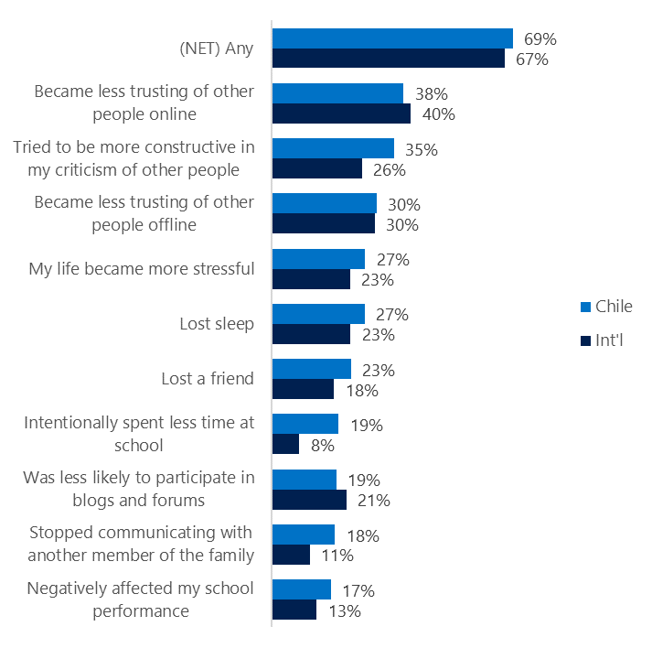**People became less trusting of others**

**Top 10 consequences**

**(Happened to me)**

More than two-thirds of Chileans reported a consequence from exposure to an online risk. This was similar to the international average.

* The most likely consequence from online risk exposure was a loss of trust online (38%) and offline (30%). As a result, people tended to become more stressed and withdrawn.
* 35% tried to counterbalance negative outcomes by being more constructive in their criticism of others. These attempts at constructive criticism were higher in Chile vs. international (35%, 26%).
* 19% of Chilean youth spent less time at school which was more than double the international rate (8%).

**Online risks prompted strong concerns**

52% of Chileans were much more or more concerned about online risks overall. This level of concern was echoed similarly outside the country (49%).

Like China, Reputational (67%) risks were ranked the most worrisome in Chile outpacing the international average by 14-points (67%, 53%). The remaining three risk categories were also significantly higher than the international averages.

* Doxing (55%), Damage to personal reputation (51%) and Non-consensual pornography (50%, ”revenge porn”) were the top three concerns in Chile.
* In general, people in Chile expressed higher levels of concern across most online risks compared to international. Non-consensual pornography (50%, 31%, “revenge porn”) and Sextortion (48%, 32%) showed the largest differences between Chile and international.

**Over one in three experienced an online risk within the past month**

* 36 of Chileans experienced their most recent online risk within the past month.
* 12% said the most recent online risk happened within the past week which was equal to international.
* 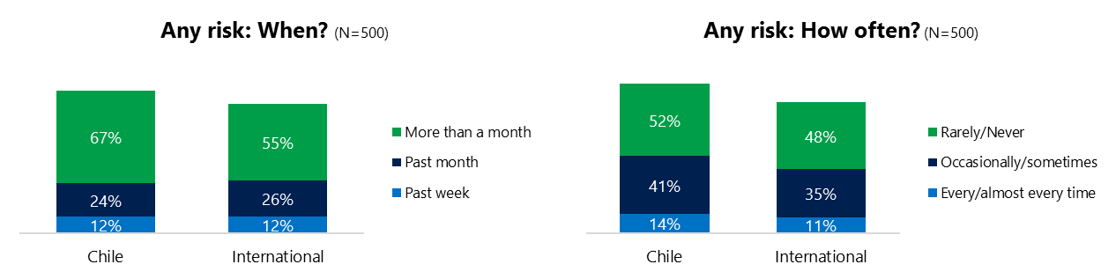14% reported online risks happened every/almost every time compared to 11% internationally.

**Demographics**

**Age**: Surprisingly, adults reported having greater number of interactions online than youth (161, 151)[1]. The higher interaction level among adults led to higher reported rates of online risk (75%, 70%) than youth. Youth were more likely to share their online risk stories with each other compared to adults as evidenced by the higher rate among family and friends (80%, 73%).

Youth were more likely to encounter Behavioral risks (42%, 32%) while adults reported Sexual risks at a higher rate (46%, 31%). Adults were more confident than youth in managing uncivil behavior, (49%, 41%) but youth were more knowledgeable about where to get help (55%, 35%) if needed.**Gender**:Males reported exposure to risks at the same rate as females (72%, 72%). Males were more likely to report Behavioral risks (40%, 34%) while females experienced higher rates of Cyberbullying 911%, 5%).

Females were more likely to have acted (87%, 82%) in response to a risk and expressed a slightly higher level of concern than males (54%, 49%).

Both genders shared a neutral outlook on civility (97, 97). Females were more pessimistic about the future of safety (113 105)[2].



1. Past year interactions (% more minus % less x 100 +100)

   2 Lower scores = felt more civil, safer (% worse - % better) x 100+100

   3 Ibid.
2.