**Digital Civility Index (DCI) – China**



Microsoft conducted research among adults and teenagers in 14 countries to study the level of civility across various online interactions. These results expand on the behavioral component of Microsoft’s Computer Safety Index (MCSI) by examining the extent of negative civil and personal safety interactions and their consequences.

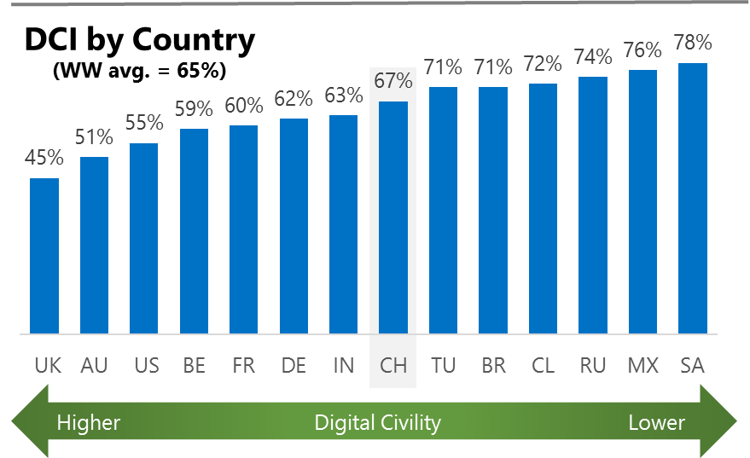The Digital Civility Index (DCI) measures consumers’ lifetime exposure to online risks. Online risks were divided into four categories: Behavioral, Intrusive, Reputational and Sexual. Each category consisted of several individual risks. DCI scores were calculated by using the percentage of consumers who were exposed at some point in time to at least one of 17 different online risk(s). **Lower scores equate to lower online risk exposure and a higher Digital Civility**.

**China ranked 8th in DCI**

67% reported having ever been exposed to an online risk. China exceeded the international averages on Reputational and Sexual risks and was below average on Intrusive risks.

**Intrusive**

* Unwanted contact (35%) was the primary driver of Intrusive risks and had the highest incidence of any risk. Intrusive risks were significantly lower than the international average (43%, 51%).

**Behavioral**

* Behavioral risks (43%) were the second most common occurring risk category. Several individual risks varied significantly from the international averages. Treated mean (-11%) and Trolling (-10%) had below average incidences while Online harassment (+11%) had above average incidence compared to international.

**Reputational**

* Reputational risks were much higher in China compared to international (39%, 17%) driven by Doxing (34%). The Doxing rate in China was double the second ranked country (Russia, 17%).

**Sexual**

* Consumers in China had an above average chance of experiencing any Sexual online risk compared to international (36%, 29%).
* Unwanted sexting (received or sent, 32%) and Sexual solicitation (16%) were the most common sexual risks.



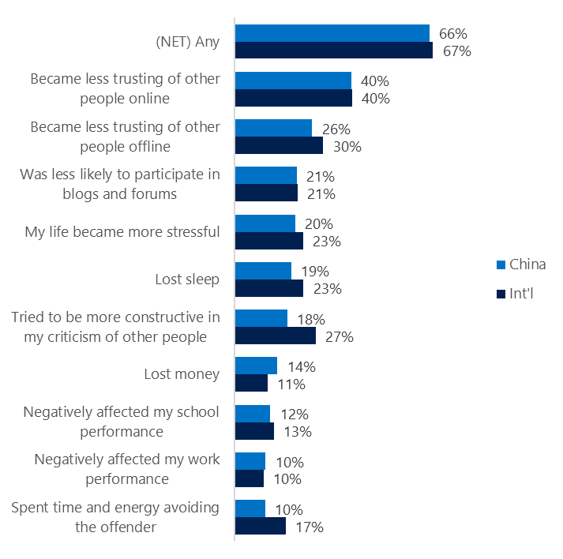**People became less trusting of others**

**Top 10 consequences**

**(Happened to me)**

Nearly two-thirds of Chinese reported a consequence from exposure to an online risk. This was similar to the international average.

* The most likely consequence from online risk exposure was a loss of trust both online (40%) and offline (26%). As a result, people tended to become more stressed and withdrawn.
* 18% made an effort to counterbalance negative outcomes by being more constructive in their criticism of others. These attempts at constructive criticism were much lower in China vs. international (27%).

**Online risks prompted strong concerns**

44% of Chinese were much more or more concerned about online risks overall. This concern was echoed more strongly outside the country. (International, 50%).

Unlike all other countries surveyed, Reputational (63%) risks were ranked the most worrisome in China outpacing the international average by 10 points (63%, 53%).

Intrusive (50%, 57%) and Sexual (43%, 48%) risk categories were significantly lower than international.

* Doxing (55%) generated the highest level of concern in China. This was the highest rate among all countries surveyed by a wide margin.
* In general, Chinese said they had lower concerns across most online risks compared to international. In Terrorism recruiting (24%, 41%) and Discrimination (22%, 36%) were less likely to occur in China than international.

**Over four in ten experienced an online risk within the past month**

* 42% of Chinese experienced their most recent online risk within the past month.
* 14% said the most recent online risk happened within the past week.
* 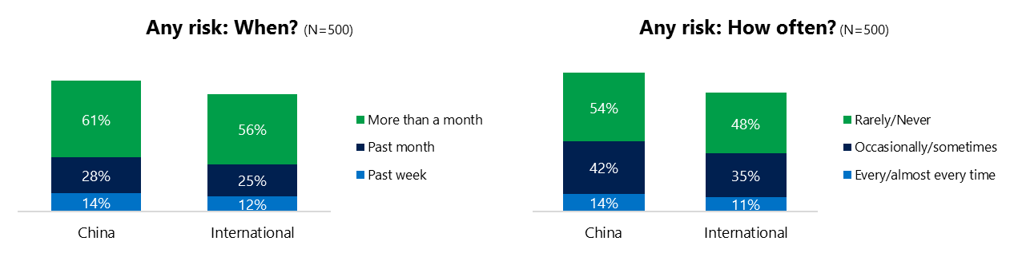14% reported online risks happened every/almost every time compared to 11% internationally.

**Demographics**

**Age**: Unsurprisingly, youth (ages 13-17) were found to have a greater number of interactions online than adults (171, 160)[1]. Despite lower interaction levels, adults reported higher rates of online risk (73%, 61%) than youth. This may suggest that youth were better than adults at avoiding online risks or engaged in less risky online behavior.

Youth were less confident than adults in managing uncivil behavior, (40%, 54%) but youth were more sure of themselves about where to get help (45%, 37%) if needed.**Gender**:Males reported much higher exposure to risks than females (75%, 58%). All categories of risk were higher for males led by a 17-point difference on Sexual risks (45%, 28%).

Females were more likely to have acted (93%, 87%) and felt equally confident in managing risks (46%, 48%).

Males were slightly more pessimistic about the future of safety (43, 38)[2] although both genders agreed that safety conditions are likely to be better one year from now.



1. Past year interactions (% more minus % less x 100 +100)

   2 Lower scores = felt more civil, safer (% worse - % better) x 100+100

   3 Ibid.
2.