**Digital Civility Index (DCI) – United States**



Microsoft conducted research among adults and teenagers in 14 countries to study the level of civility across various online interactions. These results expand on the behavioral component of Microsoft’s Computer Safety Index (MCSI) by examining the extent of negative civil and personal safety interactions and their consequences.

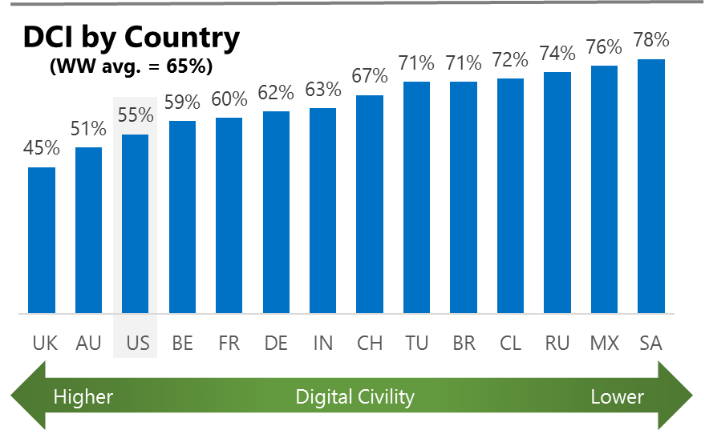The Digital Civility Index (DCI) measures consumers’ lifetime exposure to online risks. Online risks were divided into four categories: Behavioral, Intrusive, Reputational and Sexual. Each category consisted of several individual risks. DCI scores were calculated by using the percentage of consumers who were exposed at some point in time to at least one of 17 different online risk(s). **Lower scores equate to lower online risk exposure and a higher Digital Civility**.

**The U.S. ranked 3rd in DCI**

55% of Americans said they were exposed to an online risk in the past. Most online risks in the U.S. were below the international averages apart from low incidence risks Sextortion (6%, 3%) and Terrorism Recruiting (5%, 1%).

**Intrusive**

* Unwanted contact (34%) was the primary driver of Intrusive risks and had the highest score of any online risk. Incidence of unwanted contact was significantly lower than international.
* Terrorism recruiting was one of the least common risks overall (5%), but was reported more often in the U.S. vs. international.

**Behavioral**

* Treated mean (24%) was the leading Behavioral risk and ranked second overall among all online risks.
* Trolling (18%) and Online Harassment (17%) were among the top five highest online risks.

**Sexual**

* Unwanted sexting (received or sent, 18%) was the most common sexual risk in the U.S.
* Sextortion (6%, 3%) and Non-consensual pornography (6%, 3%, ”revenge porn”) were higher in the U.S. vs. international although incidence for both risks was low.

**Reputational**

* Reputational risks in the U.S. were slightly lower vs. international (16% vs. 19%) led by Doxing and Damage to personal reputation.



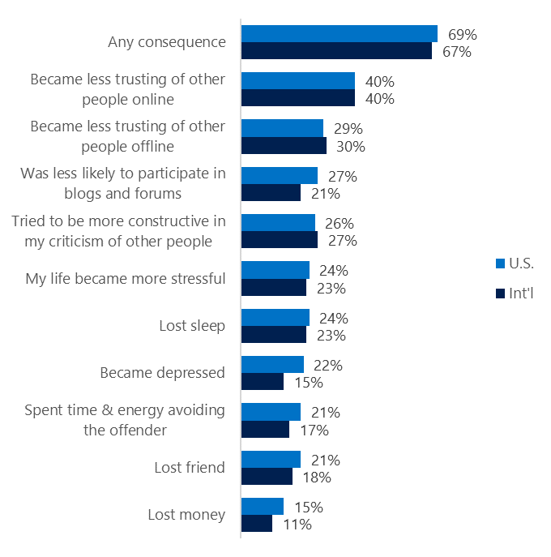**People became less trusting of others**

**Top 10 consequences**

**(Happened to me)**

69% of Americans reported a consequence after being exposed to an online risk. This was comparable to the international average.

* The biggest consequence from online risk exposure was a loss of trust both online (40%) and offline (29%). Thus, people tended to become more stressed and withdrawn.
* 26% tried to counterbalance negative outcomes by being more constructive in their criticism of others which matched the international average.
* Reducing participation in blogs and forums was more common in the U.S. vs. international (27% vs. 21%).
* Other consequences that were felt more strongly in the U.S. included depression (22%, 15%), was physically threatened (12%, 7%) and thoughts of suicide (10%, 5%).

**Online risks prompted strong concerns**

47% of consumers in the U.S. were much more or more concerned about online risks overall. This concern was echoed strongly outside the country (International, 50%).

Looking one year ahead, Intrusive (52%) and Behavioral (49%) risk categories garnered the most concern in the U.S.

* Cyberbullying (37%), doxing (36%) and terrorism recruiting (36%) were the three most concerning online risks in the U.S.
* Americans expressed a high level of concern about reputational risks (46%) despite it being the least likely risk to have occurred.
* Consumers in the U.S. reported having lower concerns across all online risks compared to international.

**Over one-third experienced an online risk within the past month**

* 38% of Americans experienced their most recent online risk within the past week or month.
* 15% said the most recent online risk happened within the past week.
* 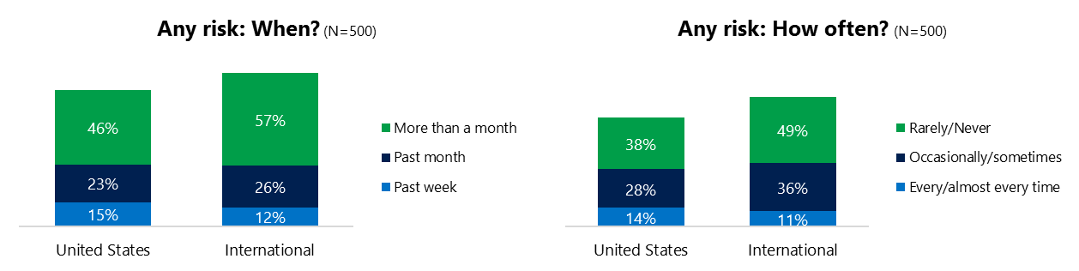14% reported online risks happened every or almost every time compared to 11% internationally.

**Demographics**

**Age**: Unsurprisingly, youth (ages 13-17) were found to have a greater number of interactions online than adults (160, 107)[1]. Higher interactions among youth translated into much higher rates of online risk for their friends and family (66%, 46%), but not for themselves (59%, 52%) compared to adults. This suggested that youth may have underreported their exposure to online risks and were more willing to share their negative online experiences.

Youth were more likely (59%, 35%) to have met in person the individual responsible for the online risk.

Youth showed greater concern about the future of online risks (51%, 42%), more likely to take actions (81%, 69%) and expressed more confidence in responding to uncivil behavior than adults (64%, 57%).**Gender**:Males reported higher numbers of online interactions (136, 131)[2] and exposure to online risks (60%, 51%). Greater exposure for males was driven by behavioral and sexual risks.

Males reported being more confident in dealing with an online risk (65%, 56%) and more likely to have acted in response to a risk (81%, 69%). Yet more males than females expressed concern about online risks becoming worse in the future (53%, 40%). Males were also more likely to have met in person the individual responsible for the online risk (53%, 41%).

Females were more pessimistic about the future of civility and safety. Females were less likely than males to say their interactions will increase in the future (111, 129)[3].

1. Past year interactions (% more minus % less x 100 +100)
2. Ibid.
3. Ibid.