**Digital Civility Index (DCI) – Turkey**



Microsoft conducted research among adults and teenagers in 14 countries to study the level of civility across various online interactions. These results expand on the behavioral component of Microsoft’s Computer Safety Index (MCSI) by examining the extent of negative civil and personal safety interactions and their consequences.

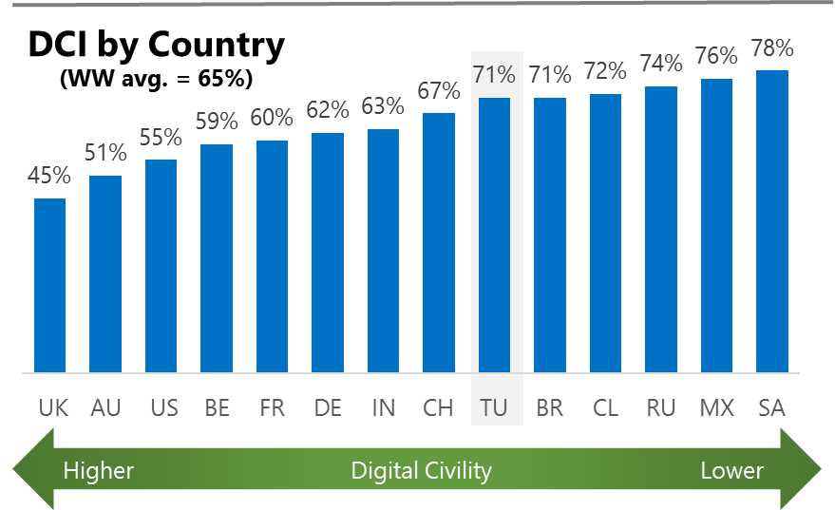The Digital Civility Index (DCI) measures consumers’ lifetime exposure to online risks. Online risks were divided into four categories: Behavioral, Intrusive, Reputational and Sexual. Each category consisted of several individual risks. DCI scores were calculated by using the percentage of consumers who were exposed at some point in time to at least one of 17 different online risk(s). **Lower scores equate to lower online risk exposure and a higher Digital Civility**.

**Turkey ranked 9th in DCI**

71% reported having ever been exposed to an online risk. Turkey was above the international average on Behavioral risks and was equal to the international averages on the other three risk categories.

**Behavioral**

* Behavioral risk was the most common risk category and exceeded the international average by 16-points (54%, 38%). Trolling (44%) was the primary driver of Behavioral risks and had the highest incidence of any risk.

**Intrusive**

* Unwanted contact (37%) was ranked second among all risks and the primary driver of the Intrusive risk category. Hate speech was significantly higher in Turkey than international (24%, 15%).

**Sexual**

* Consumers in Turkey had an equal chance of exposure to a Sexual online risk compared to international (30%, 30%).
* Unwanted sexting (received or sent, 29%) and Sexual solicitation (18%) were the most common sexual risks.

**Reputational**

* People encountered Reputational risks at the same rate vs. international (18% vs. 19%) led by Doxing (11%) and Damage to personal reputation (8%).

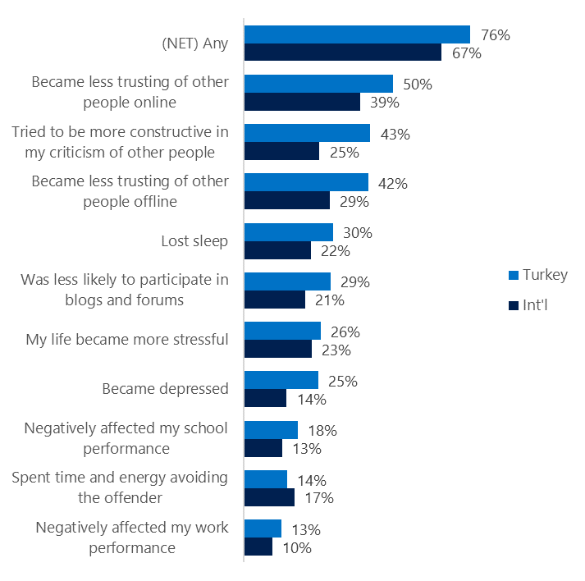**People became less trusting of others**

**Top 10 consequences**

**(Happened to me)**

76% of consumers in Turkey reported a consequence from exposure to an online risk. This was significantly higher than the international average.

* The most likely consequence from online risk exposure was a loss of trust both online (50%) and offline (42%). As a result, people tended to become more stressed and withdrawn.
* 43% tried to counterbalance negative outcomes by being more constructive in their criticism of others. These attempts at constructive criticism were much higher in Turkey vs. international (25%).
* In general, consequences were felt more strongly in Turkey than outside the country. The largest gaps with international incidence rates were in Tried to be more constructive in my criticism (+18), Became less trusting offline (+13), Became less trusting online (+11).

**Online risks prompted strong concerns**

More than half of consumers in Turkey had strong concerns across all four risk categories. The level of concern in Turkey was generally higher for most risks when compared to international averages.

Intrusive risks were ranked the most worrisome in Turkey outpacing the international average by 9-points (65%, 56%). Concerns about Behavioral risks were nearly as strong driven by Cyberbullying (46%) and Online harassment (43%).

* Doxing (49%) was the most frequently reported concern in Turkey followed closely by Cyberbullying (46%) and Unwanted contact (45%).
* Risks that had the largest gaps with international incidence rates were Unwanted contact (+11) and Unwanted sexting (received or sent, +10).

**Nearly four in ten experienced an online risk within the past month**

* 37% of Turkish consumers experienced their most recent online risk within the past month.
* 10% said the most recent online risk happened within the past week which mirrored international.
* 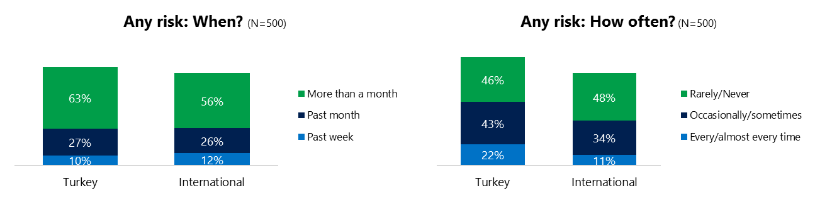22% reported online risks happened every/almost every time, twice the international rate (11%).

**Demographics**

**Age**: Unsurprisingly, youth (ages 13-17) were found to have a greater number of interactions online than adults (144, 133).[1] Higher interaction levels by youth did not translate into higher rates of online risk (68%, 73%). Youth showed higher rates of exposure for Behavioral risks (57%, 52%) but adults led on the other three risk categories – especially Sexual risks (42%, 18%).

Youth were less confident than adults in managing uncivil behavior, (44%, 53%) but youth were more knowledgeable about where to get help (46%, 35%) if needed.**Gender**:There were few significant differences by gender. Males reported higher overall concern about risk exposure than females (58%, 50%). Males were more pessimistic about the outlook for personal safety than females (122, 112).



1. Past year interactions (% more minus % less x 100 +100)

   2 Lower scores = felt more civil, safer (% worse - % better) x 100+100

   3 Ibid.