**Digital Civility Index (DCI) – South Africa**



Microsoft conducted research among adults and teenagers in 14 countries to study the level of civility across various online interactions. These results expand on the behavioral component of Microsoft’s Computer Safety Index (MCSI) by examining the extent of negative civil and personal safety interactions and their consequences.

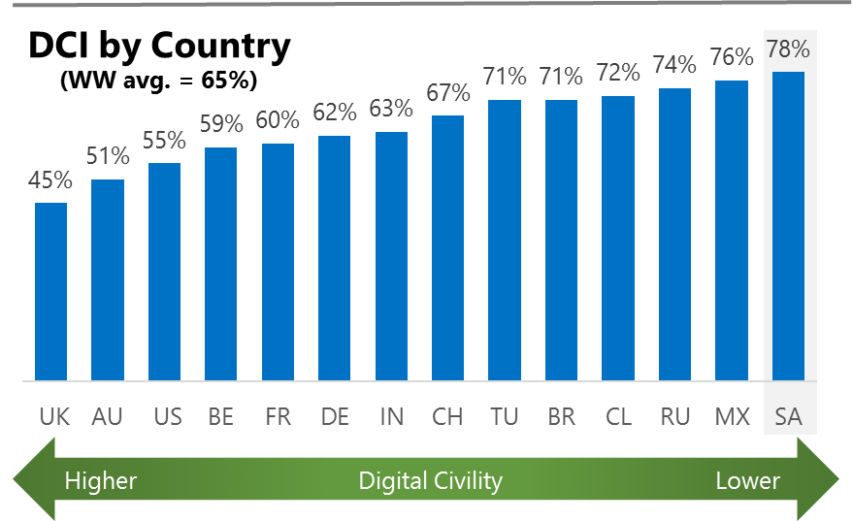The Digital Civility Index (DCI) measures consumers’ lifetime exposure to online risks. Online risks were divided into four categories: Behavioral, Intrusive, Reputational and Sexual. Each category consisted of several individual risks. DCI scores were calculated by using the percentage of consumers who were exposed at some point in time to at least one of 17 different online risk(s). **Lower scores equate to lower online risk exposure and a higher Digital Civility**.

**South Africa ranked 14th in DCI**

78% reported having ever been exposed to an online risk. South Africa exceeded the international averages for Intrusive and Behavioral risks.

**Intrusive**

* Unwanted contact (60%) was the primary driver of Intrusive risks and had the highest incidence of any risk. This was the highest Unwanted contact score across all countries surveyed. Intrusive risks were significantly higher than the international average (67%, 49%).

**Behavioral**

* Behavioral (48%) was the second most common occurring risk category led by Treated mean (33%). This was the second highest Treated mean score behind Russia (47%).

**Sexual**

* Consumers reported a higher rate of Sexual risks compared to international (35%, 30%).
* Unwanted sexting (received or sent, 30%) and Sexual solicitation (14%) were the most common sexual risks.

**Reputational**

* South Africans encountered Reputational risks more often than international (22% vs. 18%) led by Doxing (14%) and Damage to personal reputation (11%).

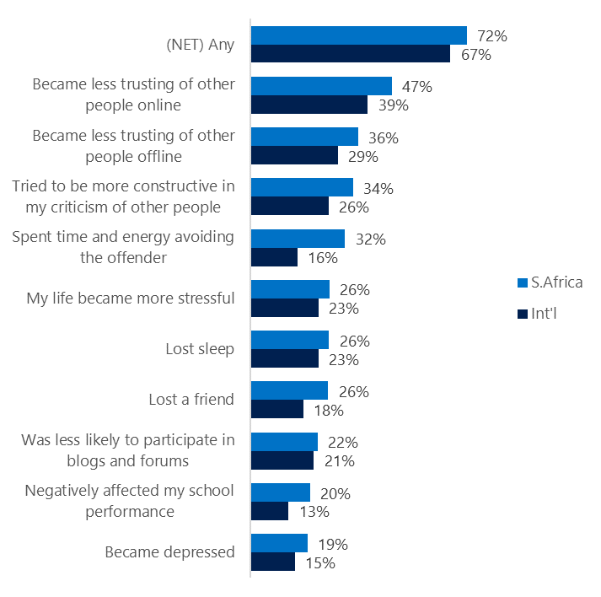**People became less trusting of others**

**Top 10 consequences**

**(Happened to me)**

Over seven in ten South Africans reported a consequence from exposure to an online risk. This was slightly higher than the international average.

* The most likely consequence from online risk exposure was a loss of trust both online (47%) and offline (36%). As a result, people tended to become more stressed and withdrawn.
* 34% tried to counterbalance negative outcomes by being more constructive in their criticism of others. These attempts at constructive criticism were higher in South Africa vs. international (26%).
* In general, the top ten consequences were experienced at the same or higher levels in South Africa compared to international. Risks that showed the widest gap between in country and international were Avoiding the offending person (+16%) and Lost a friend (+8%).

**Online risks prompted strong concerns**

Concern was high across all four risk categories in absolute terms and relative to international. Intrusive risks garnered the highest concern (73%) followed closely by Reputational (68%) and Behavioral risks (67%).

* Doxing (55%), Hate speech (53%) and Unwanted contact (53%) were the most frequently reported concerns in South Africa.
* In general, South Africans said they had higher concerns across all online risks compared to international. Intrusive risks generated the largest differences about concern led by Discrimination (+19%) and Unwanted contact (+19%).

**Nearly four in ten experienced an online risk within the past month**

* 38% of South Africans experienced their most recent online risk within the past month.
* 11% said the most recent online risk happened within the past week which mirrored international.
* 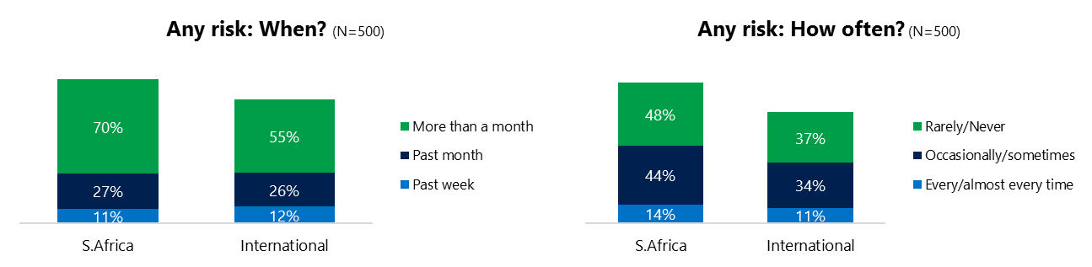14% reported online risks happened every/almost every time compared to 11% internationally.

**Demographics**

**Age**: Unsurprisingly, youth (ages 13-17) were found to have a greater number of interactions online than adults (176, 145).[1] Higher interaction levels by youth did not translate into higher rates of online risk than adults (76%, 80%). Unwanted contact (65%, 55%) and Sexual risks (43%, 26%) were higher for adults (28%, 19%) while youth experienced higher rates of Behavioral risks (54, 42%).

Youth were less confident than adults in managing uncivil behavior, (55%, 60%) but youth were more sure of themselves about where to get help (48%, 25%) if needed.**Gender**:Remarkably, there were no significant differences by gender with one exception regarding the outlook for safety. Males and females reported the same levels of exposure to risks (78%, 78%) overall and across the four risk categories.

Both groups were equally likely to act (84%, 82%) in response to a risk and confident in managing risks (59%, 56%).

Females were more pessimistic about the future of personal safety (113, 96)[2] than males and both genders agreed that civility would improve one year from now.



1. Past year interactions (% more minus % less x 100 +100)

   2 Lower scores = felt more civil, safer (% worse - % better) x 100+100

   3 Ibid.
2.