**Digital Civility Index (DCI) – United Kingdom**



Microsoft conducted research among adults and teenagers in 14 countries to study the level of civility across various online interactions. These results expand on the behavioral component of Microsoft’s Computer Safety Index (MCSI) by examining the extent of negative civil and personal safety interactions and their consequences.

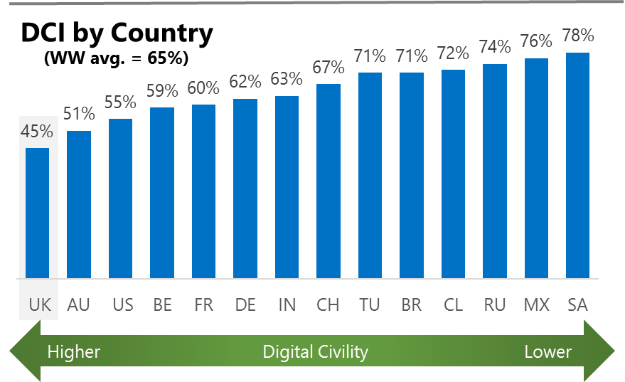The Digital Civility Index (DCI) measures consumers’ lifetime exposure to online risks. Online risks were divided into four categories: Behavioral, Intrusive, Reputational and Sexual. Each category consisted of several individual risks. DCI scores were calculated by using the percentage of consumers who were exposed at some point in time to at least one of 17 different online risk(s). **Lower scores equate to lower online risk exposure and a higher Digital Civility**.

**United Kingdom ranked 1st in DCI**

45% reported having ever been exposed to an online risk. The UK scored significantly below the international averages across all risk categories although the incidence of some individual risks was close to average.

**Intrusive**

* Unwanted contact (30%) was the primary driver of Intrusive risks and had the highest incidence of any risk. Intrusive risks were significantly lower than the international average (34%, 52%).

**Behavioral**

* Behavioral (28%) was the second most common risk category led by Treated mean (22%) and Trolling (14%).

**Sexual**

* Consumers in the UK had a lower chance of experiencing any Sexual online risk compared to international (14%, 32%).
* Unwanted sexting (received or sent, 11%) and Sexual solicitation (5%) were the most common sexual risks.

**Reputational**

* People encountered Reputational risks at a lower rate vs. international (7% vs. 19%) led by Damage to personal reputation (4%) and Doxing (4%).



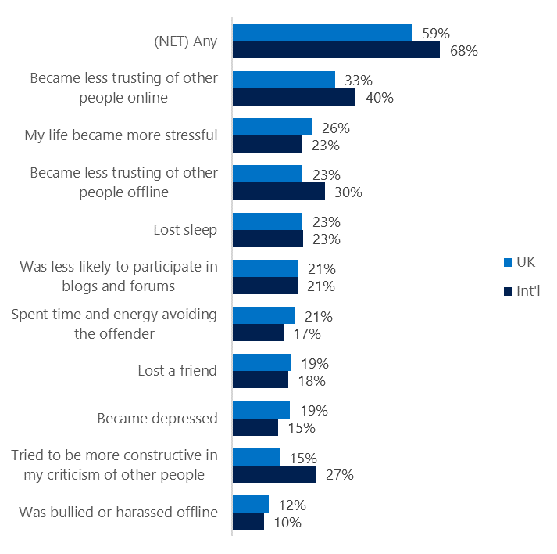**People became less trusting of others**

**Top 10 consequences**

**(Happened to me)**

Almost six in ten of people in the UK reported a consequence from exposure to an online risk. This was significantly lower than the international average.

* The most likely consequence from online risk exposure was a loss of trust both online (33%) and offline (23%). As a result, people tended to become more stressed and withdrawn.
* 15% tried to counterbalance negative outcomes by being more constructive in their criticism of others. These attempts at constructive criticism were much lower in the UK vs. international (27%).
* The largest gaps with international incidence rates were in Tried to be more constructive in my criticism (-12), Became less trusting online (-7), Became less trusting offline (-7).

**Online risks prompted strong concerns**

Overall concern about online risks was the lowest in the UK among the fourteen countries surveyed. Not surprisingly, concern was much lower at the category and individual item levels compared to the international averages.

Intrusive (37%) and Behavioral (36%) risks were ranked the most worrisome in the UK although much lower than the international averages. Reputational and Sexual risks showed even larger gaps with their corresponding international averages.

* Terrorism recruiting (23%) Online harassment (23%) and Cyberbullying (23%) generated the most concern although many other risks ranked nearly as high.

**Over one in five experienced an online risk within the past month**

* 23% of consumers in the UK experienced their most recent online risk within the past month.
* 6% said the most recent online risk happened within the past week which was half the international rate.
* 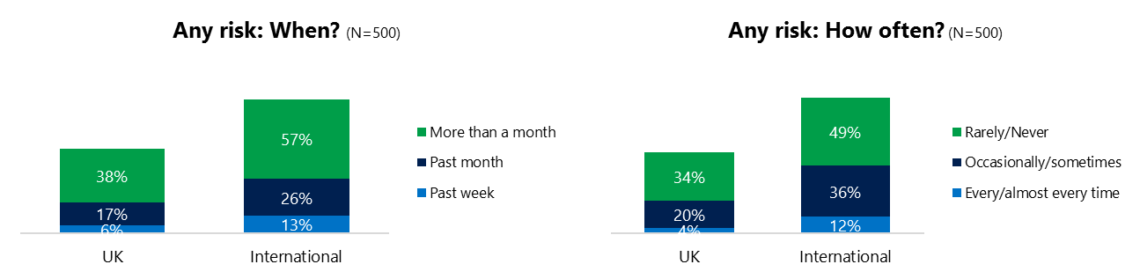4% reported online risks happened every/almost every time, three times lower than the international rate (12%). internationally.

**Demographics**

**Age**: Unsurprisingly, youth (ages 13-17) were found to have a greater number of interactions online than adults (154, 96).[1] The higher interaction level of youth translated into greater exposure to online risks (49%, 40%) which was atypical compared to most other countries surveyed. Youth were nearly twice as likely as adults to report a family or friend was affected by a risk. This suggested youth were more willing than adults to share their risk experiences and had possibly underreported their actual risk exposure.

Youth were as confident as adults in managing uncivil behavior, (45%, 43%) and much more knowledgeable about where to get help (60%, 16%) if needed.

**Gender**:Males and females reported the same rate of exposure to risks (44%, 45%). Males said they encountered Behavioral risks more often (31%, 26%) than females. Females expressed greater overall concern about online risks (37%, 26%).

Both genders were equally likely to act (68%, 66%) in response to a risk and to have met in person the party responsible for the risk. (46%, 45%).

Males expressed greater confidence in managing a risk (51%, 37%) but were less likely to know where to turn for help if needed (35%, 41%). Females were slightly less optimistic about the future of civility than males (114, 105).[2]



1. Past year interactions (% more minus % less x 100 +100)

   2 Lower scores = felt more civil, safer (% worse - % better) x 100+100

   3 Ibid.
2.