**Digital Civility Index (DCI) – India**



Microsoft conducted research among adults and teenagers in 14 countries to study the level of civility across various online interactions. These results expand on the behavioral component of Microsoft’s Computer Safety Index (MCSI) by examining the extent of negative civil and personal safety interactions and their consequences.

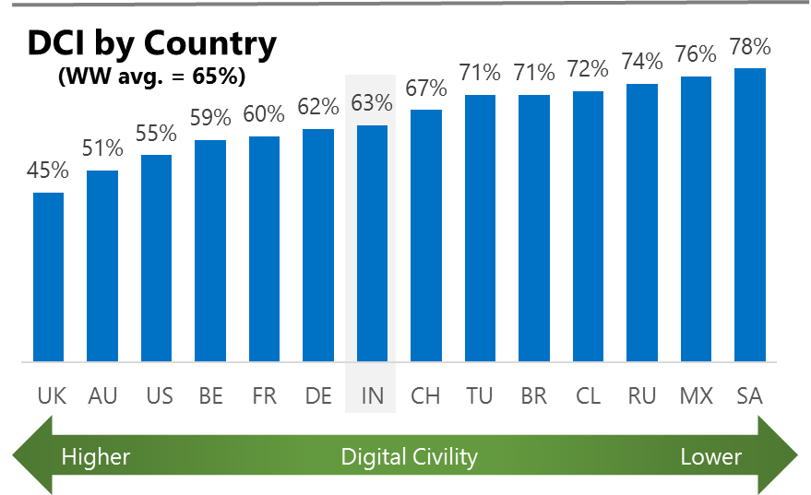The Digital Civility Index (DCI) measures consumers’ lifetime exposure to online risks. Online risks were divided into four categories: Behavioral, Intrusive, Reputational and Sexual. Each category consisted of several individual risks. DCI scores were calculated by using the percentage of consumers who were exposed at some point in time to at least one of 17 different online risk(s). **Lower scores equate to lower online risk exposure and a higher Digital Civility**.

**India ranked 7th in DCI**

63% of Indians reported having ever been exposed to an online risk. India had incidence levels that were close to the international averages across most online risks.

**Intrusive**

* Unwanted contact (46%) was the primary driver of Intrusive risks and had the highest incidence of any risk. Incidence of Intrusive risks in India mirrored the international averages.

**Behavioral**

* Behavioral (33%) was the second most common occurring risk category and significantly below the international average (39%). Lower levels of Behavioral risks in India were due to Online harassment (-8%) and Treated mean (-6%).

**Sexual**

* Indians had a lower chance of experiencing any Sexual online risk compared to international (25%, 30%).
* Unwanted sexting (received or sent, 21%) and Sexual solicitation (9%) were the most common sexual risks.

**Reputational**

* People encountered Reputational risks at about the same rate vs. international (18% vs. 19%) led by Doxing (10%) and Damage to personal reputation (9%).



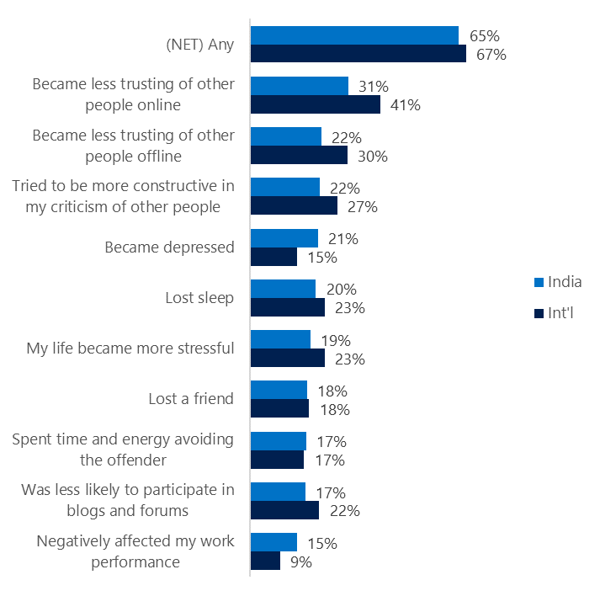**People became less trusting of others**

**Top 10 consequences**

**(Happened to me)**

65% of Indians reported a consequence from exposure to an online risk. This was similar to the international average.

* The most likely consequence from online risk exposure was a loss of trust both online (31%) and offline (22%). Thus, people tended to become more depressed and stressed. The loss of trust was felt more strongly outside of India.
* 22% tried to counterbalance negative outcomes by being more constructive in their criticism of others. These attempts at constructive criticism were slightly lower in India vs. international (27%).

**Online risks prompted strong concerns**

Indians expressed the highest level of overall concern (69%) among the countries surveyed. This concern was echoed much less strongly compared to the international average (48%).

All categories of risk generated elevated levels of concern with Indian levels exceeding international levels by 26-points on average.

* Doxing (65%), Online harassment (65%), Terrorism recruiting (65%) and Sextortion (62%) garnered the most concerns in India.
* Sexual risks had the greatest differences with international led by Unwanted sexting (sent, +32), Sextortion (+31) and Non-consensual pornography

(” revenge porn”, +30).

**Over one in four experienced an online risk within the past month**

* 44% of Indians experienced their most recent online risk within the past month.
* 14% said the most recent online risk happened within the past week which mirrored international.
* 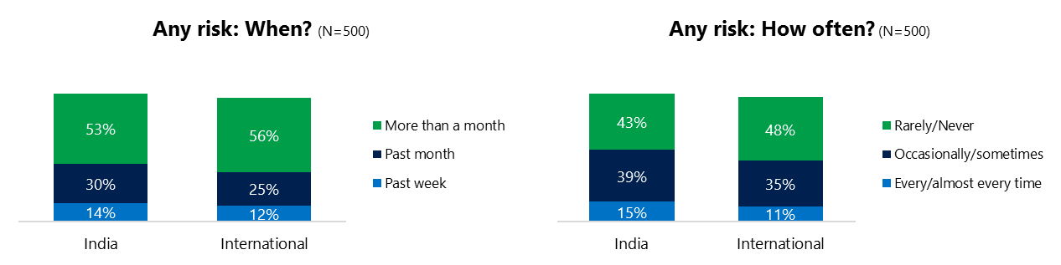15% reported online risks happened every/almost every time compared to 11% internationally.

**Demographics**

**Age**: Unsurprisingly, youth (ages 13-17) were found to have a greater number of interactions online than adults (163, 155)[1]. Despite higher interaction levels, youth reported similar rates of online risk (64%, 61%) as adults. Youth reported higher incidence of risks among family and friends (75%, 61%) than adults. This suggested that youth were more willing to share their negative online experiences and may have underreported their online risk exposure.

Youth were as confident than adults in managing uncivil behavior, (72%, 69%) and were more knowledgeable about where to get help (50%, 35%) if needed.**Gender**:Males reported about the same level of exposure to risks than females (64%, 61%). There were no significant differences by gender at the category or individual online risk level. Remarkably, the lack of differences by gender extended to all other important measures including having acted (87%, 87%), met the perpetrator (43%, 47%) and knowing where to get help if needed (42%, 42%) as well as their respective outlooks for civility and personal safety.



1. Past year interactions (% more minus % less x 100 +100)

   2 Lower scores = felt more civil, safer (% worse - % better) x 100+100

   3 Ibid.