**Digital Civility Index (DCI) – Belgium**



Microsoft conducted research among adults and teenagers in 14 countries to study the level of civility across various online interactions. These results expand on the behavioral component of Microsoft’s Computer Safety Index (MCSI) by examining the extent of negative civil and personal safety interactions and their consequences.

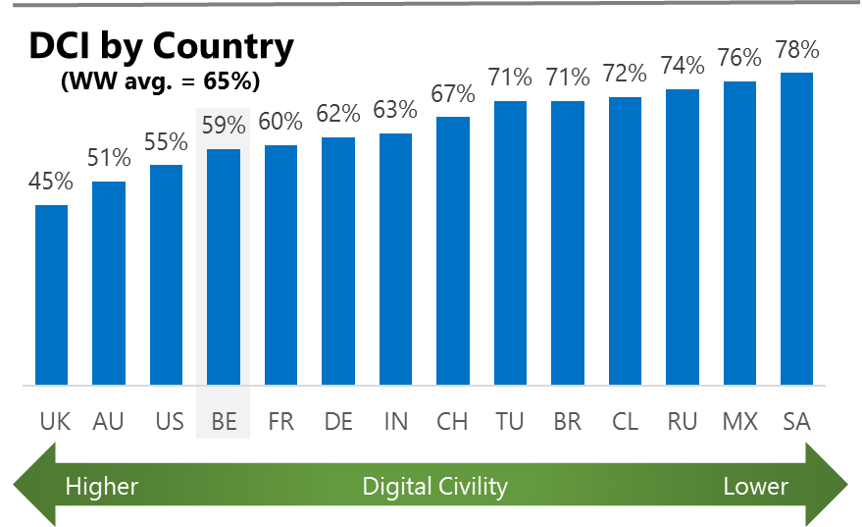The Digital Civility Index (DCI) measures consumers’ lifetime exposure to online risks. Online risks were divided into four categories: Behavioral, Intrusive, Reputational and Sexual. Each category consisted of several individual risks. DCI scores were calculated by using the percentage of consumers who were exposed at some point in time to at least one of 17 different online risk(s). **Lower scores equate to lower online risk exposure and a higher Digital Civility**.

**Belgium ranked 4nd in DCI**

59% of Belgians reported having ever been exposed to an online risk. Belgium scored at or below international levels on most category and individual risks.

**Intrusive**

* Unwanted contact (34%) was the primary driver of Intrusive risks which had the highest score of any online risk category. The incidence of Intrusive risks was significantly lower than international (42%, 51%).

**Behavioral**

* Treated mean (24%) was the leading Behavioral risk and ranked second overall among all online risks in Belgium.
* Trolling (21%) and Online Harassment (16%) were among the top five highest online risks.

**Sexual**

* Belgians were close to the international average on experiencing any Sexual risk (28%, 30%).
* Unwanted sexting (received or sent, 24%) and Sexual solicitation (11%) were the most common sexual risks.

**Reputational**

* Doxing (10%) and Damage to personal reputation (10%) were the most common Reputational risks.

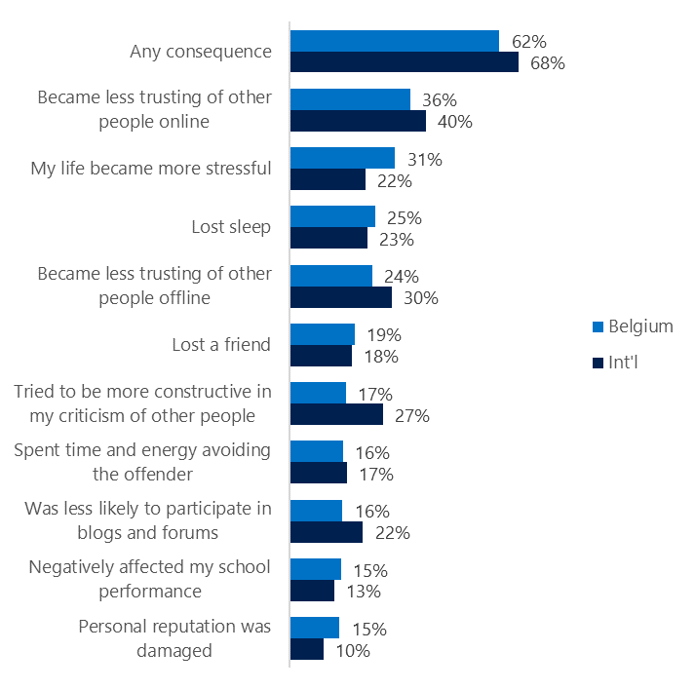**People became less trusting of others**

**Top 10 consequences**

**(Happened to me)**

62% of Belgians reported a consequence from exposure to an online risk. This was significantly lower than the international average.

* The most common consequence from online risk exposure was becoming less trustful of others online (36%).
* Overall, Belgians scored similarly across the top ten consequences compared to international. The one exception was Becoming more stressed (31%) which was higher in Belgium than international (22%).
* 17% made an effort to counterbalance negative outcomes by being more constructive in their criticism of others. This was considerably lower than similar efforts made internationally (27%).

**Online risks prompted strong concerns**

40% of people in Belgium were much more or more concerned about online risks overall. This concern was echoed more strongly outside the country. (International, 50%).

Looking one year ahead, Intrusive (41%) risks garnered the most concern both in Belgium and internationally. Concerns about Behavioral (38%) and Reputational (37%) risks were nearly as high as Intrusive risks.

* Terrorism Recruiting (32%), Doxing (28%), and Damage to personal reputation (25%), and were the three most concerning online risks.
* Consumers reported having lower concerns across all category and individual online risks compared to international. The largest differences were in Online Harassment (21%, 40%), Behavioral (38%, 55%) and Reputational risks (37%, 55%).

**Nearly one-third experienced an online risk within the past month**

* 30% of Belgians experienced their most recent online risk within the past month.
* 19% said the most recent online risk happened within the past week which was much lower than international (26%).
* 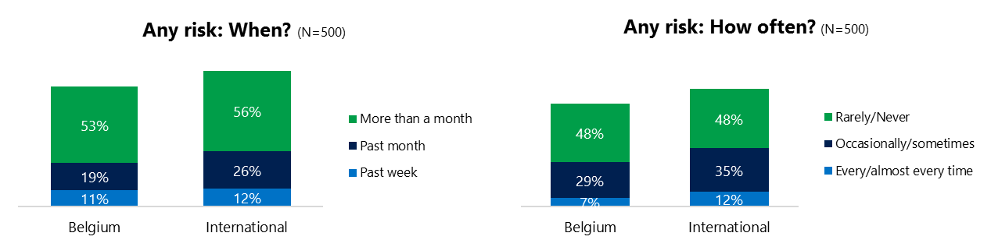7% reported online risks happened every/almost every time compared to 12% internationally.

**Demographics**

**Age**: Unsurprisingly, youth (ages 13-17) were found to have a greater number of interactions online than adults (153, 114)[1]. Higher interactions among youth translated into much higher rates of online risk for their friends and family (60%, 28%), but not for themselves (57%, 61%) compared to adults. This suggested youth may have underreported their exposure to online risks and were more willing to share their negative online experiences.

Youth were almost twice as likely (61%, 34%) to have met in person the individual responsible for the online risk.

Youth were slightly less confident than adults in managing uncivil behavior, (34%, 38%) but were more knowledgeable about where to get help (38%, 14%) if needed.

**Gender**:Males reported higher exposure to online risks than females (62%, 52%). Females said they experienced more Behavioral risks (44%, 34%) than males.

Females expressed greater concern (45%, 36%) than males and were more likely to take action in response to an online risk (78%, 70%).

Males said they were more confident in dealing with an online risk (41%, 32%) than females and slightly more likely to know where to get help if needed (34%, 28%).

Females were slightly more pessimistic about the future of safety (136, 130)[2] and civility (116, 111)[3].

1. Past year interactions (% more - % less x 100+100)
2. Felt more civil, safer (% less - % more) x 100+100)
3. Ibid.