Microsoft Digital Civility Index (DCI) 2017 – Vietnam



The 2017 Civility, Safety and Interaction Online study examines the extent of negative behaviors and online interactions and their consequences. These results build on last year’s study and were based on interviews with teens ages 13-17 and adults ages 18-74. The scope of research increased to encompass 23 countries and 20 online risks (nine newly included countries, three added risks).[1]

Themes for 2017

Risk exposure was above the global averages

1. 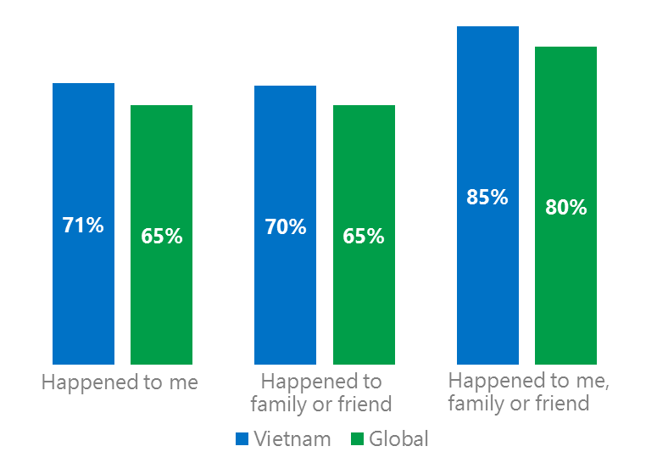Online risk exposure for respondents, their family and friends were higher than the global averages.
2. Targets of online risks often named acquaintances, friends or family as perpetrators.
3. Encouraging signs emerged as people began to evolve their approaches towards the challenges of negative online interactions.
4. Millennials (ages 18-34) had the highest lifetime exposure to online risks while Baby Boomers (ages 50-74) reported the highest level of civil behavior.
5. Harassment was higher for females than males while teens suffered more of the consequences from online risks.

Six in 10 experienced an Intrusive risk

1 Vietnam DCI was 71%

Vietnam ranked 14th out of 23 countries for exposure to online risks. In 2017, we maintained and added two risks to the Intrusive category and one risk to Behavioral. Without these changes, DCI would have been two points lower to 69%.

**Intrusive:** Unwanted Contact (49%) was the most common risk and eight points above the global average. The addition of Hoaxes, Scams & Frauds (22%) and Misogyny (3%) added five points to the category overall.

**Behavioral:** Over four in 10 respondents experienced a Behavioral risk led by Trolling (24%) and Microaggression (17%) both five points above the global average. Being Treated Mean was 50% below the global average affecting one in 10 respondents.

**Sexual:** Over one-third of respondents had a Sexual risk led by Unwanted Sexting Received or Sent (28%) and Sexual Solicitation (23%). Overall, the category was six points above the global average.

**Reputational:** The category was 10 points higher than the global average driven by Doxxing which was double the global average.

2Targets of online risks often named 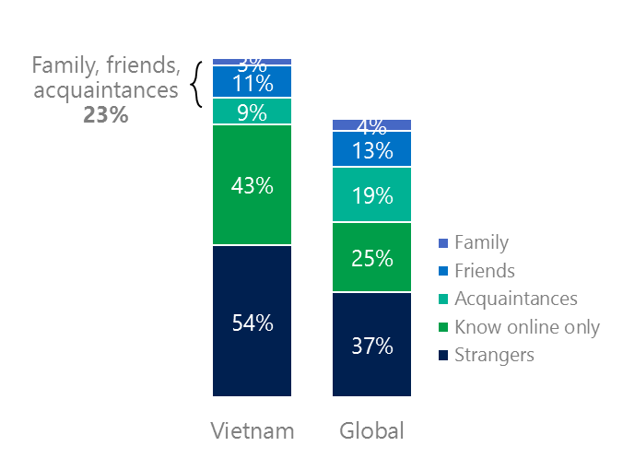people they knew as perpetrators

23% of perpetrators were family, friends or acquaintances

(among those who said they were treated unsafely or uncivilly)

Although many believe online risks are facilitated by the anonymity provided by the internet, these experiences often involved people they knew personally including family or friends (23%) compared to 36% globally. Vietnam had the second highest percentage of perpetrators who were strangers, second only to Russia (57%). 79% had met their perpetrator in real life which was the highest among the 23 countries surveyed and 26 points above the global average (53%). Among those who had met their perpetrator, three-quarters of respondents (75%) met before the risk. Familiarity with the perpetrator in real life was related to an increased exposure to online risks. The average number of risks was 98% higher among those who had met the perpetrator in real life vs. those who had not (4.8 vs. 2.4).

Over three-quarters of respondents (76%) suffered at least one negative consequence from online risks with less trusting of people online and lost sleep being the most common. Familiarity with the perpetrator in real life also affected exposure to consequences. Among those who had met their perpetrator in real life, 49% lost trust in others online and 41% reported losing sleep. This compared to a loss of trust in others online (38%) and 24% said they lost sleep for those who had not met the perpetrator in real life.

Loss of trust was the biggest consequence

3 Encouraging signs emerged

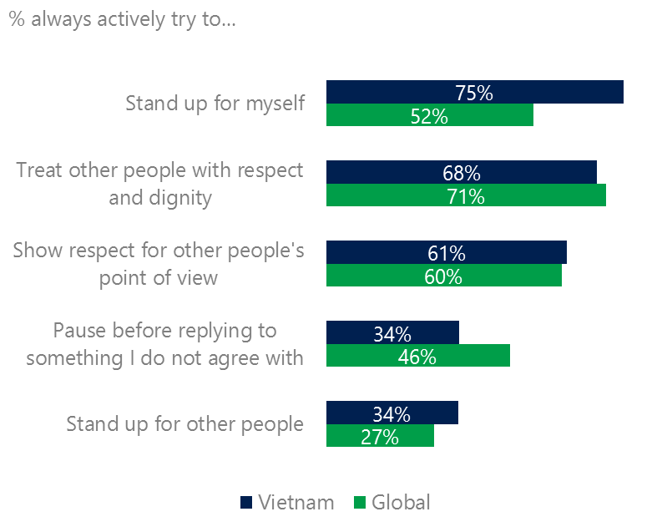Compared to the global averages, civil behaviors as defined by the Microsoft Digital Civility Challenge, announced in 2017 were mixed. Unlike other countries, standing up for myself was the top civil behavior and exceeded the global average by 23 points. Respondents were in line with the global averages on treating people with respect and dignity, showing respect for other people’s point of view and standing up for other people. Only 34% reported pausing before replying to something they disagreed with, 12 points below the global average.

Reports of civil behavior were widespread

43% of respondents said they were extremely or very confident in managing online risks three points below the global average (46%). 41% of respondents knew where to find help if needed, four points under the global average.

Civil behaviors did not vary between genders or adults and teens with the one exception - males were more likely than females to pause before replying to something they disagreed with (38%, 30%).

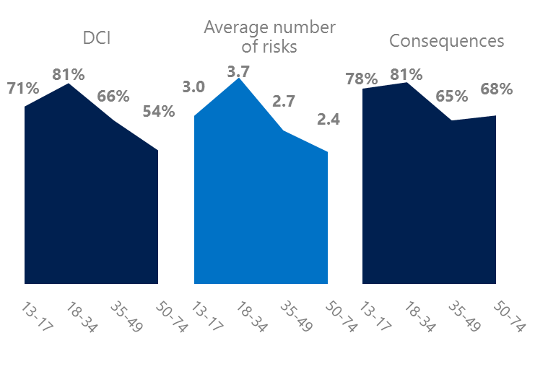4 Millennials had the highest exposure to online risks and their consequences

Millennials suffered the most consequences

Millennial generation respondents (ages 18-34) had the highest levels of risk exposure as measured by DCI (81%), average number of risks (3.7) and consequences from risks (81%). One possible explanation for these high levels is that Millennials were the first generation to grow up in a digital, media-saturated world with abundant free time to explore and experiment. 13% of Millennials said they were not treated in a safe or civil manner online – highest among all age groups. Not surprisingly, more than half of Millennials (57%) were extremely or very concerned about online risks, the highest among all age groups.

Boomers reported the highest scores for civil behaviors online as defined by the Microsoft Digital Civility Challenge, announced in 2017. Boomers had the best scores across all civil behaviors with the highest being treating other people with respect and dignity and showing respect for other people’s point of view.

Boomers reported the strongest civil behavior

5 Harassment was higher for females than males

43% of respondents experienced one or more forms of harassment. This study defined harassment as Unwanted Contact, Unwanted Sexting, Online Harassment, Cyberbullying or Misogyny. Females had a higher overall rate of harassment than males driven by Unwanted Contact (53%, 45%). Males reported a higher rate of Unwanted Sexting than females (31%, 25%). Adults reported higher rates of harassment than teens led by Unwanted Contact (54%, 44%) and Unwanted Sexting (32$, 25%).

Nearly six in 10 respondents were harassed

Teens suffered higher rates of consequences from online risks compared to adults led by loss of trust in other people online (52%, 47%), life became more stressful (45%, 30%). Consequences from online risks were equally challenging for both females and males.

Definitions of online risks

1. **Cyberbullying:** When the Internet, phones or other devices are used to send or post text, images, or video intended to hurt, embarrass or intimidate another person.
2. **Damage to Personal reputation:** Damage or destruction to the image created of you through PERSONAL information you or others shared online in blogs, postings, pictures, tweets, videos, etc.
3. **Damage to Professional/Work reputation:** Damage or destruction to the image created of you through work information you or others shared online in blogs, postings, pictures, tweets, videos, etc.
4. **Discrimination:** A person who is discriminated against or excluded based on gender, ethnic origin, religion, race, disability, or sexual orientation.
5. **Doxxing:** The process of collecting and distributing or posting information about a person (e.g., name, age, email, address, phone number, photographs, etc.) without their permission.
6. **Hate speech:** speech that attacks a person or group based on gender, ethnic origin, religion, race, disability, or sexual orientation.
7. **Hoaxes, scams, frauds:** The spreading of false rumors (e.g., chain letters), criminal attempts to obtain personal information often for monetary gain (e.g., phishing scams), malicious emails disguised as someone you know (e.g. virus).
8. **Microaggression:** Casual insults made towards any marginalized group in society (e.g., religious or ethnic minorities, women, LGBT, people with disabilities, etc.).
9. **Misogyny**: An expression or demonstration of dislike, contempt for, or ingrained prejudice against women.
10. **Online harassment:** Threats or other offensive behavior (not sexual solicitation) sent online or posted online for others to see.
11. **Revenge pornography:** A sexually explicit portrayal of one or more people distributed without their consent.
12. **Sextortion:** When someone threatens to distribute your private and sensitive material if you don’t provide them images of a sexual nature, sexual favors, or money. The perpetrator may also threaten to harm your friends or relatives by using information they have obtained from your electronic devices unless you comply with their demands.
13. **Sexual solicitation:** A person who requests to engage in sexual activities or sexual talk or to give personal sexual information that is unwanted.
14. **Swatting:** The act of deceiving emergency services (e.g., police, fire, medical) into sending an emergency response based on the false report of an ongoing critical incident or crime.
15. **Terrorism recruiting:** An attempt by a terrorist or terrorist organization to recruit a person for the purposes of causing harm.
16. **Treated Mean:** Words or messages sent to another person online that are unkind, unfair or malicious.
17. **Trolling:** A deliberate act to make someone mad or angry using online or social media comments in a clever, but deceitful manner.
18. **Unwanted Sexting Sent:** I sent unwanted sexually explicit messages and imagery.
19. **Unwanted Sexting Received:** Received unwanted sexually explicit messages and imagery.
20. **Unwanted contact:** Being personally contacted (by phone or in person) by someone who obtained your information online but without inviting them to contact you.

1. 9 new countries: Argentina, Colombia, Peru, Hungary, Ireland, Italy, Japan, Malaysia, Vietnam

   14 Wave 1 countries: Australia, Belgium, Brazil, Chile, China, France, Germany, India, Mexico, Russia, South Africa, Turkey, UK, U.S.

   3 new online risks: Hoaxes, Frauds and Scams as one collective risk, Microaggression, Misogyny