Microsoft Digital Civility Index (DCI) 2017 – United States



The 2017 Civility, Safety and Interaction Online study examines the extent of negative behaviors and online interactions and their consequences. These results build on last year’s study and were based on interviews with teens ages 13-17 and adults ages 18-74. The scope of research increased to encompass 23 countries and 20 online risks (nine newly included countries, three added risks).[1]

Themes for 2017

Risk exposure was below the global averages

1. 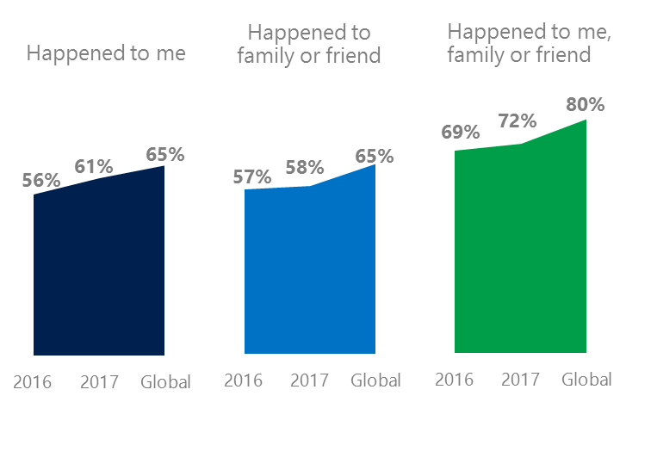The level of online risks increased for respondents and their family and friends since 2016. The United States’ risk exposure was below the global averages.
2. Targets of online risks often named acquaintances, friends or family as perpetrators.
3. Encouraging signs emerged as people began to evolve their approaches towards the challenges of negative online interactions.
4. Teens (ages 13-17) had the highest exposure to online risks among all age groups.
5. Harassment and their consequences were higher for females than males.

Sexual risks dropped nine points YOY

1 United States DCI was 61%

United States ranked second out of 23 countries for exposure to online risks. In 2017, we maintained and added two risks to the Intrusive category and one risk to Behavioral. Without these changes, DCI would have been eight points lower to 43%.

**Intrusive:** The addition of Hoaxes, Scams & Frauds (22%) and Misogyny (3%) drove the category higher by seven points YOY. Unwanted Contact (28%) remained the most common risk.

**Behavioral:** The category trend held steady with only small changes YOY to individual risks. Microaggression (6%), new in 2017 was 50% below the global average.

**Sexual:** A large drop in Sexual risks led by Unwanted Sexting Received or Sent (12%) which was unchanged from 2016. The category was seven points below the global average.

**Reputational:** The category trend was flat YOY with Damage to Personal Reputation becoming the most common risk ahead of Doxxing.

2Targets of online risks often named 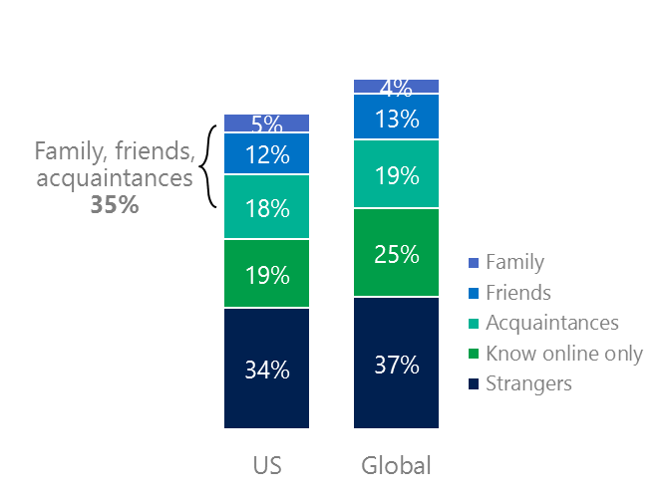people they knew as perpetrators

35% of perpetrators were family, friends or acquaintances

(among those who said they were treated unsafely or uncivilly)

Although many believe online risks are facilitated by the anonymity provided by the internet, these experiences often involved people they knew personally including family or friends (35%) compared to 36% globally. 44% had met their perpetrator in real life, a 4-point drop since 2016 and nine points below the global average (53%). Among those who had met their perpetrator, over eight in 10 (84%) met before the risk occurred – fourth highest among the 23 countries surveyed. Familiarity with the perpetrator in real life was related to an increased exposure to online risks. The average number of risks was 86% higher among those who had met the perpetrator in real life vs. those who had not (5.6 vs. 3.0).

Over six in 10 respondents (64%) suffered at least one negative consequence from online risks with less trusting of people online and life became more stress being the most common. Familiarity with the perpetrator in real life also affected exposure to consequences. Among those who had met their perpetrator in real life, 60% lost trust in others online and 46% reported life became more stressful. This compared to a loss of trust in others online (31%) and 19% said life became more stressful for those who had not met the perpetrator in real life.

Loss of trust was the biggest consequence

3 Encouraging signs emerged

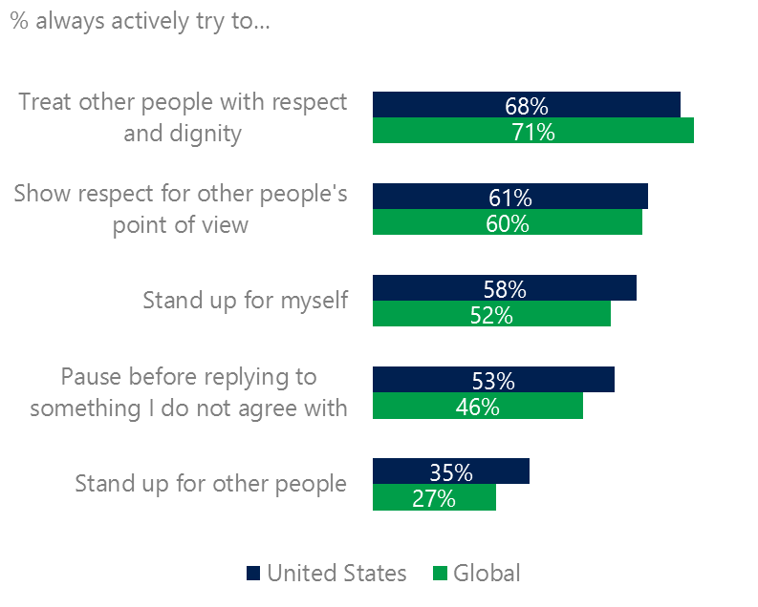United States equaled or exceeded the global averages for civil behavior as defined by the Microsoft Digital Civility Challenge, announced in 2017. Nearly seven in 10 respondents said they always treated people with respect and dignity and 61% of respondents reported always showing respect for other people’s point of view. 58% said they always pause before replying to something they disagreed with, six points above the global average.

Reports of civil behavior were widespread

60% of respondents said they were extremely or very confident in managing online risks – second highest among the 23 countries surveyed and 14-points above the global average (46%). 51% of respondents knew where to find help if needed, up six points YOY and six points above the global average (45%).

Females were more likely than males to treat others with respect and dignity (72%, 64%) and pause before replying to something they disagreed with (57%, 49%). Males were more likely than females to stand up for themselves (64%, 52%).

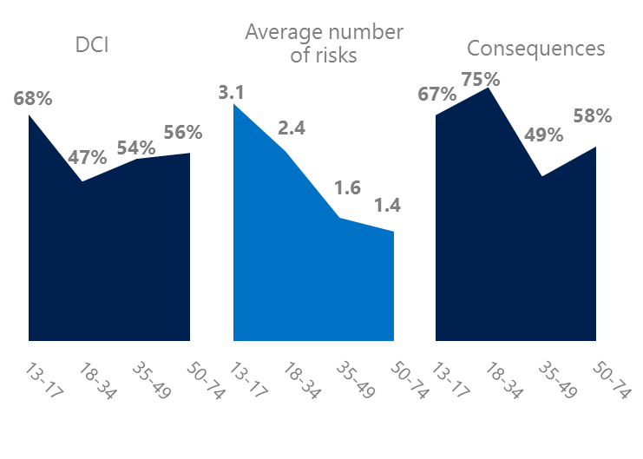4 Teens had the highest exposure to online risks

Millennials suffered the most consequences

Teens had the highest levels of risk exposure as measured by DCI (68%), and average number of risks (3.1) and the second highest level of consequences from risks (67%). The high DCI score may reflect teens having a greater breadth and depth of online activities relative to older age groups. Like several other countries, Millennials (18-34) had the highest level of consequences from risks and were ranked second in average number of risks.

Boomers reported the highest scores for civil behaviors online as defined by the Microsoft Digital Civility Challenge, announced in 2017. Boomers were the most likely to treat others with respect and dignity, respect other people’s point of view, pause before replying to something they disagreed with, stand up for themselves and stand up for other people.

Boomers reported the strongest civil behavior

5 Harassment and their consequences were higher for females than males

43% of respondents experienced one or more forms of harassment. This study defined harassment as Unwanted Contact, Unwanted Sexting, Online Harassment, Cyberbullying or Misogyny. Most forms of harassment were higher for females than males with the largest gaps being in total Harassment (53%, 34%), Unwanted Contact (41%, 24%) and Unwanted Sexting (26%, 10%). Teens were more likely than adults to report driven by Unwanted Contact, Online Harassment and Cyberbullying. Adults reported higher rates of Unwanted Sexting than teens.

Over four in 10 respondents were harassed

Females suffered disproportionately the consequences from online risks among those who were harassed. Females were 17 points higher than males on life became more stressful, 13 points higher on lost trust in other people offline, 12 points higher on became depressed, six points higher on, five points higher on.

Teens reported higher levels of consequences than adults on lost trust in other people offline (55%, 40%), life became more stressful (42%, 25%) and became depressed (39%, 17%).

Definitions of online risks

1. **Cyberbullying:** When the Internet, phones or other devices are used to send or post text, images, or video intended to hurt, embarrass or intimidate another person.
2. **Damage to Personal reputation:** Damage or destruction to the image created of you through PERSONAL information you or others shared online in blogs, postings, pictures, tweets, videos, etc.
3. **Damage to Professional/Work reputation:** Damage or destruction to the image created of you through work information you or others shared online in blogs, postings, pictures, tweets, videos, etc.
4. **Discrimination:** A person who is discriminated against or excluded based on gender, ethnic origin, religion, race, disability, or sexual orientation.
5. **Doxxing:** The process of collecting and distributing or posting information about a person (e.g., name, age, email, address, phone number, photographs, etc.) without their permission.
6. **Hate speech:** speech that attacks a person or group based on gender, ethnic origin, religion, race, disability, or sexual orientation.
7. **Hoaxes, scams, frauds:** The spreading of false rumors (e.g., chain letters), criminal attempts to obtain personal information often for monetary gain (e.g., phishing scams), malicious emails disguised as someone you know (e.g. virus).
8. **Microaggression:** Casual insults made towards any marginalized group in society (e.g., religious or ethnic minorities, women, LGBT, people with disabilities, etc.).
9. **Misogyny**: An expression or demonstration of dislike, contempt for, or ingrained prejudice against women.
10. **Online harassment:** Threats or other offensive behavior (not sexual solicitation) sent online or posted online for others to see.
11. **Revenge pornography:** A sexually explicit portrayal of one or more people distributed without their consent.
12. **Sextortion:** When someone threatens to distribute your private and sensitive material if you don’t provide them images of a sexual nature, sexual favors, or money. The perpetrator may also threaten to harm your friends or relatives by using information they have obtained from your electronic devices unless you comply with their demands.
13. **Sexual solicitation:** A person who requests to engage in sexual activities or sexual talk or to give personal sexual information that is unwanted.
14. **Swatting:** The act of deceiving emergency services (e.g., police, fire, medical) into sending an emergency response based on the false report of an ongoing critical incident or crime.
15. **Terrorism recruiting:** An attempt by a terrorist or terrorist organization to recruit a person for the purposes of causing harm.
16. **Treated Mean:** Words or messages sent to another person online that are unkind, unfair or malicious.
17. **Trolling:** A deliberate act to make someone mad or angry using online or social media comments in a clever, but deceitful manner.
18. **Unwanted Sexting Sent:** I sent unwanted sexually explicit messages and imagery.
19. **Unwanted Sexting Received:** Received unwanted sexually explicit messages and imagery.
20. **Unwanted contact:** Being personally contacted (by phone or in person) by someone who obtained your information online but without inviting them to contact you.

1. 9 new countries: Argentina, Colombia, Peru, Hungary, Ireland, Italy, Japan, Malaysia, Vietnam

   14 Wave 1 countries: Australia, Belgium, Brazil, Chile, China, France, Germany, India, Mexico, Russia, South Africa, Turkey, UK, U.S.

   3 new online risks: Hoaxes, Frauds and Scams as one collective risk, Microaggression, Misogyny