Microsoft Digital Civility Index (DCI) 2017 – Turkey



The 2017 Civility, Safety and Interaction Online study examines the extent of negative behaviors and online interactions and their consequences. These results build on last year’s study and were based on interviews with teens ages 13-17 and adults ages 18-74. The scope of research increased to encompass 23 countries and 20 online risks (nine newly included countries, three added risks).[1]

Themes for 2017

Risk exposure was above the global averages

1. 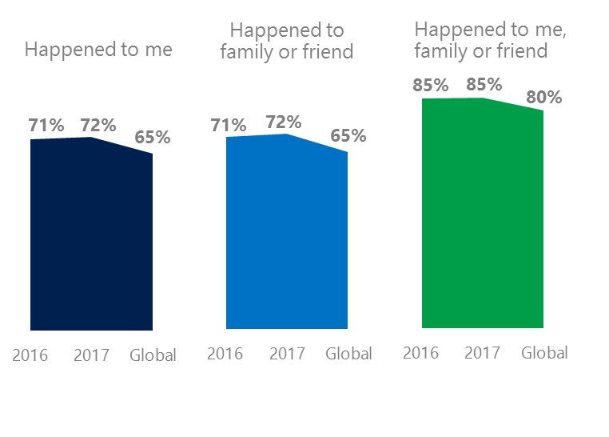The level of online risks held steady YOY for respondents and their family and friends since 2016. Turkey’s DCI was above the global average.
2. Targets of online risks often named acquaintances, friends or family as perpetrators.
3. Encouraging signs emerged as people began to evolve their approaches towards the challenges of negative online interactions.
4. Millennials (ages 18-34) had the highest lifetime exposure to online risks.
5. Female respondents suffered harassment and their consequences at higher rates than males.

Unwanted contact fell since 2016

1 Turkey DCI was 72%

Turkey ranked 16th out of 23 countries for exposure to online risks. In 2017, we maintained and added two risks to the Intrusive category and one risk to Behavioral. Without these changes, DCI would have been two points lower to 70%.

**Intrusive:** Increases in Hate Speech (+8 points) and Discrimination (+6 points) coupled with the addition of Hoaxes, Scams & Frauds (23%) and Misogyny (11%) propelled the category higher by 10 points YOY.

**Behavioral:** Behavioral risks rose five points YOY led by a 5-point increase in Trolling. Microaggression (8%), new in 2017 was below the global average.

**Sexual:** Over one in three respondents experienced a Sexual risk driven by Unwanted Sexting Received or Sent (33%) which was up four points since 2016. Sexual Solicitation increased five points YOY and is now seven points above the global average.

**Reputational:** The category increased YOY driven primarily by a six-point jump in Damage to Personal Reputation.

2Targets of online risks often named 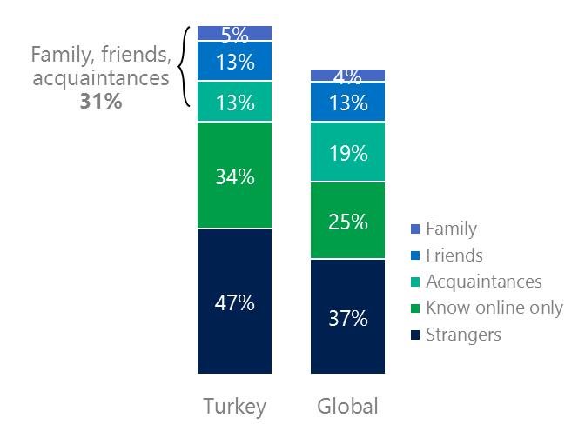people they knew as perpetrators

31% of perpetrators were family, friends or acquaintances

(among those who said they were treated unsafely or uncivilly)

Although many believe online risks are facilitated by the anonymity provided by the internet, these experiences often involved people they knew personally including family or friends (31%) compared to 36% globally. 47% had met their perpetrator in real life, a five-point drop since 2016 and six points below the global average (53%). Among those who had met their perpetrator, nearly eight in 10 (79%) met before the risk occurred. Familiarity with the perpetrator in real life was related to an increased exposure to online risks. The average number of risks was 30% higher among those who had met the perpetrator in real life vs. those who had not (5.6 vs. 4.3).

Eight in 10 respondents (80%) suffered at least one negative consequence from online risks with less trusting of people online and offline being the most common. Familiarity with the perpetrator in real life also affected exposure to consequences. Among those who had met their perpetrator in real life, 62% lost trust in others online and lost trust in others offline (51%). This compared to a loss of trust in others online (58%) and offline (44%) for those who had not met the perpetrator in real life.

Loss of trust was the biggest consequence

3 Encouraging signs emerged

Turkey exceeded or met the global averages for civil behavior as defined by the Microsoft Digital Civility Challenge, announced in 2017. Respondents were 19 points higher on standing up for myself, seven points higher on showed respect for other people’s point of view and six points higher on treating other people with respect and dignity.

Reports of civil behavior were widespread

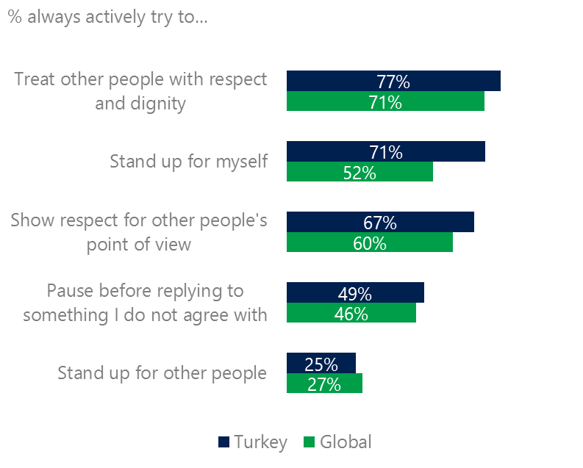Nearly six in 10 respondents (49%) said they were extremely or very confident in managing online risks about the same YOY and three points above the global average (46%). 47% of respondents knew where to find help if needed, up six points YOY two points above the global average (45%).

Females were more likely than males to show respect for other people’s point of view (71%, 63%). Adults were more likely than teens to treat others with respect and dignity (82%, 72%) while teens were more likely to stand up for themselves (77%, 65%).

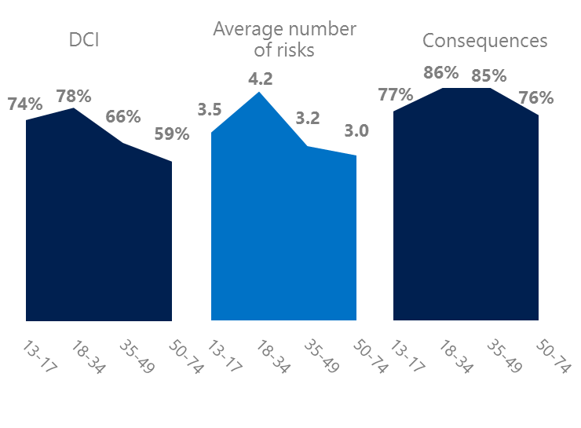4 Millennials had the highest exposure to online risks

Millennials (ages 18-34) had the highest levels of risk exposure as measured by DCI (78%), average number of risks (4.2) and consequences from risks (86%). 36% of Millennials were extremely or very concerned about online risks, the highest among all age groups. These high levels of risk exposure coincided with some positive civil behaviors online as defined by the Microsoft Digital Civility Challenge, announced in 2017. Millennials were likely to treat others with respect and dignity, respect other people’s point of view or stand up for other people. They were the least likely age group to pause before replying to something they disagreed with while Baby Boomers (ages 50-74) were the most thoughtful before responding to something they disagreed with.

Boomers suffered the most consequences

Millennials respected others point of view

5 Harassment and its consequences were higher for females than males

52% of respondents experienced one or more forms of harassment. This study defined harassment as Unwanted Contact, Unwanted Sexting, Online Harassment, Cyberbullying or Misogyny. All forms of harassment were higher for females than males with the largest gaps being in Unwanted Sexting (40%, 25%), Online Harassment (25%, 10%) and total harassment (58%, 46%), Adults were more likely to report some form of harassment than teens led by Unwanted Contact and Unwanted Sexting.

Over half of respondents were harassed

The consequences from online risks affected females at higher rates than males. Females scored 15 points higher on became depressed, 14 points higher on lost trust in other people offline, nine points higher on life became more stressful and nine points higher on lost trust in other people online.

Definitions of online risks

1. **Cyberbullying:** When the Internet, phones or other devices are used to send or post text, images, or video intended to hurt, embarrass or intimidate another person.
2. **Damage to Personal reputation:** Damage or destruction to the image created of you through PERSONAL information you or others shared online in blogs, postings, pictures, tweets, videos, etc.
3. **Damage to Professional/Work reputation:** Damage or destruction to the image created of you through work information you or others shared online in blogs, postings, pictures, tweets, videos, etc.
4. **Discrimination:** A person who is discriminated against or excluded based on gender, ethnic origin, religion, race, disability, or sexual orientation.
5. **Doxxing:** The process of collecting and distributing or posting information about a person (e.g., name, age, email, address, phone number, photographs, etc.) without their permission.
6. **Hate speech:** speech that attacks a person or group based on gender, ethnic origin, religion, race, disability, or sexual orientation.
7. **Hoaxes, scams, frauds:** The spreading of false rumors (e.g., chain letters), criminal attempts to obtain personal information often for monetary gain (e.g., phishing scams), malicious emails disguised as someone you know (e.g. virus).
8. **Microaggression:** Casual insults made towards any marginalized group in society (e.g., religious or ethnic minorities, women, LGBT, people with disabilities, etc.).
9. **Misogyny**: An expression or demonstration of dislike, contempt for, or ingrained prejudice against women.
10. **Online harassment:** Threats or other offensive behavior (not sexual solicitation) sent online or posted online for others to see.
11. **Revenge pornography:** A sexually explicit portrayal of one or more people distributed without their consent.
12. **Sextortion:** When someone threatens to distribute your private and sensitive material if you don’t provide them images of a sexual nature, sexual favors, or money. The perpetrator may also threaten to harm your friends or relatives by using information they have obtained from your electronic devices unless you comply with their demands.
13. **Sexual solicitation:** A person who requests to engage in sexual activities or sexual talk or to give personal sexual information that is unwanted.
14. **Swatting:** The act of deceiving emergency services (e.g., police, fire, medical) into sending an emergency response based on the false report of an ongoing critical incident or crime.
15. **Terrorism recruiting:** An attempt by a terrorist or terrorist organization to recruit a person for the purposes of causing harm.
16. **Treated Mean:** Words or messages sent to another person online that are unkind, unfair or malicious.
17. **Trolling:** A deliberate act to make someone mad or angry using online or social media comments in a clever, but deceitful manner.
18. **Unwanted Sexting Sent:** I sent unwanted sexually explicit messages and imagery.
19. **Unwanted Sexting Received:** Received unwanted sexually explicit messages and imagery.
20. **Unwanted contact:** Being personally contacted (by phone or in person) by someone who obtained your information online but without inviting them to contact you.

1. 9 new countries: Argentina, Colombia, Peru, Hungary, Ireland, Italy, Japan, Malaysia, Vietnam

   14 Wave 1 countries: Australia, Belgium, Brazil, Chile, China, France, Germany, India, Mexico, Russia, South Africa, Turkey, UK, U.S.

   3 new online risks: Hoaxes, Frauds and Scams as one collective risk, Microaggression, Misogyny